* Upto Tableau Architecture Lecture we have ppt so go through it.
* ETL: Extract Transform Load

Tableau Prep Instoduction & Installation

* Download tableau prep <https://www.tableau.com/products/prep/download>
* Prep me hum flow create karte hai.
* 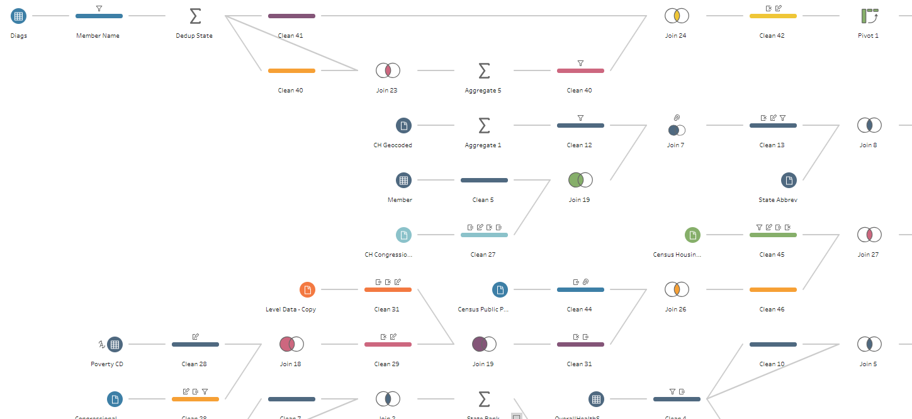
* Incremental refresh vs cold refresh
* Download and install tableau prep
* Open tableau prep builder application
* 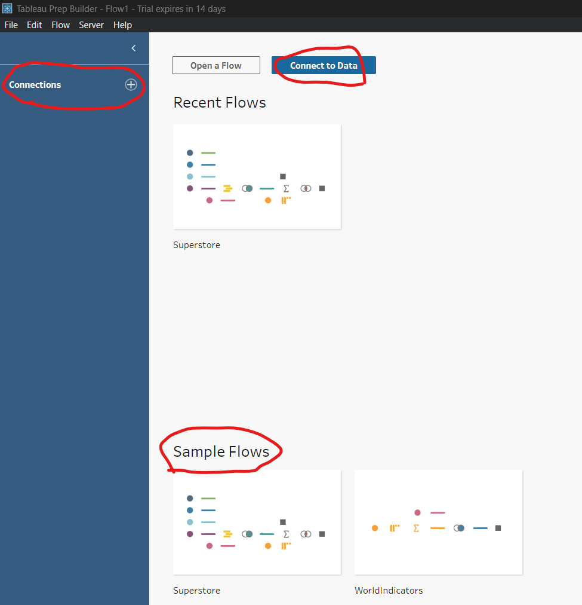
* 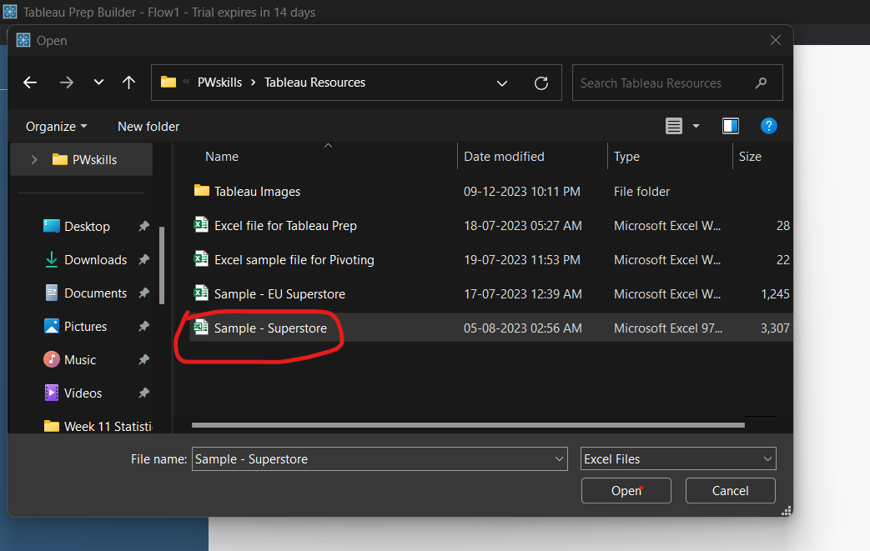
* 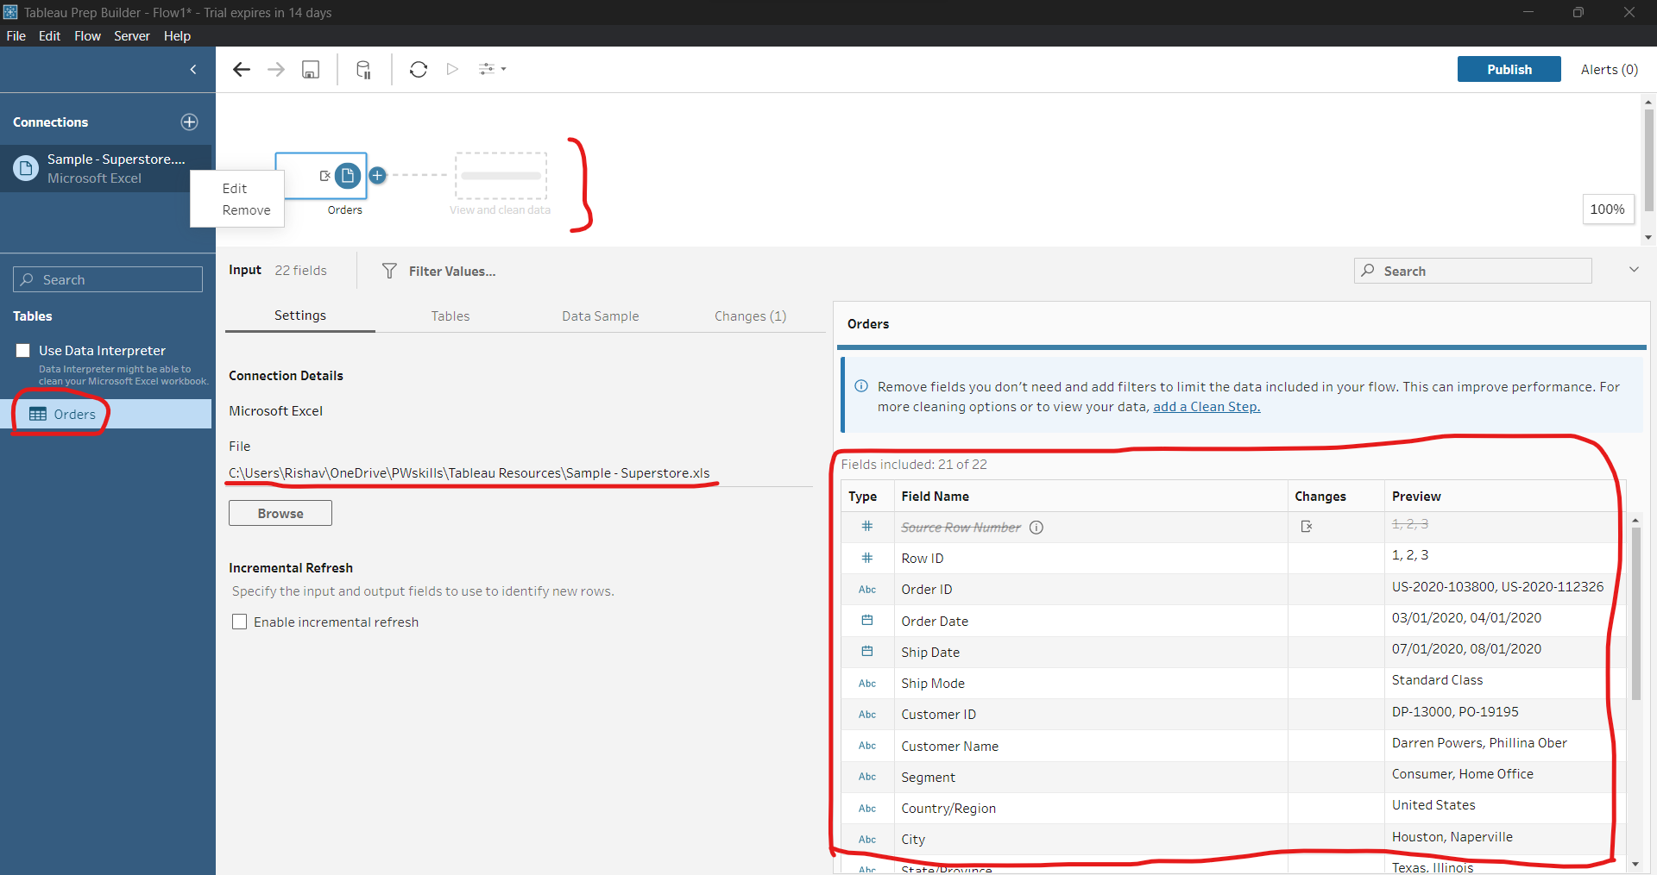
* We can add more files from browse. For joining two or more tables.
* Double click on table to add in workflow area.
* Click on tables workflow to niche ka area show hoga.
* 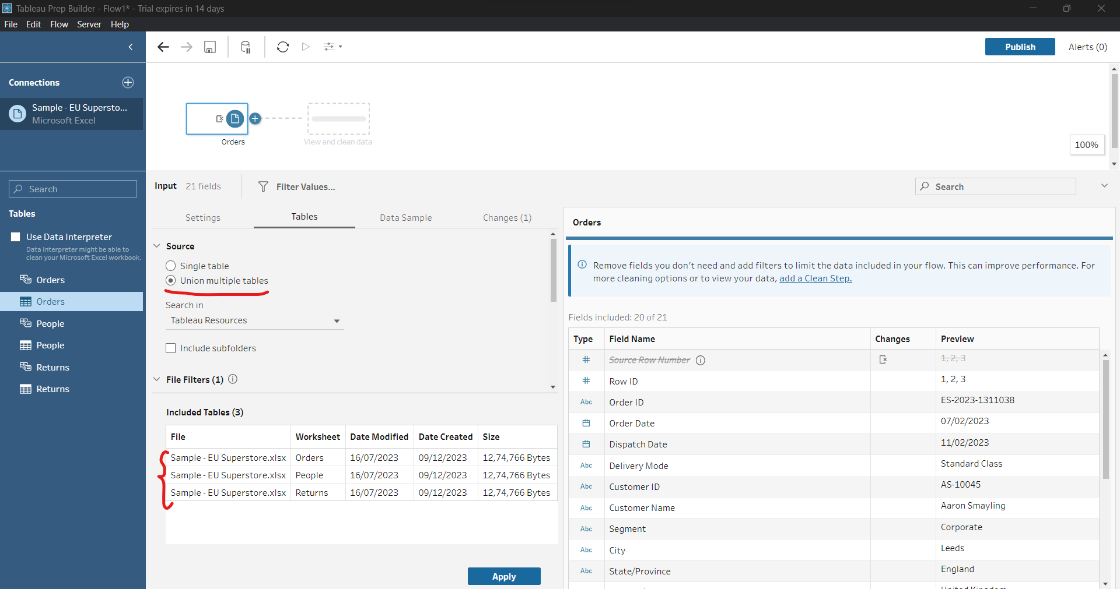
* Apply pe click karne pe teeno hi table combine ho jaayegi.
* But for now, I will work on single table.
* 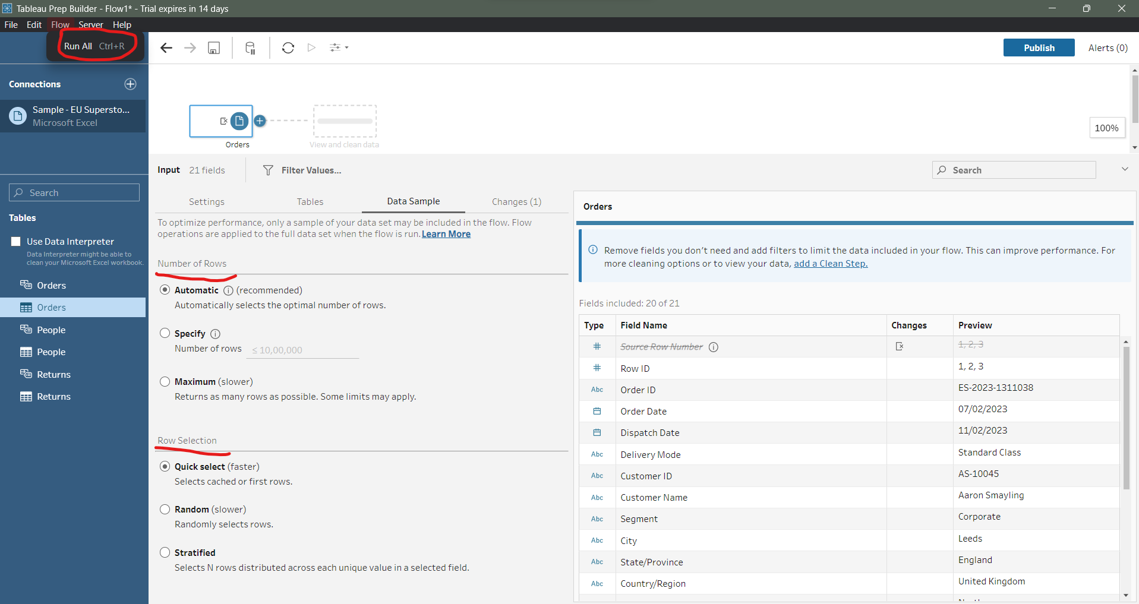
* Data sample me number of rows select karte hai.
* Flow -> Run All se saara row select ho jaayega.
* 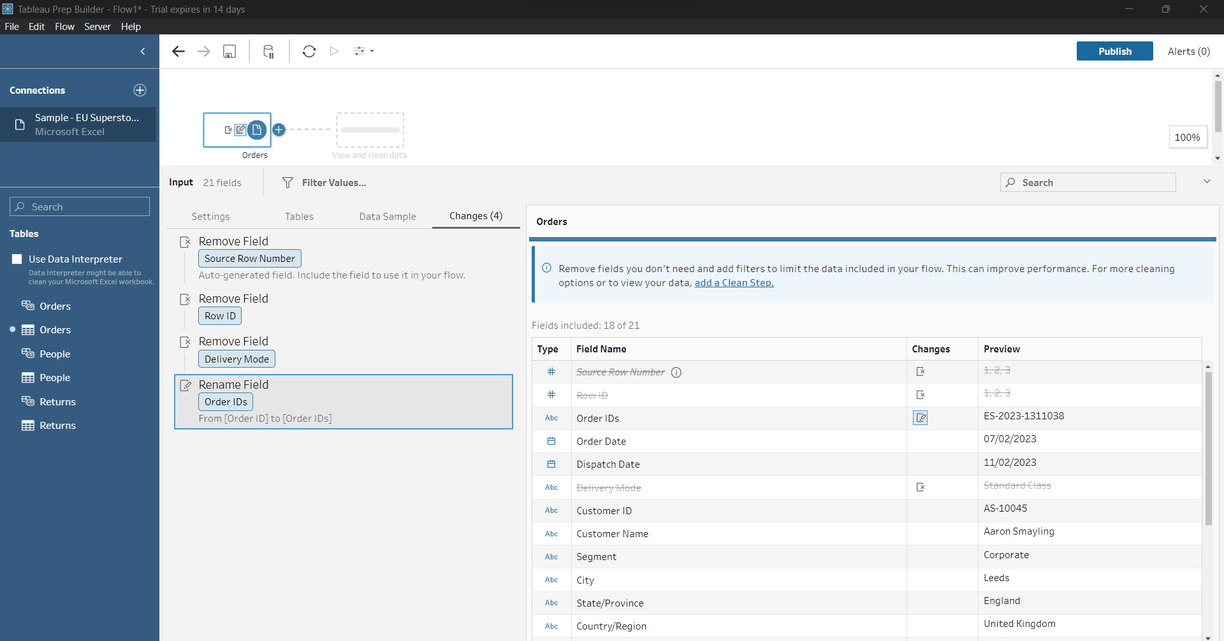
* We can delete, remove, rename, hide column
* 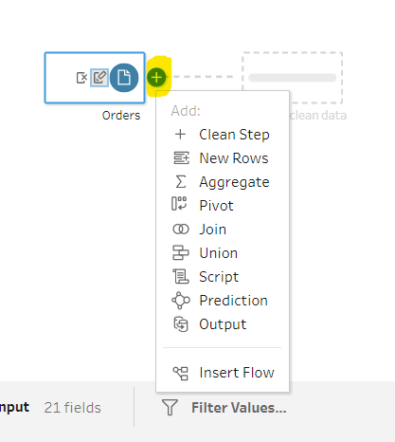
* 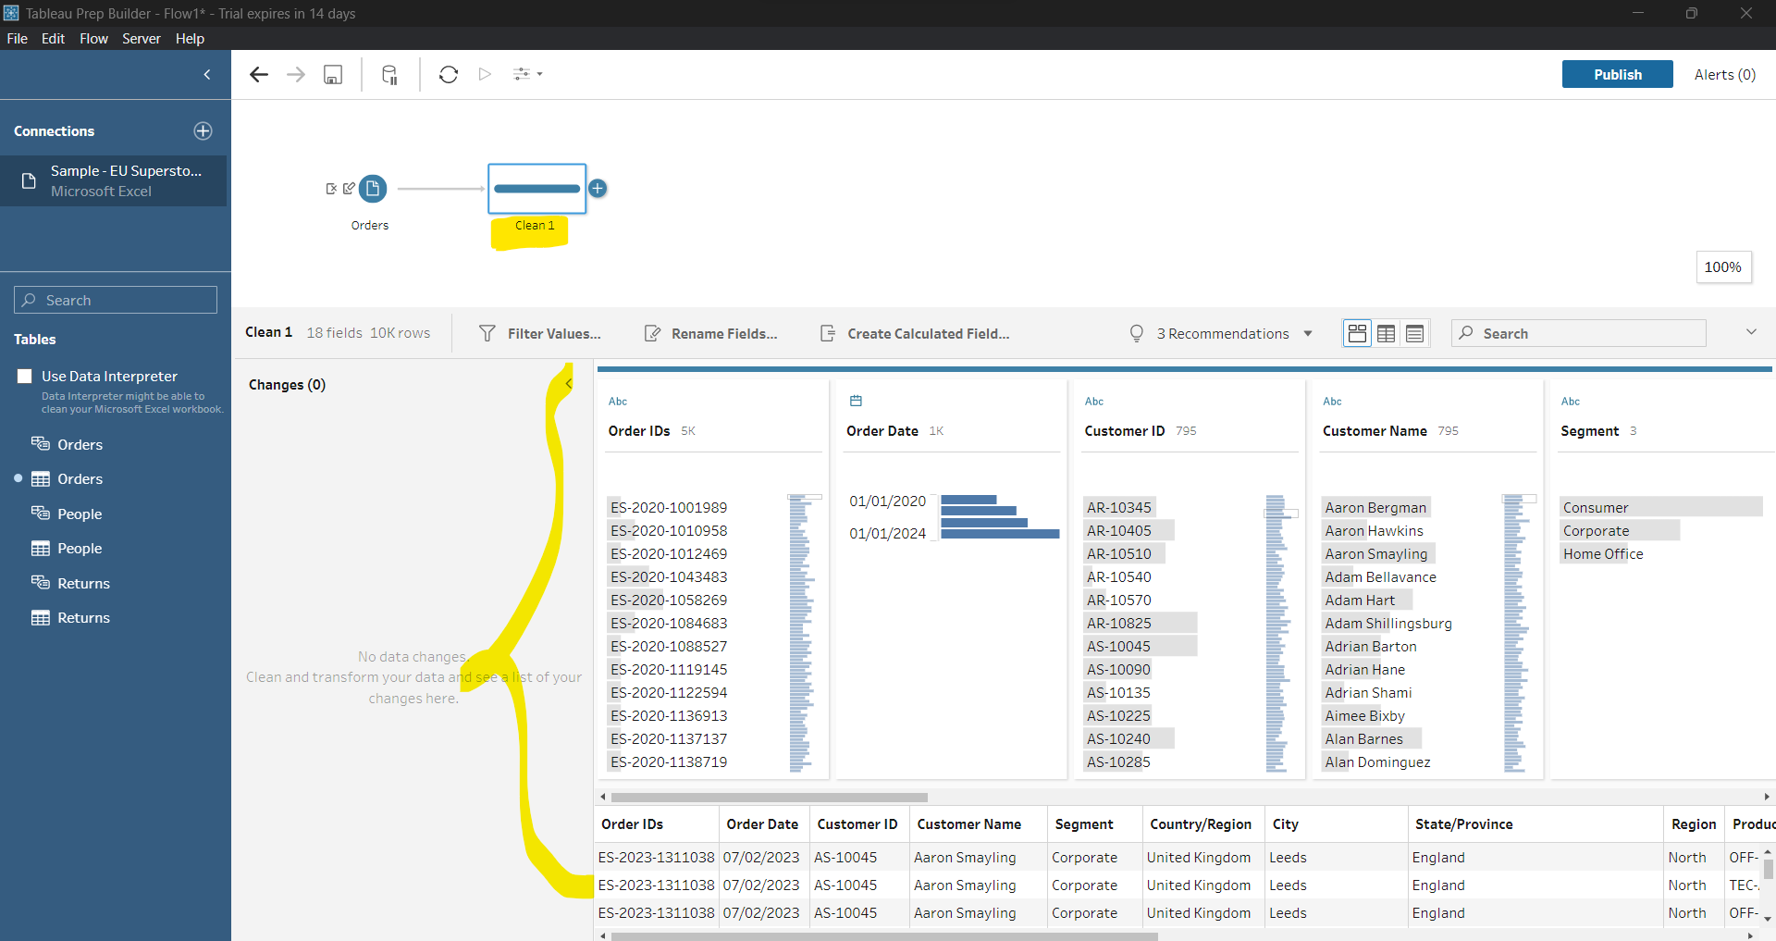
* 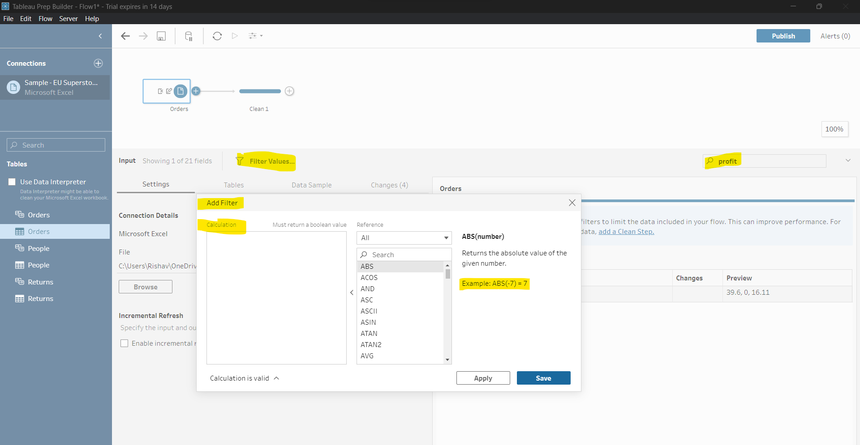
* In search we can search for column. Filter me kuchm calculation karte hai. It will return yes/no or true/false or Boolean value.
* 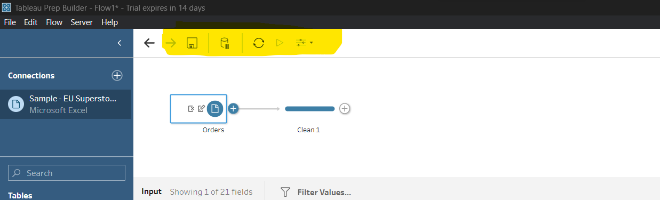
* Save, Update Pause, Refresh Data, Run all flows, Parameters
* Workflow in 2 format -> .tlf and .tlfx
* .tlf me sirf skeleton share hota hai
* .tlfx me data bhi saath me share hota hai.
* Tlf= tableau flow
* Ye automatic kuch hud tak data clean kar dega.
* 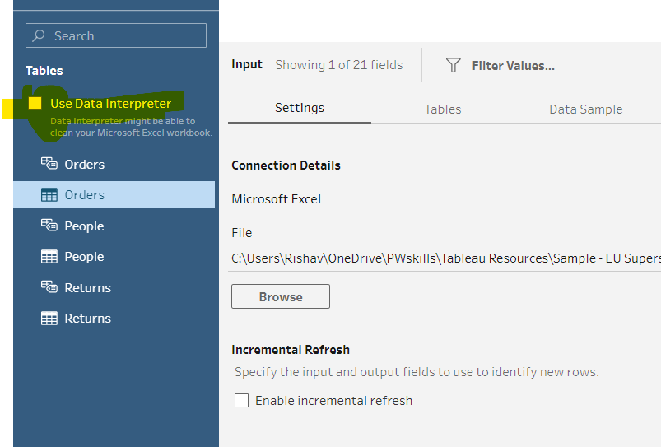
* We can remove fields from this way also. 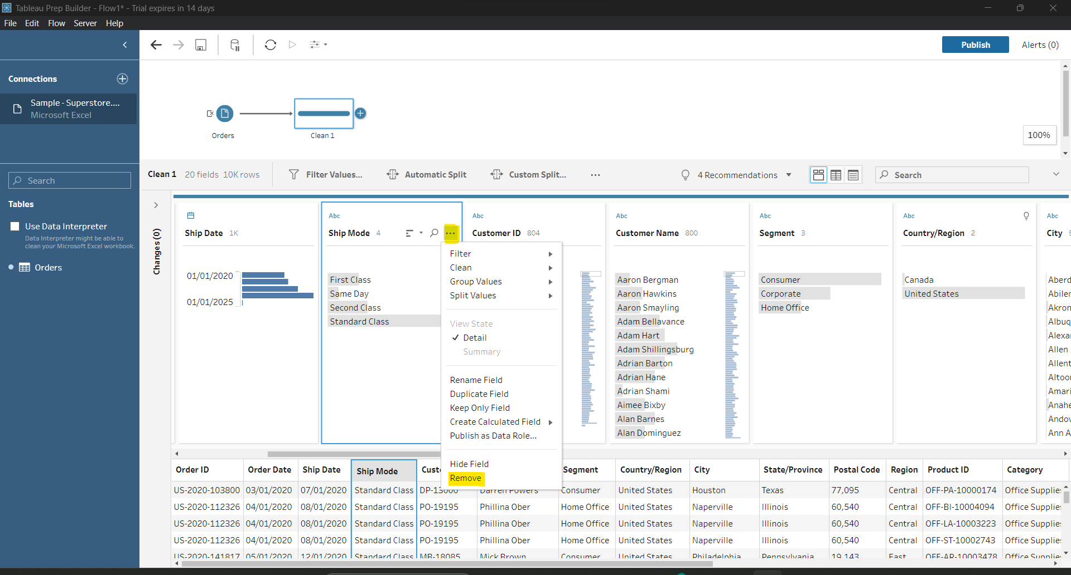
* 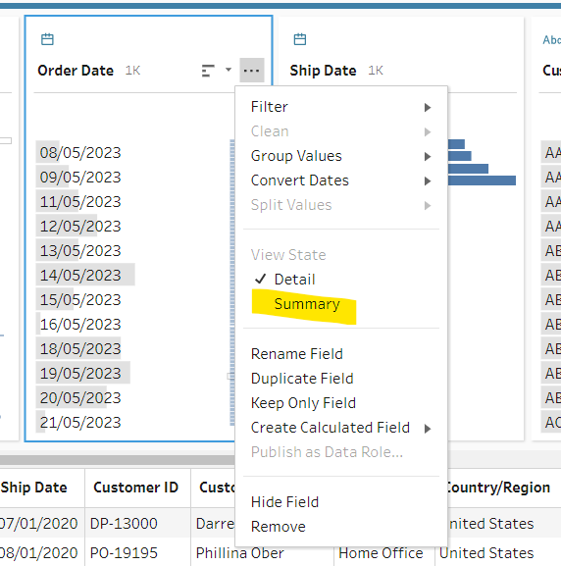
* Summary is specific to some column only.
* 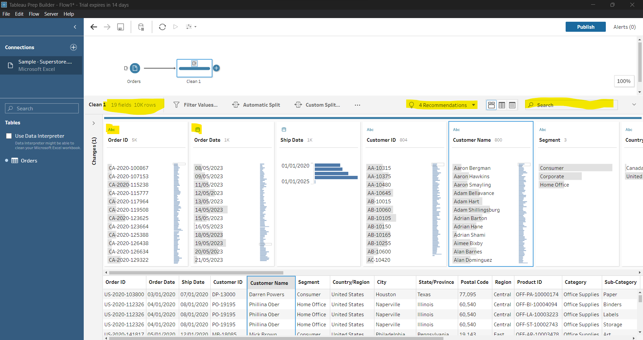
* We can change data type.
* Undo and redo ctrl+z ctrl+y
* 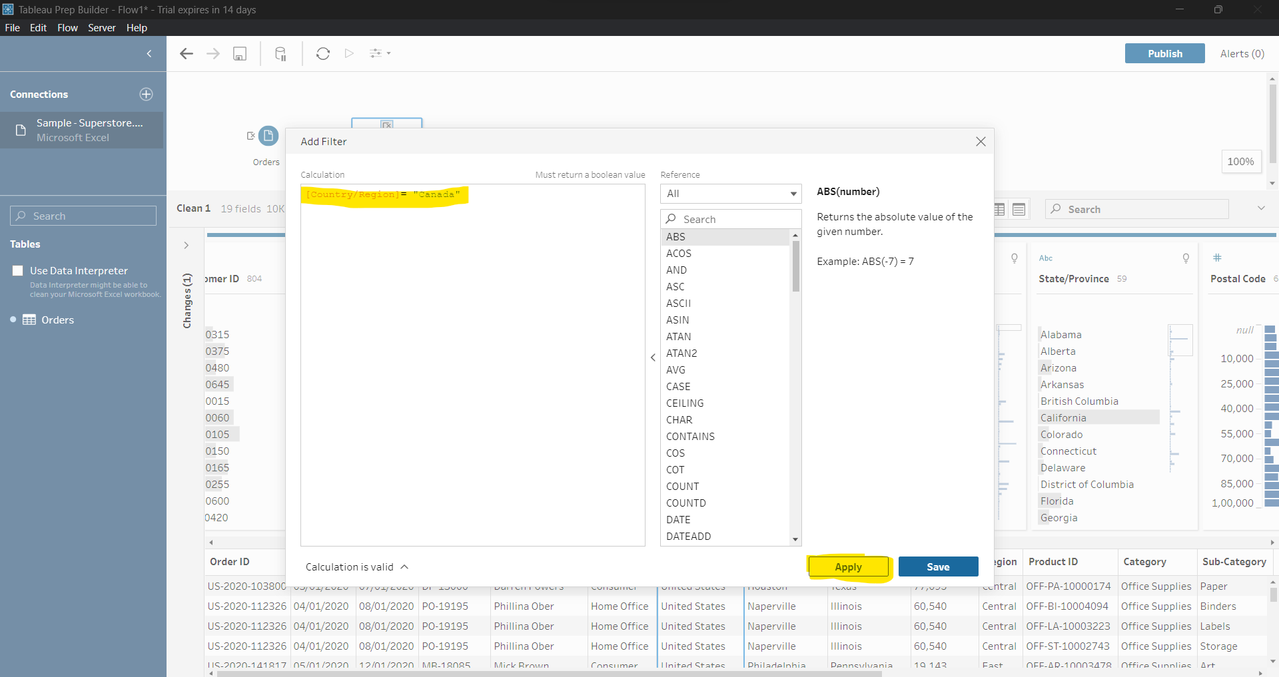
* Create Calculate Field : Used to merging column like date.month,year
* It is also used for applying some condition in workflow.
* MAKEDATE([year],[month],[date]) :create a date column
* Change data type
* It will help to remove something from column. 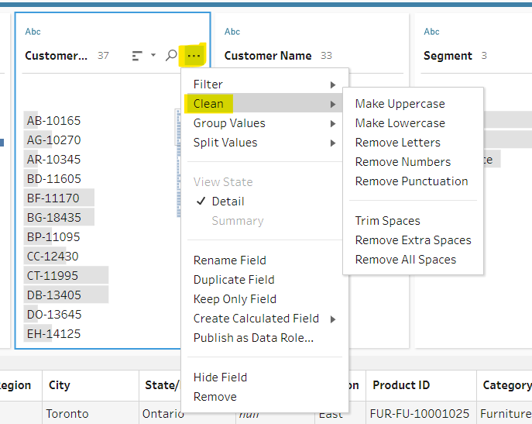
* Tableau data type recommend karti hai. Agar koi value invalid hai jaise ND, KNP to invalid ko filter karke uske New Delhi, Kanpur se replace kar sakte hai. Just double click and enter valid name.
* Jo name multiple time honge wo group ho jaayega uske left me clip ka icon dikhega.
* Split: Automatic and custom split. Split kisi deliminiter ke basis pe hota hai.
* 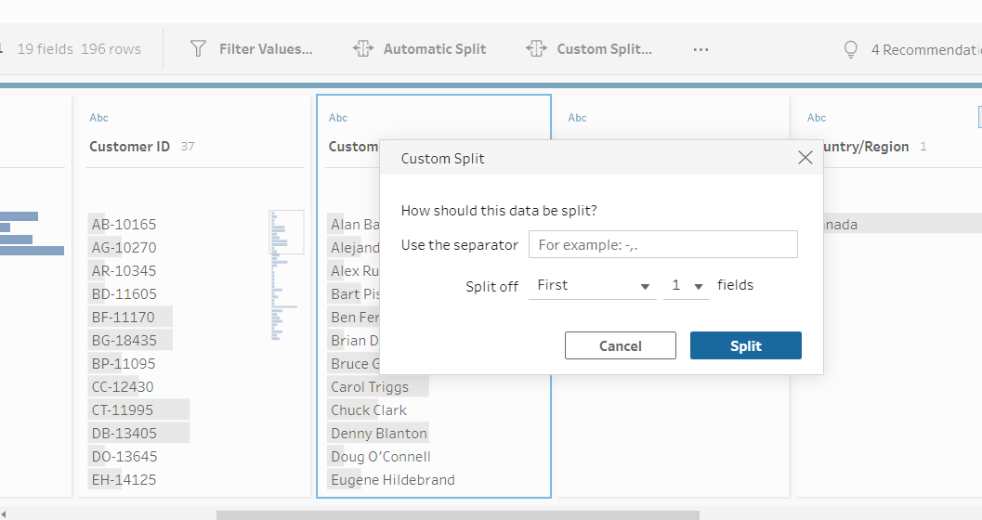
* We can remove letter from order id to get only numeric part.
* Double click on any text to modify it.

Data Preparation Using Tableau Prep Part-I

* Connect data sample superstore
* 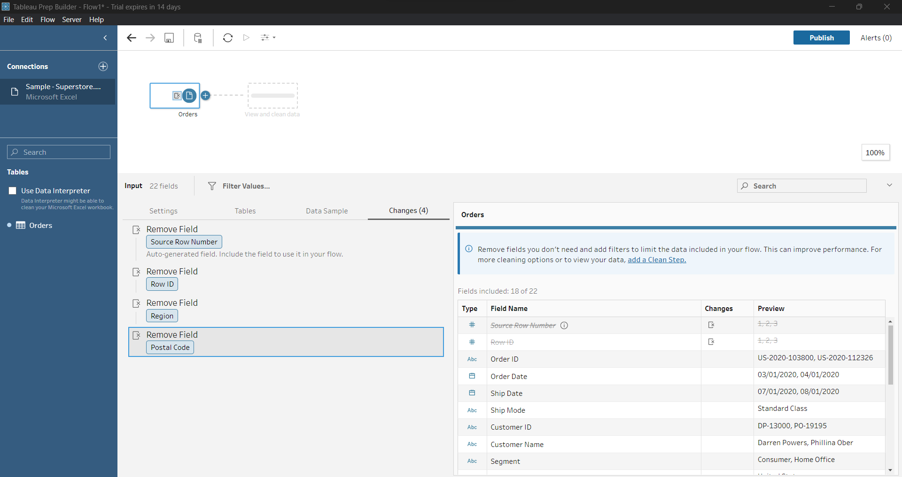
* Add clean step
* Remove ship mode
* It will show data only for Canada. 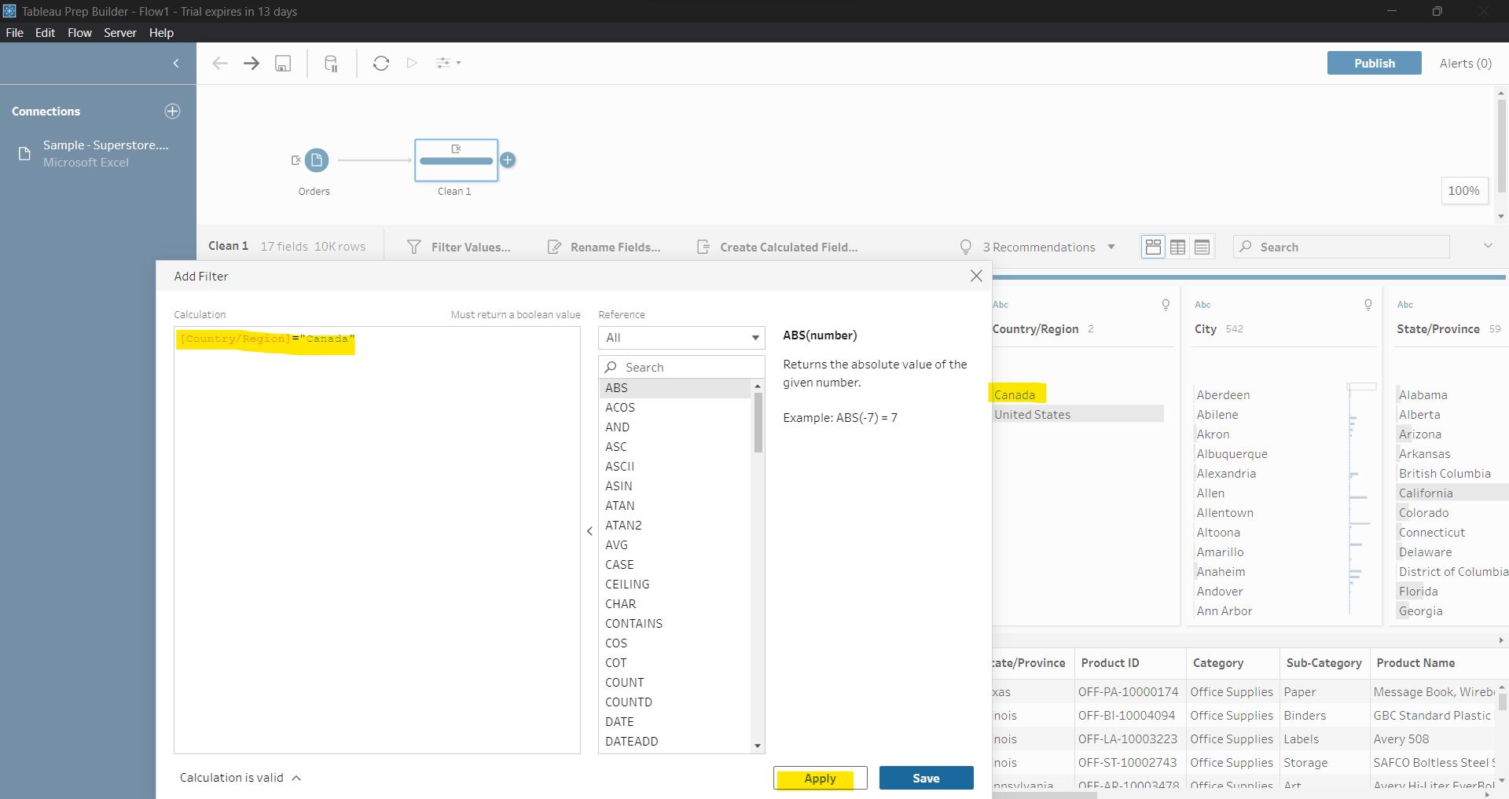
* Ctrl + z = undo
* 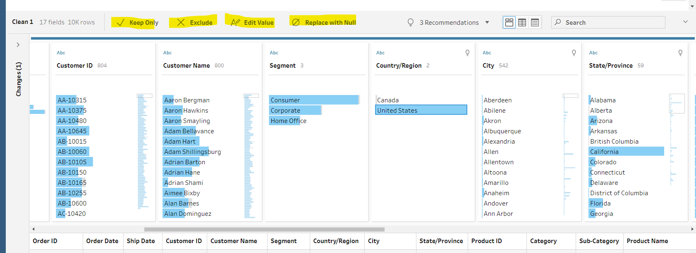
* Keep only : filter Exclude: exclude kar dega Edit Value: change value Replace with null: null replaced
* Refer this file for small data analysis. 
* Open this file in tableau.
* Add clean step 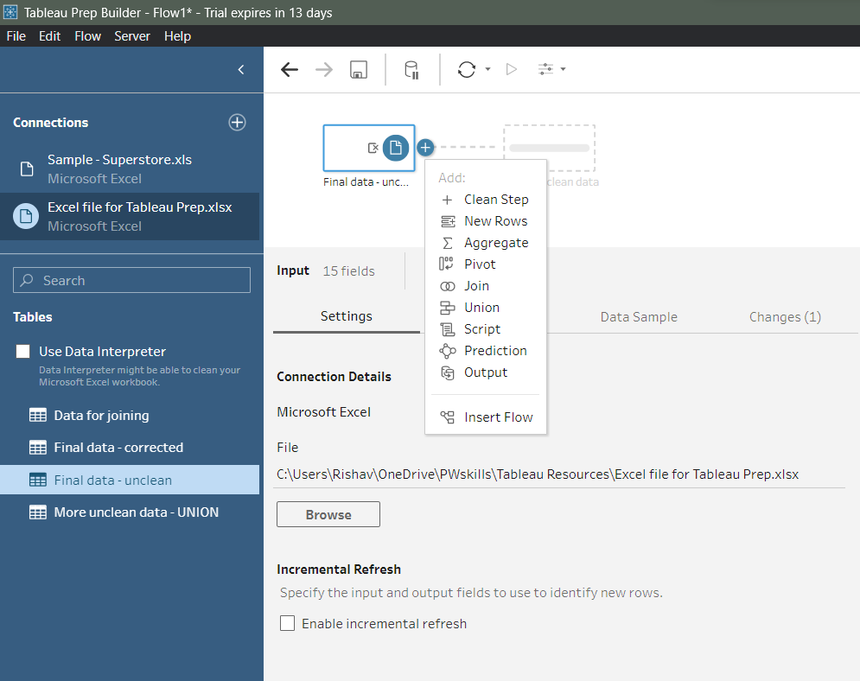
* Add a Order Dates column and remove order year,date, month column. Hi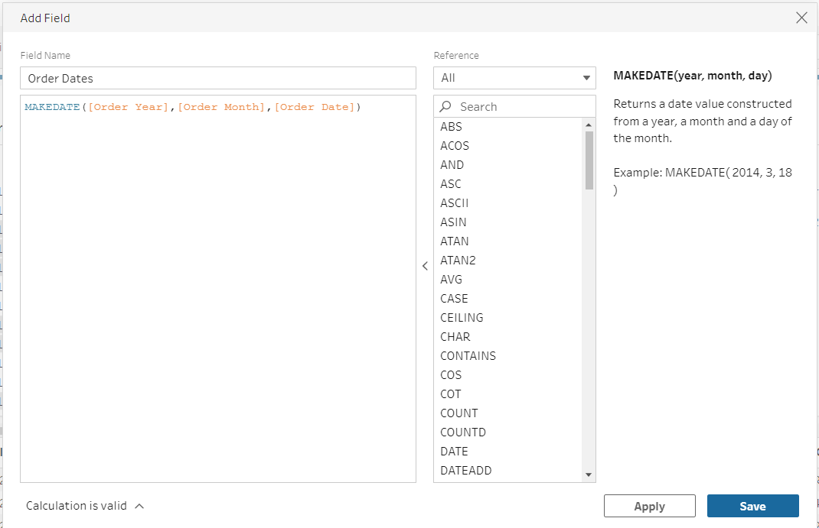
* Hint: Use Create Calculated Field.
* This is showing formula applied on this column. 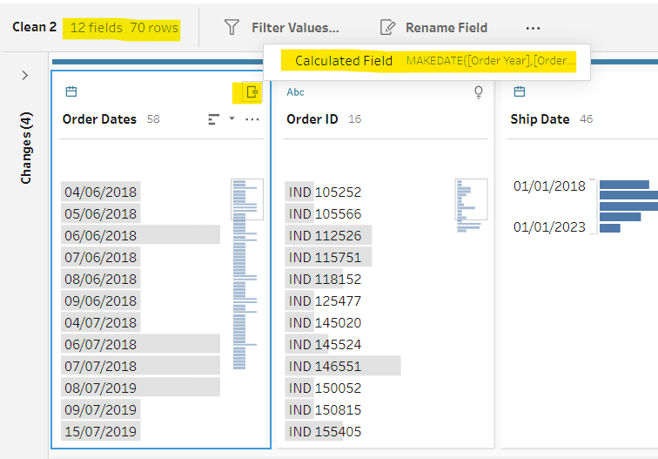
* Cost Price ka data type abc show kar rha hai. Aisa q ?
* 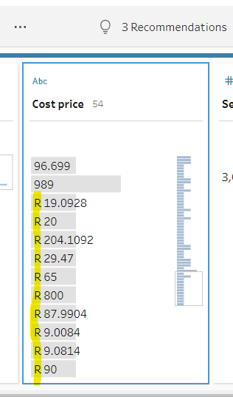
* So, we have to remove letters from it. 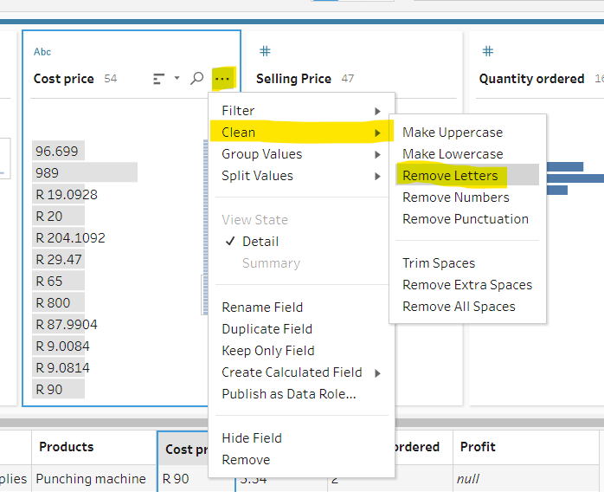
* Now change its data type to whole no.
* Ascending, descending kitni count hai uske hisab se hoga.
* Change country data type. 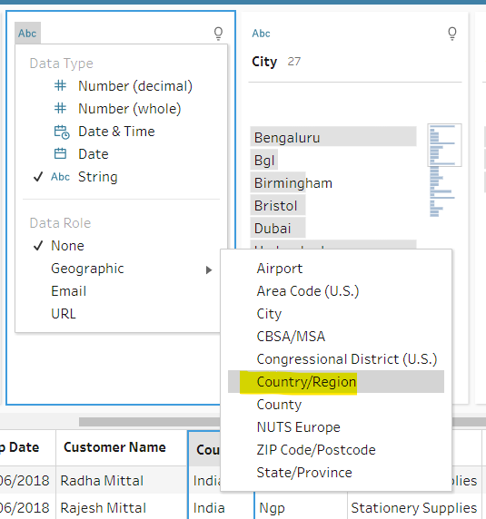
* Change for city to city. But we have some red flag invalid data. 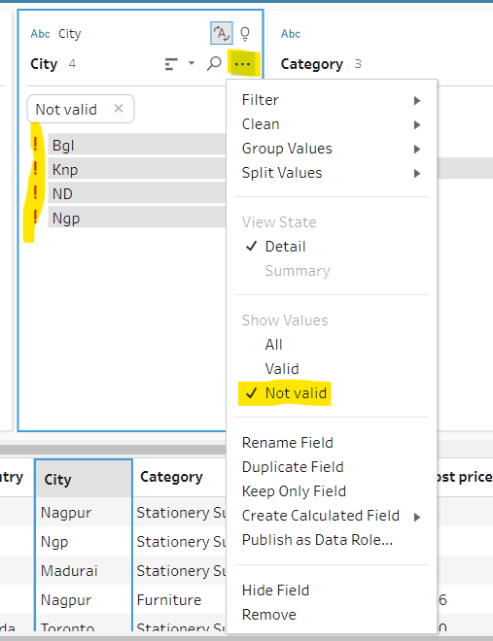
* Is subko double click karke change kar do.
* This is indicator what we have done. 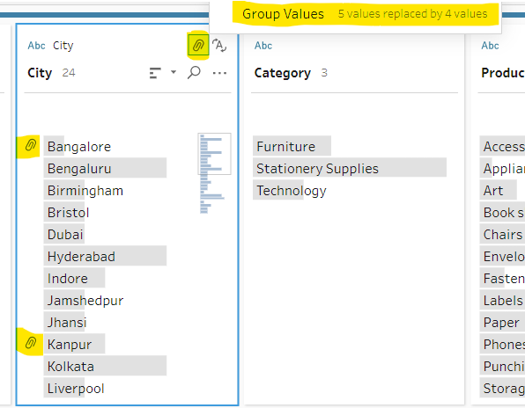
* This will separate IND and numeric part. 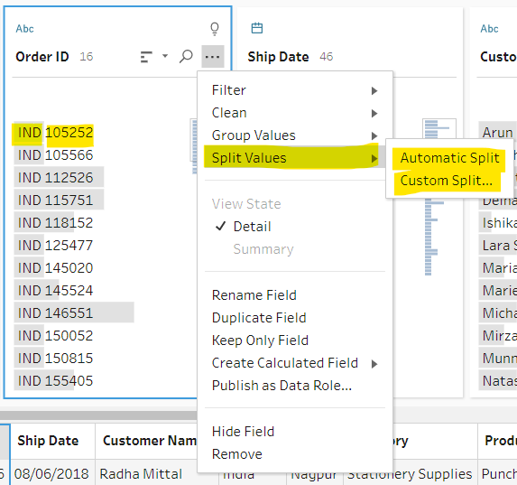
* 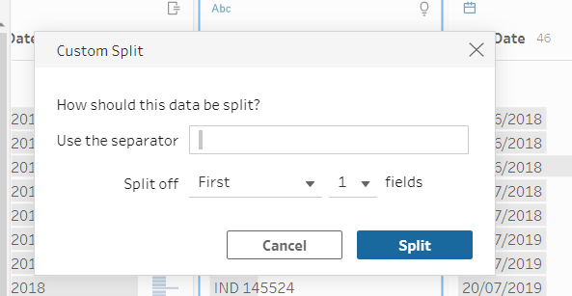 o/p 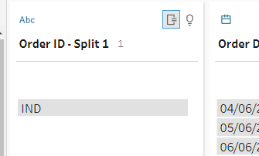

Data Preparation Using Tableau Prep Part-2

* Union and Join
* Union me table me data add hota hai. Join me common column ke basis pe data filter hota hai.
* For union data gets taller, datatype should same, both table should have same structure.
* For join table gets wider, data type may or may not same, at least one common column.
* We use this data for joining or union. 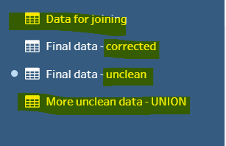
* Unclean ko humne clean kar lia last lecture me ab ussi se join or union karenge.
* Now add more uncleaned data to workflow space and check for some cleaning. 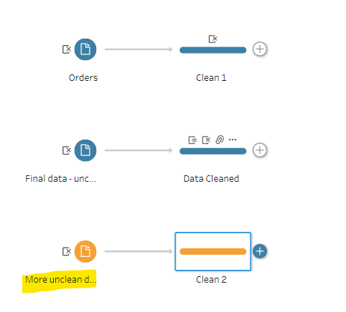
* 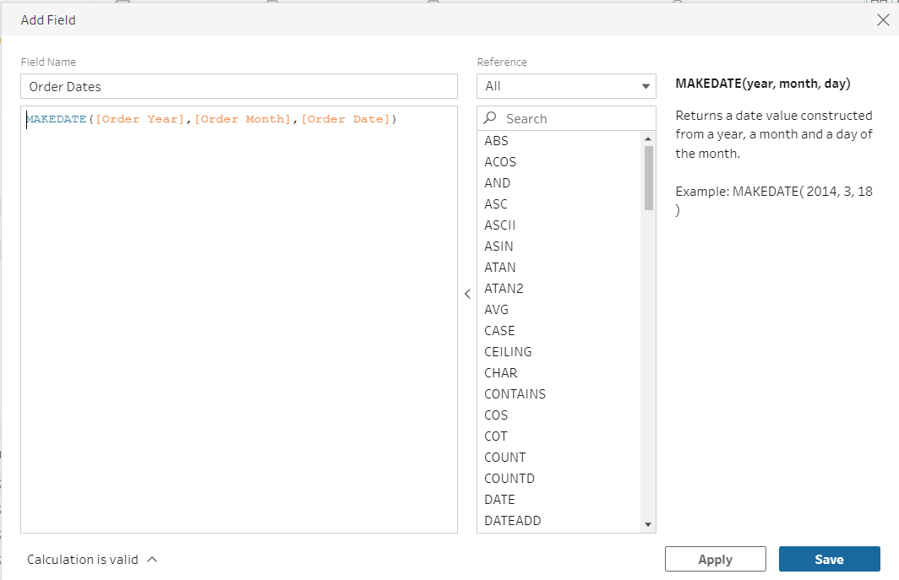
* Remove year, date, month column
* Recommendation me jo hai split order id ko chod ke baaki dono ko apply kar do.
* We use final data corrected and union sheets for union operation.
* Final Data corrected and Join sheets for joining operation.
* 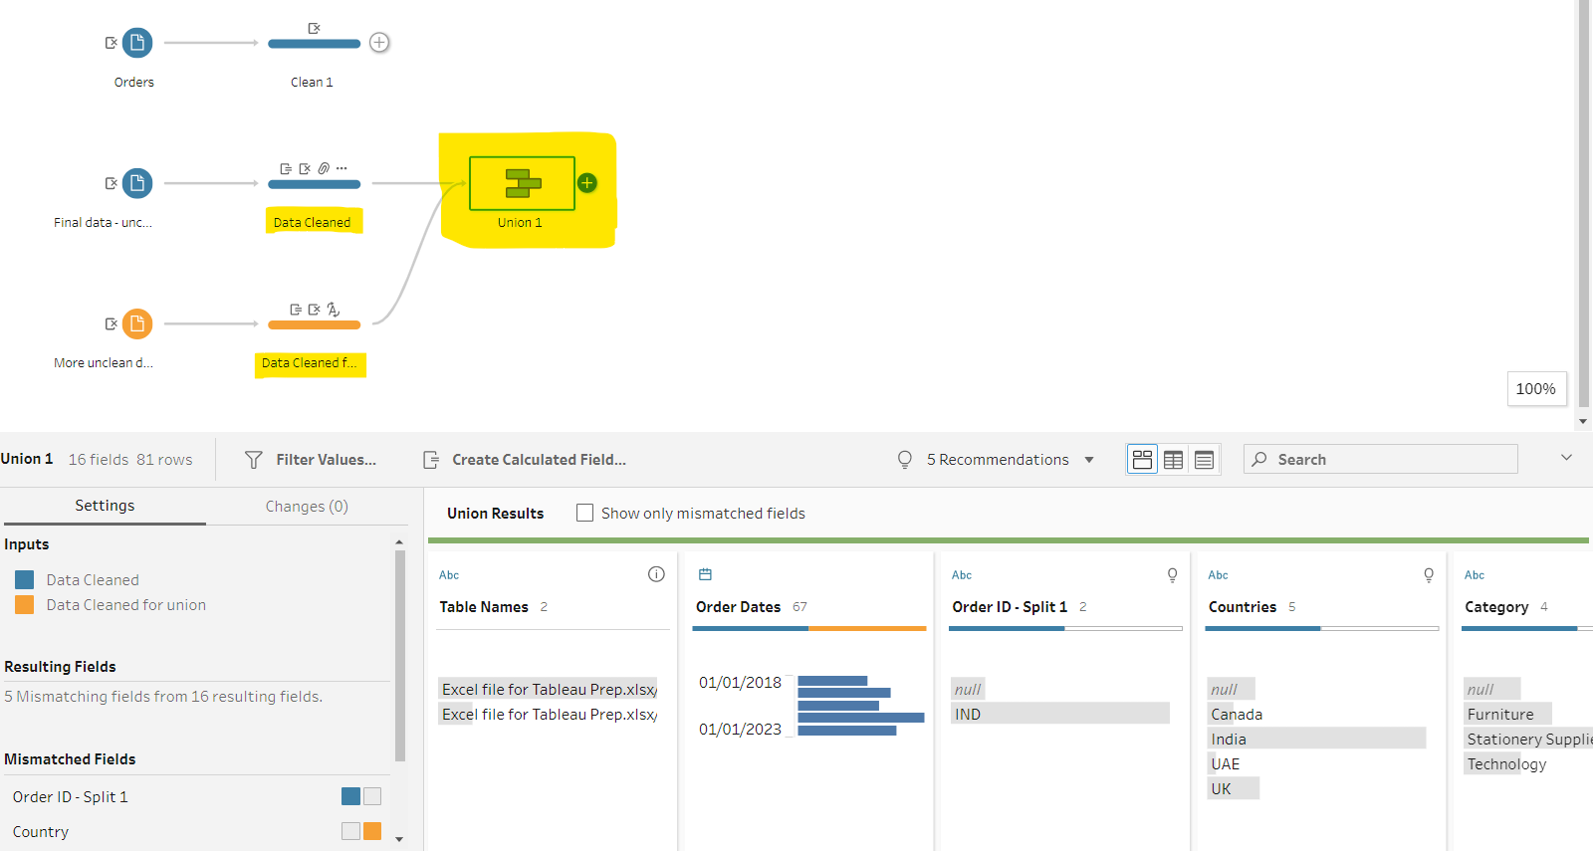
* Niche wale ko drag and drop karne hai middle wale pe union karne ke liye.
* Fix mismatch columns/values. 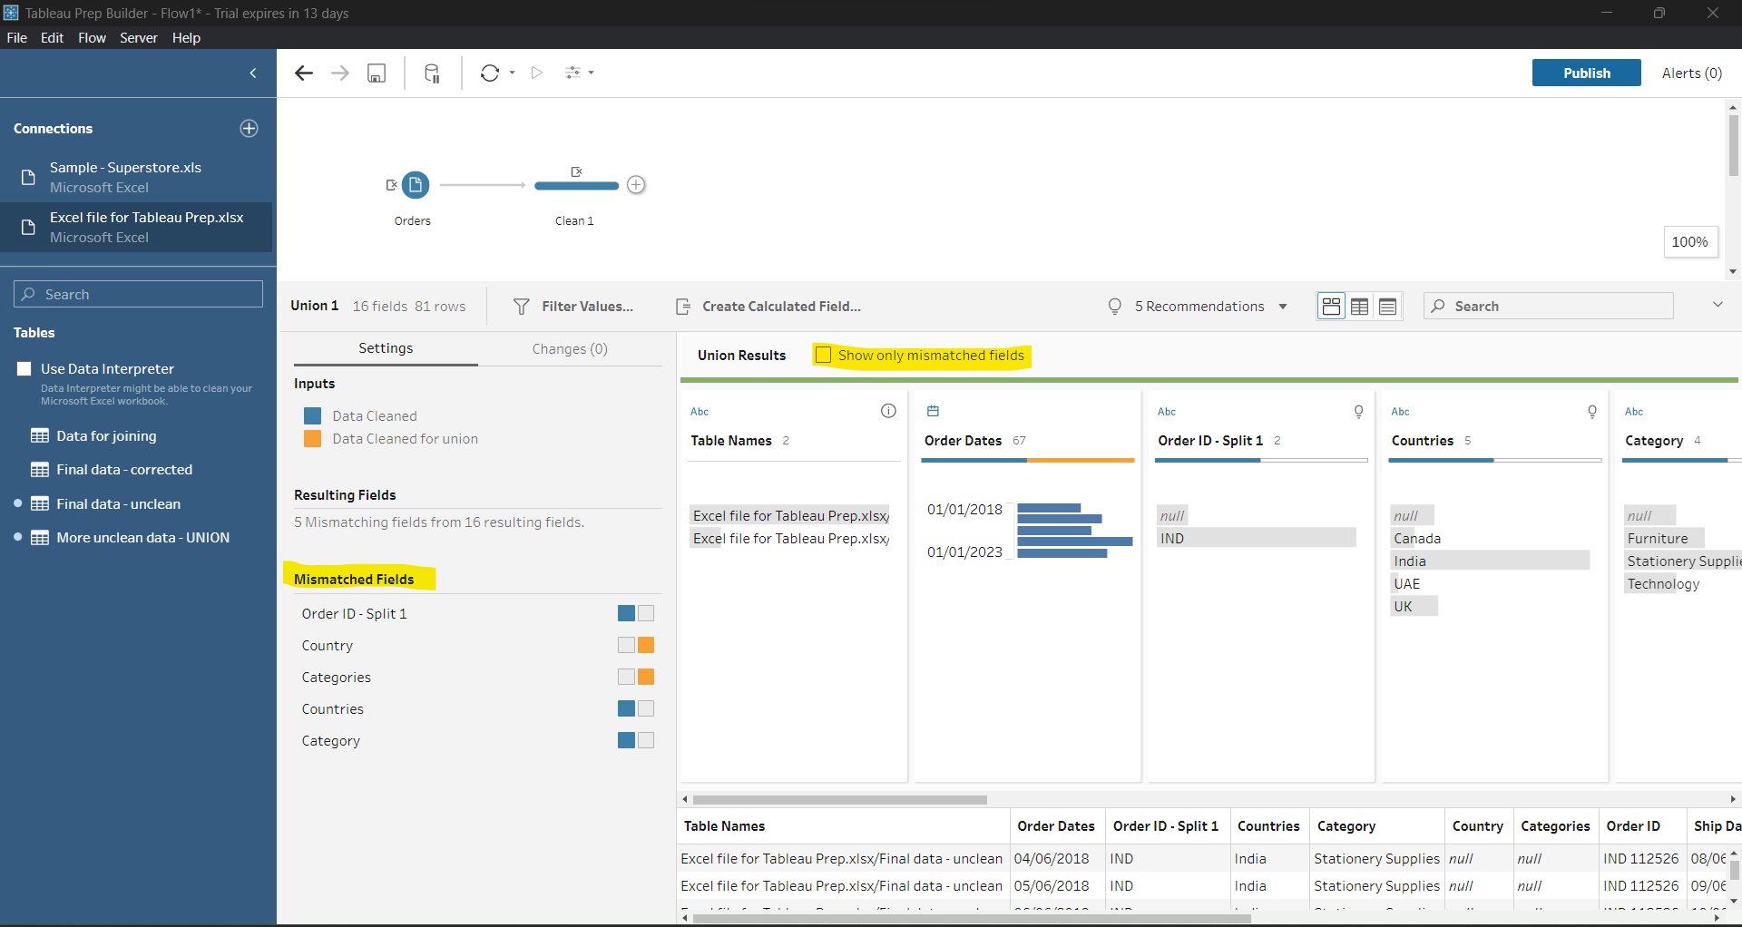
* Remove Order Id
* Countries have more data than country so drag country and drop to countries column.
* Drag from yellow part and drop to yellow part. Means mouse pointer should be from yelloe to yellow part.
* Similarly do for categories.
* Rename union of cleaned data. 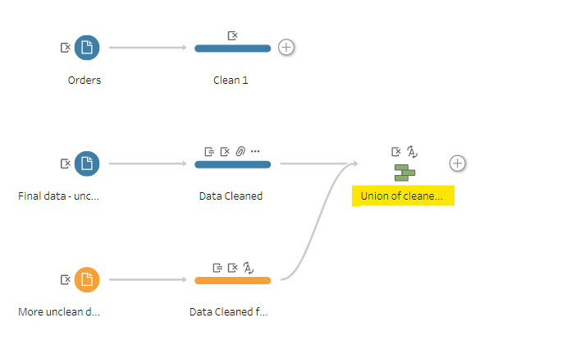
* Take join sheets into workflow area and do some cleaning then join it.
* Here no cleaning required so, we can remove clean steps from diagram.
* Wow now our diagram. 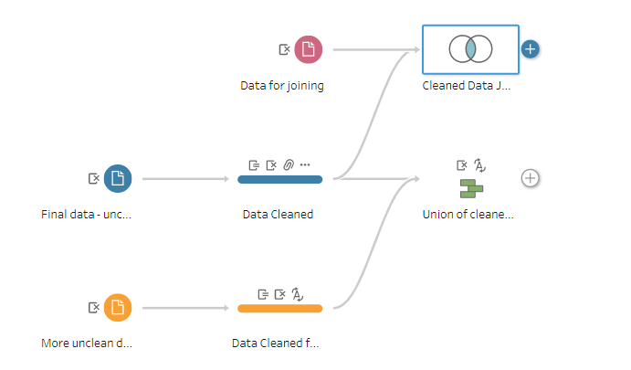
* Explore these window upon clicking on Cleaned Data Joining. 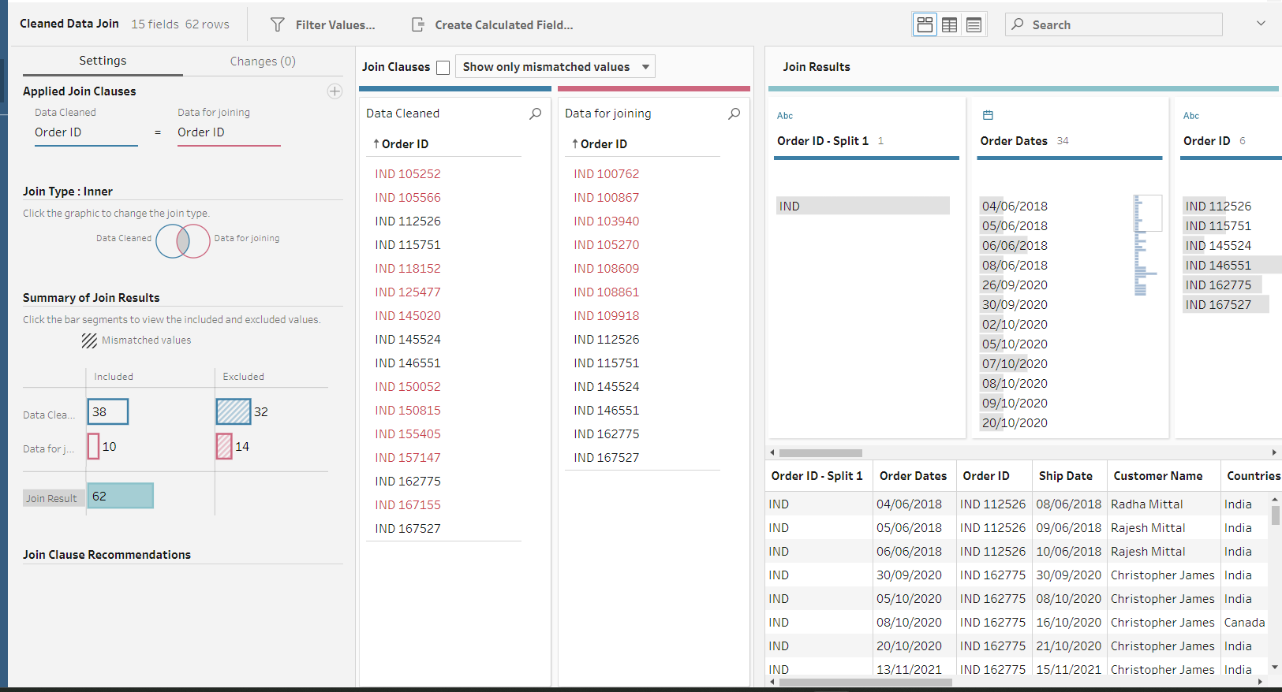
* Is window me bahut cheez likha hai, samjho isko ache se.
* We can do some cleaning after union and join as well.

Data Preparation Part-3 Aggregation, Pivoting, Saving Flow And Output.

* Aggregation : Bahut saari value ko combine karke ek single value banana.
* SUM, Average, Count, Min, Max, is aggregation functions.
* Work on sample superstore cleaned data. 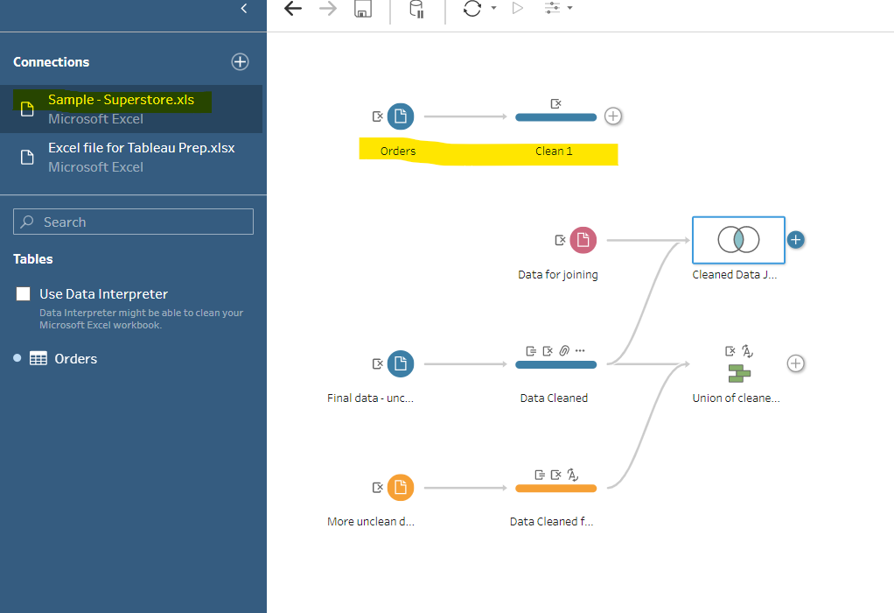
* Add aggregation branch.
* 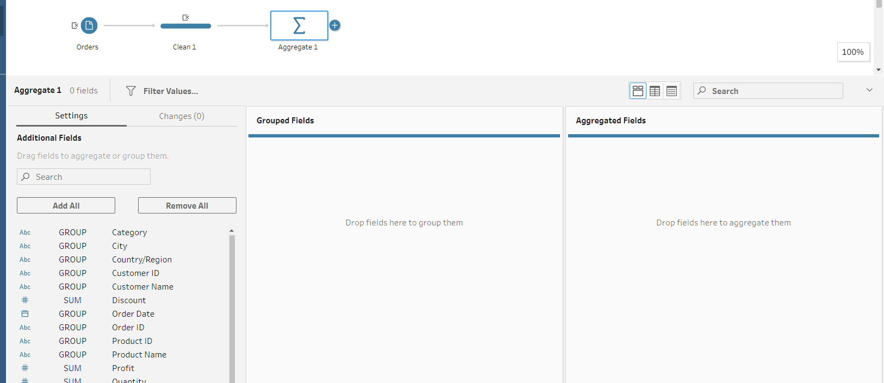
* Aggregated fields me numeric data le jaate hai, whi grouped fields me text data le jaate hai.
* Sum waale pe double click karne pe wo automatically Aggregated Fields me chala jaayega, whi Group wala grouped fields me.
* We can drag and drop for adding and removing from fields.
* 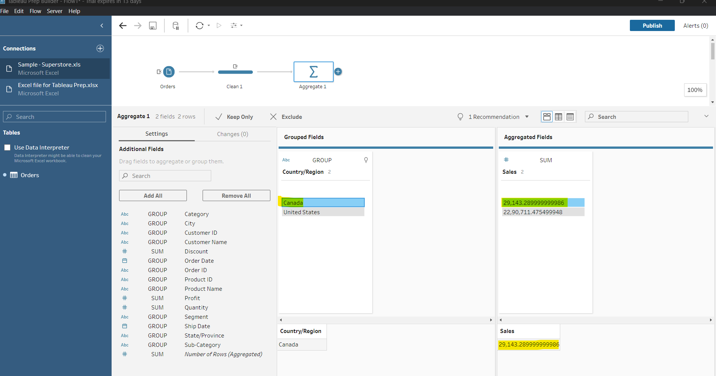
* Ye highlighted sirf Canada ka data bta rha hai.
* Basis of more than one column data. 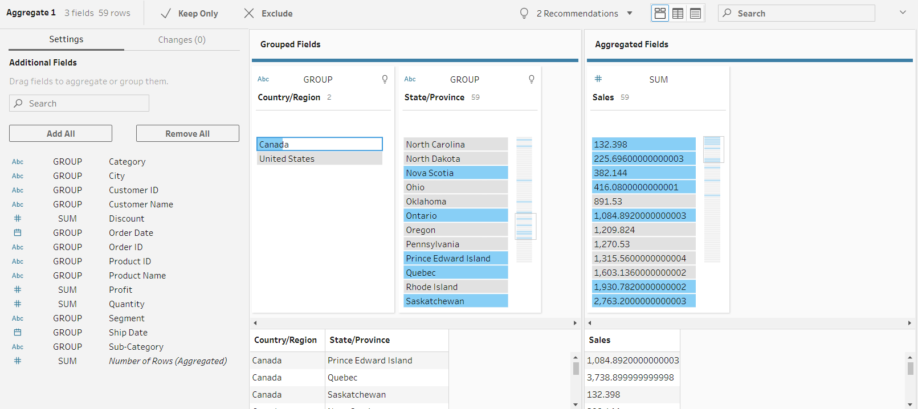
* 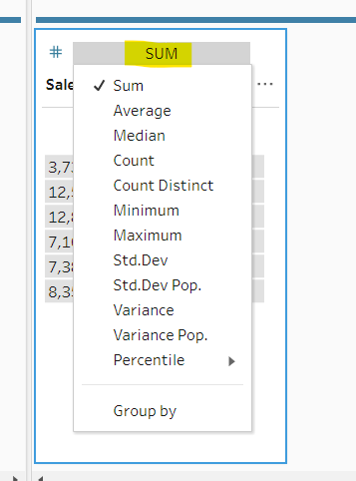 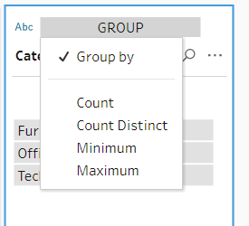
* Now, join aggregate and cleaned data. 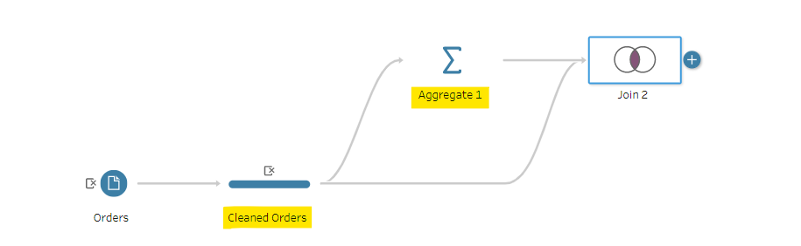
* Abhi join quantity pe hua, but no data shown. So we will join on other column.
* 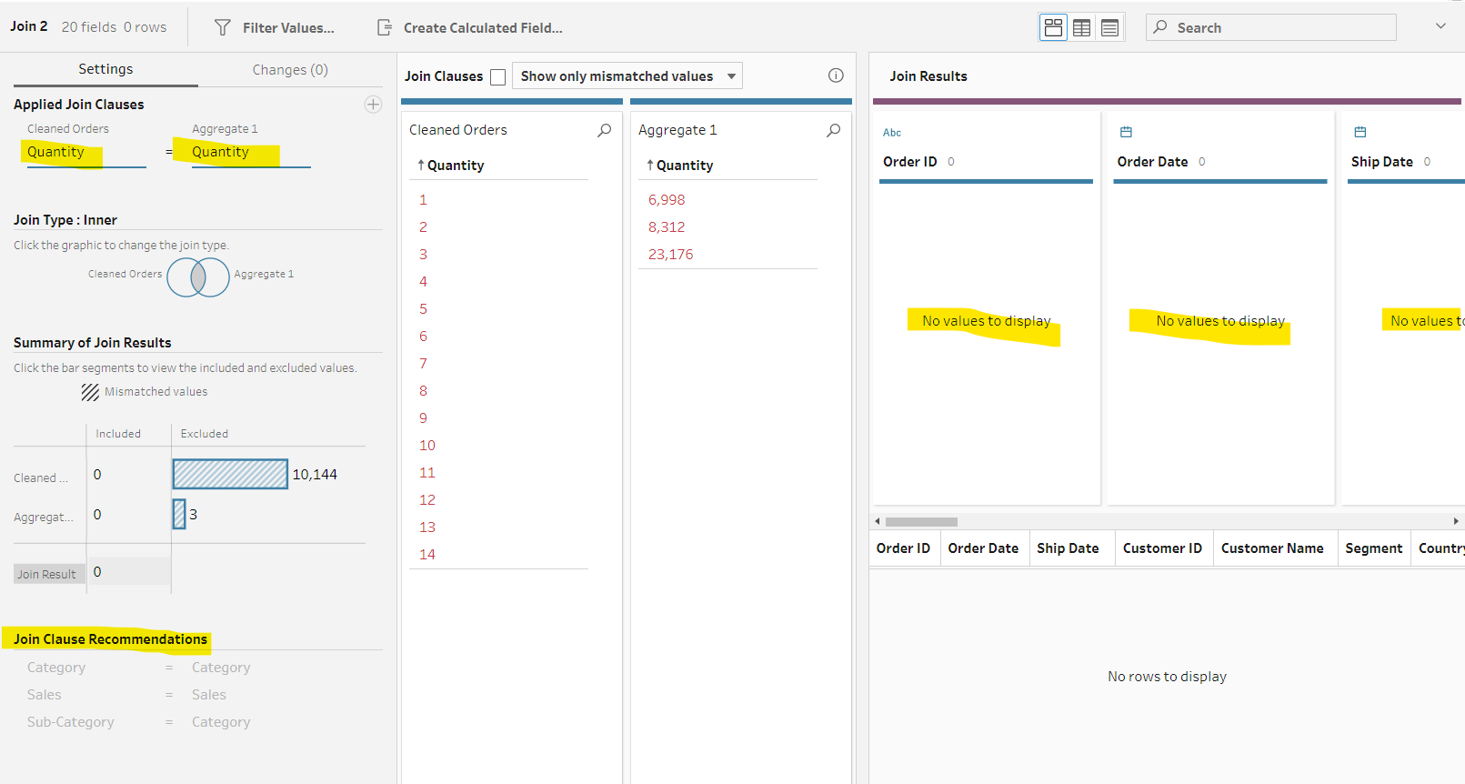
* 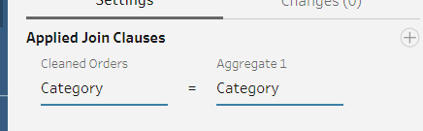
* Now, add a cleaning step and do some cleaning.
* 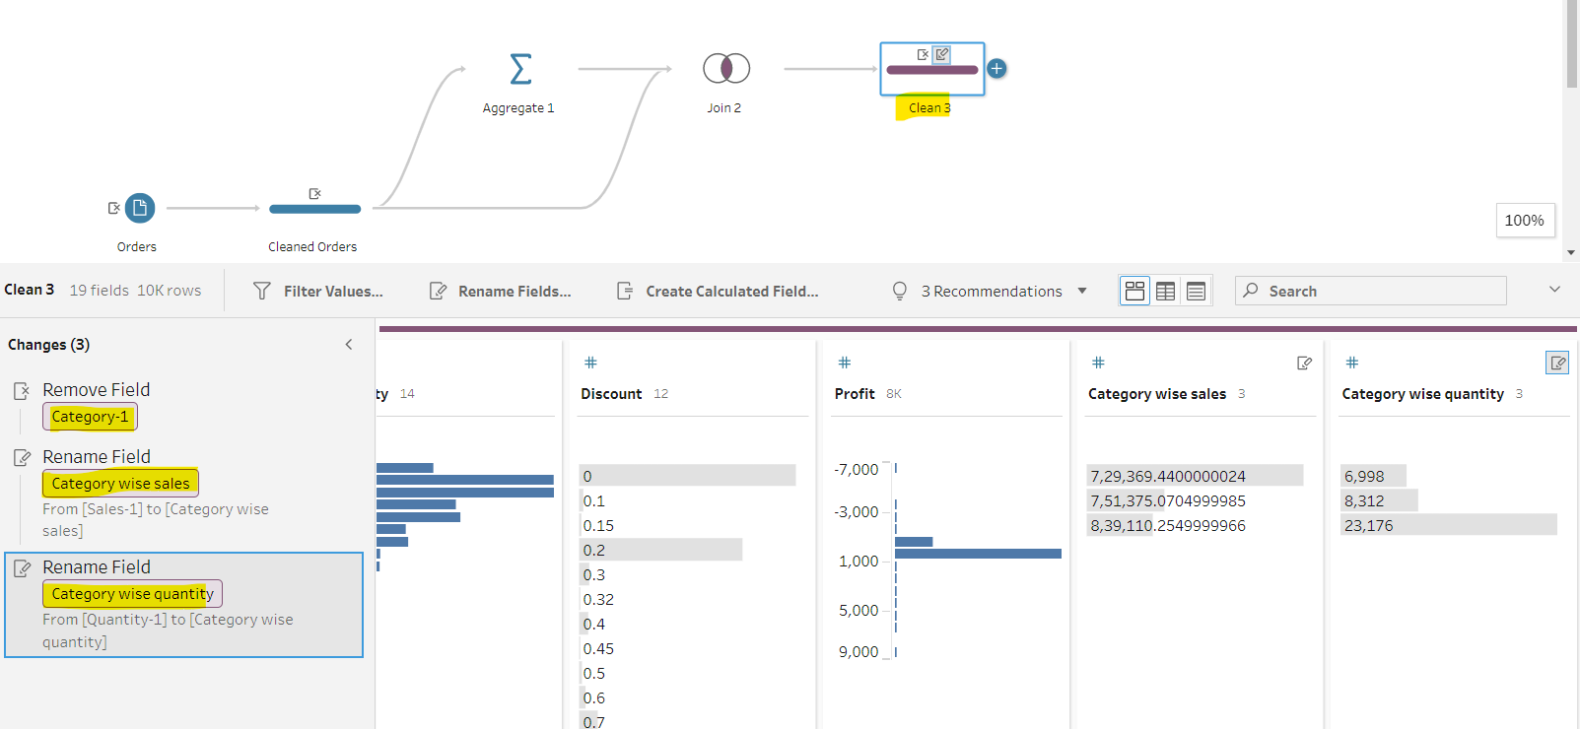
* Do category column hoge aur value same hai to ek ko remove kar denge.
* Sales and quantity bhi do hai to last wale ka naam change kar denge. 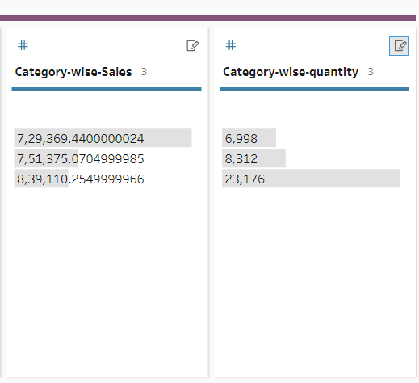
* We can show these data in Tableau Desktop. 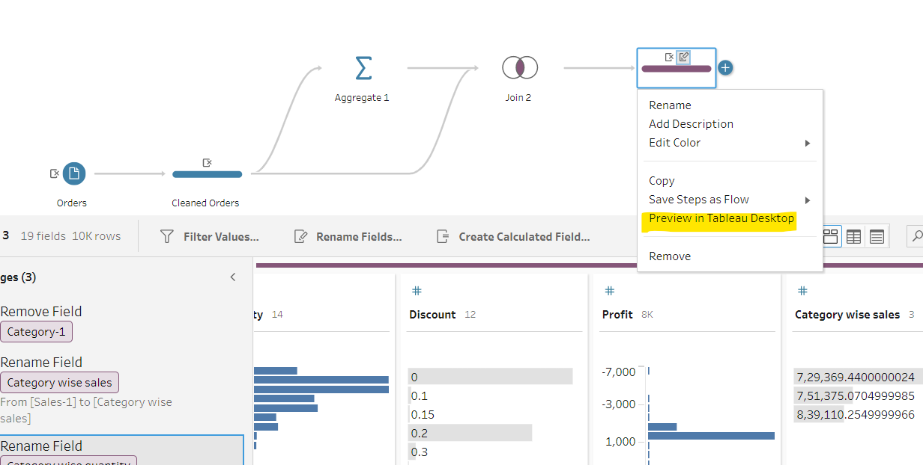
* Pivot: Kisi cheez ko dusre perspective se dekhna. Data ko summarize karna. Rows ko columns me convert karna.
* Un-pivot means columns ko row me convert karna.
* We will use this sheet. 
* Add connection and use this excel sheet.
* Add New Data Sheet in workflow area.
* 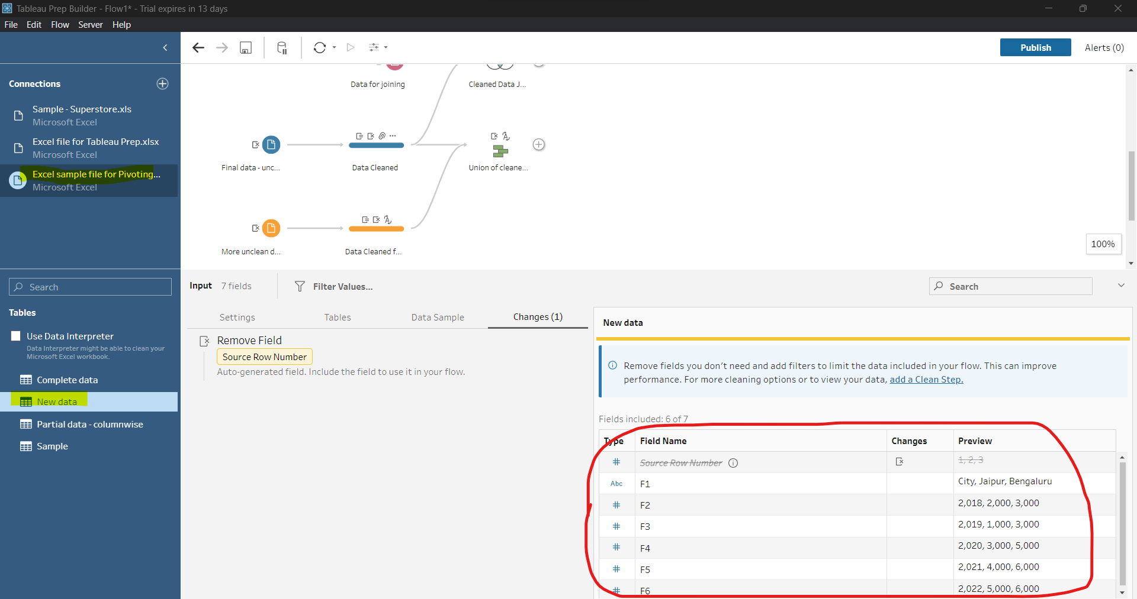
* Ye to kuch gadbad hai. F1, F2, F3 sheet me to nhi dikh rha tha.
* Check this, it will solve. 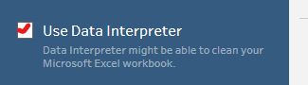
* Now, better 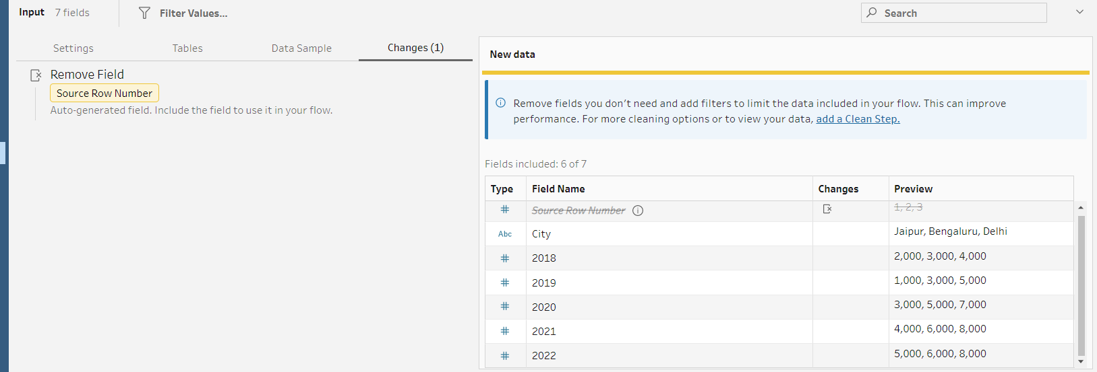
* Add a cleaning step.
* 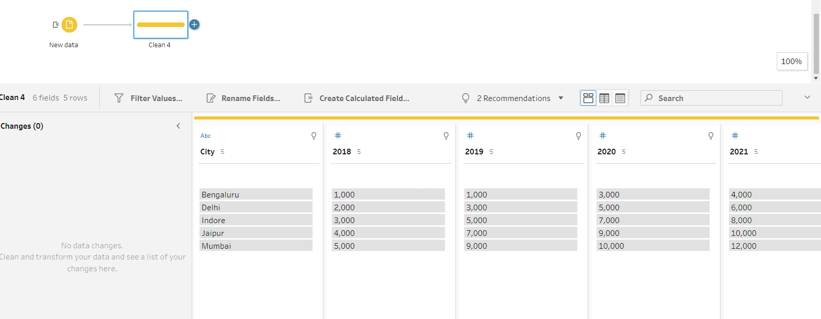
* Add a pivot step. 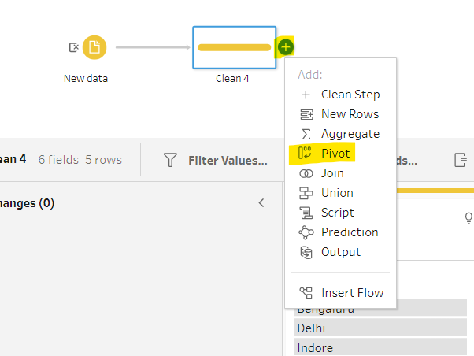
* These r pivoting and un-pivoting.
* 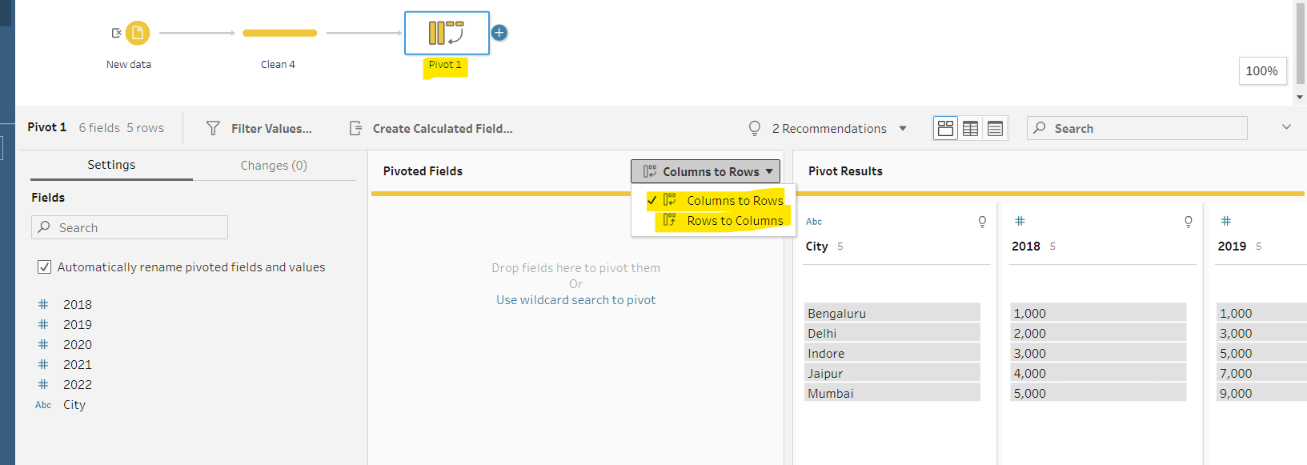
* Click on 2018 and shift + click on 2022 and drag and drop to pivoted fields.
* Add a cleaning step to see how our data looks like.
* 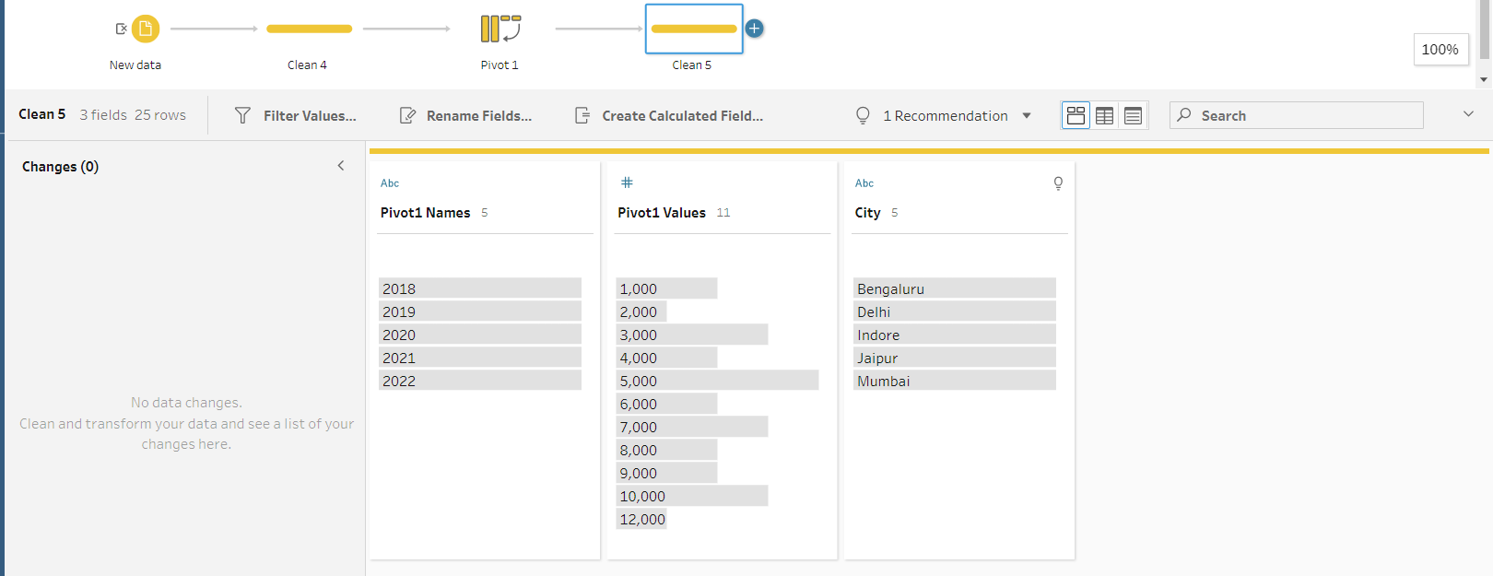
* Rename fields. 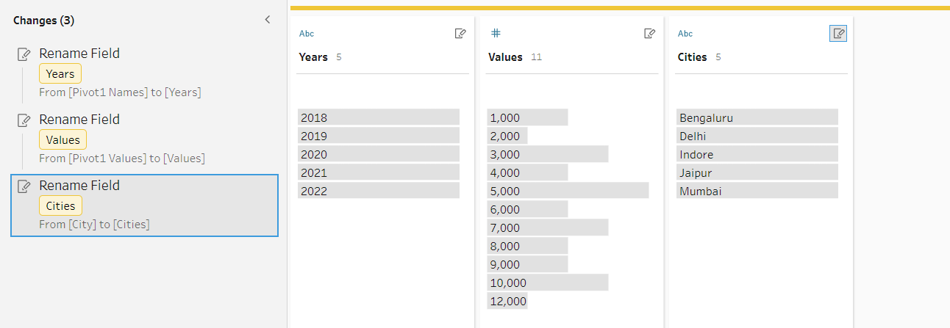
* 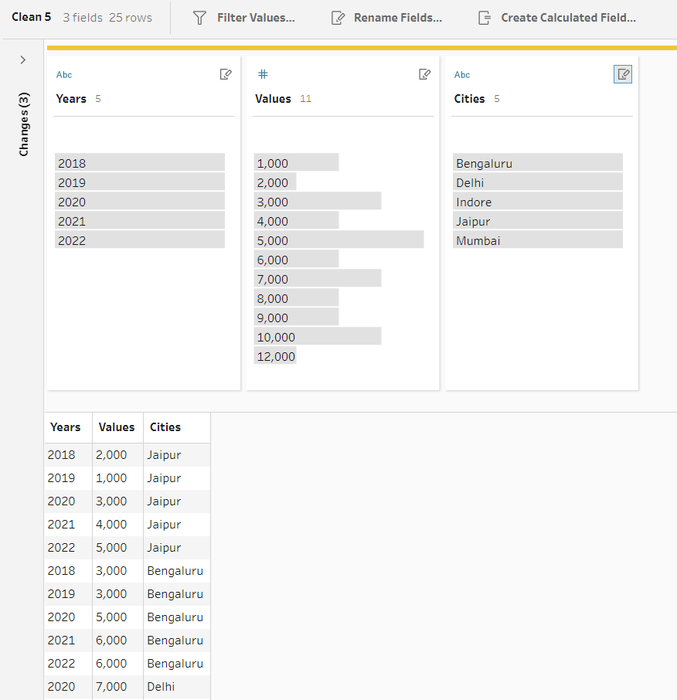
* Ab is sheet ko wokflow me add karenge aur long data ko wide karenge. 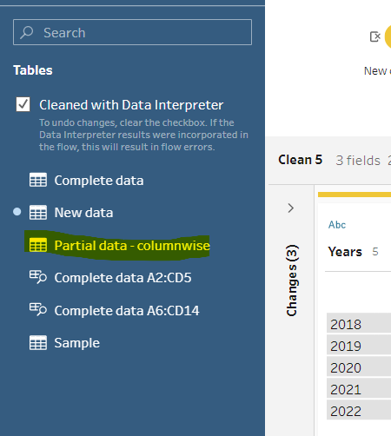
* Add clean view branch and see content of this sheet.
* 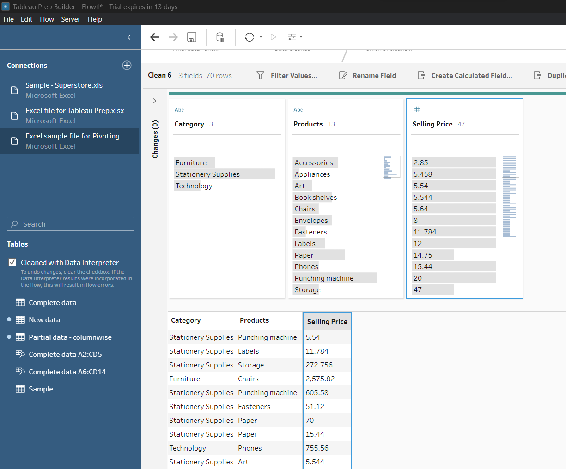.
* Add pivot branch.
* 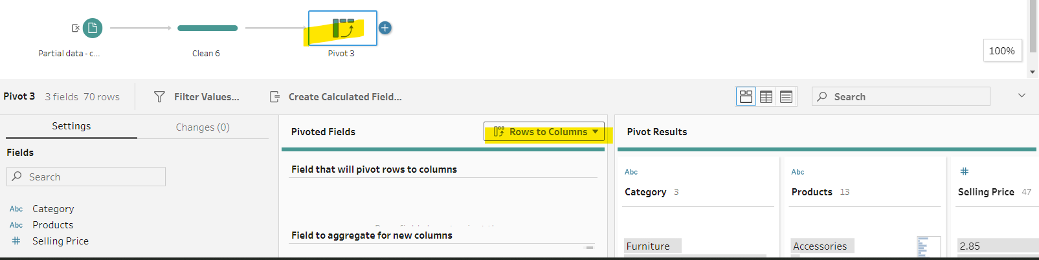
* Ek baar me ek hi columns ko pivoted Fields me add kar sakte hai. Dusro ko karna hai to pehle ko remove karna hoga.
* Products ko pivoted me move and selling price ko Aggregated me move karo. 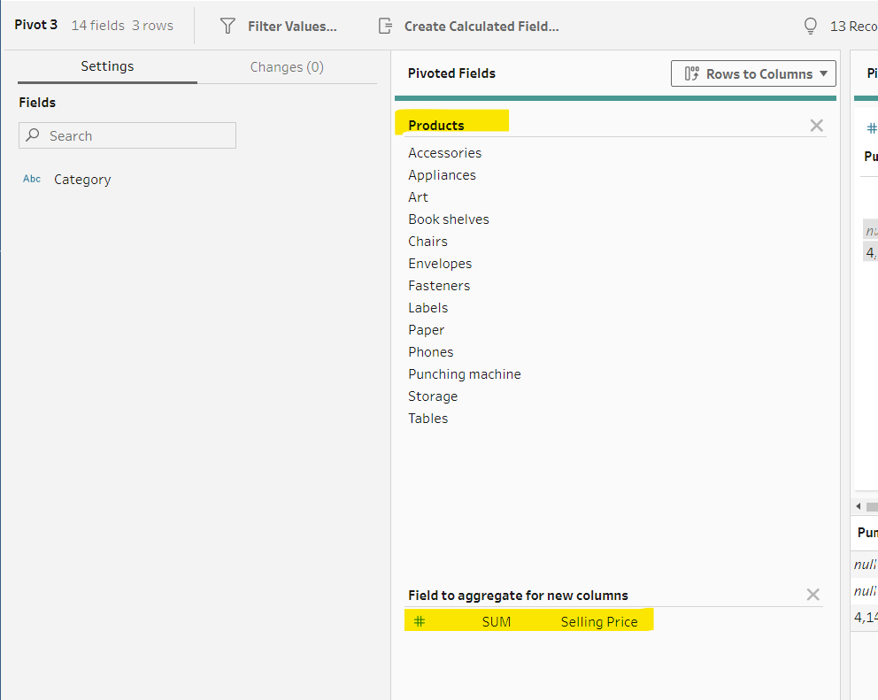
* Add a cleaning step and see how data looks like.
* 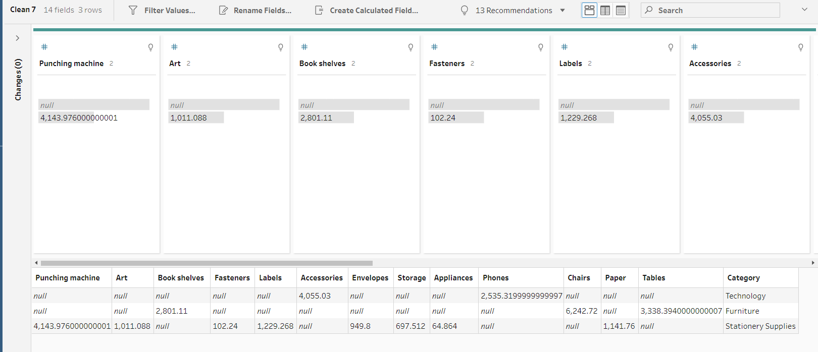
* We can do this things in tableau desktop as well.
* Now, we will convert this wide data to tall data.
* 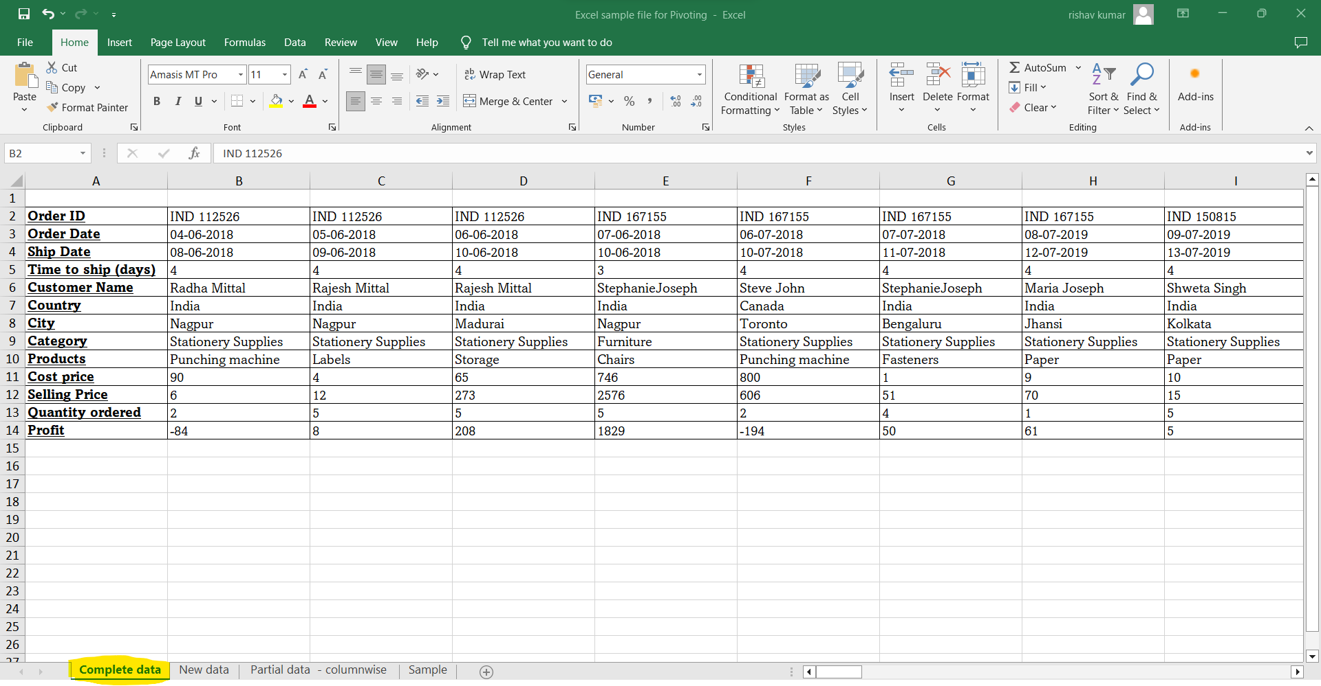
* Add connections -> import to workflow area.
* Add a cleaning step to see data.
* 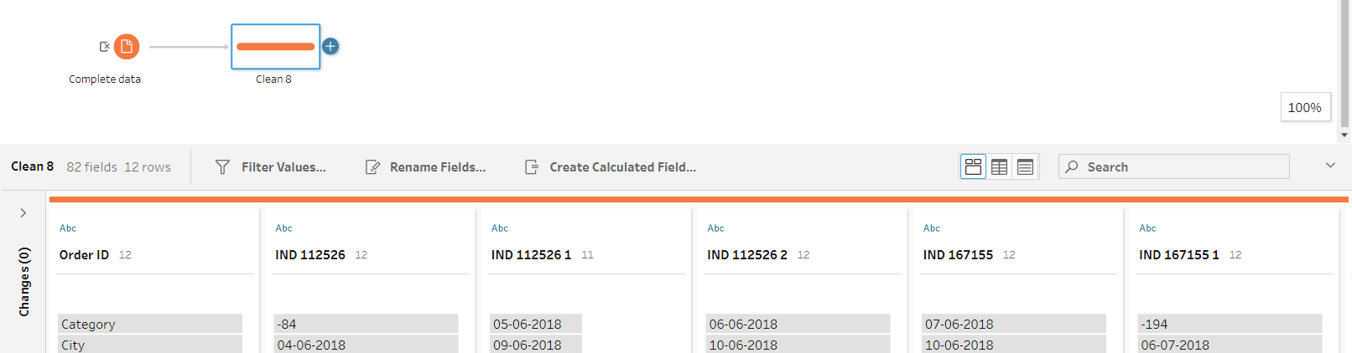
* Add pivot branch.
* Select all order id and dgrag and drop to pivoted fields area.
* Add a cleaning branch see our data. Do some columns name changes.
* 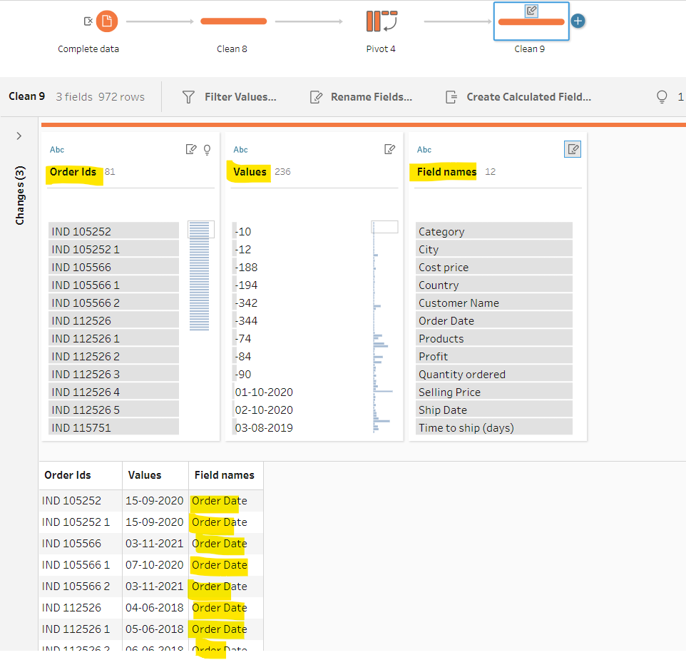
* Now, goto flow-> Run All -> Click on save icon
* Click on run all. It will be saved and double click on it will directly open in tableau desktop. 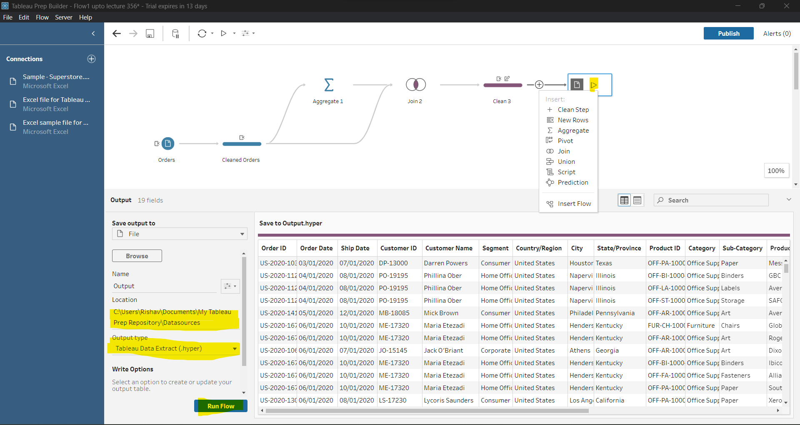
* O/P file generated. 

Connections to Different Data Sources.

* More than 75 data sources.
* Now, we will work on tableau desktop.
* 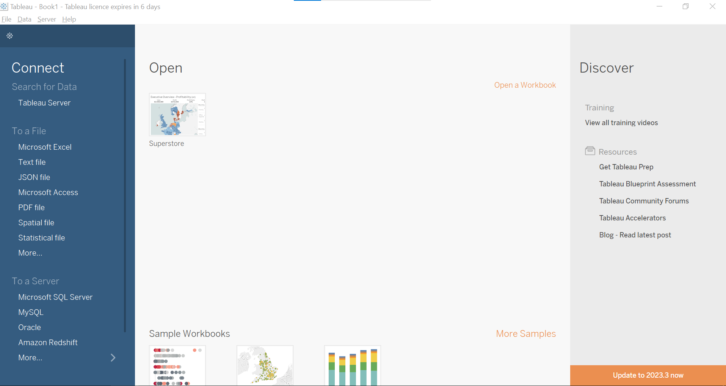
* 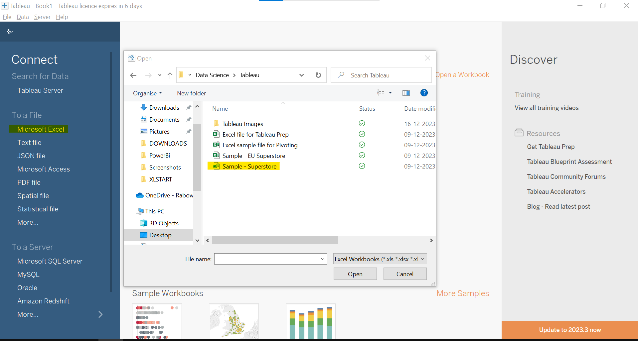
* Import sample – **Superstore data**
* Learn all the icon/ functions. 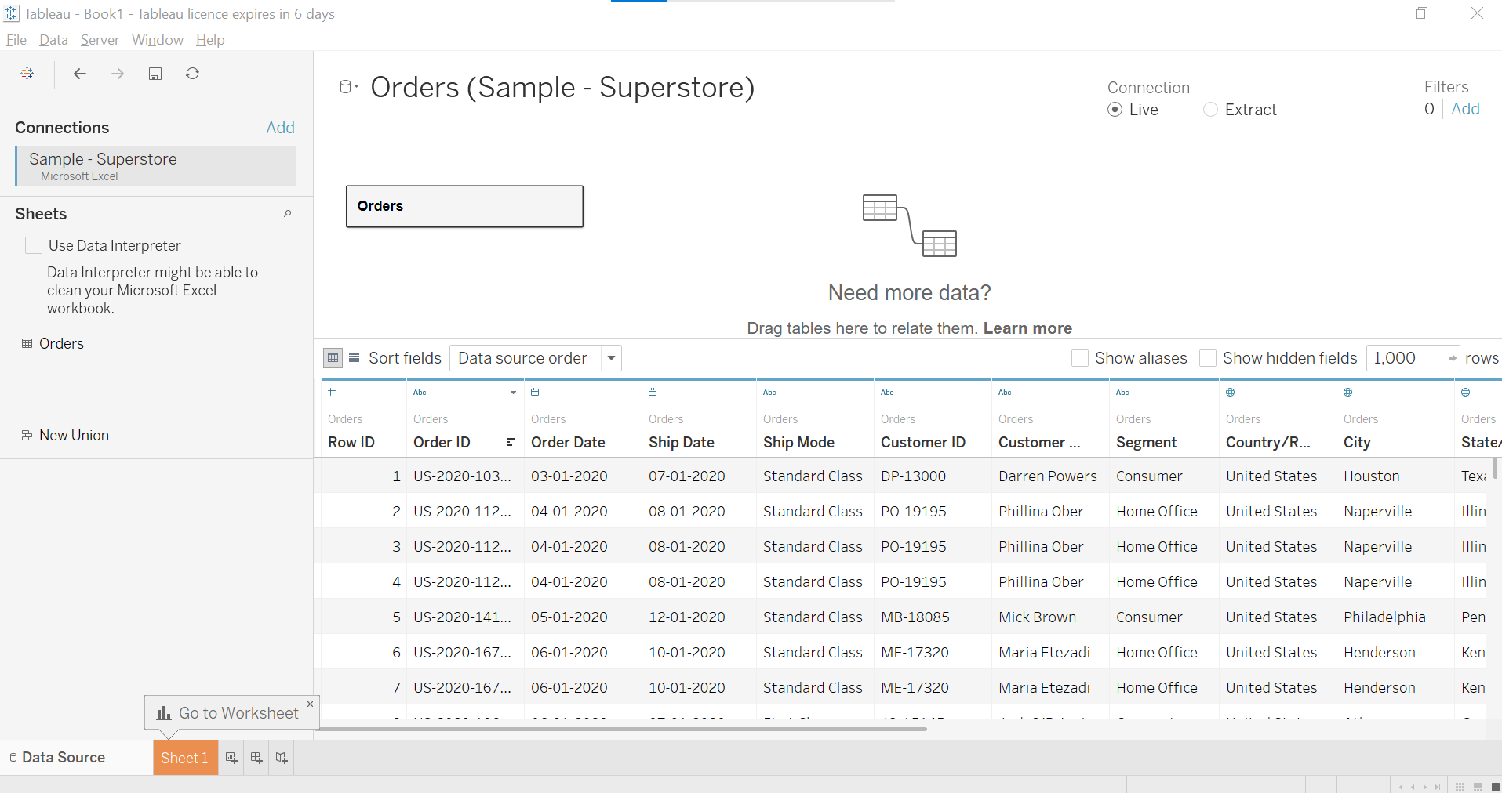
* Tableau prep me data clean karne ke baad usko yha laake visualization karte hai.
* Yha tableau desktop me bhi kuch visualization kar sakte hai.
* Sheet1 pe click karke visalization part me enter ho jaayenge.
* Data Source me sheet ki data dikhegi.
* Click on File -> Close to close all file.
* Click on more. It will prompt us to open cleaned data which we prepared in tableau prep.
* It can be Tableau Flow File or Tableau Packaged Workbook or .twb or .twbx file.
* Hum tableau prep me prepared flow ko bhi import kar sakte hai.
* In this lecture we more learnt about database data accessing, .txt file and many more data sources.
* Now click on MS-Excel select Sample- EU SuperStore. 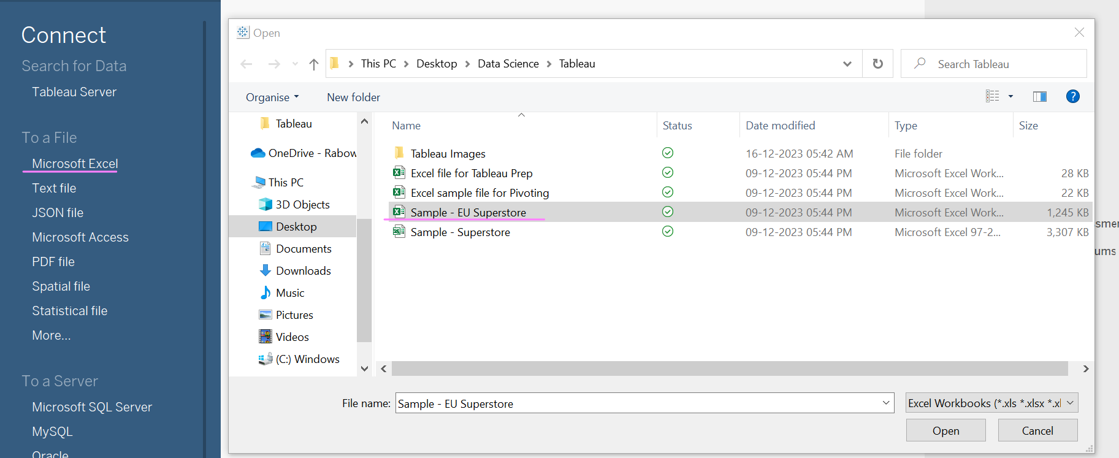
* We can drag and drop sheets in workflow area.
* Drag orders and click on arrow and select open.
* Now, Drag Returns and set join relationship.
* We can change tyes of join. We can see all types of joins no of rows.
* 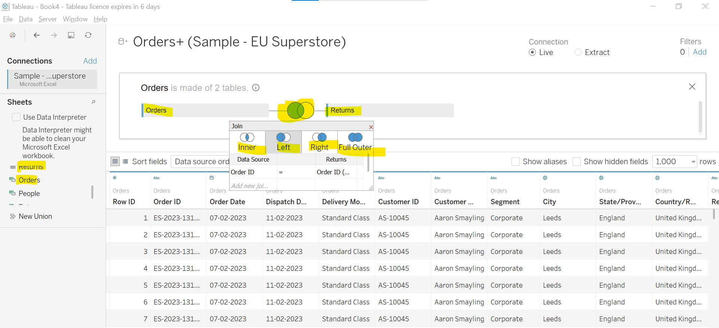
* Similar way, drag table and drop near bottom of table for union.
* Or click on left side New Union option and provide table name for union.
* 
* 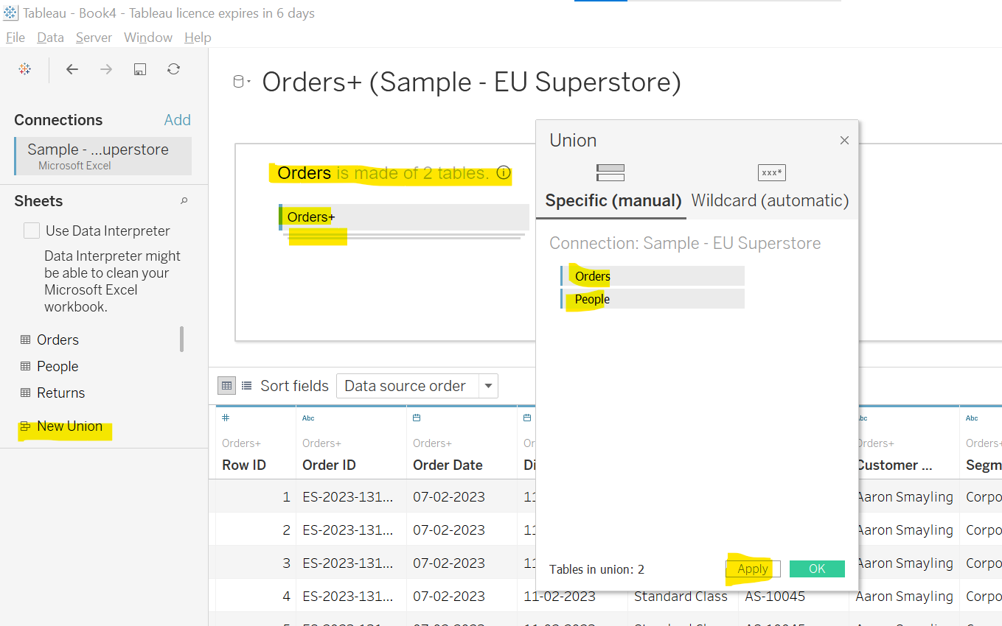

Tableau Desktop Basics

* Import cleaned Order Sample Superstore which we prepared in tableau prep. File type will be Tableau Extract.
* Connections types:
  + Live: Isme agar data me kuch change honge to wo Tableau me bhi show hoga. Tableau har step me check karega ki kuch file me change hua hai. Isme process bahut hoti hai. Isme time bhi lag sakta hai. So, it is useful when live data is more important. Better to use for small datasets. It is used when we are working on live datasets.
  + Extract: Isme tableau datasets ka ek snapshot le leta hai. Isme tableau har time datasets ko nhi dekhta ki kuch change hue yan hi. It is used for static type of datqa.
* One cylinder live connection, two cylinder – Extract connection.
* 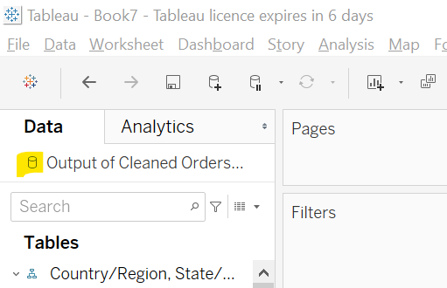
* Jaise hin hum extract choose karenge aur Sheet1 pe click karenge tableau is data ka ek snapshots pehle save karwa lega.
* 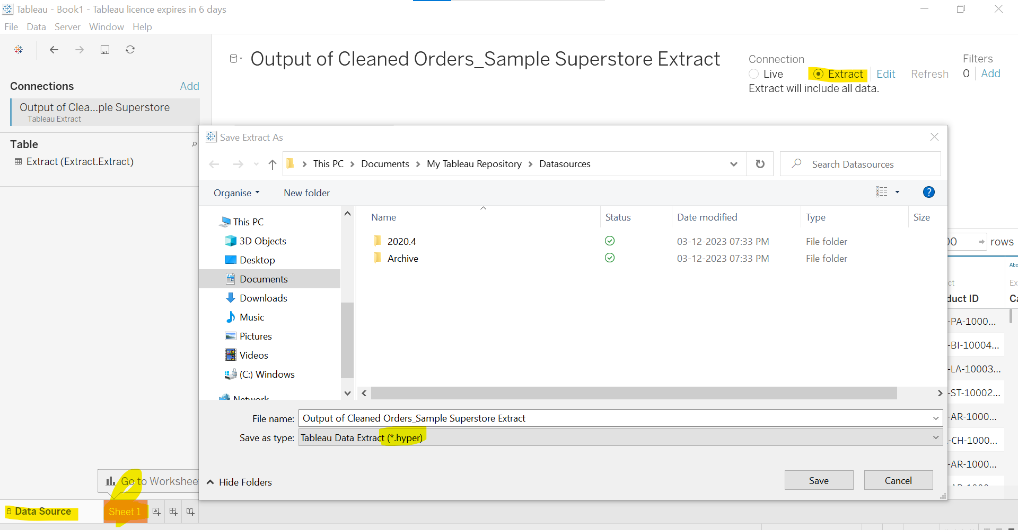
* 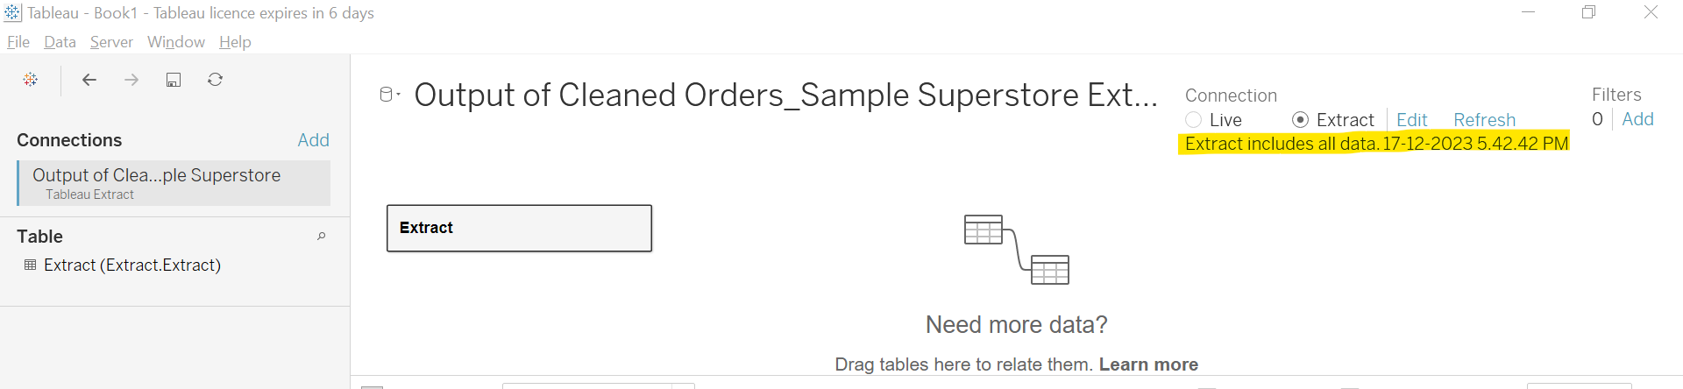
* We can also choose some time after which data will automatically refreshed.
* 
* This is refresh button which refresh data if some changes done in file will reflect. 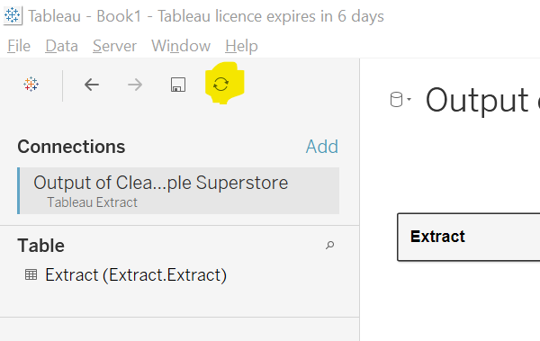
* From workbook refresh 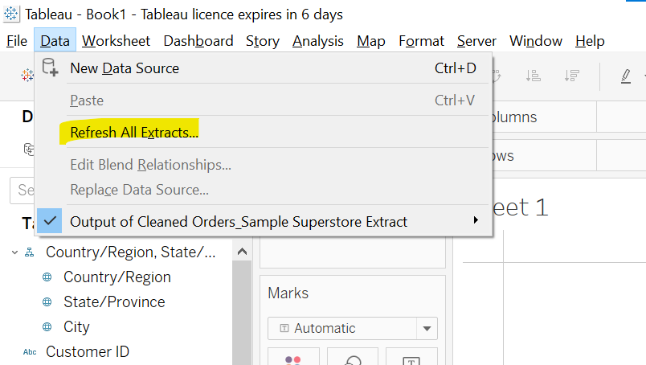
* 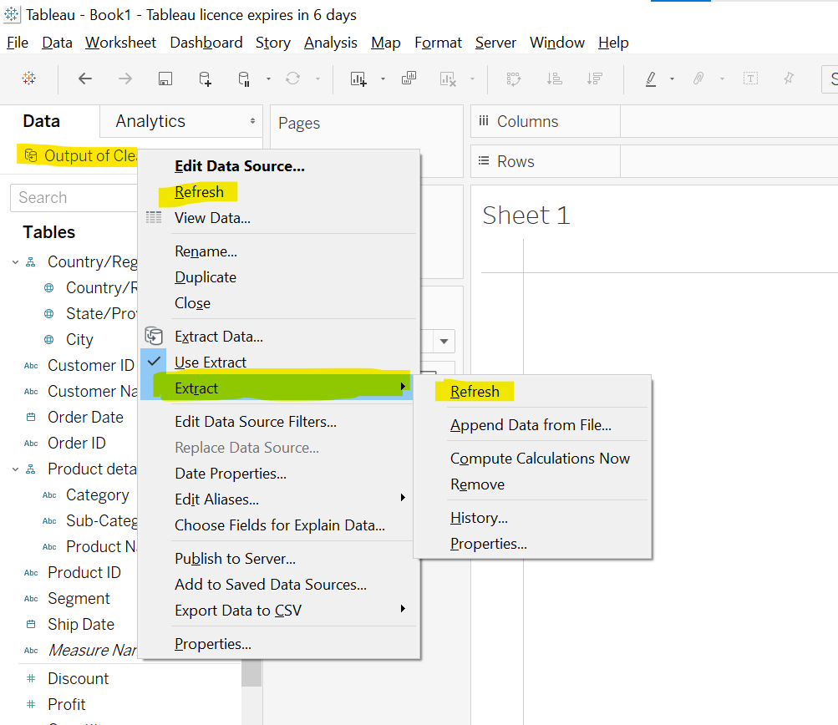
* Above is also way to refresh data.
* In live connection data is refresh very fast.
* Import Extract data and goto Sheet1.
* 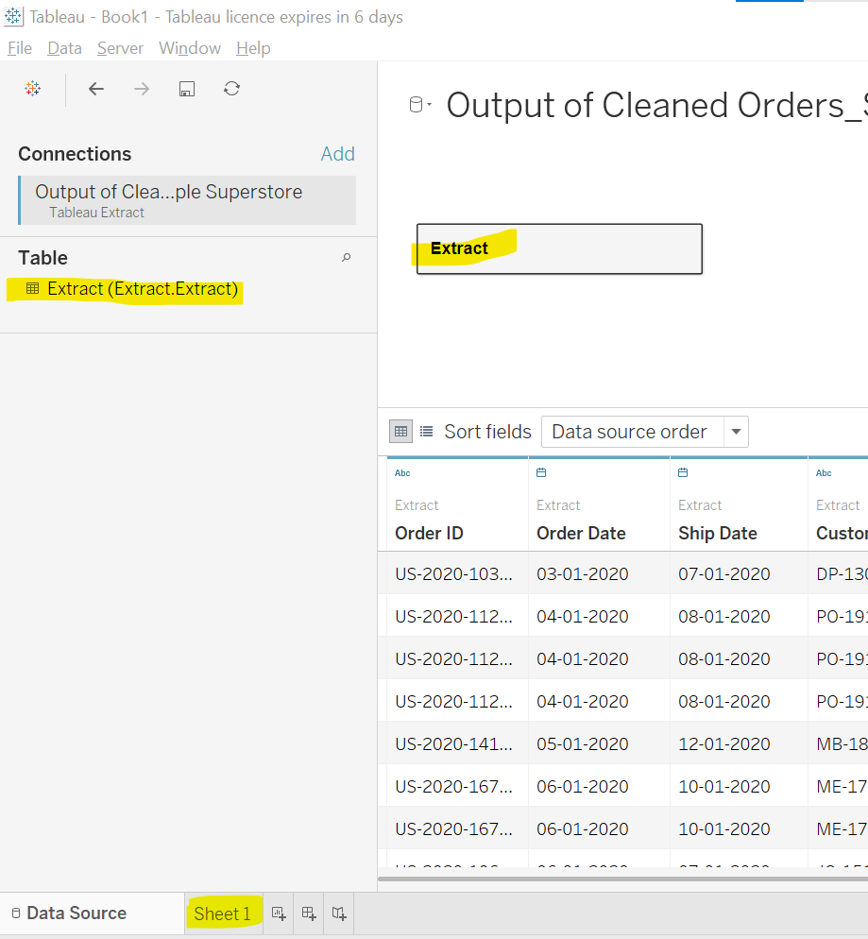
* Textual data= dimensions which gives us qualitative data.
* Measures=Quantitative data which gives us aggregation. Except order id, row id, order date, it comes in dimensions.
* Quantitative data ko workflow me drop karne pe aggregation dikhayega.
* 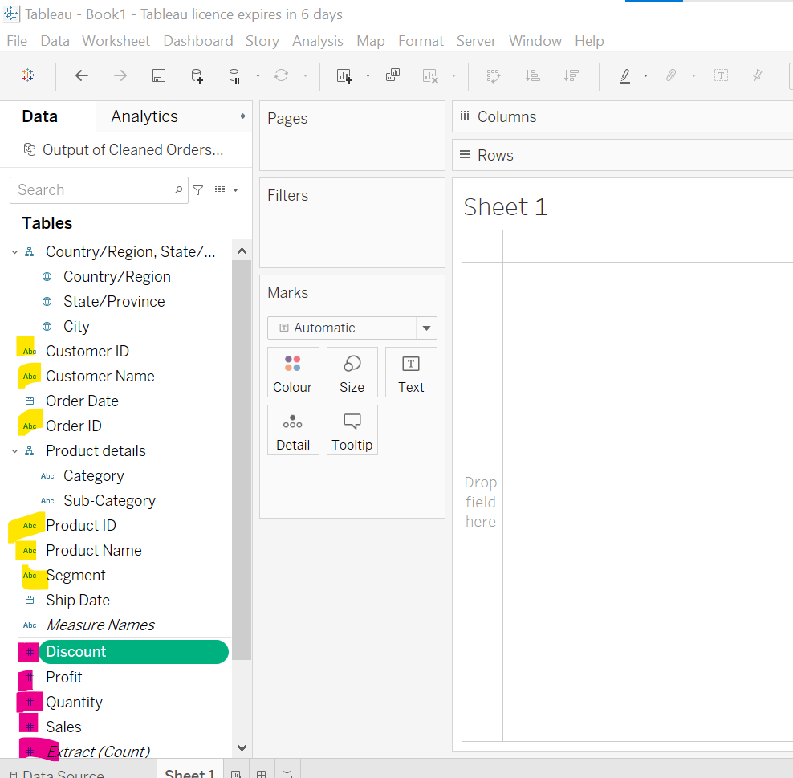
* For e.g.
* 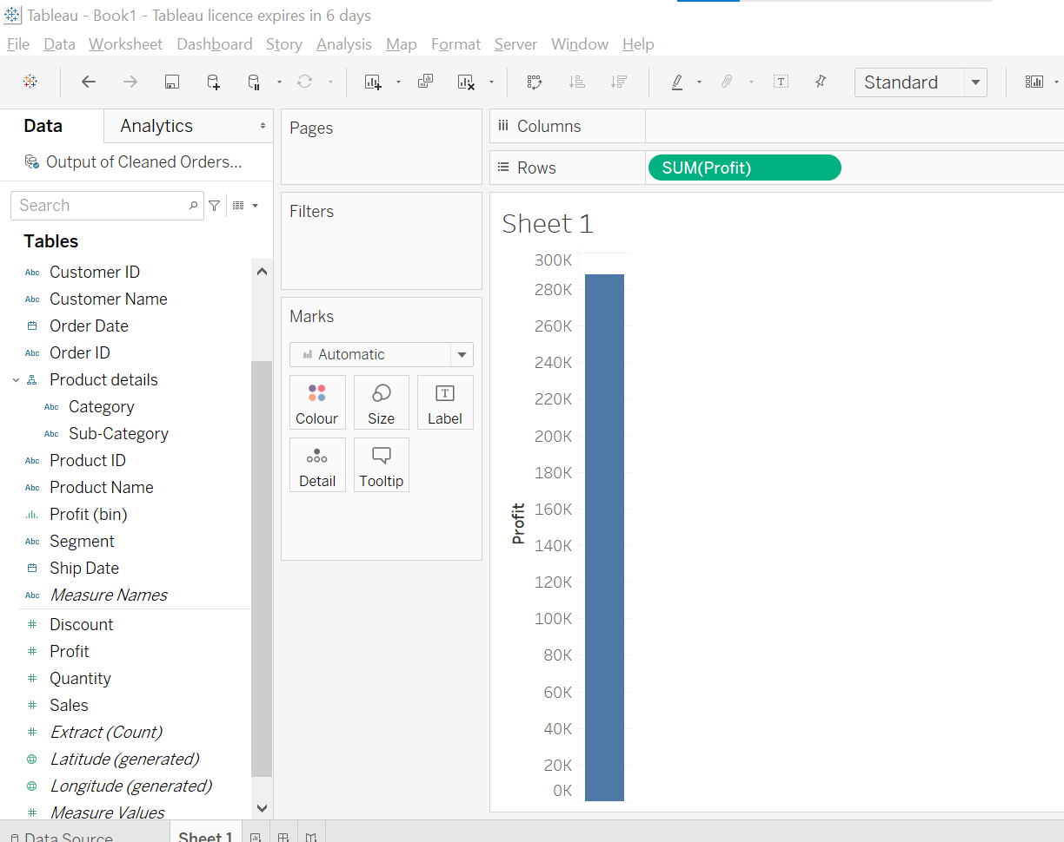
* Discrete value chart ko split karti hai aur detail info deti hai.
* Continuous value hme summarize karke deti hai, aggregate karke deti hai.
* Blue color=Discrete and Green color: Continuous
* 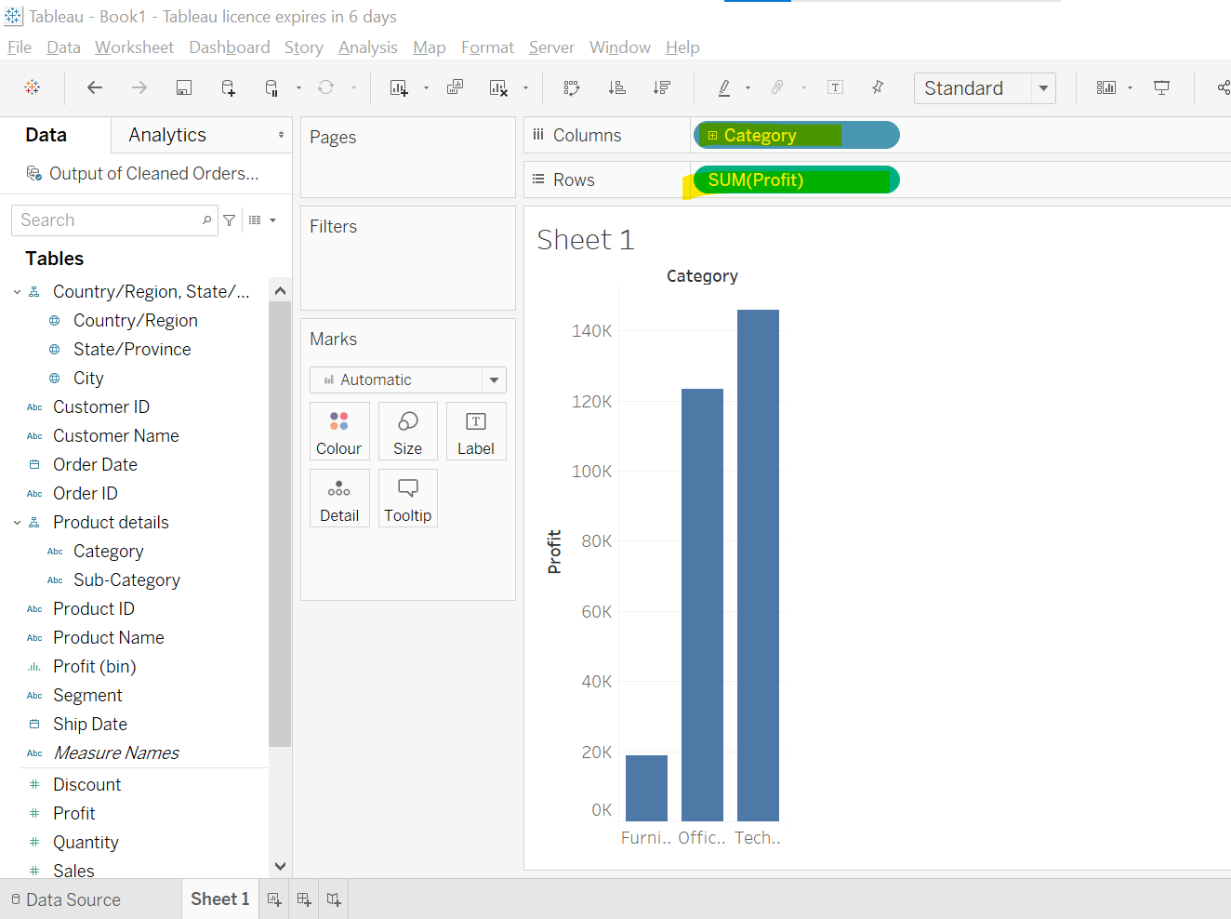
* Discrete value me color different dikhayega
* Continuous me color fade to dark depend to count dikhayega.
* 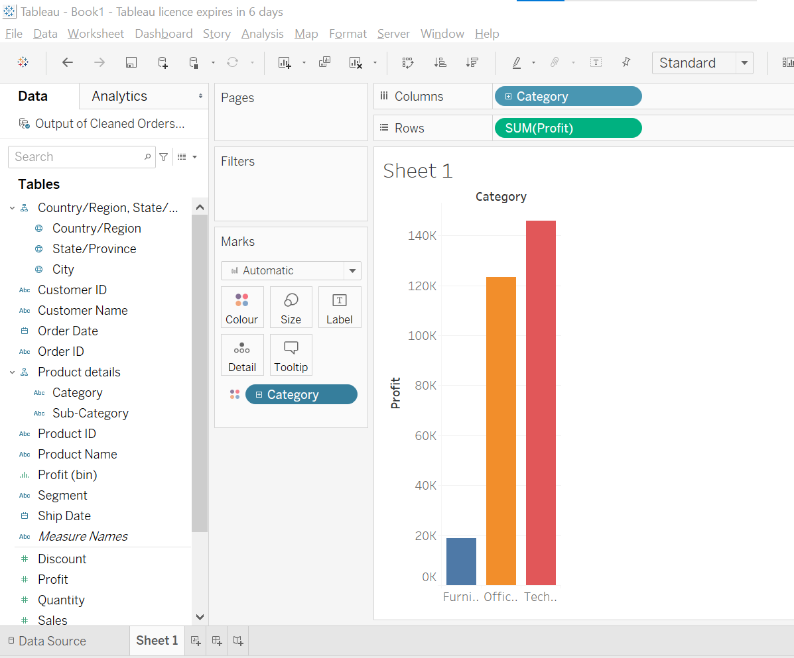
* 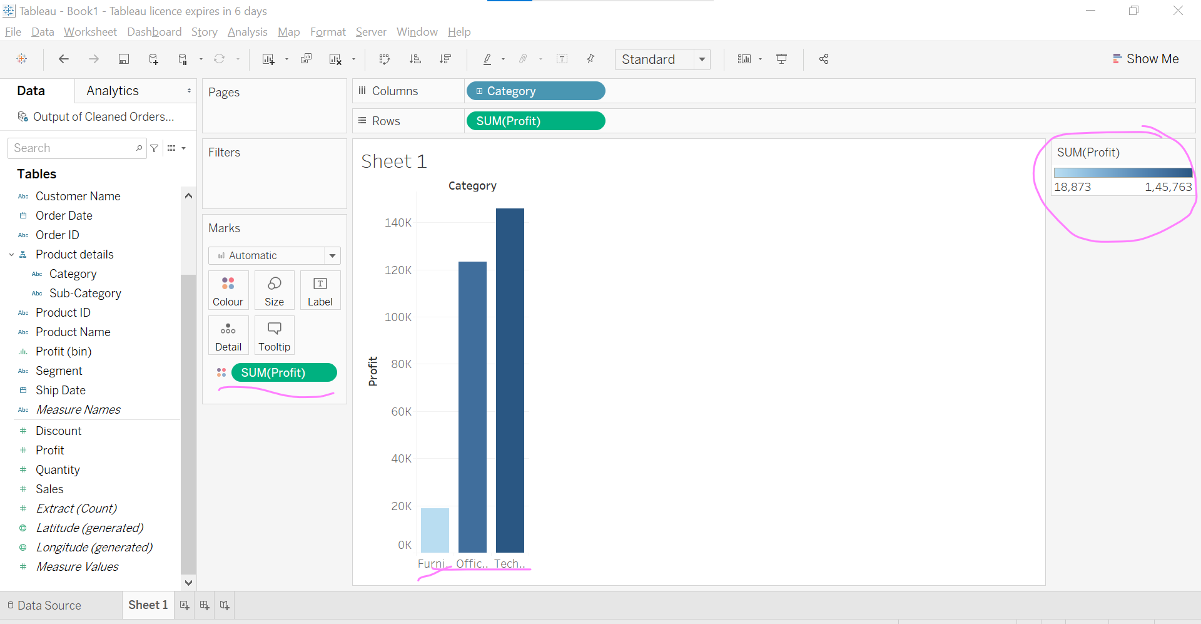
* We have sheet, dashboard, story.
* 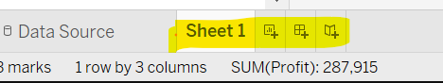
* Data Pane, Anlytics Pane, Cards, Shell, Ribbon
* 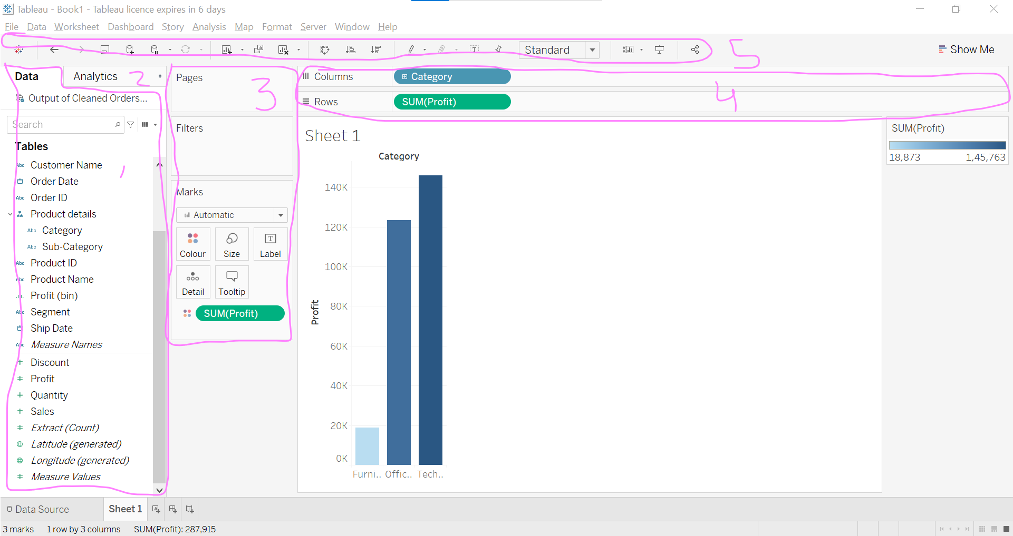

Basics Of Visualization

* Drag and Drop extract sheets. 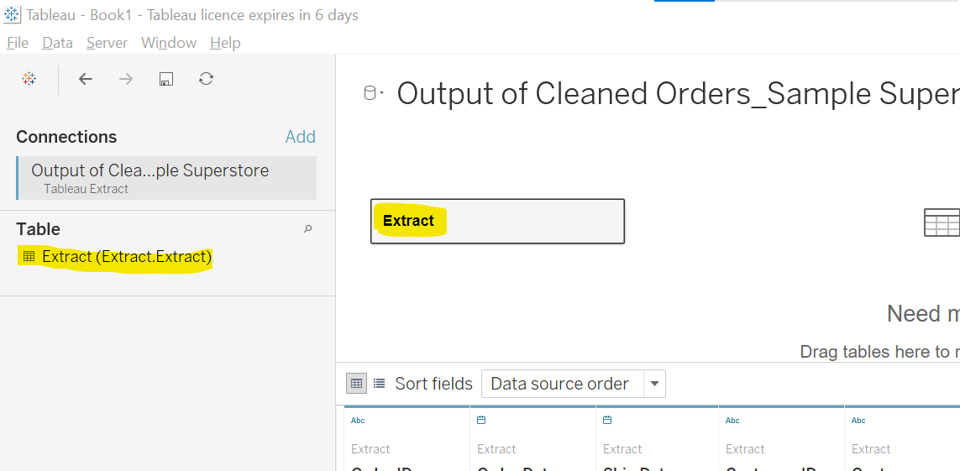
* Goto sheet 1
* We have 24 visuals. 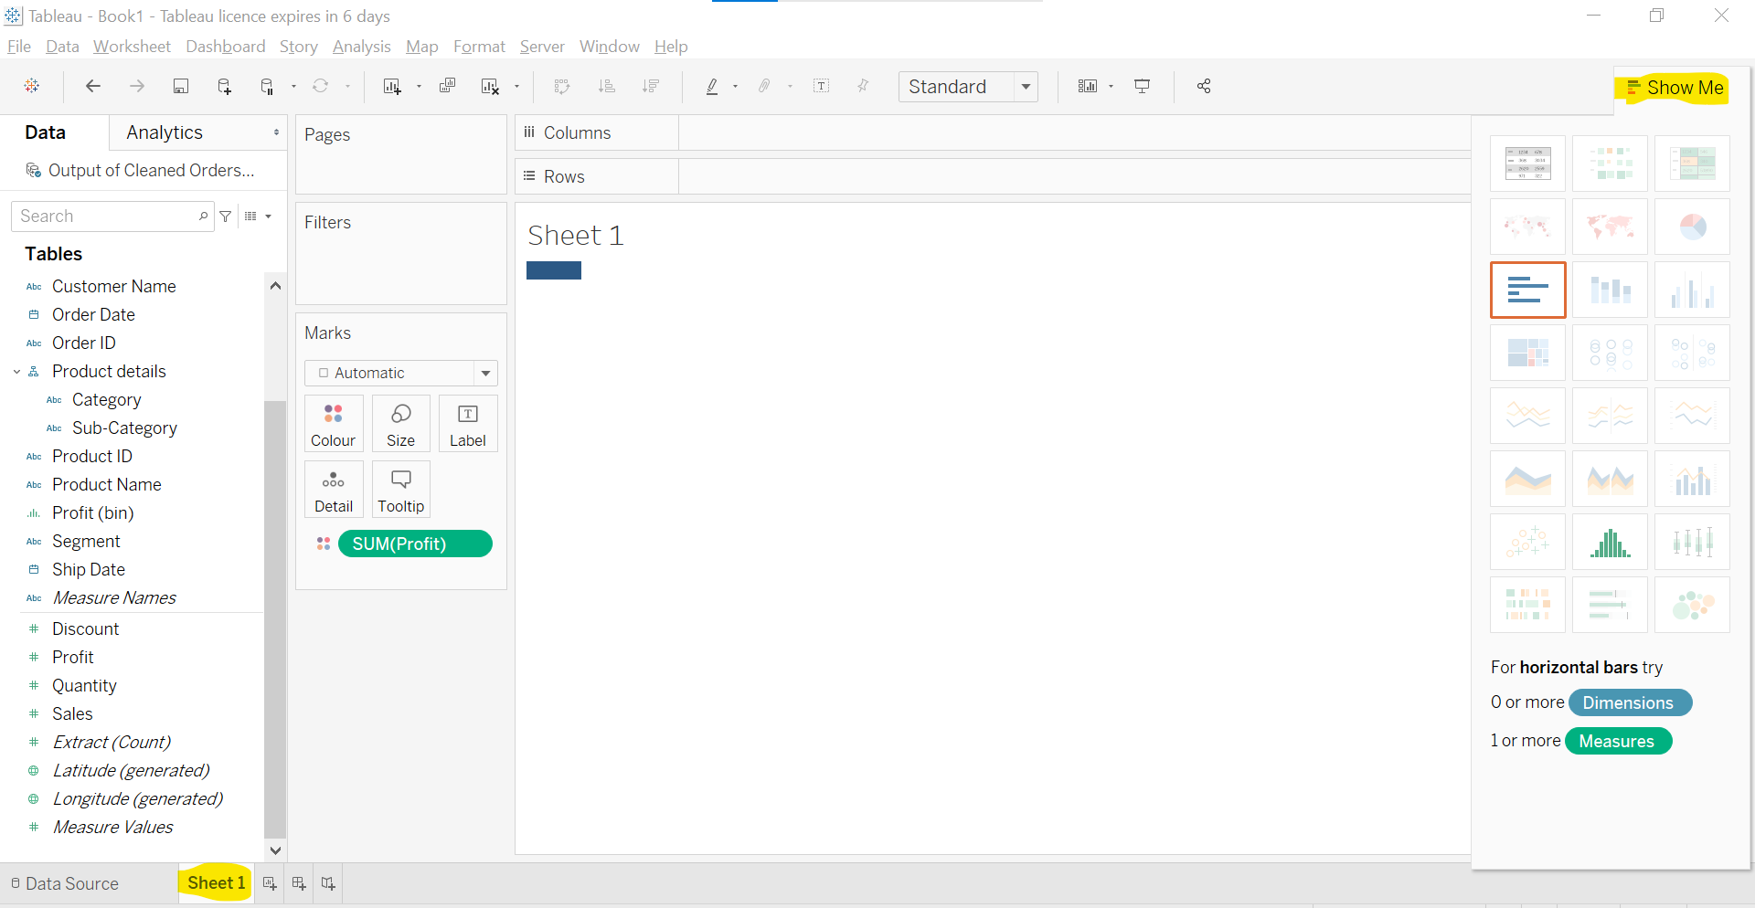
* Visuals
  1. Text tables: Tabular Format
  2. Heat Map:
  3. Highlight tables:
  4. Symbol map
  5. Field maps
  6. Pie chart
  7. Horizontal chart
  8. Stacked Bar
  9. Side by side bars
  10. Tree maps
  11. Circles view
  12. Side by side circles
  13. Lines cont : Lines chart trend over the time dekhne ke liye karte hai.
  14. Lines discrete
  15. Dual lines
  16. Area cont
  17. Area disc
  18. Dual combination
  19. Scatter
  20. Histogram
  21. Box and whisker plots
  22. Gantt
  23. Bullet
  24. Packed Bubbles
* Measure values select karne pe aggregation e.g. SUM show hota hai.
* Kisi column ko select karne pe automatically possible chart show honge.
* Hum multiple col ko ctrl + click ke select kar sakte hai. Tub humko possible banne wale charts show honge.
* 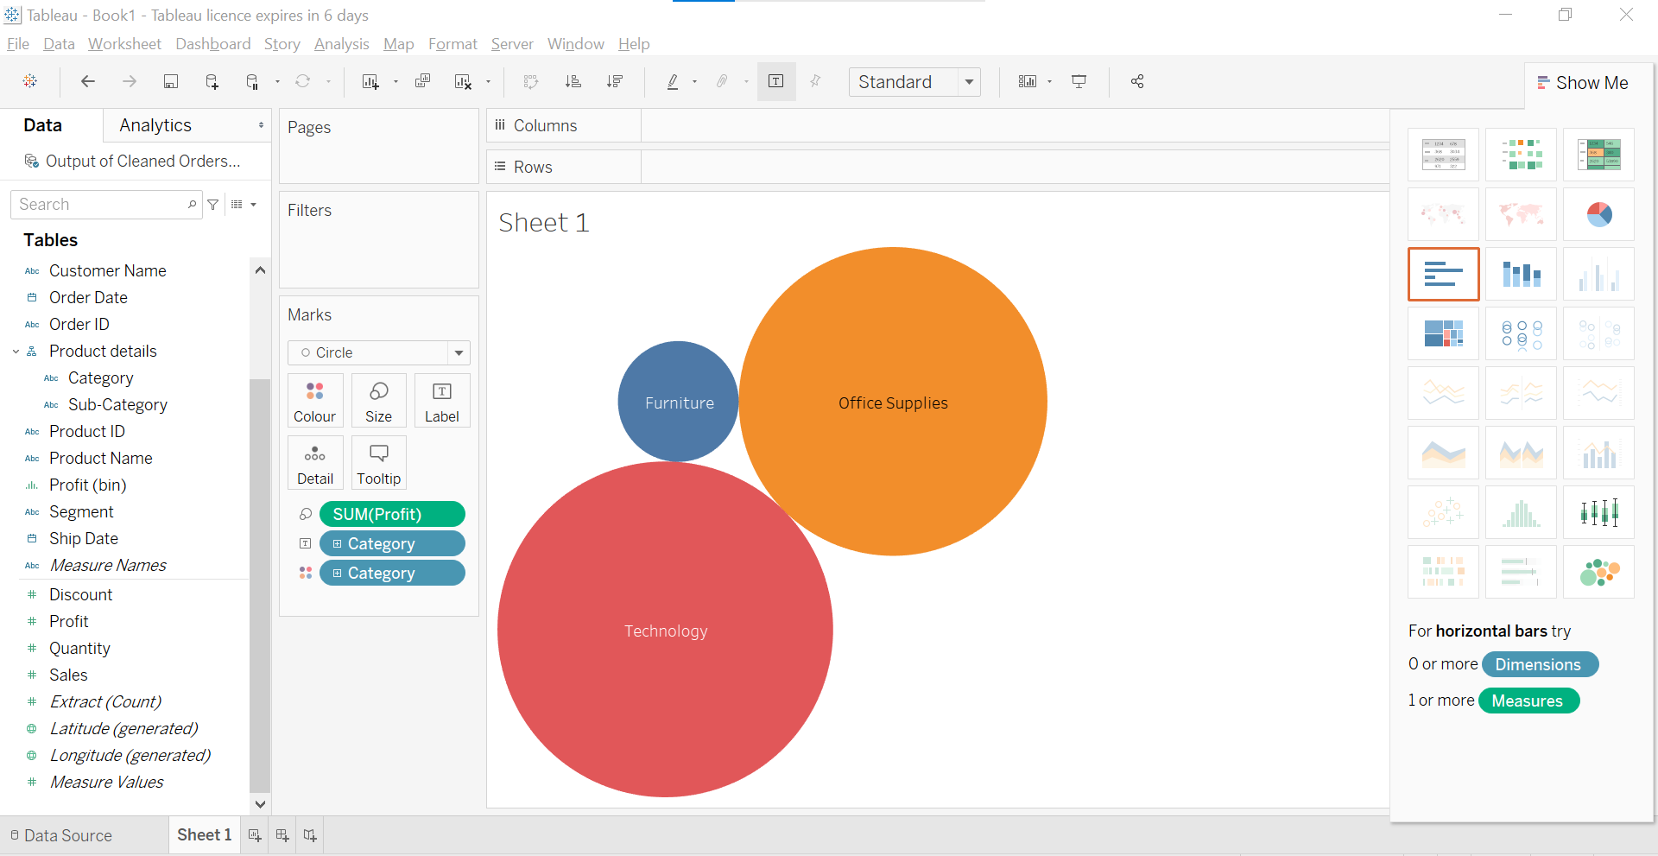
* Or we can drag and drop multiple columns in workflow area then chart dikhne lagenge.
* 0r double click on columns
* Double click on measures first tub bar chart ban jaayega.
* Double click on dimensions first then text chart ban jaayega.

Hierarchy, Marks Card, Bar Chart And Its Types

* 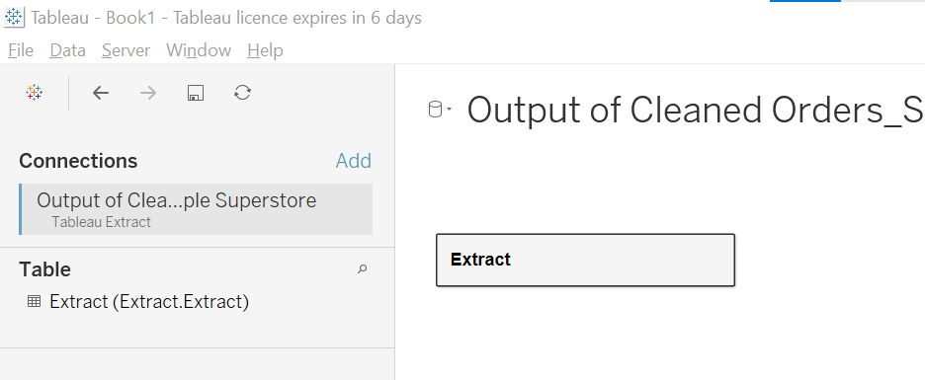
* 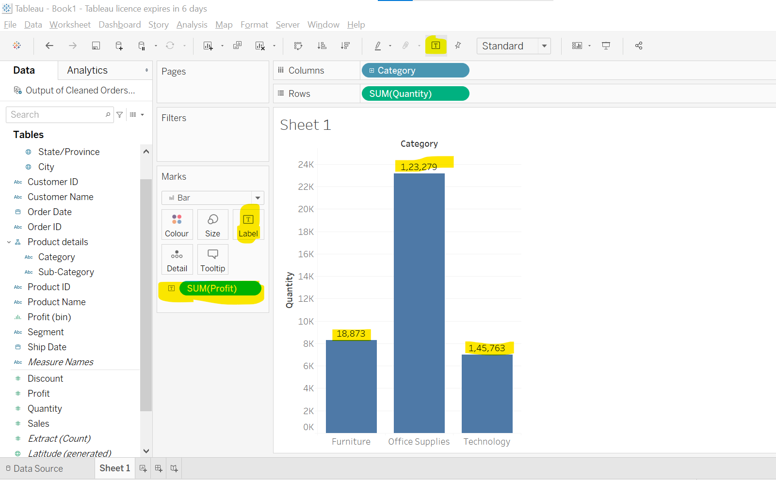
* Label use
* 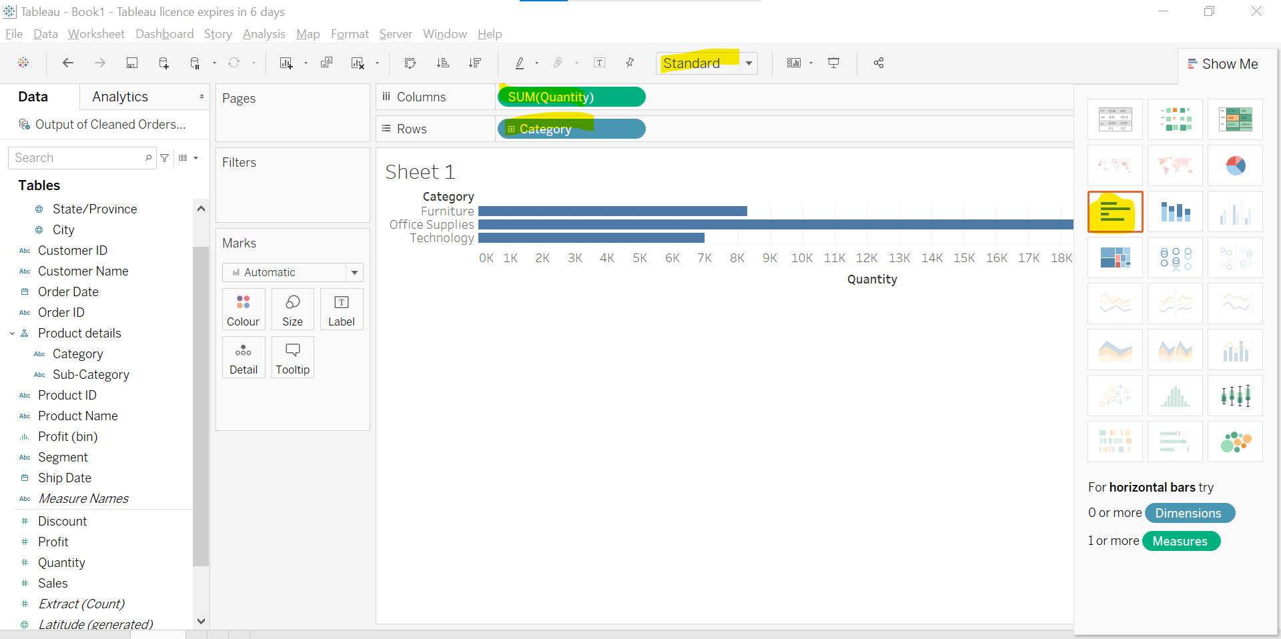
* 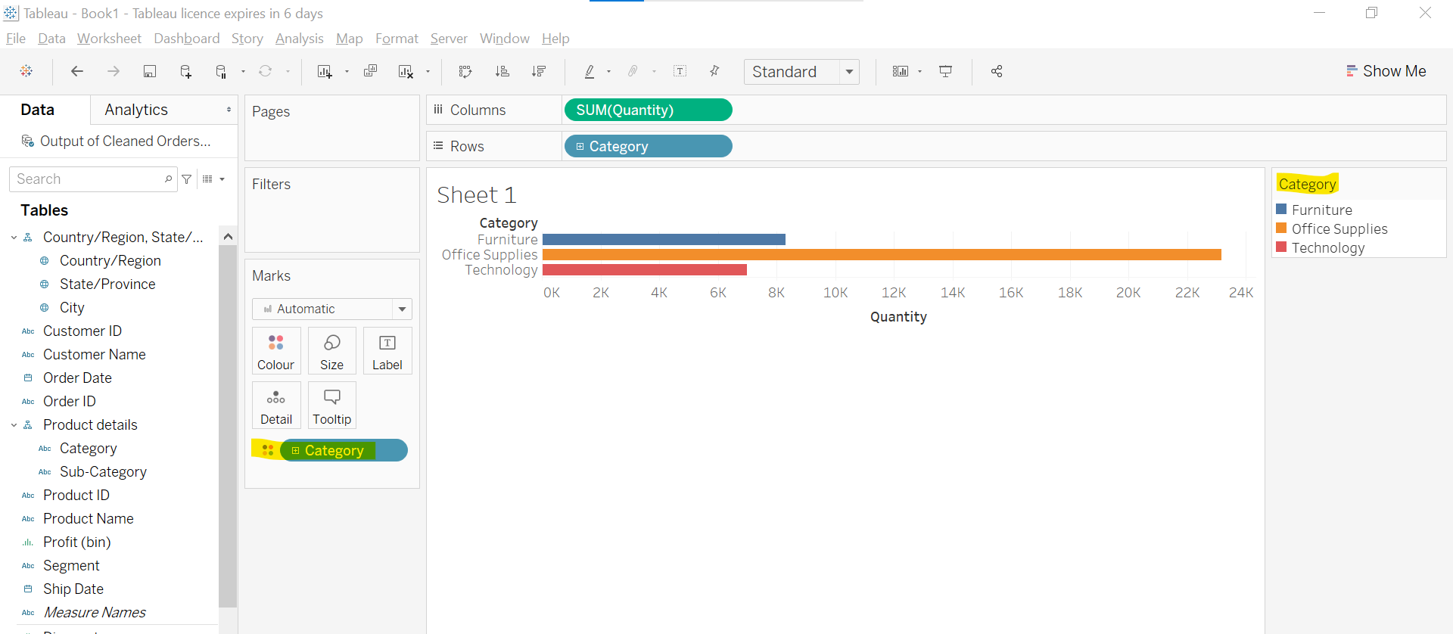
* We can move Category in cards section.
* 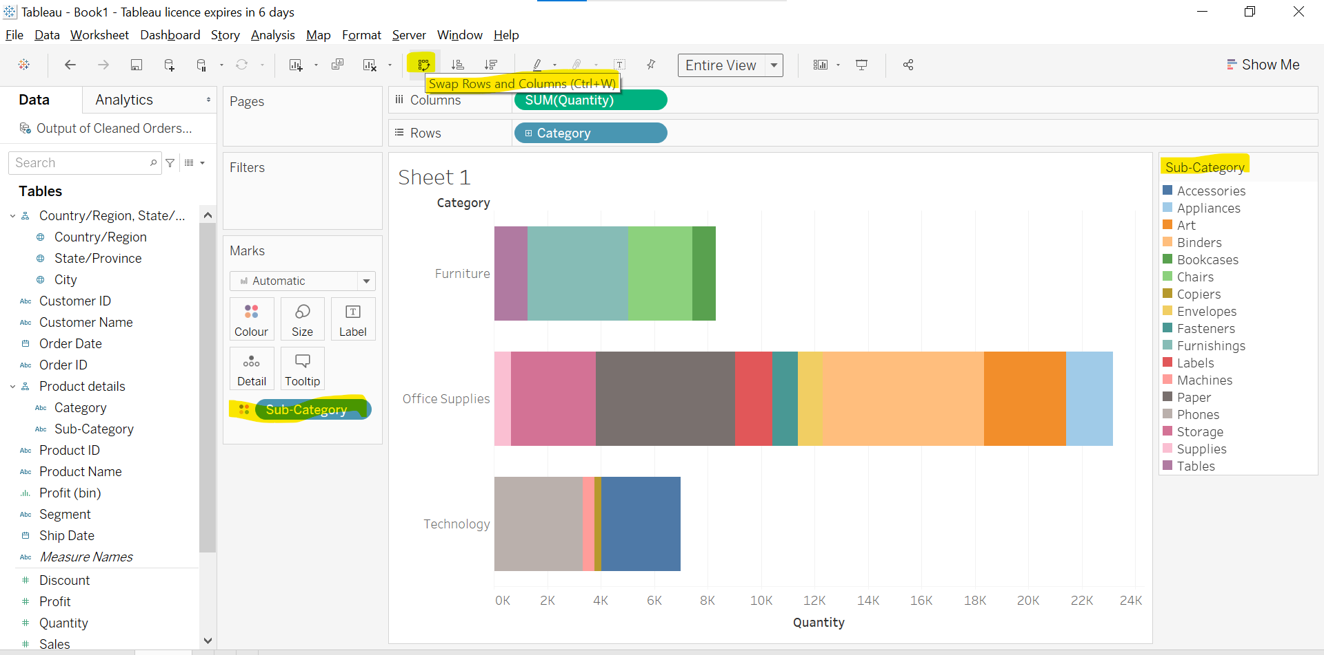
* Make a duplicate sheet and work on it. 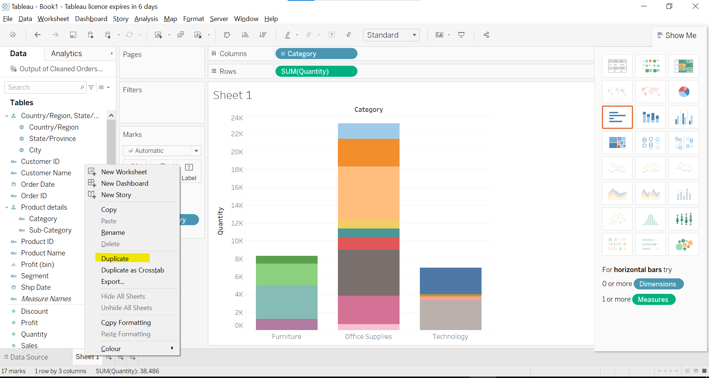
* Side by side bar chart is basically grouped bar chart.
* This is hierarchy, similarly we can create hierarchy for any column by right click.
* 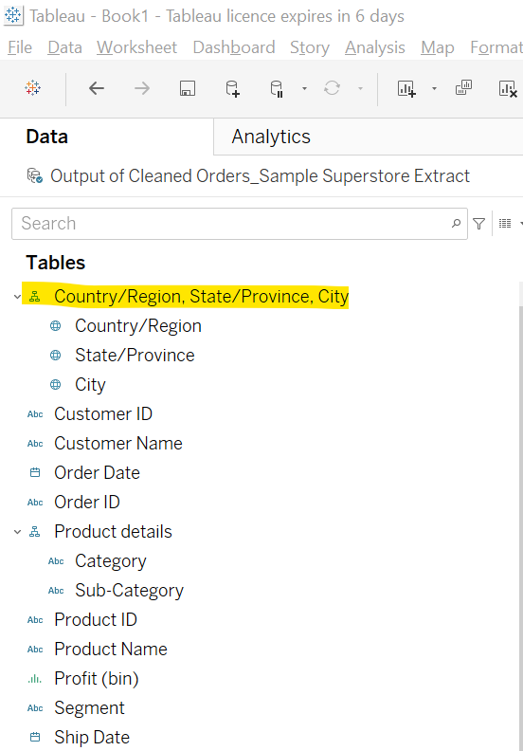
* After creating a hierarchy we can add as many column as we want by right clicking on column we want.
* 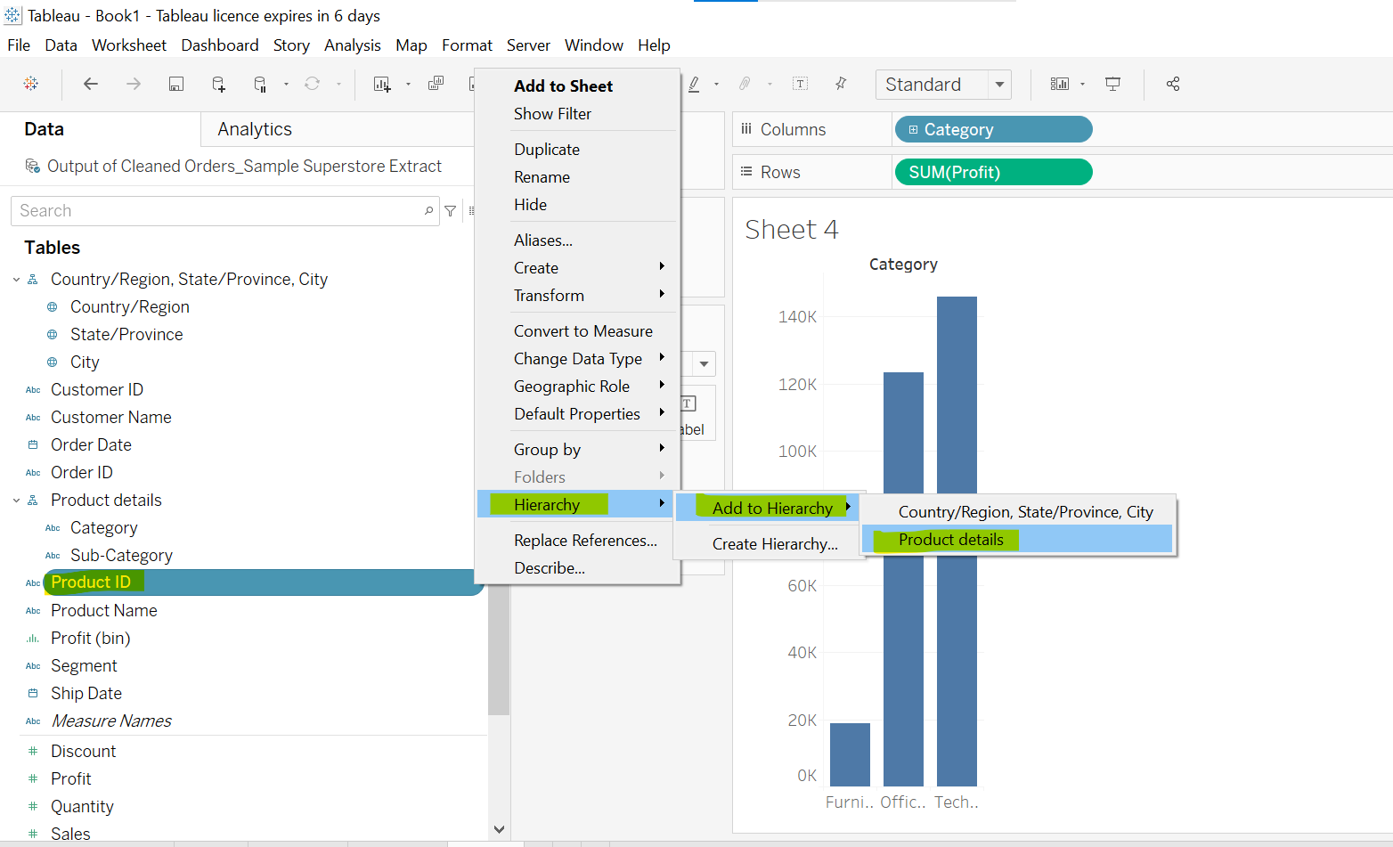
* Hierqarchy wale pe + plus icon ban jaata hai, uspe click karne har column wise chart ban jaayegi.
* 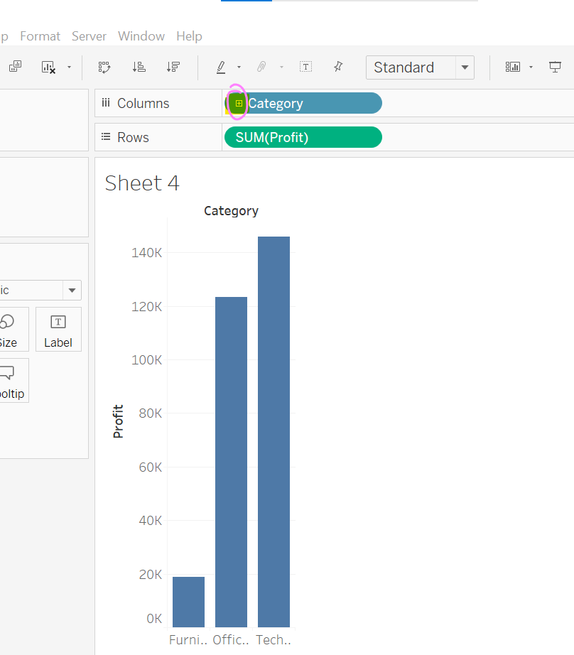
* 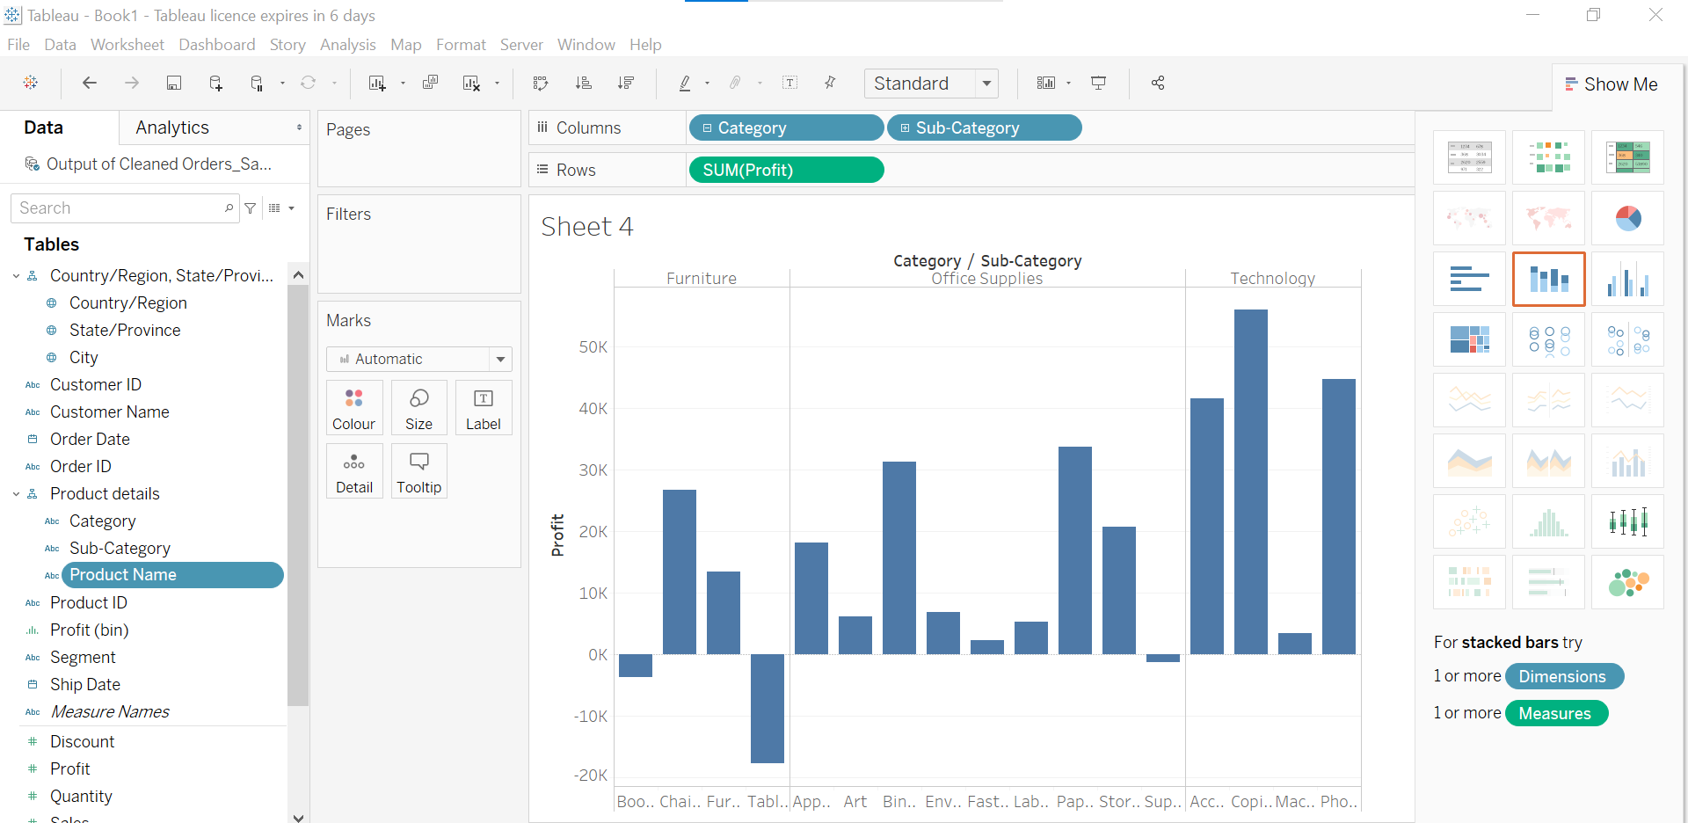
* By clicking on + plus icon.
* Size of bar inc or dec
* Size of bar depends on some column: Simply drop that col in size option
* Tooltip: Add a column to see tooltip.
* Label: Add a col to see it as label
* Detail: Drop any column. Chart will be segregated. Hover mouse on bar it will be divided into parts and separated by black border on hover it will shows.
* We can change color of bar from color icon. Or right side top color pallete.
* Sunrise-sunset is maam fav.
* We can edit color of any bar

PIE CHART

* We take measure as min as possible.
* 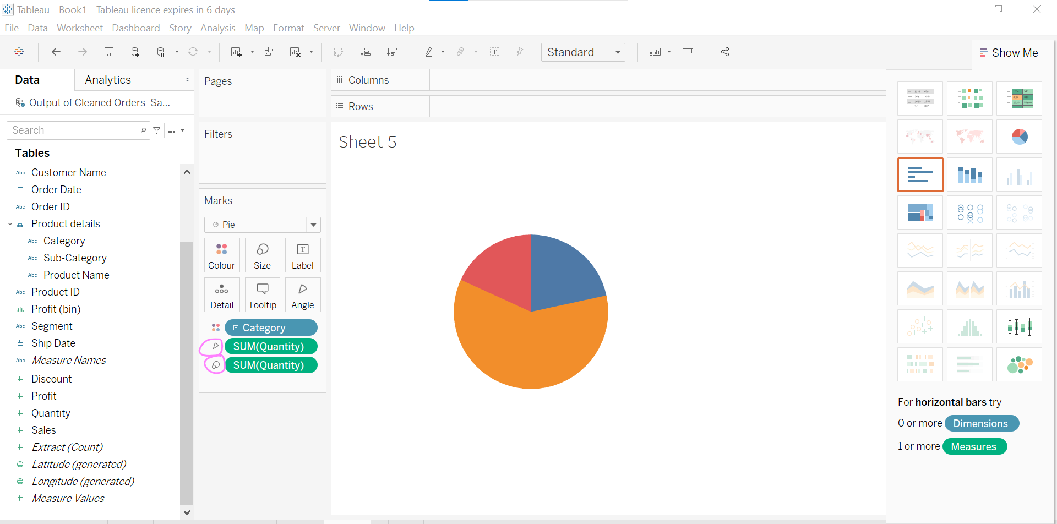
* Angle is based on sum of quantity.
* Size is based on sum of quantity.
* 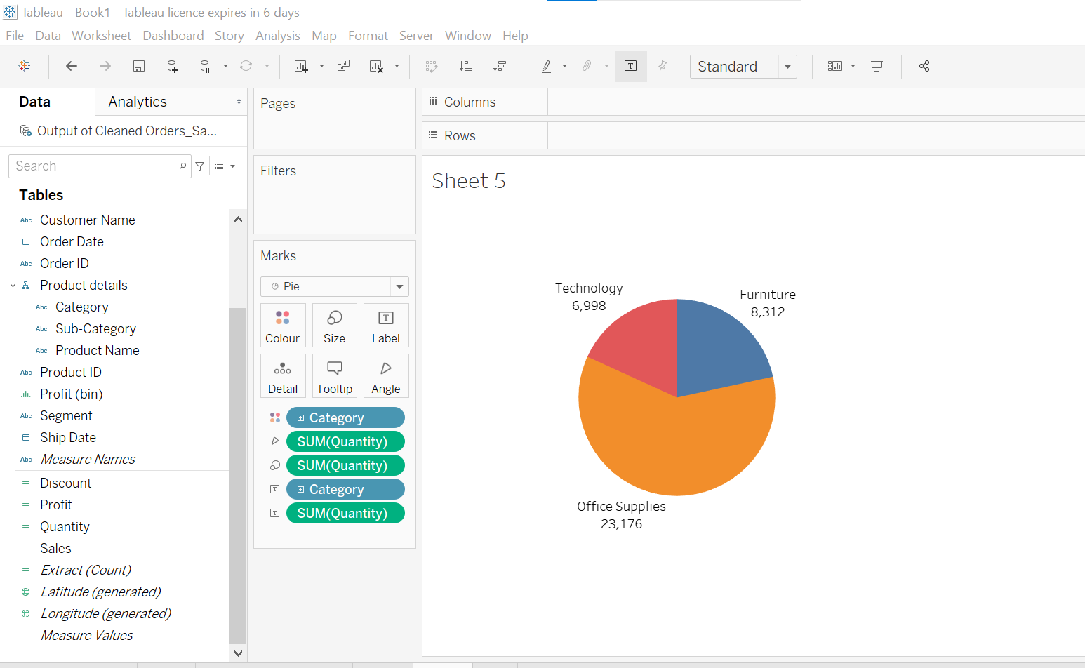
* 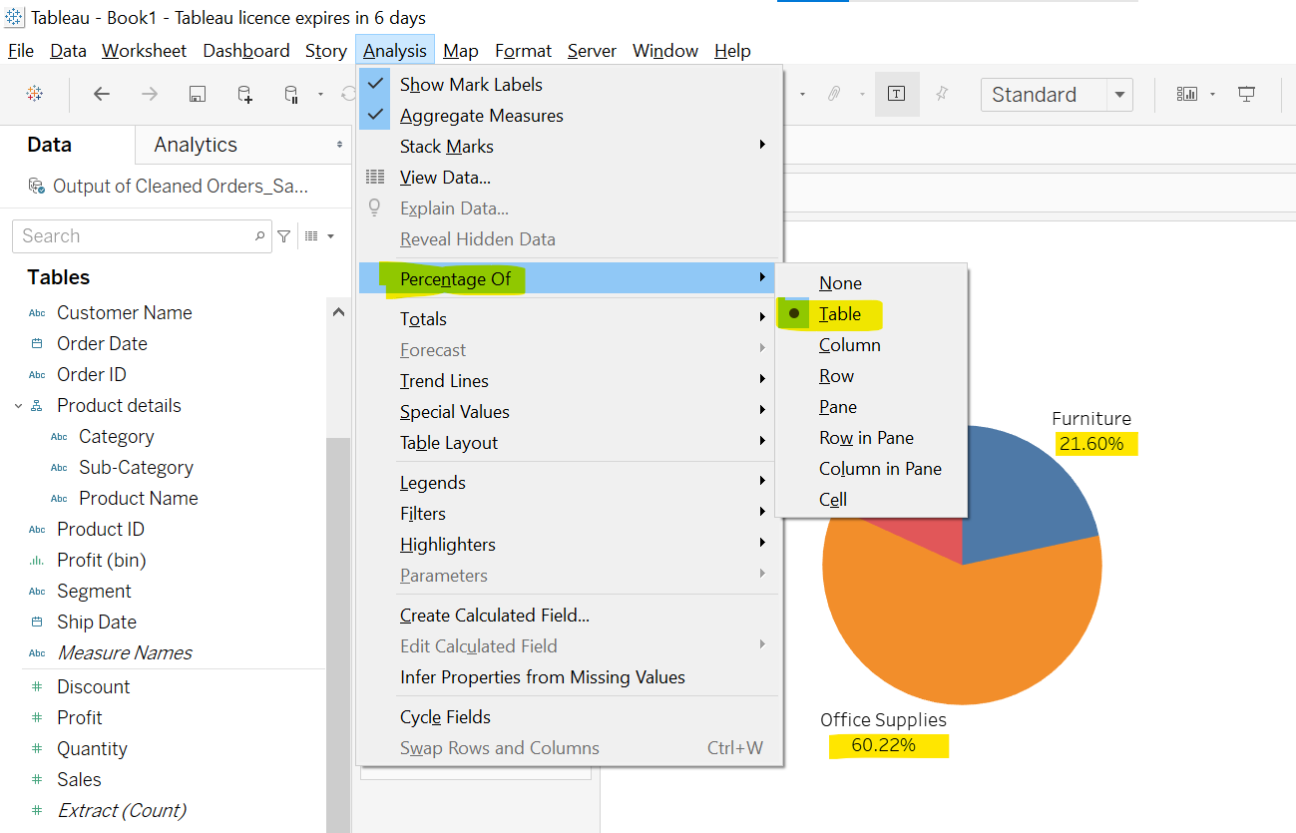
* Sub category wise plot. 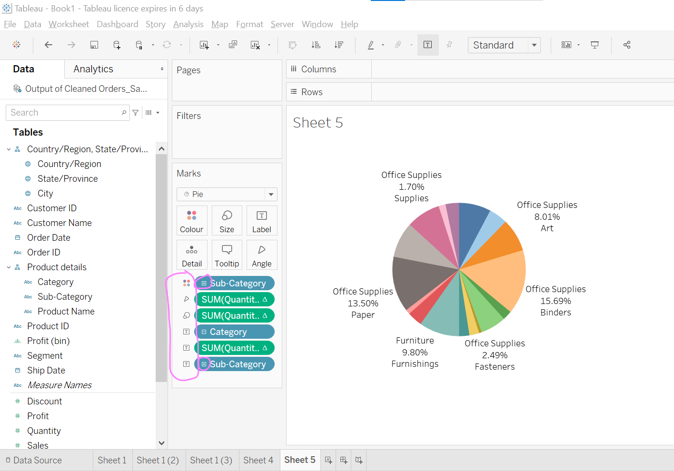
* 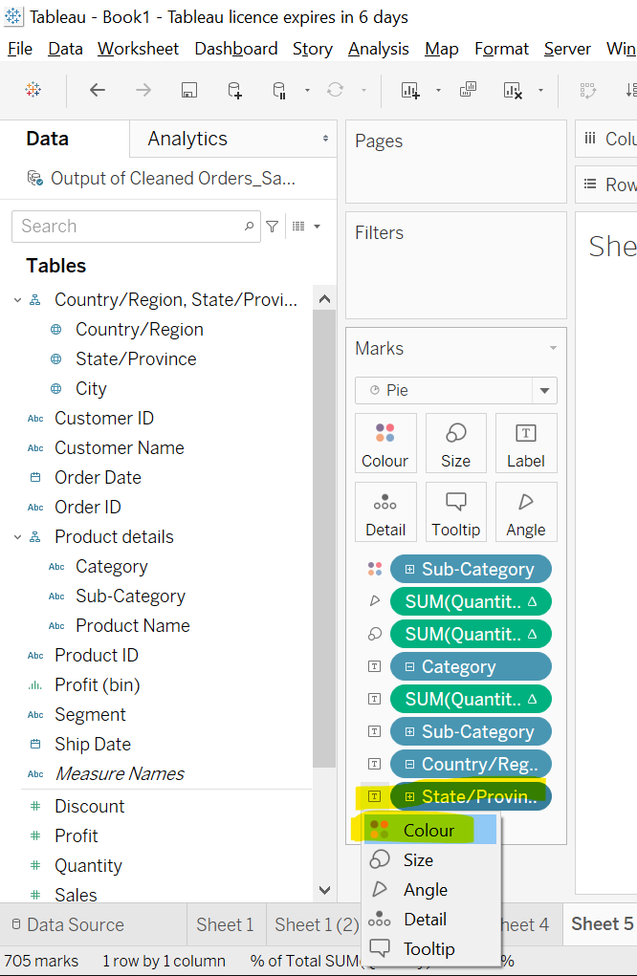 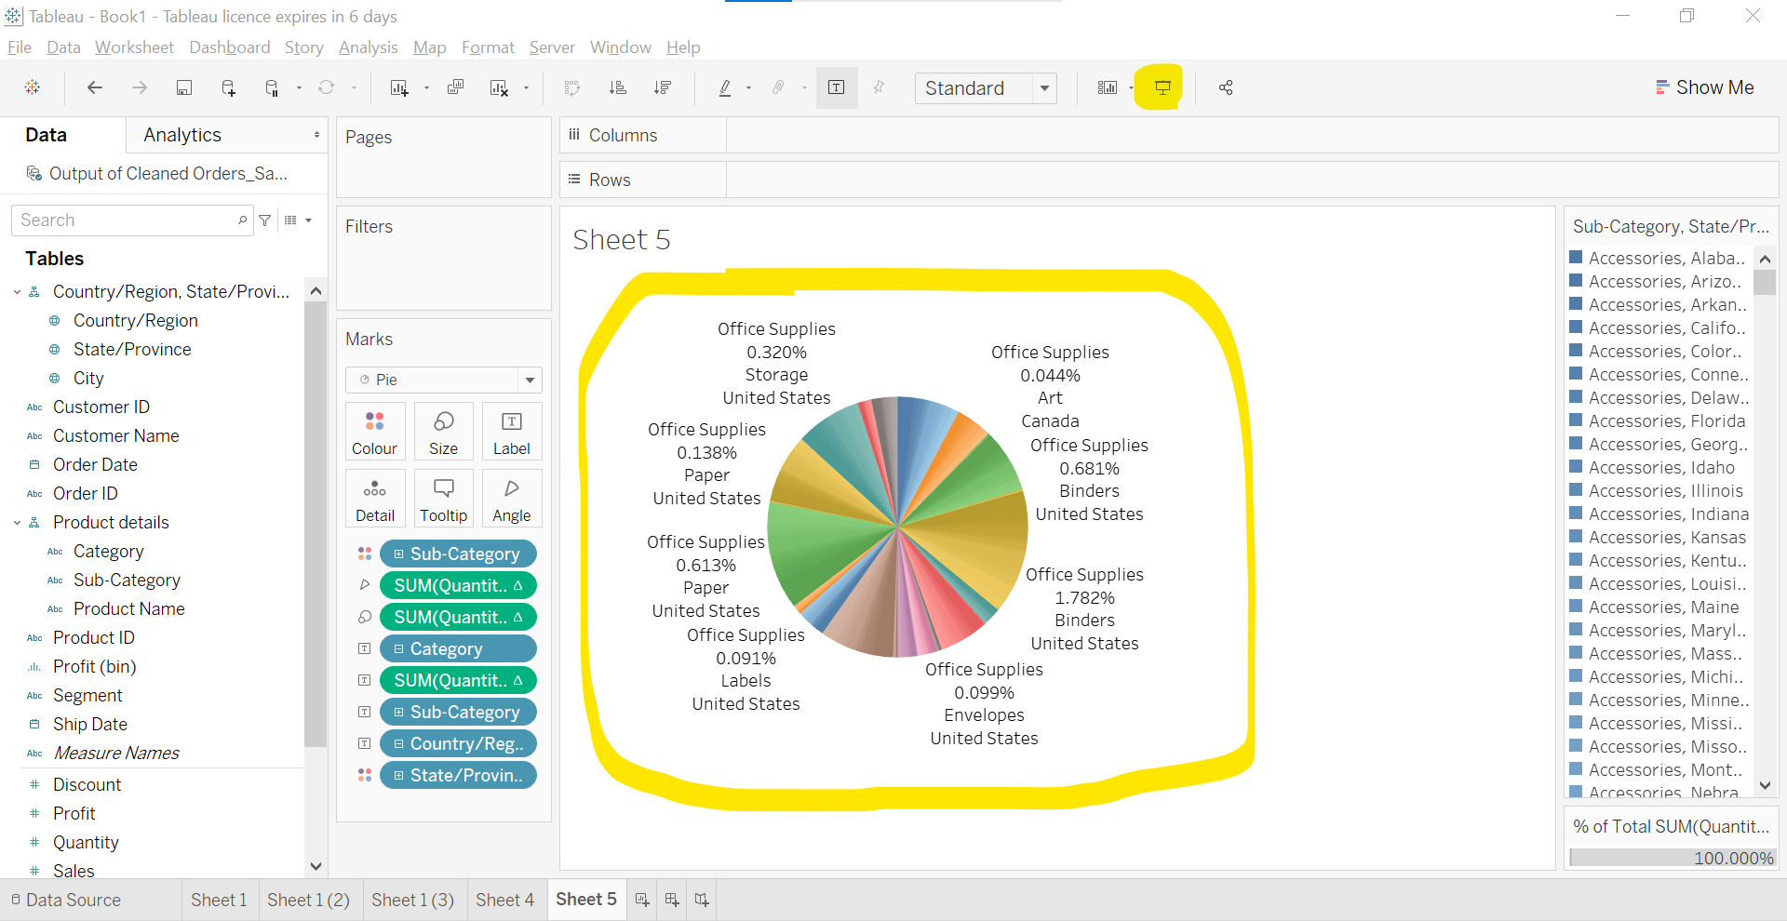
* Click on presentation mode.
* We do not make pie chart bulky like this.
* We make it simple.
* Now, learn to draw pie in different way.
* 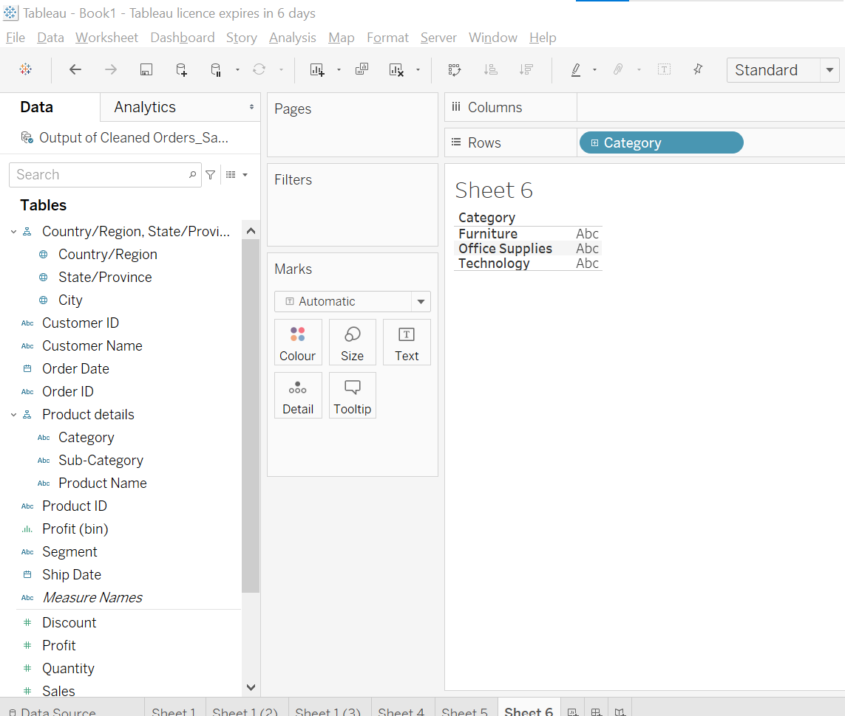
* 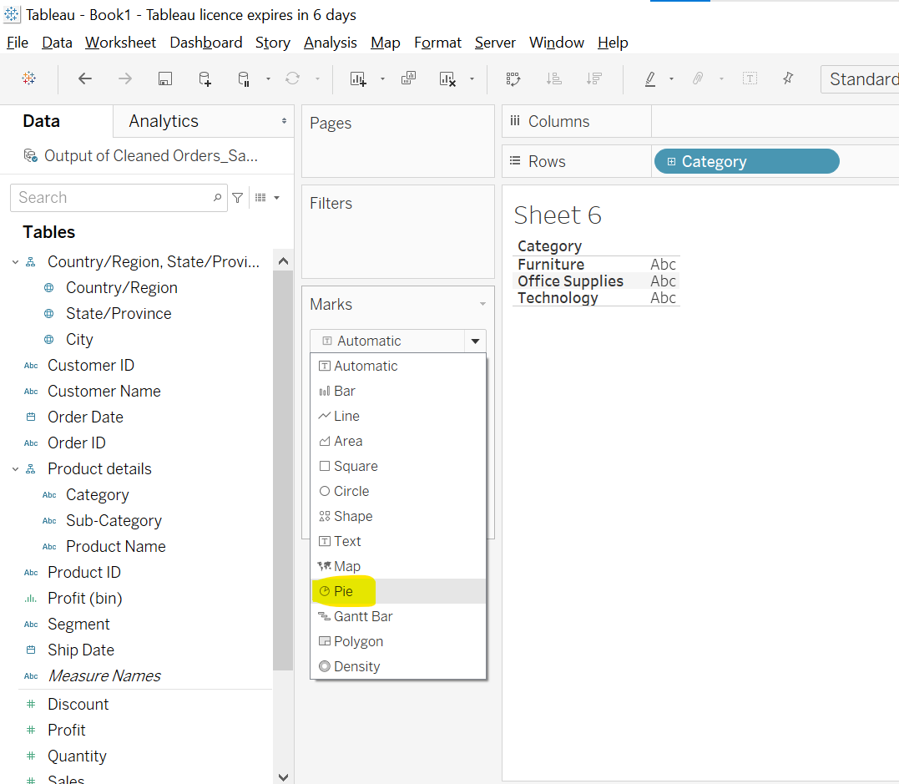 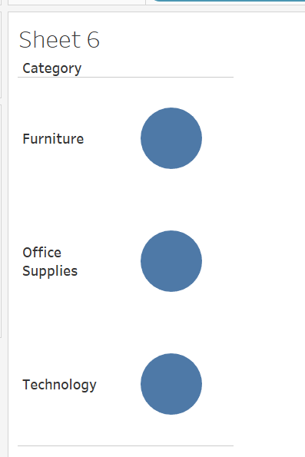
* Add qunaity in size option to make size of circle different.
* Add quantity as label
* 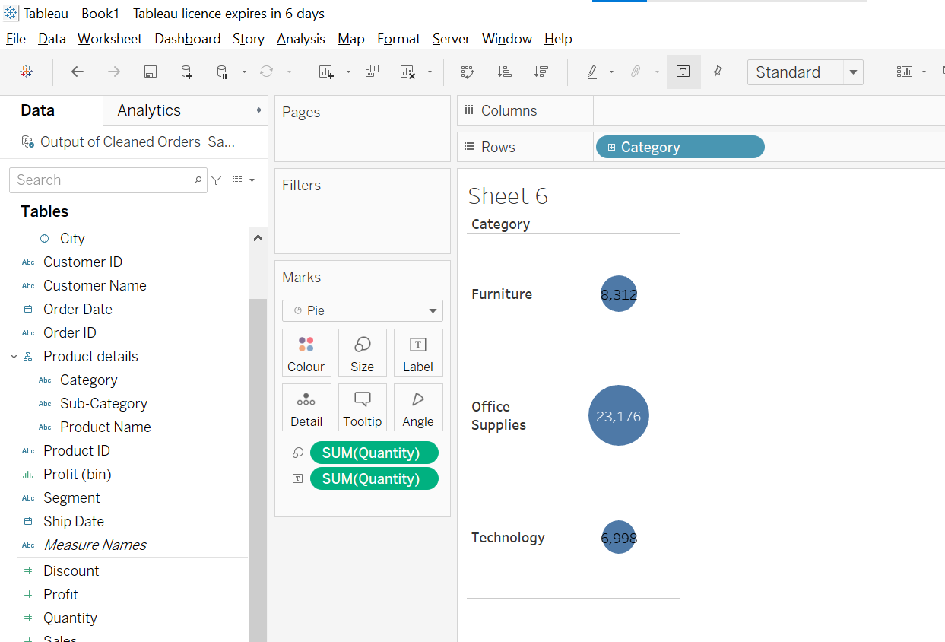
* 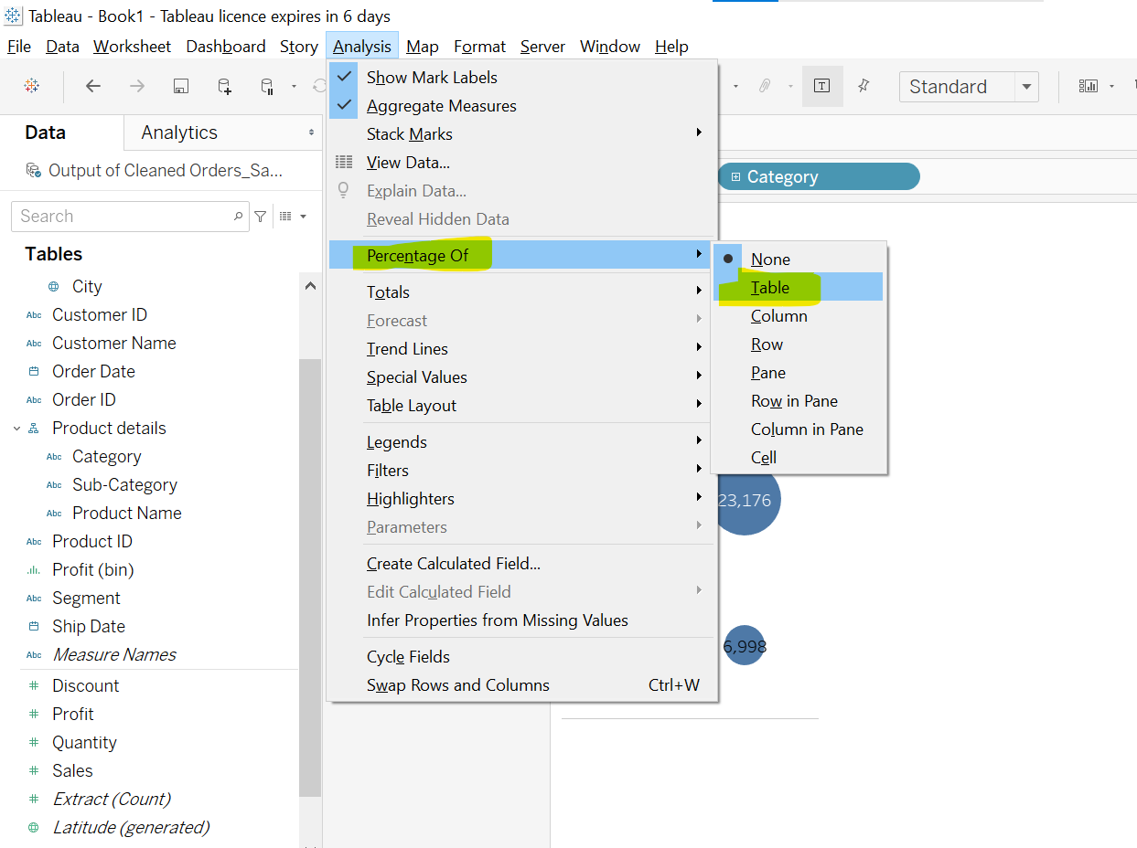
* Since we have choosed % of table so, all pie % sum will equals to 100%
* 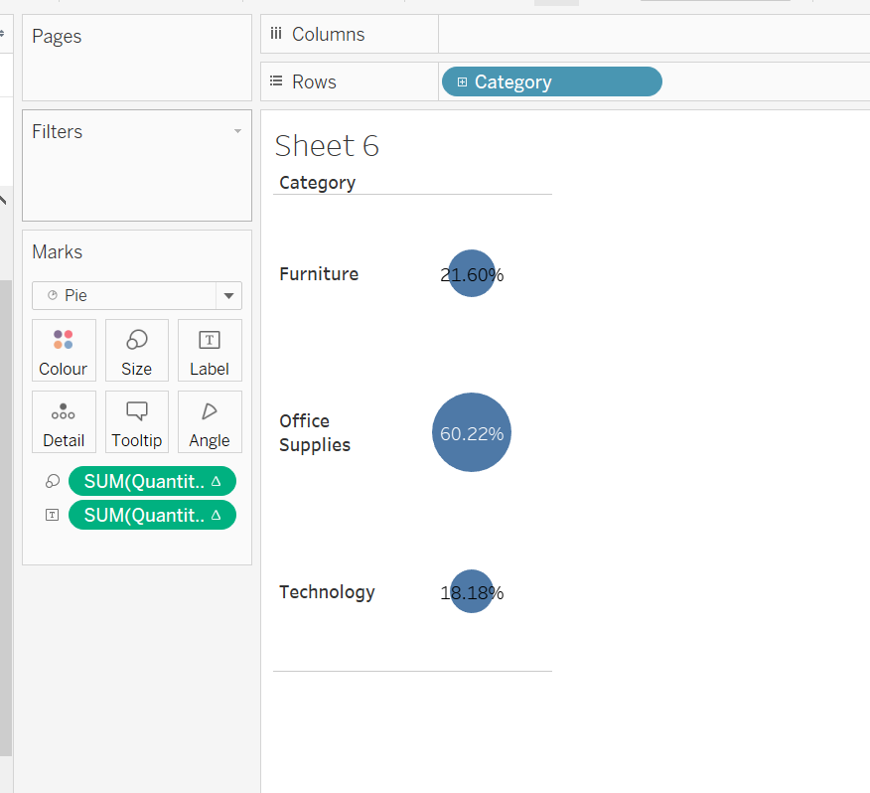
* 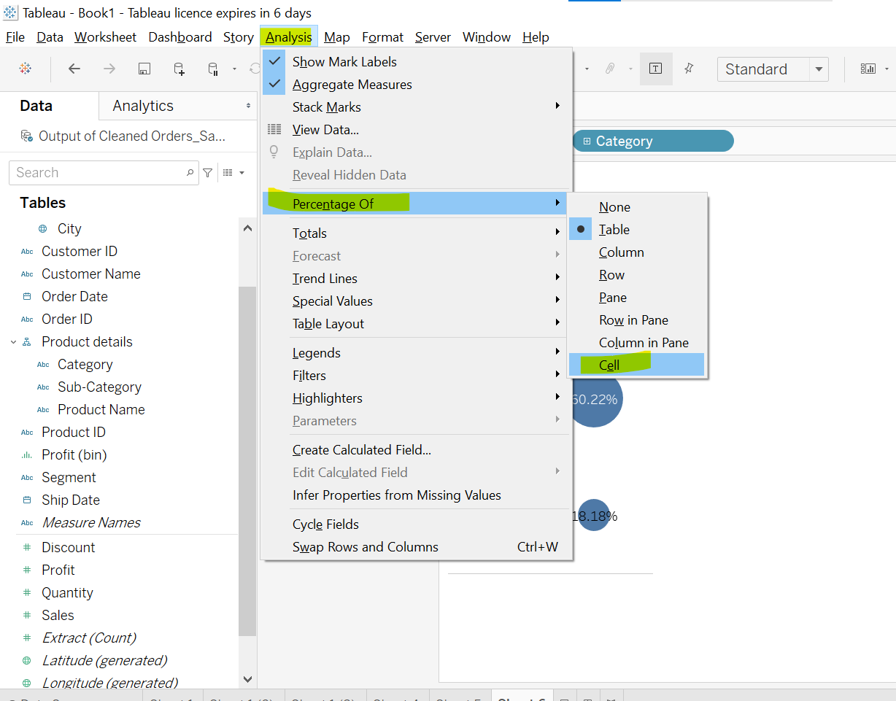
* Abhi ye individual 100% hai.
* 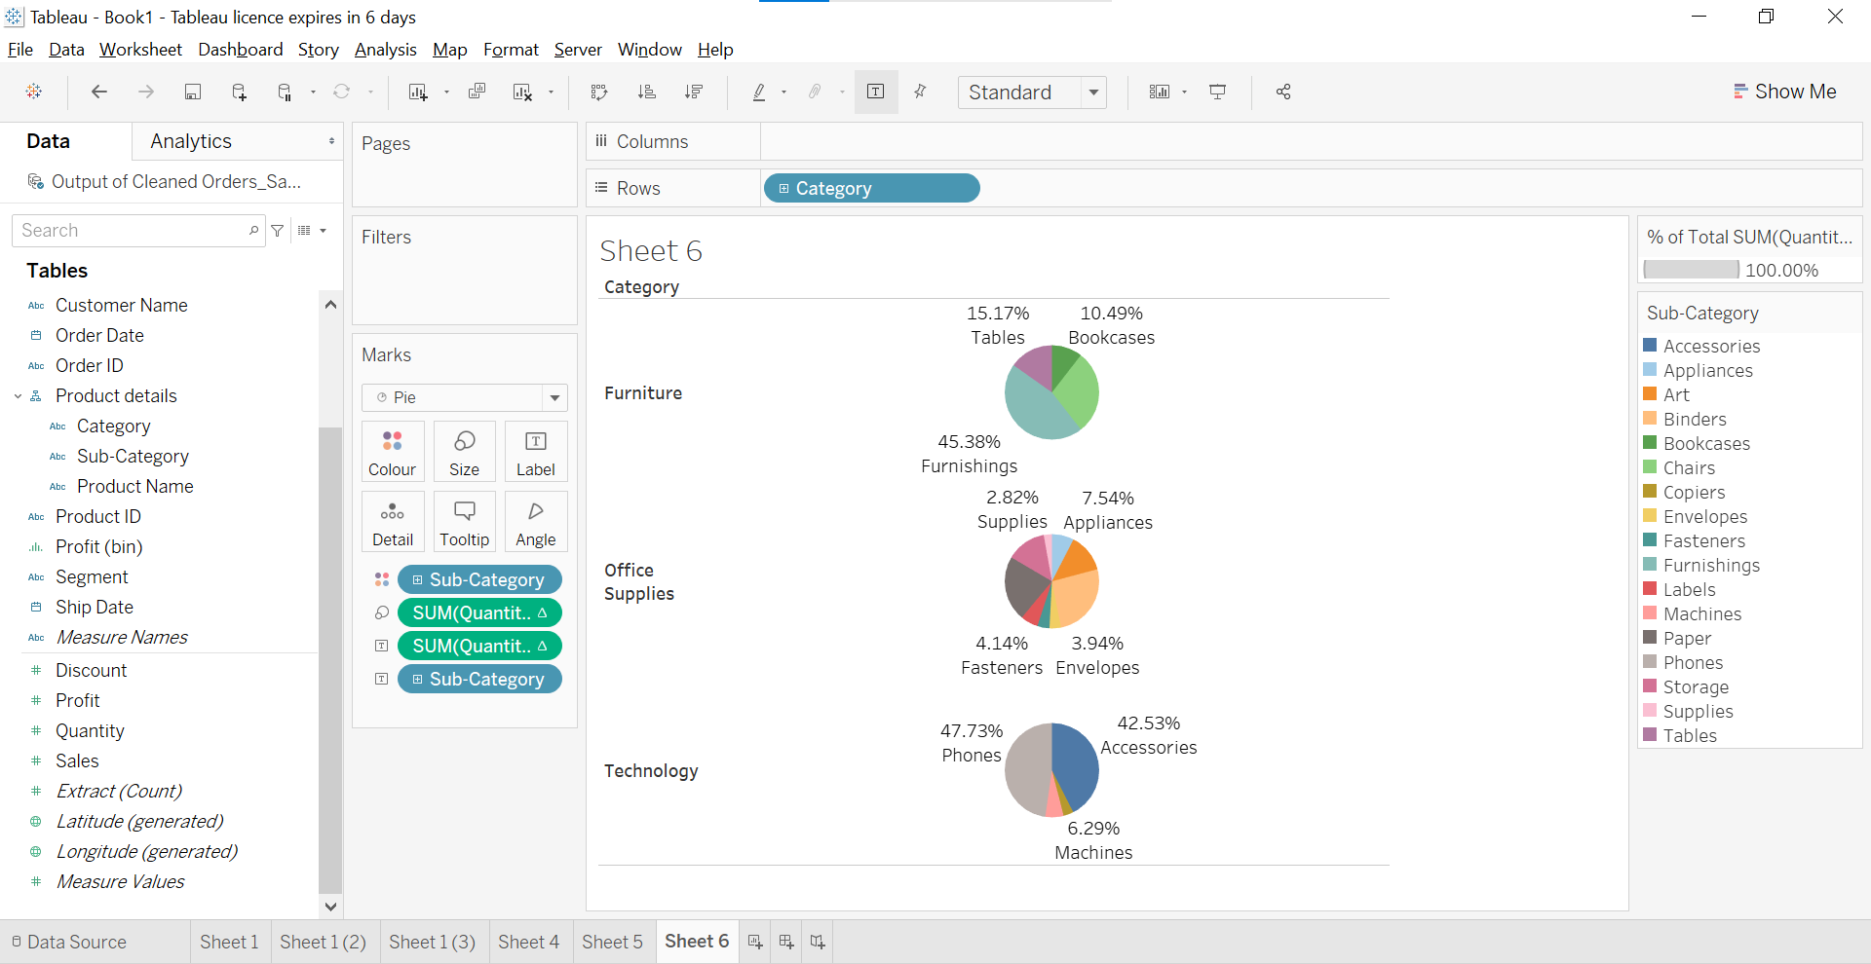
* 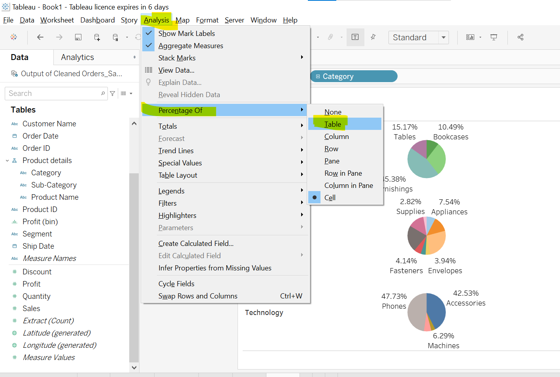
* Ab ye subke total 100% hain.
* 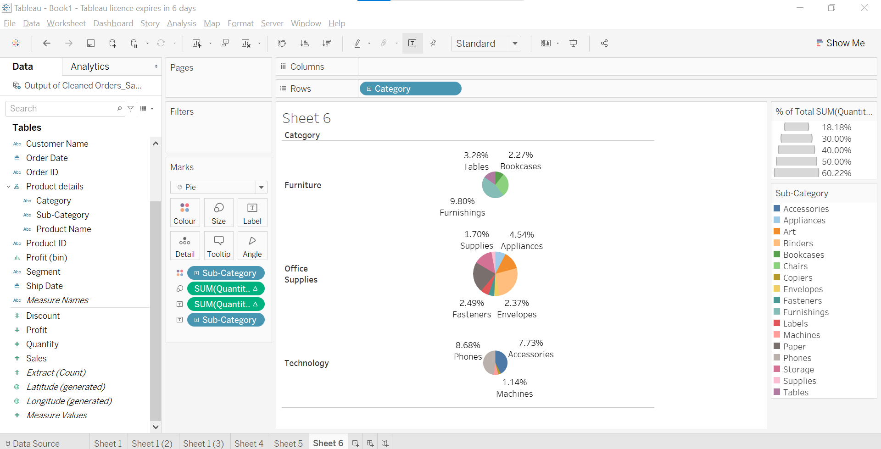

Treemap and Packed Bubbles

* 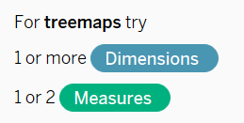
* Use: Ek dimension ke under ke value ko categorize karke dekhne ke liye.
* 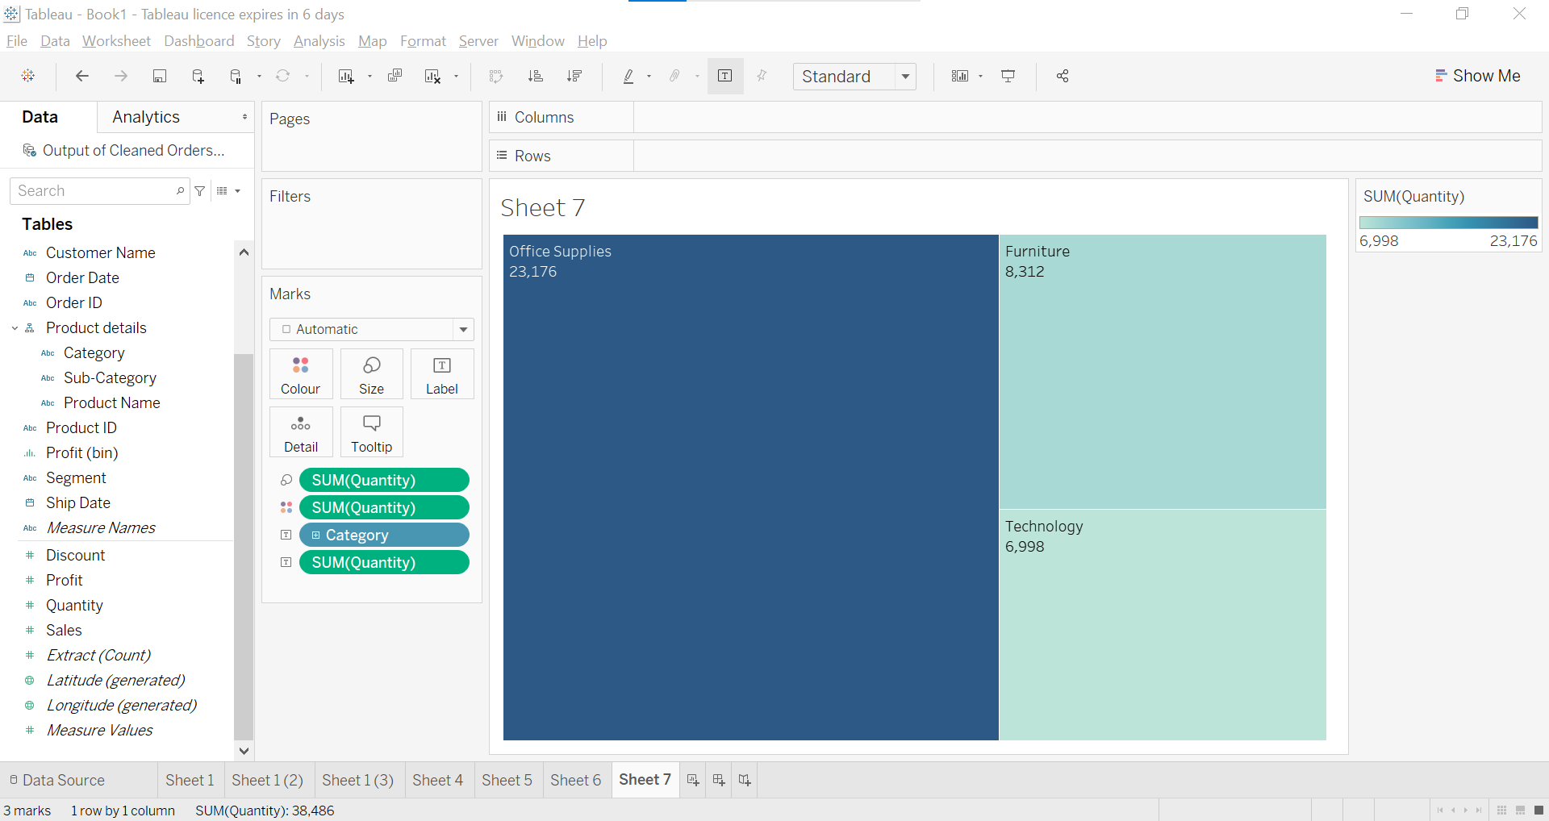
* Category me + ko click karke expand kar do.
* Observe graph carefully.
* Remove sum of quantity and category from cards.
* 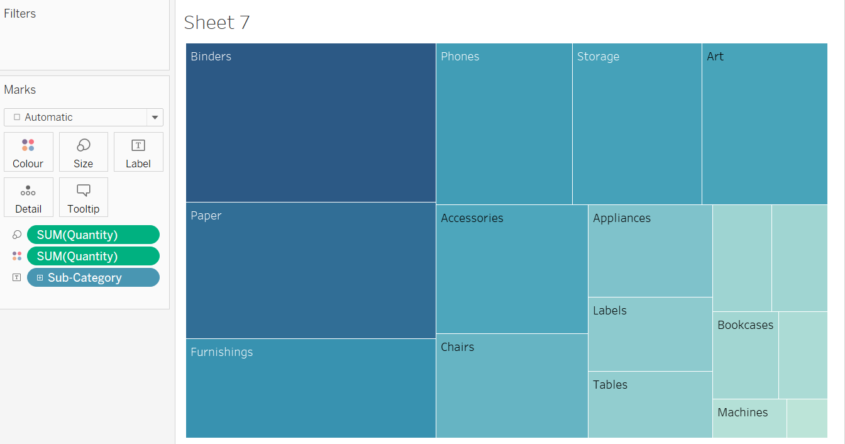
* Add category to color
* Add quantity as a label.
* 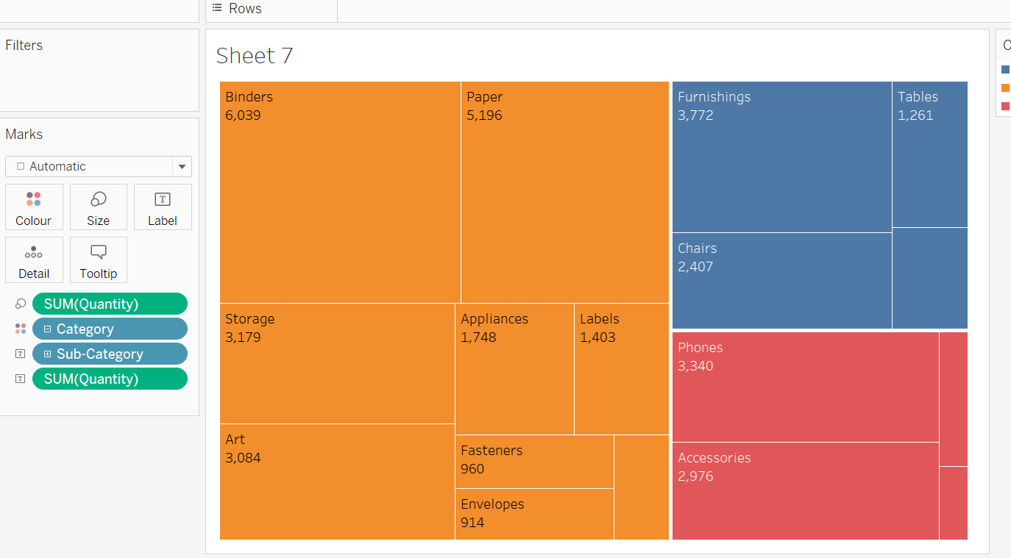
* Now, create a new sheets.
* Add year as columns and sales as rows.
* A line chart will automaticaaly formed but click on tree map to form tree map.
* 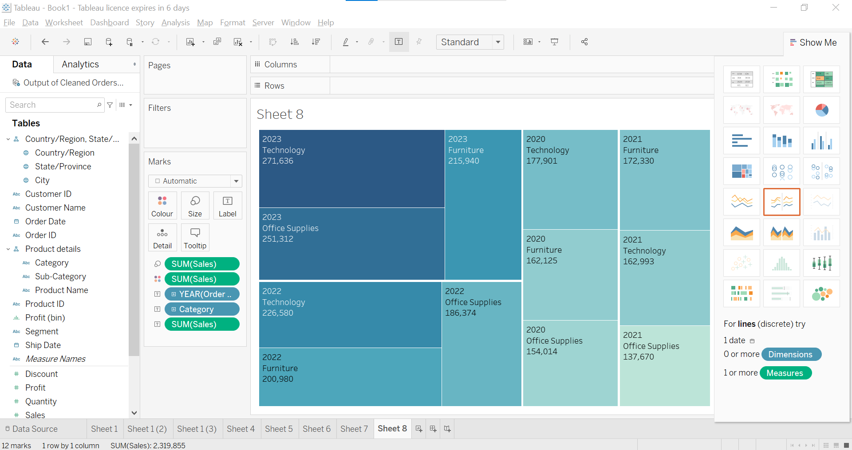
* Now, learn packed bubbles.
* 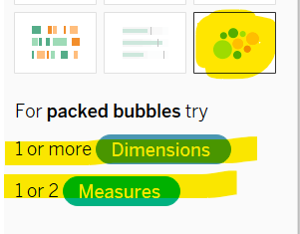
* 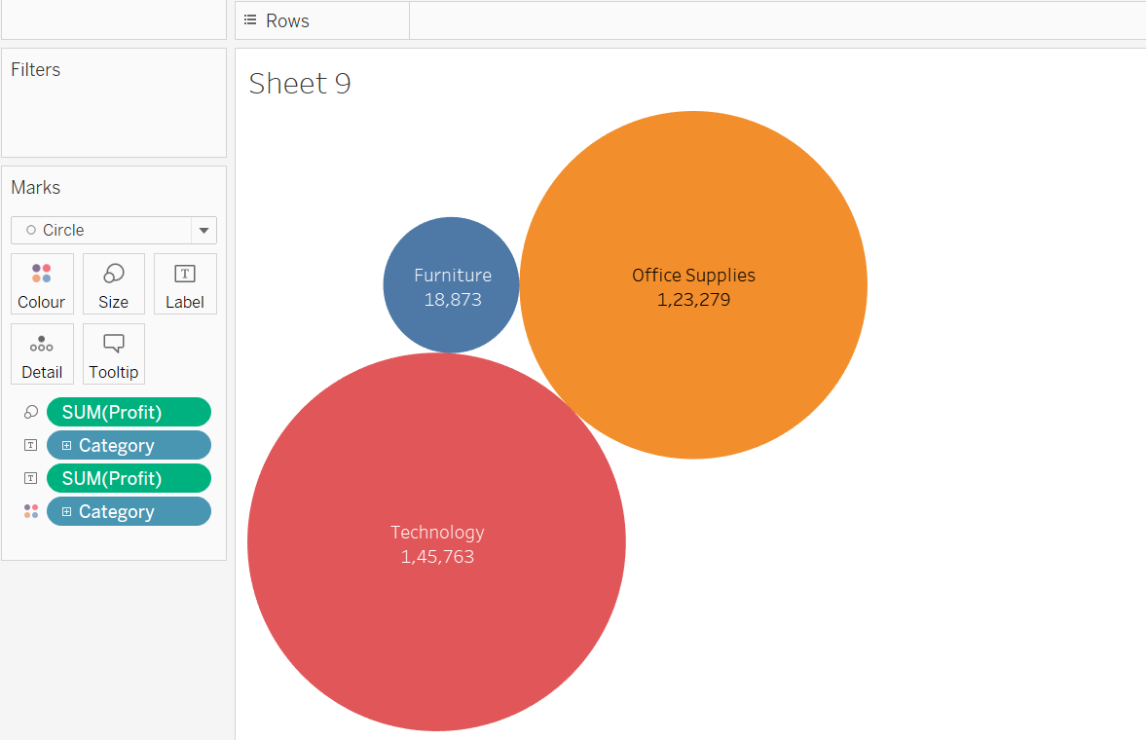
* Expand category 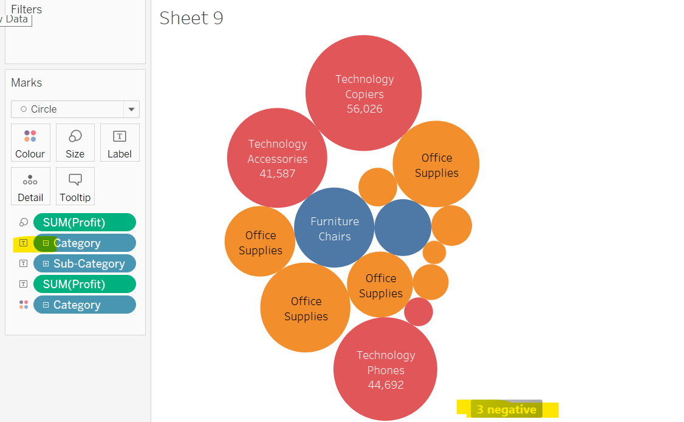
* After expanding due to small space some circle have to labels.
* 3 negative value is shown so we have to fix it.
* We will filter data in this case.
* 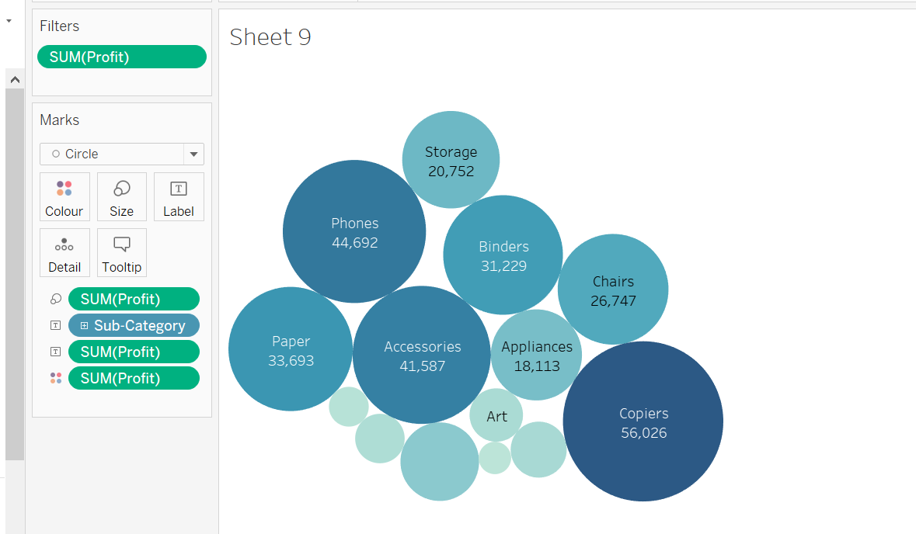
* Ordering ascending and descending is possible here. 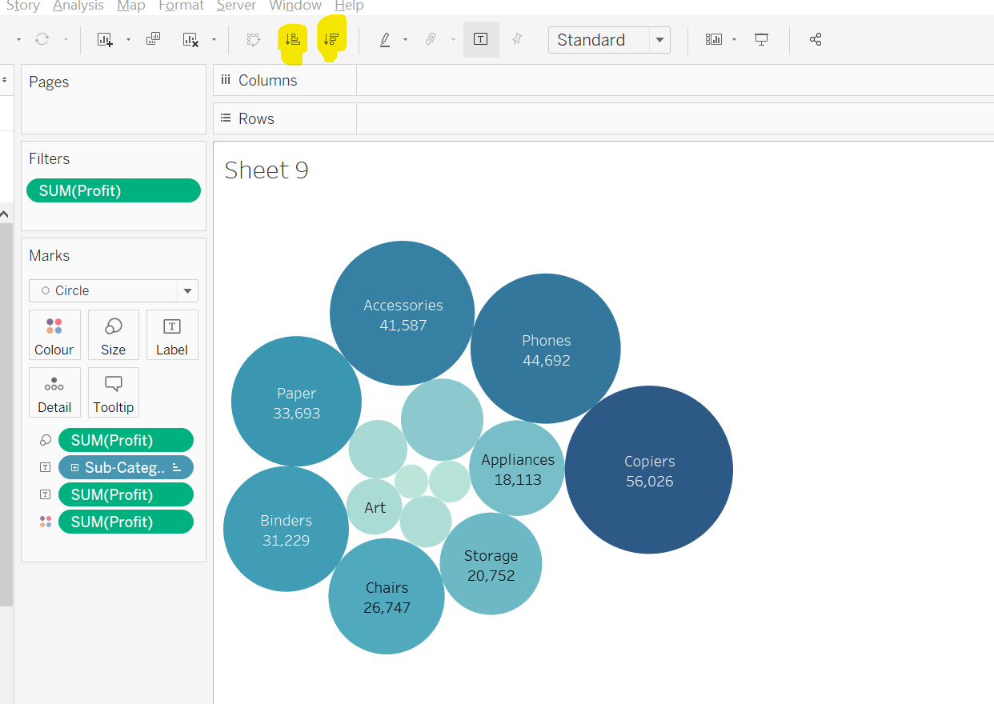
* 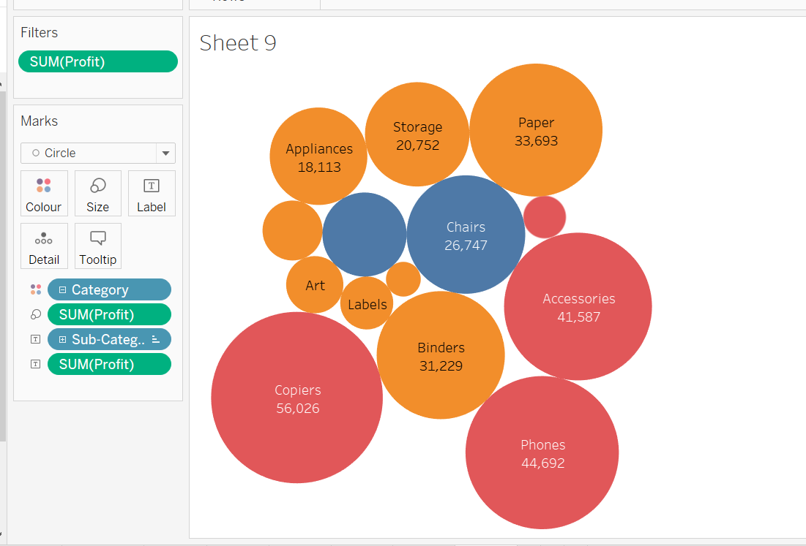

Maps

* Geographical dimension required.
* Maps types:
  + Symbol Map: Use shapes/symbols 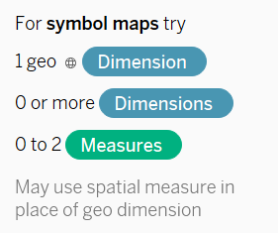
  + Filled Map: Filled or shaded region. Only 0/1 measure. 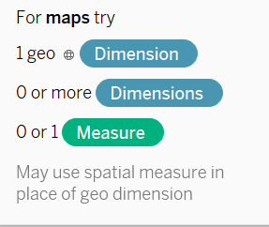
* Mouse scroll in or out for zoom in zoom out
* We cacn take columns to colour and size.
* If we take city to detail then circle will be according to city.
* We can change shape and size of circle.
* We can apply filter to see only certain number of city.
* We can change shape color.
* Use these icon 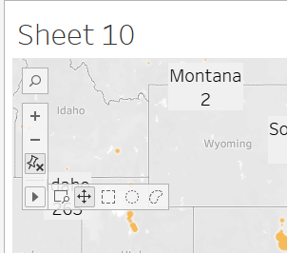
* Use label, detail, tooltip.
* 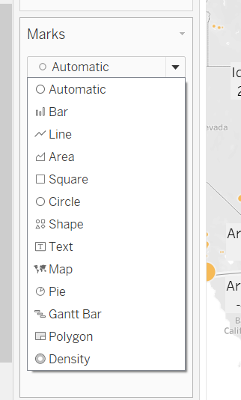

Text Table and Formatting Visuals

* 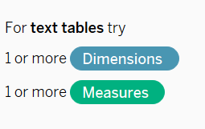
* Drag and drop in this part to add quantity. Profit pehle se hi added hai. 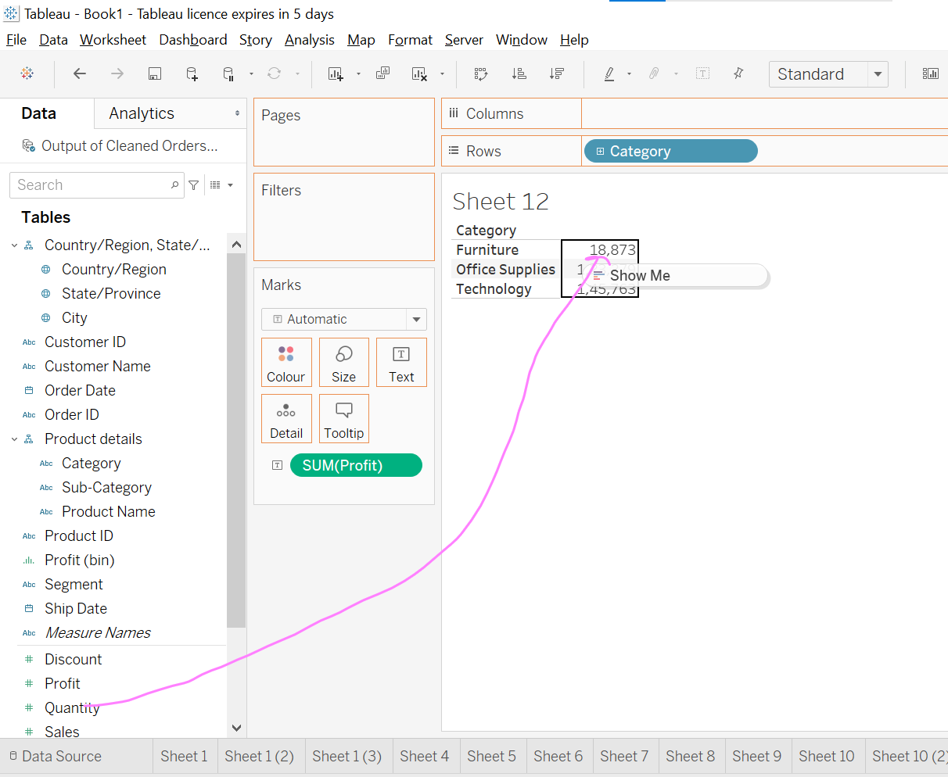
* 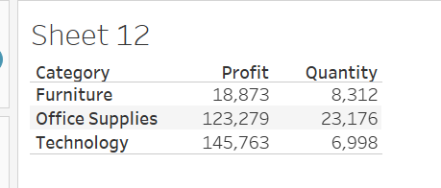
* Add sales col in workflow area
* 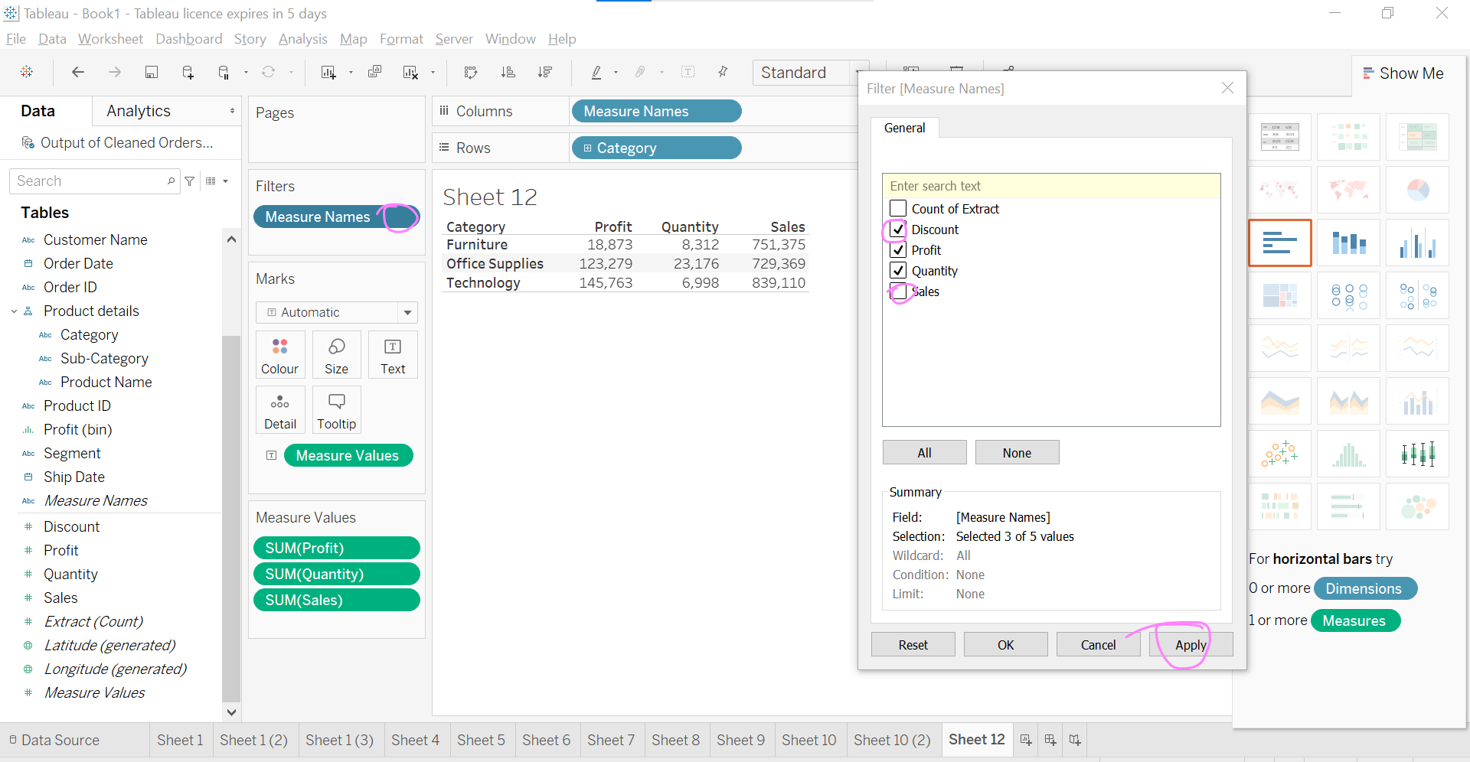
* Edit Filter o/p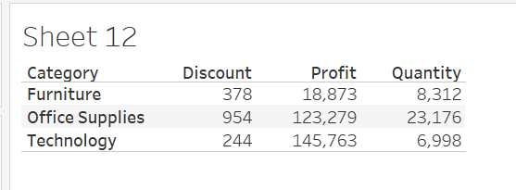
* Ye text table ke form me new sheet ban jaayega. 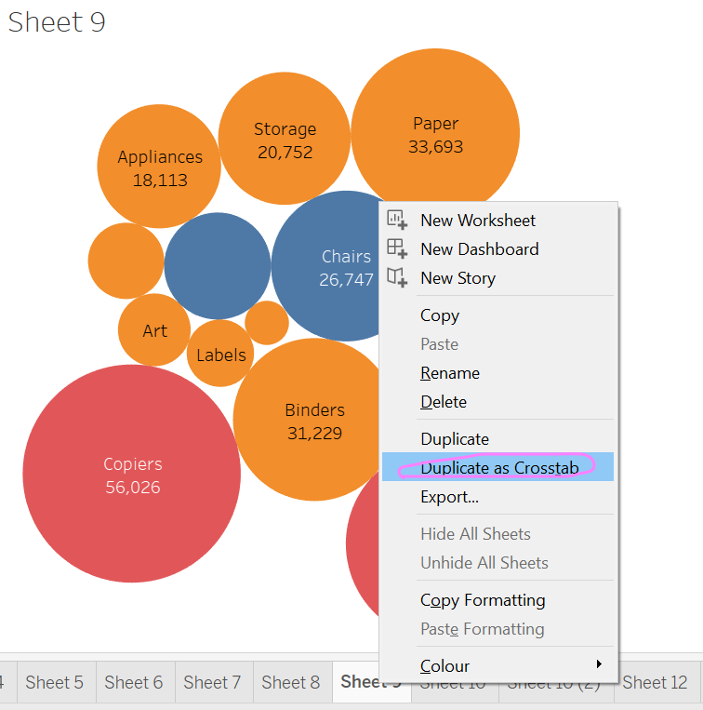
* 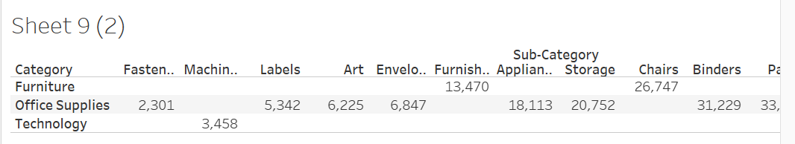
* If we want any other aggregated function. 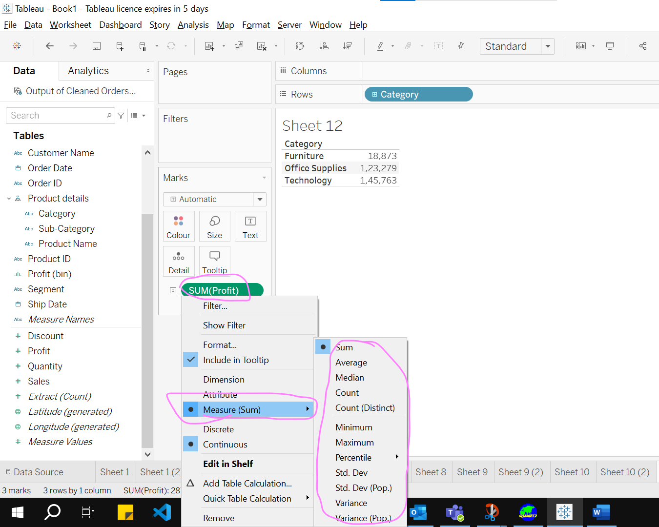
* By default koi numeric as sun aati hai to agar avg laani hai to sum ko avg me change kar de, fir se Profit ki laayes to as a sum aayega.
* We can change order in columns in visual by up and down columns in cards area.
* 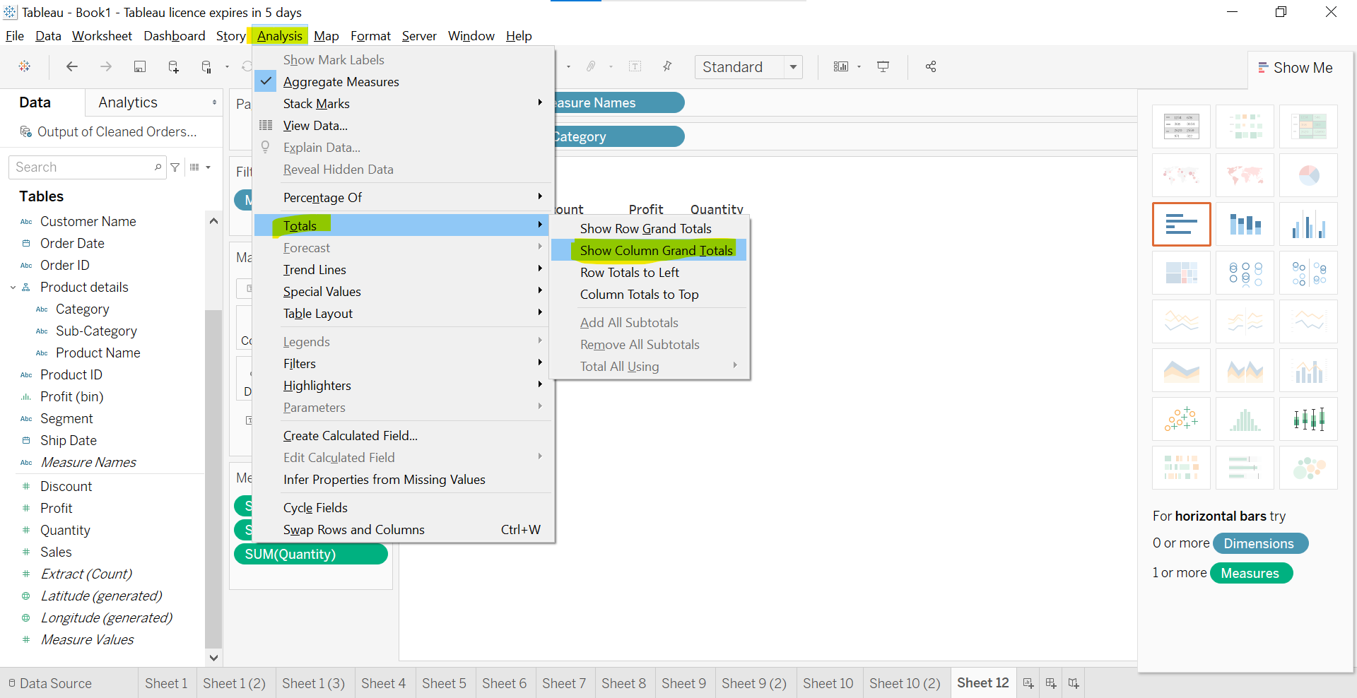
* O/P 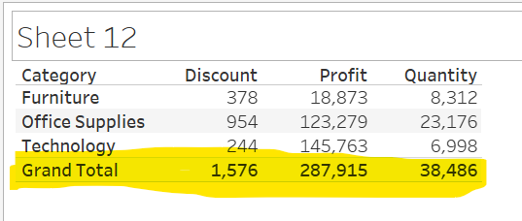
* Click on category + icon to show in details. And order by inc or dec
* 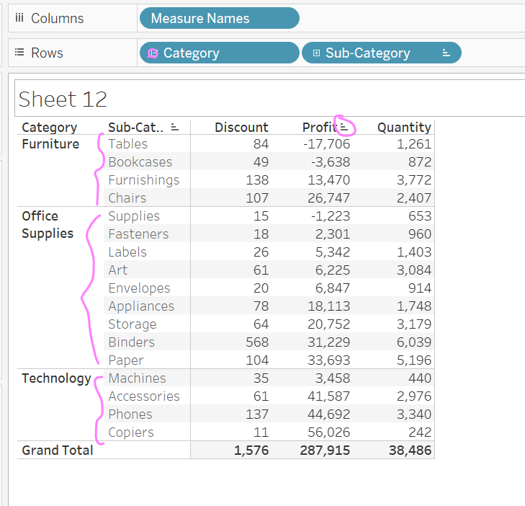
* Explore all these option to make visual beautiful.
* There are many many options available, try to explore make visual best to present.
* 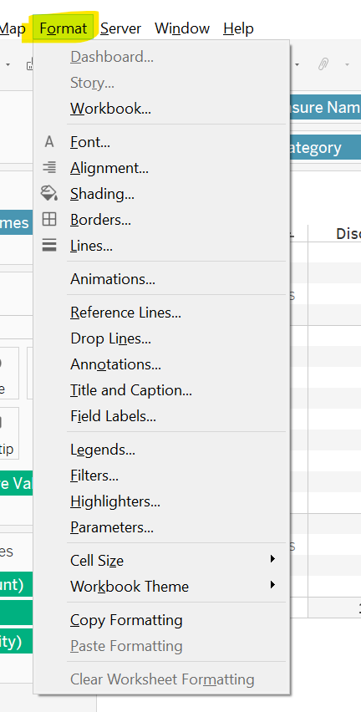

Heatmap And Highlight Table

* 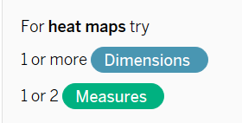 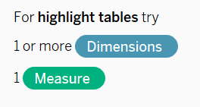
* Heat map: Use to see koi cheez ki kahi bhi kitnhi jyada intensity hai.
* Select quantiy and category and drop to workflow area and select heat map graph.
* 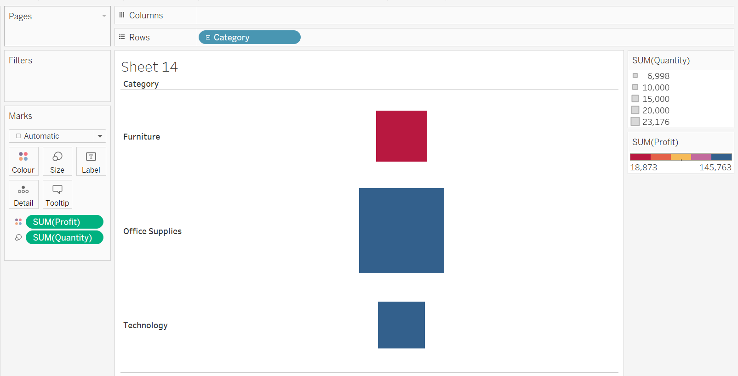
* Take profit to color
* You can change color
* Expand category
* Now see kon si cheez kha pe kitni jyada hai.
* Add quantity as label.
* 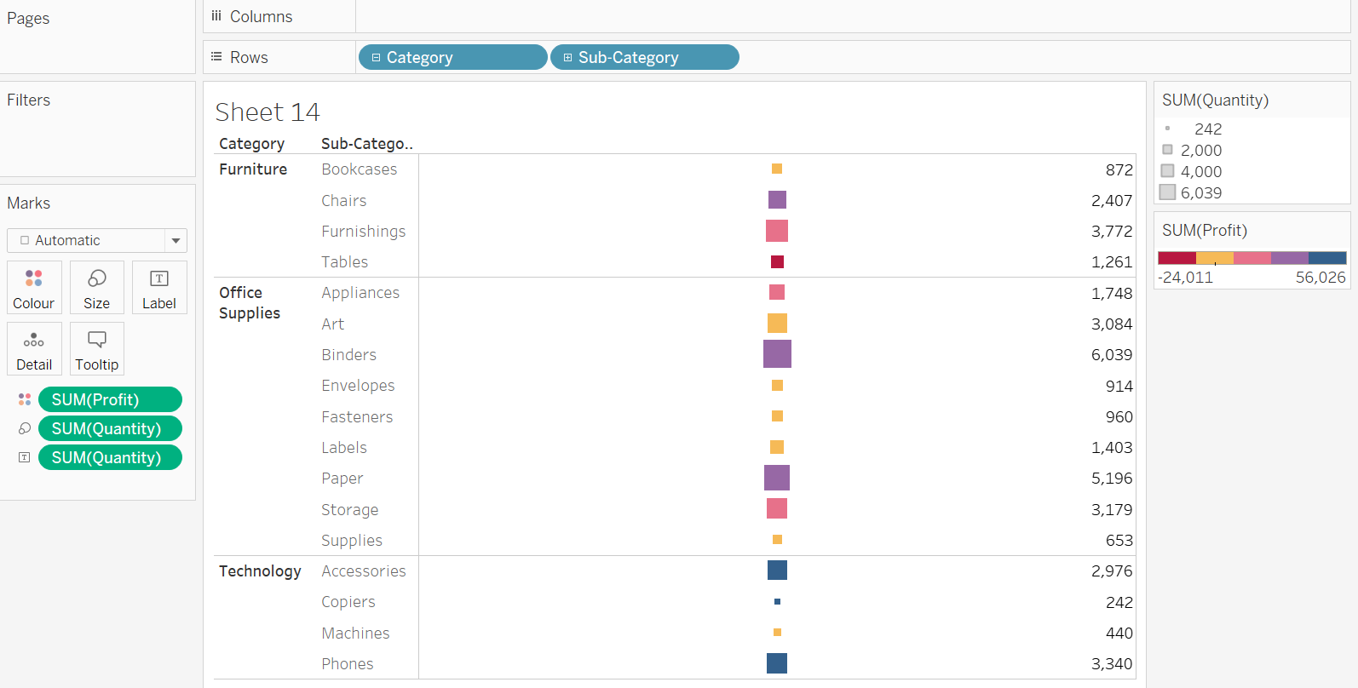
* Change alignment and font of label from here. 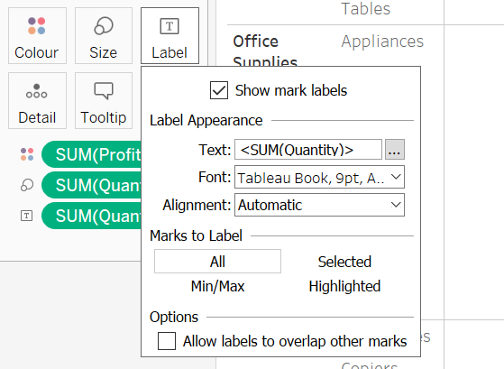
* Density map 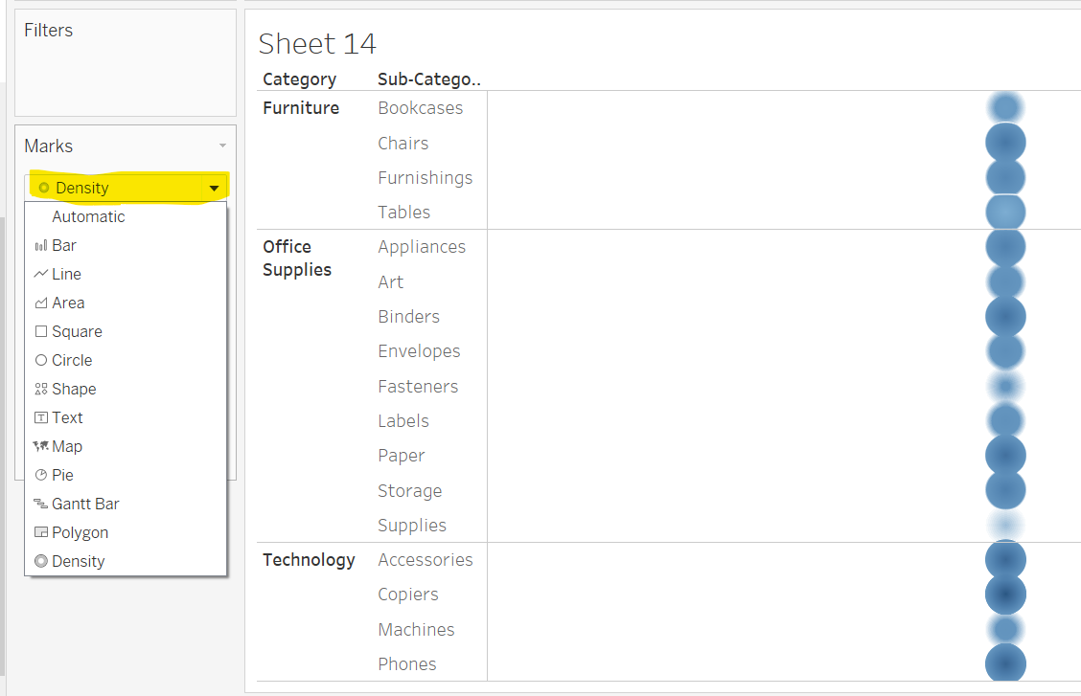
* Density map me label and size nhi lga sakte.
* Density map is best for grography visual like covid cases representation. Jha dark hoga wha jyada cases honga.
* Explore all these options. These would help for better visualizatio. Like jub kisi circle pe click kare tabhi uski profit show kare and many more beautiful functions.
* 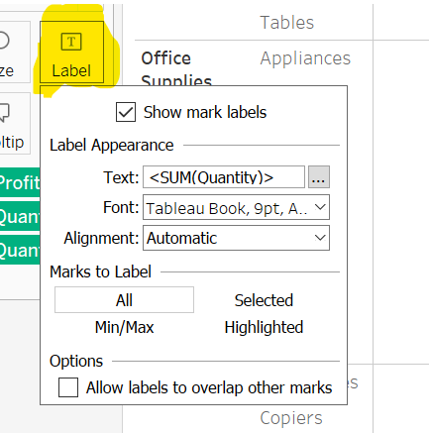

Line And Area Chart

* Line and Area have 2-2 types. Discrete and continuous.
* Helpful to see trends over the period of time.
* Date column will appropriate for better visuals.
* Take order date in workflow as col
* Profit as row
* 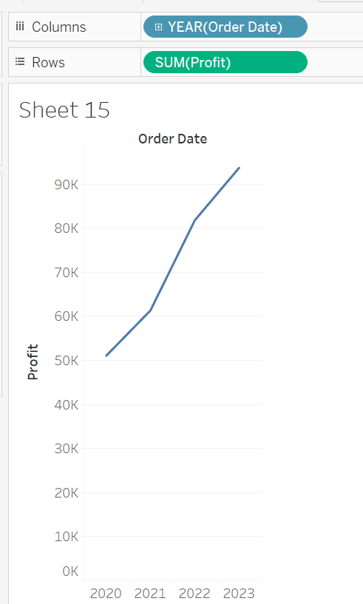
* Date fiels me automatically hierarchy created hoti hai. Year ->Quarter-> Month -> Week -> day
* Click on year + icon to show each year quarterly data.
* 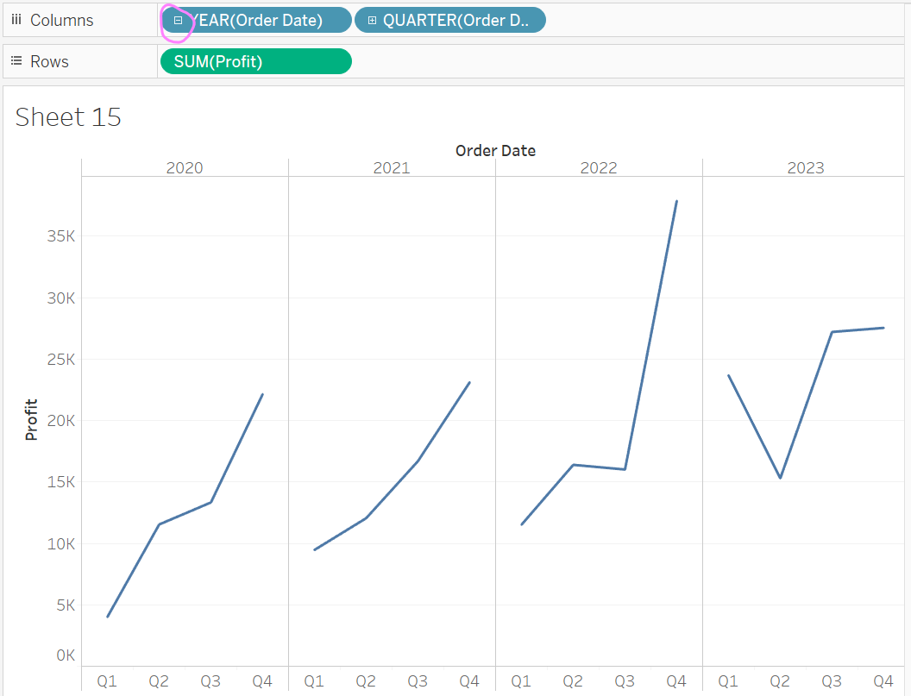
* Similarly, click on + icon of quarter to see month wise data
* 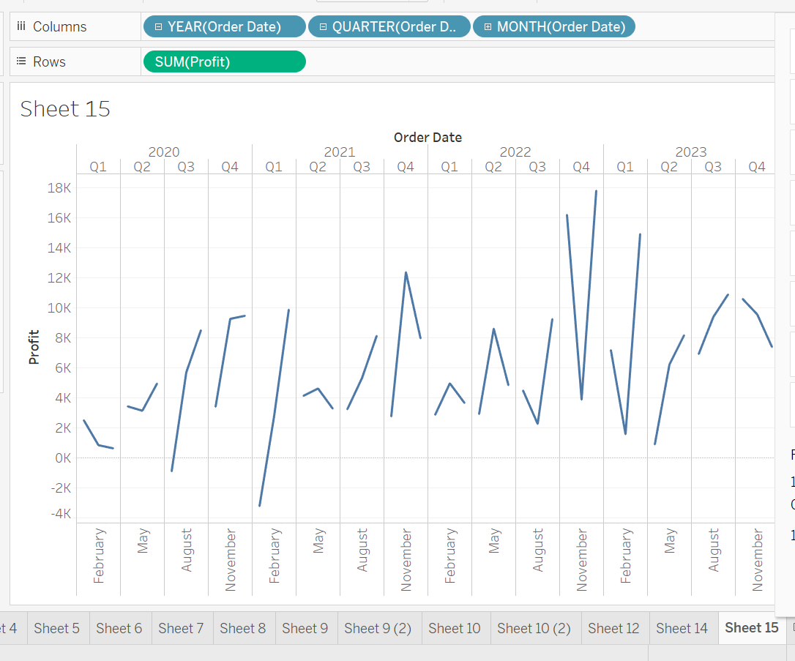
* Discrete col ke case me hi + icon aat hai. Discrte ke case me + pe click karne pe pills badhte hai.
* First 5 r dis and second 5 are cont. 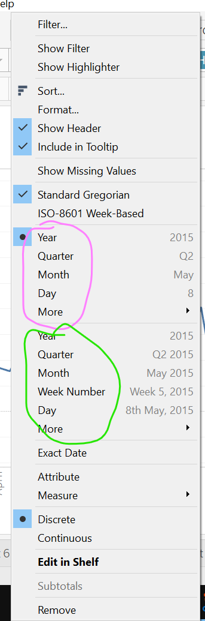 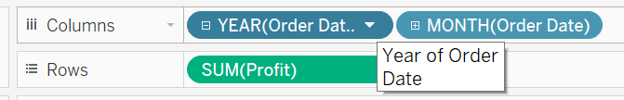
* We can change con or disc from above pane.
* We can also specify which mont, qurter, weekly we have to then pill will not increase.
* Area or line chart ko jyada complex na kare. Jyada branching ya jyada subsections wise plot nak are nhi to graph bahut complex aur chota dikhega. So agar complex dekhna hai to filter lga ke dekh sakte hai.
* Plot discrete area chart 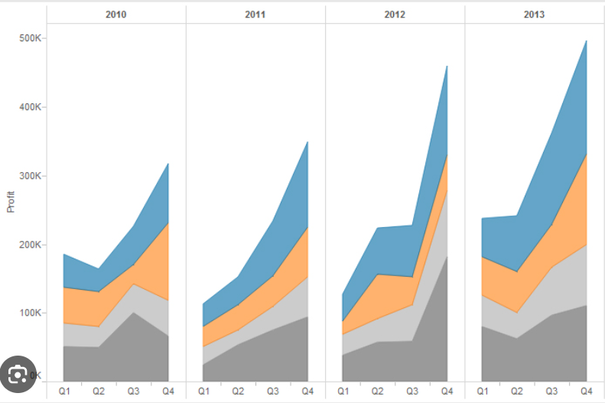
* 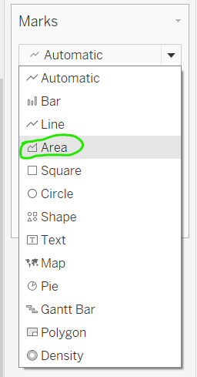 Use Area to plot discrete area chart
* Use these options 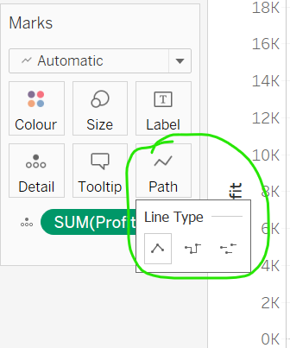
* Explore these option 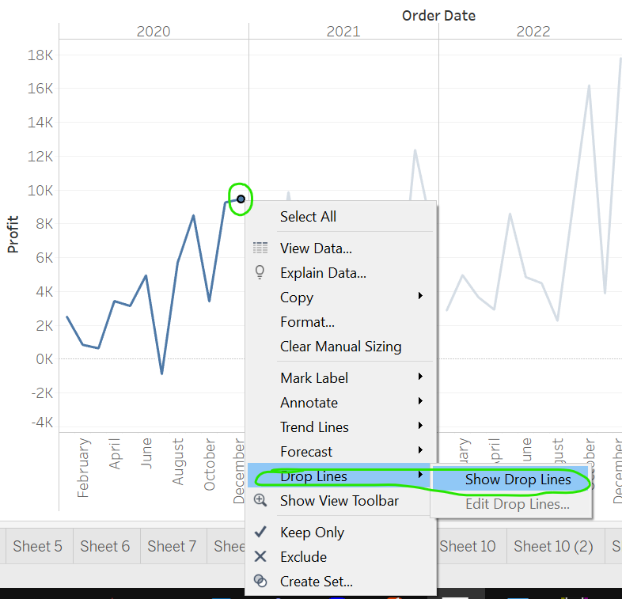
* 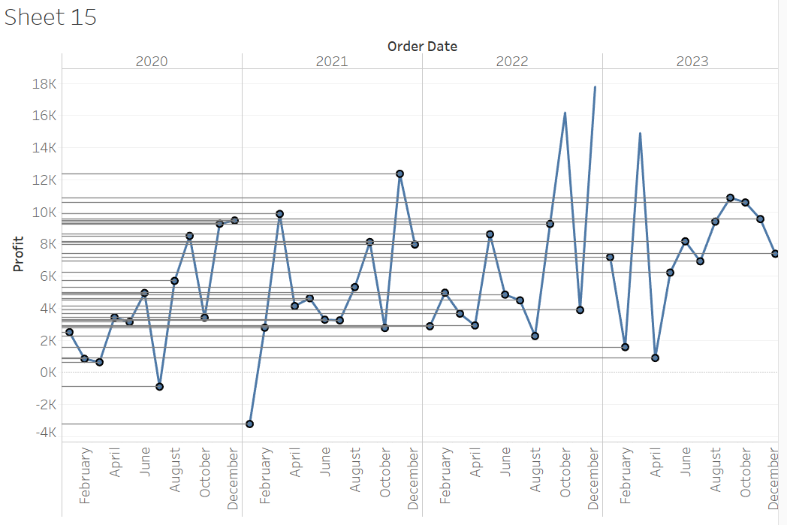
* 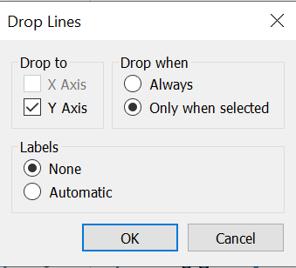
* We can fromat drop lines from format options in ribbon.

Circle, Side By Side Circle View And Shapes

* 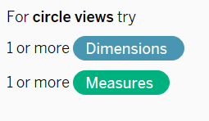 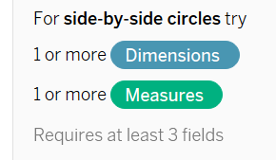
* Is type ke plot me hum apna khud ka plot shapes/images use kar sakte hai.
* Simply download some geometric shpes from google.
* Make a folder in Documents -> My Tableau Repository -> Shapes and paste all images inside a folder.
* Goto shapes -> More Shapes -> Reload Shapes ->All changes we did will reflect.
* Select folder from drop down and then select images which we want to apply.
* Agar pehle se koi color me columns hai to usse hatane pe hamara images wala shapes dikhega.
* Add any col in shapes. Then go and select your images to apply. Like har category ke apne apne icon ho to wha pe shapes images useful hoga.
* These charts is used for comparing.

WordCloud or Wordmap

* Sub-category to label move
* Move SUM(profit) to label
* WordCloud me rows and columns nhi hote hai.
* Move SUM(profit) to size
* 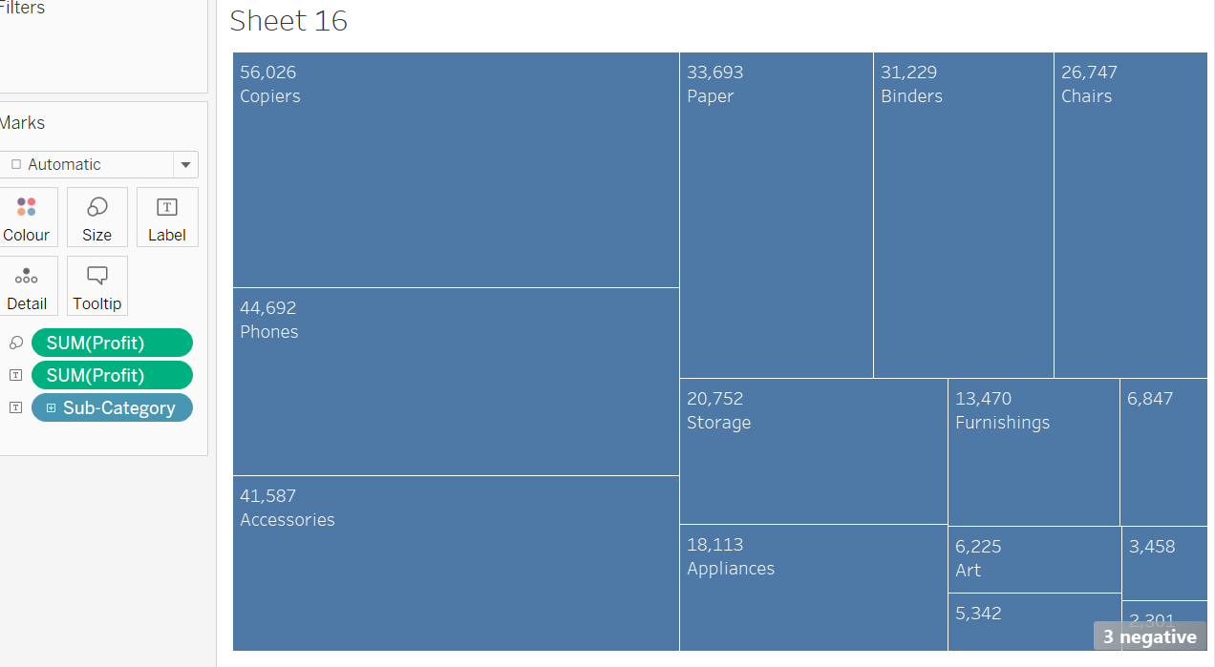
* 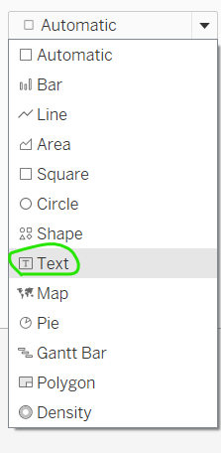
* 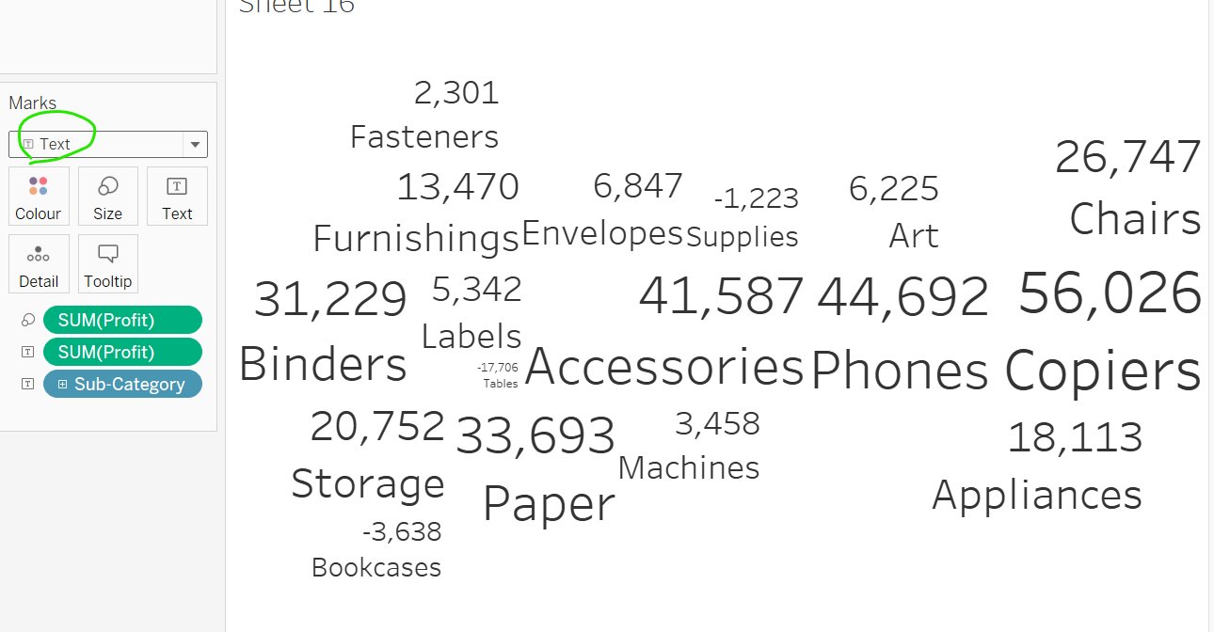
* Make it beautiful.
* Move sub category to color.
* Remove sub category from label.
* Lets say ek survey hua isme koi word jaise good/happy kitne baar hai us tarah ke visuals me ye kaam aata hai.
* Jaise work-culture me employee ko kon si cheez jyada pasand aayi.
* Word is similar to tree map. We can’t sort here.

Scatterplot

* 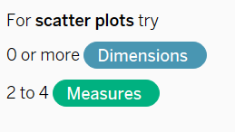
* Usage: Jitne bhi product order ho rhe hai to kya saath saath profit bhi badh rhe hai aisa dekhte hai scatter plot se.
* 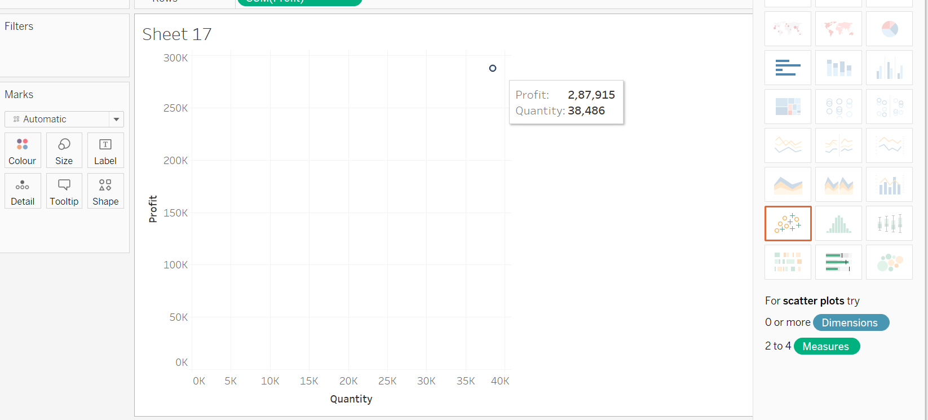
* Add subcategory to label, detail,color.
* 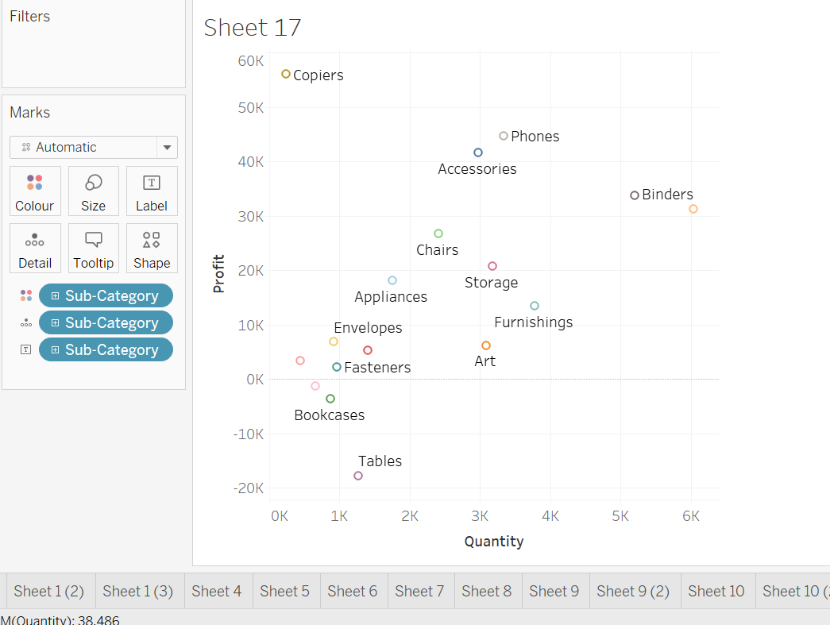
* Move profit to size.
* Add drop lines, colors, and many more to make visual beautiful.
* Change shape, label add, tooltip, change shape.
* Make side by side by adding sub-category in column.
* Used to see relationship between two columns. Like on temperature vs ice-cream selling.

Histogram and Bins

* 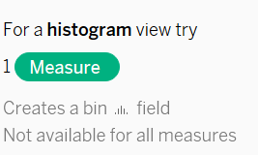
* Mean, median, mode
* Skewed positive, negative. Normal distribution
* Bins=Divide data in equal intervals.
* Bins hamare data ko equal interval me divide kar deta hai.
* Move quantity to col then click on histogram visual to make graph.
* Observe quantity column will renamed to quantity(bin)
* We can change bins size. 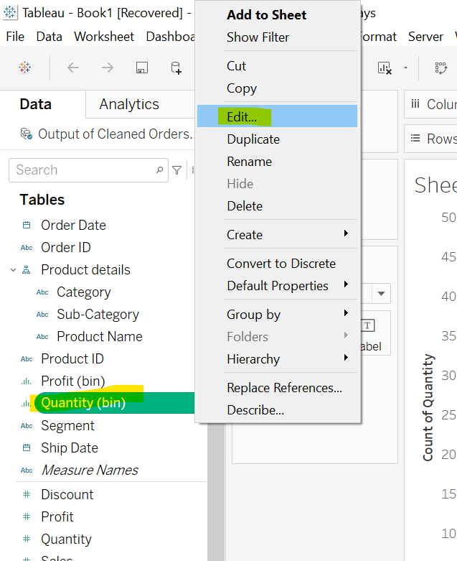 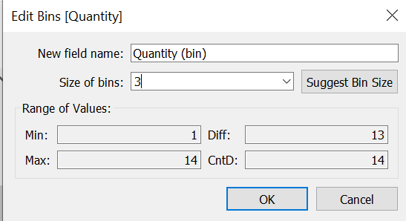
* There is difference between sum and count. In Histogram we plot count. So change to count.
* 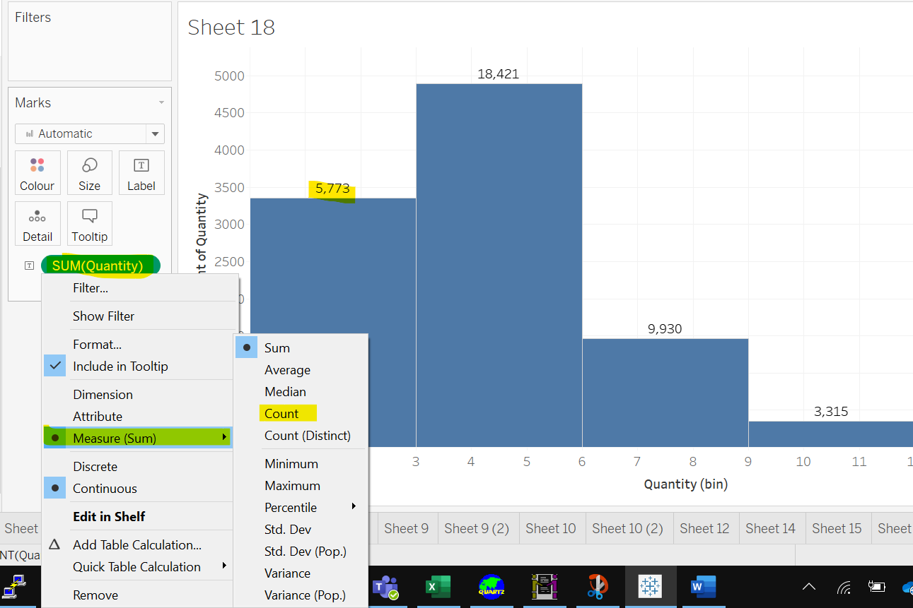
* Here we change bins size. 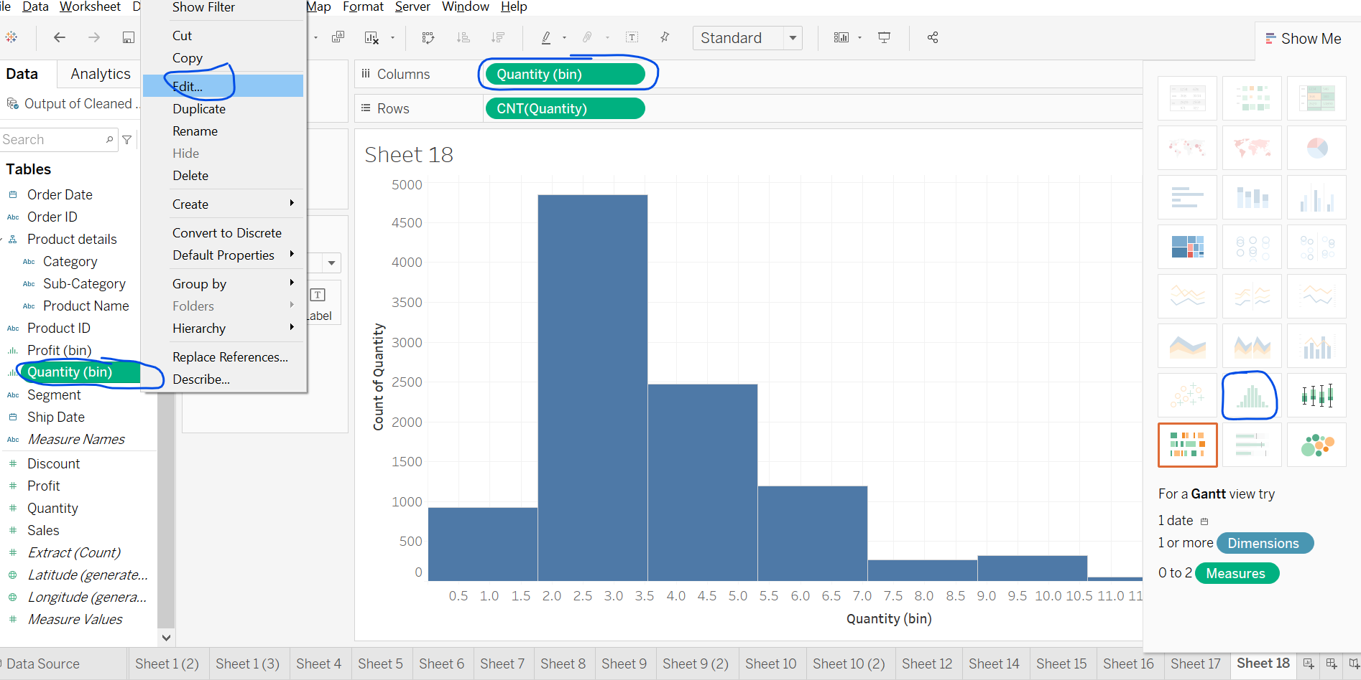
* Hum khud ka bhi bin bana sakte hai.
* Dimension ke bin nhi bante.
* Sirf, measures ke bin bante hain.
* 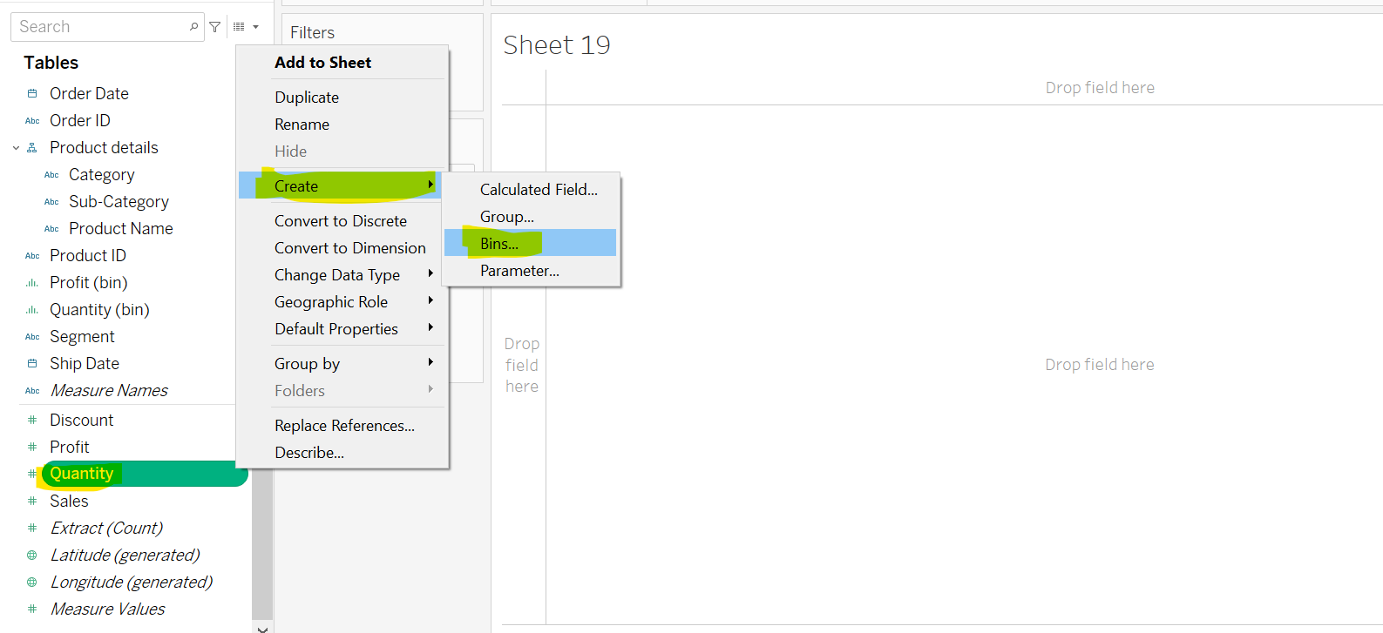
* 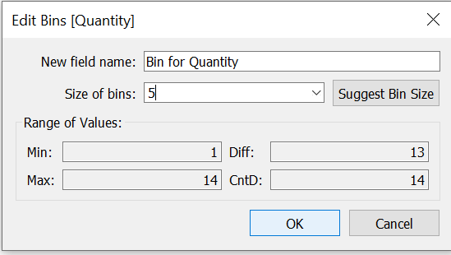
* 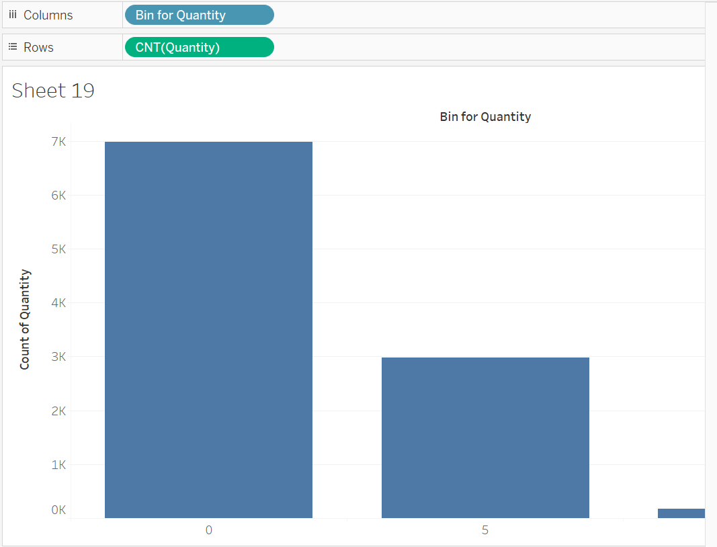
* Bin size is inversely proportions to no of bins
* 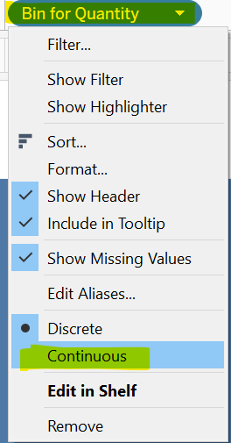
* 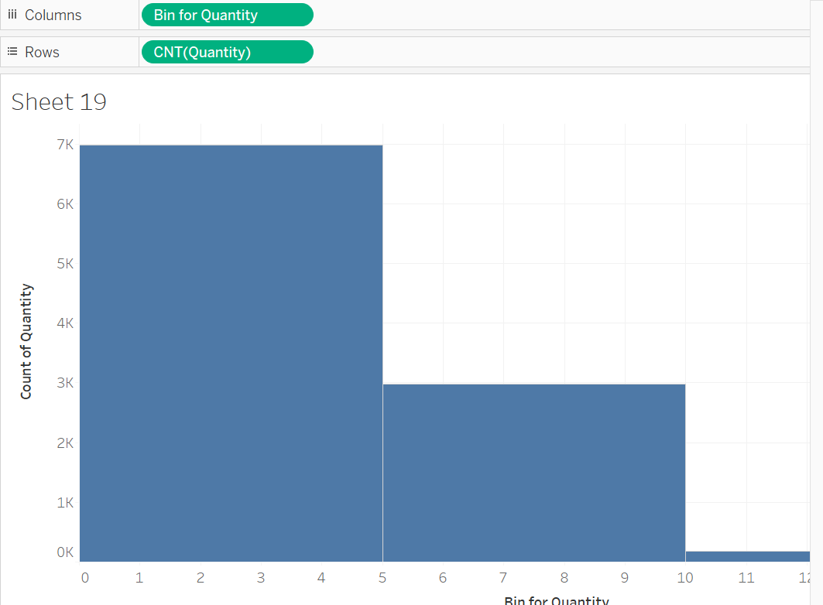
* 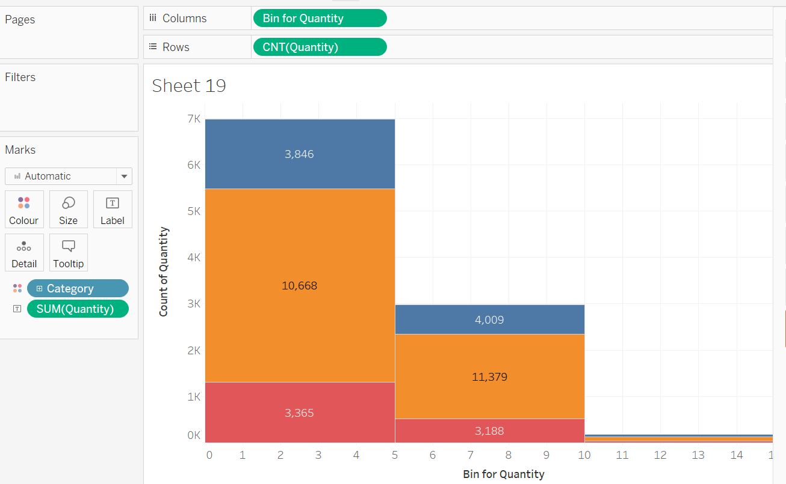

Gantt View And Waterfall Chart

Important chart

* 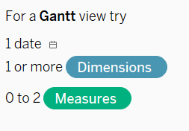
* Kisi bhi cheez ko start se end tak kitna time lag rha hai, uske dekhne ke liye Gantt View use karte hai.
* Use for Project Management like task completion duration, start,end, total time take etc. checked in this graph.

Reference Lines And Bands, Distribution Band & Bullet Graphs

* 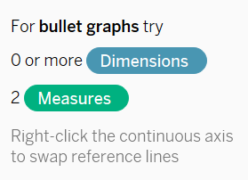
* Select profit and saled and click on bullet graph. Select entire view
* Sub-category to rows
* 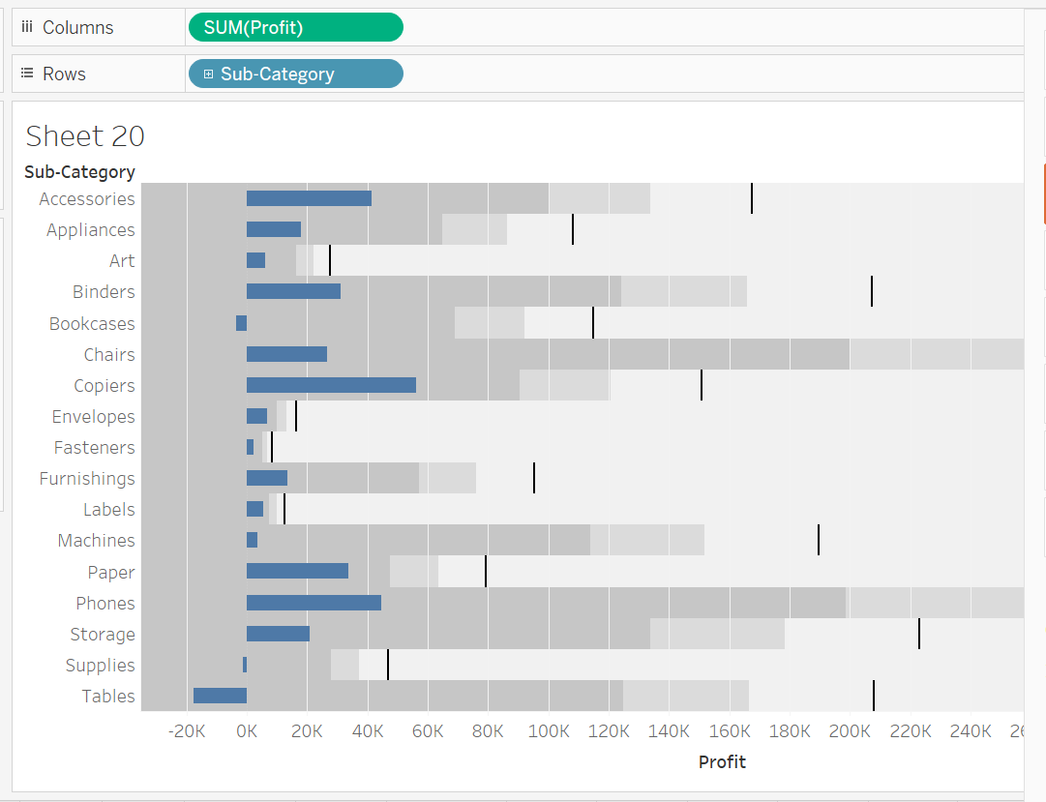
* Bullet graph is used for comparison
* Like jo benchmark humne set kiya kya wha tak pahuch paaye check karne ke liye.
* Like sales comparison ki humne goal ko achieve kiya yan hi ya kitna aage piche reh gye.
* Deadline ko touch kar paaye yan hi
* Profit=SP-CP
* Agar hamre pass SP aur CP hota to profit ko is chart se dekh sakte hai ki kitna profit hua.
* Calculate CP=SP-Profit
* Now, create a calculated field CP
* 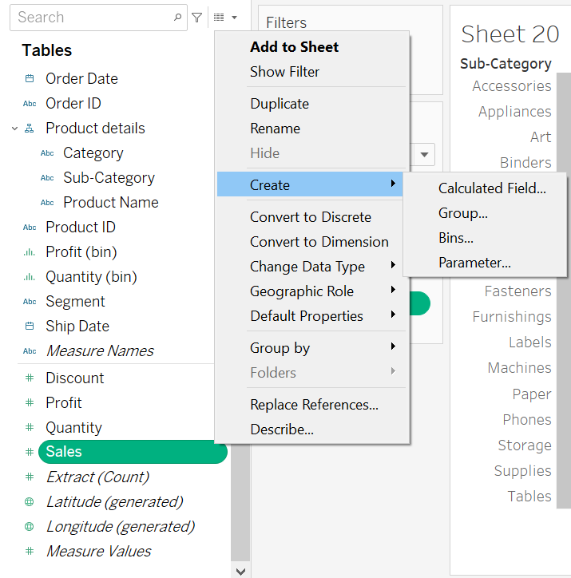
* 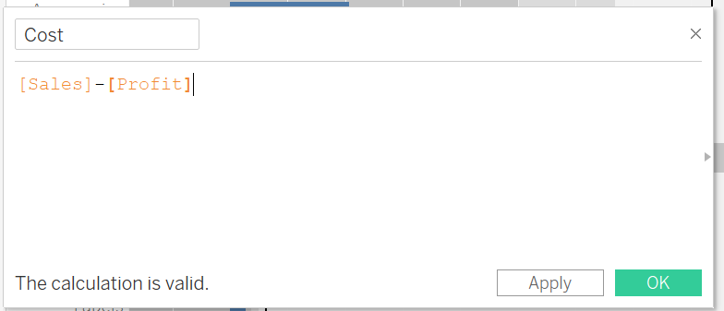
* Draw a new visuals.
* Select Cost and Sales and click on bullet graph
* Entire view.
* Take sub-category to Rows
* 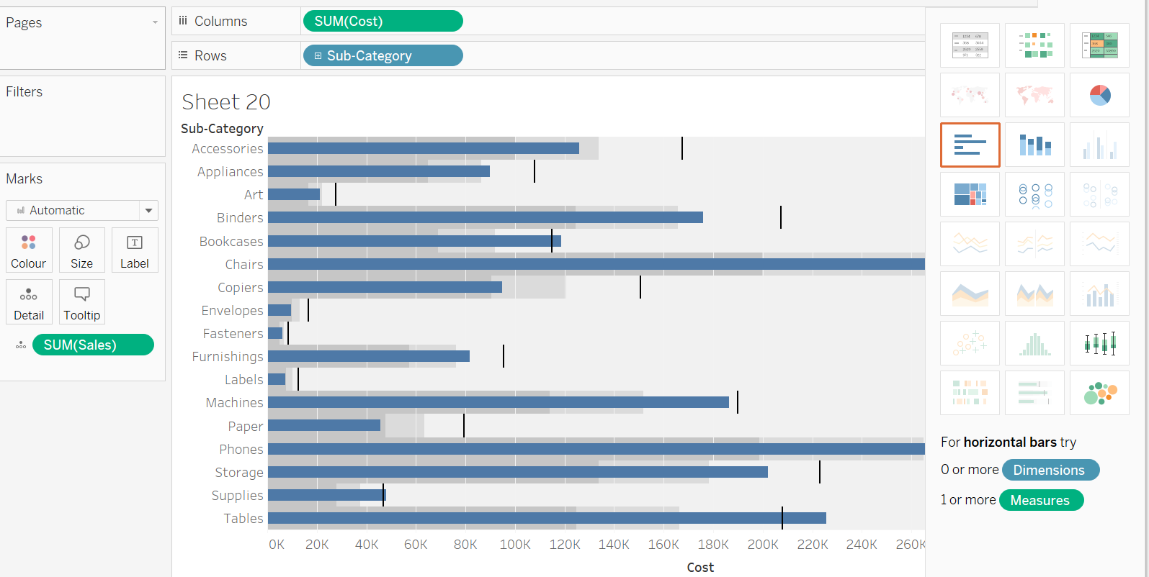
* Now understand this chart.
* Add a new sheet
* Add sub-category to col and Quantity to rows
* Add a reference line in two ways
* 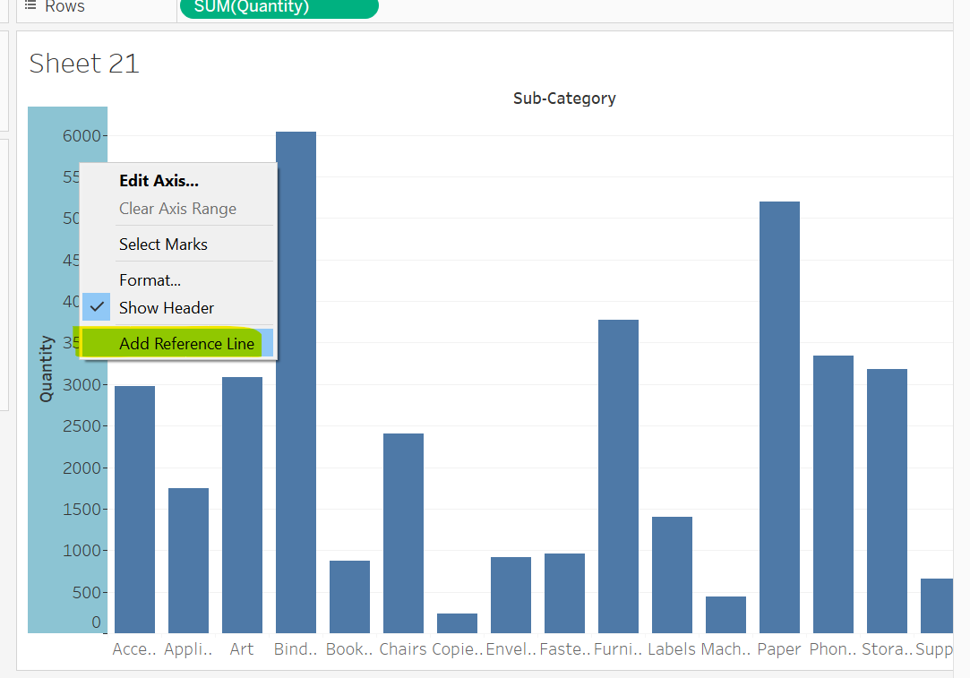
* By default average hoti hai.
* 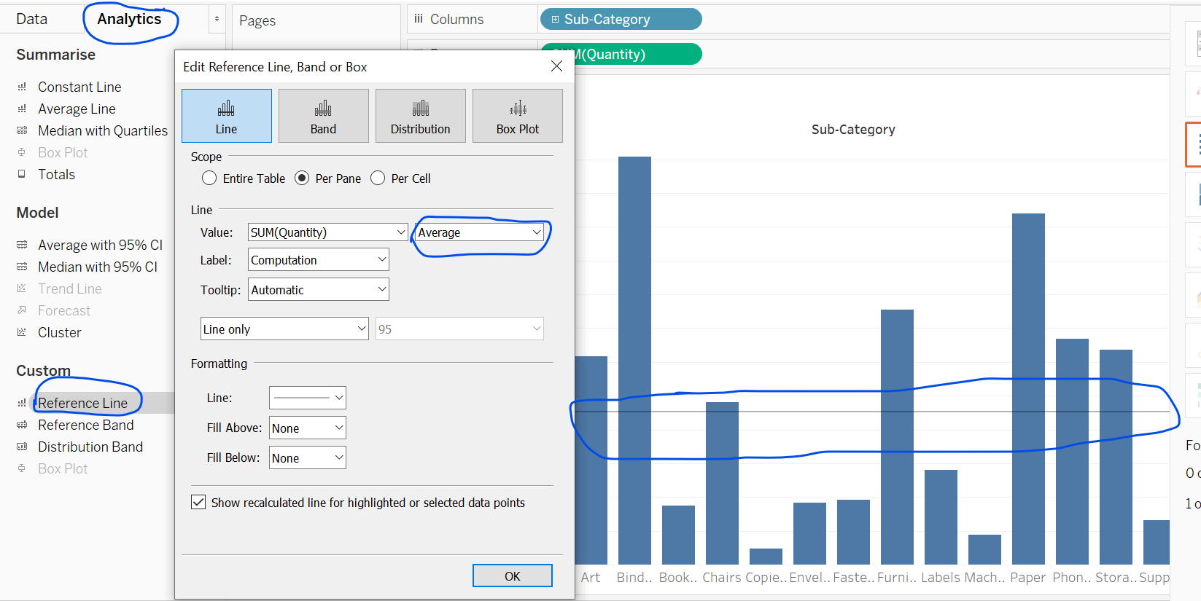
* Pane: Ek hi graph me sub-sections. Add category in columns before sub-category see three subpane will formed and every have their own average.
* Add quantity to labels to see labels.
* Per Pane -> Show aggregate for every pane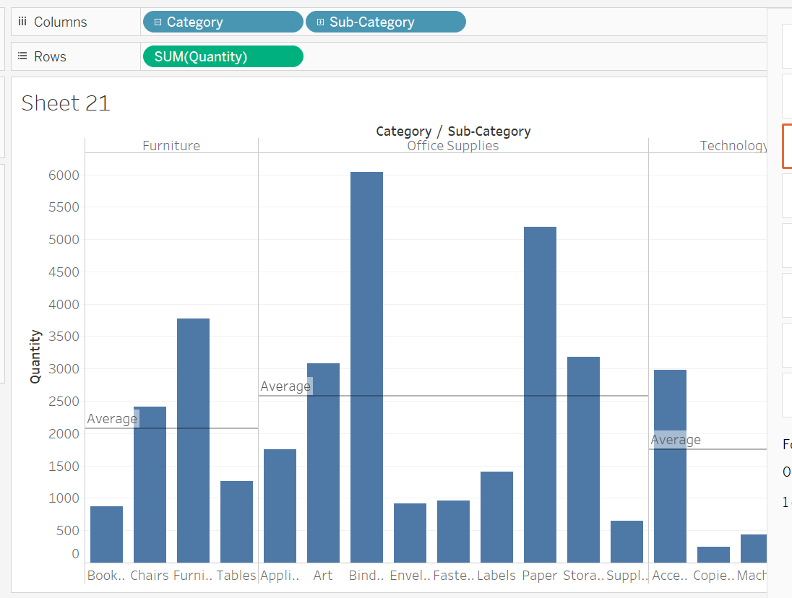
* Entire table -> onse aggregate for whole visuals
* Awsm option try once
* 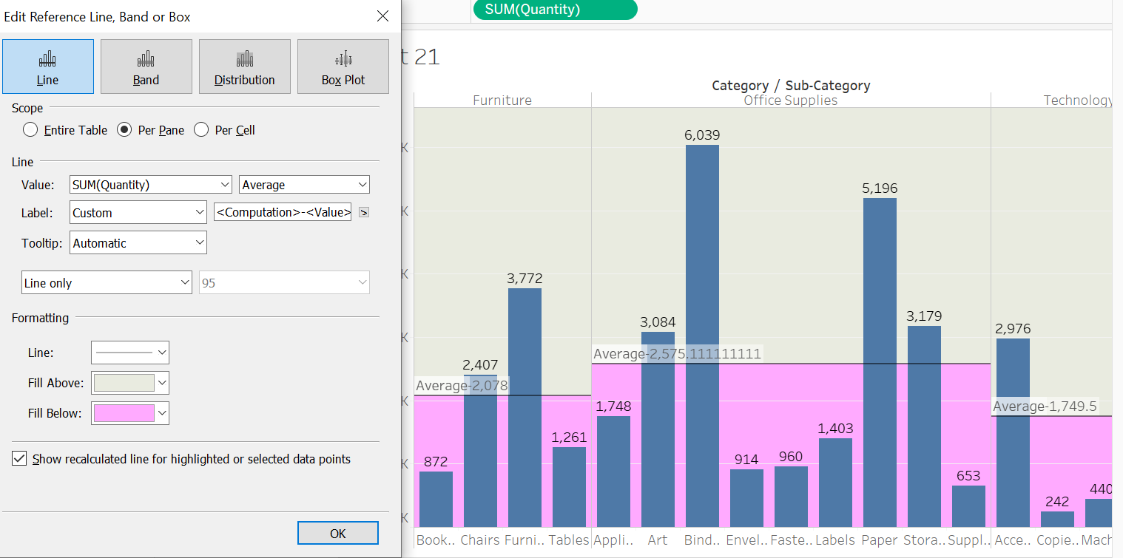
* Right click near y-axis to remove ref lines.
* 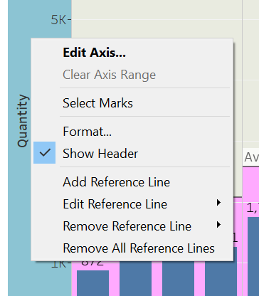
* 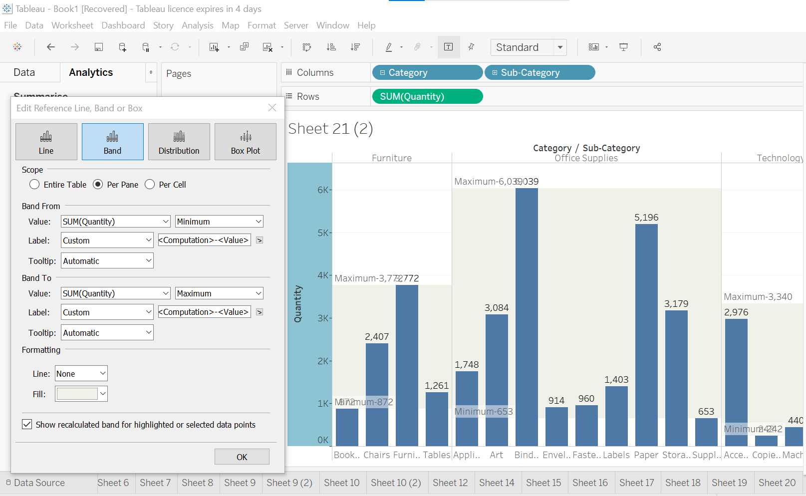
* 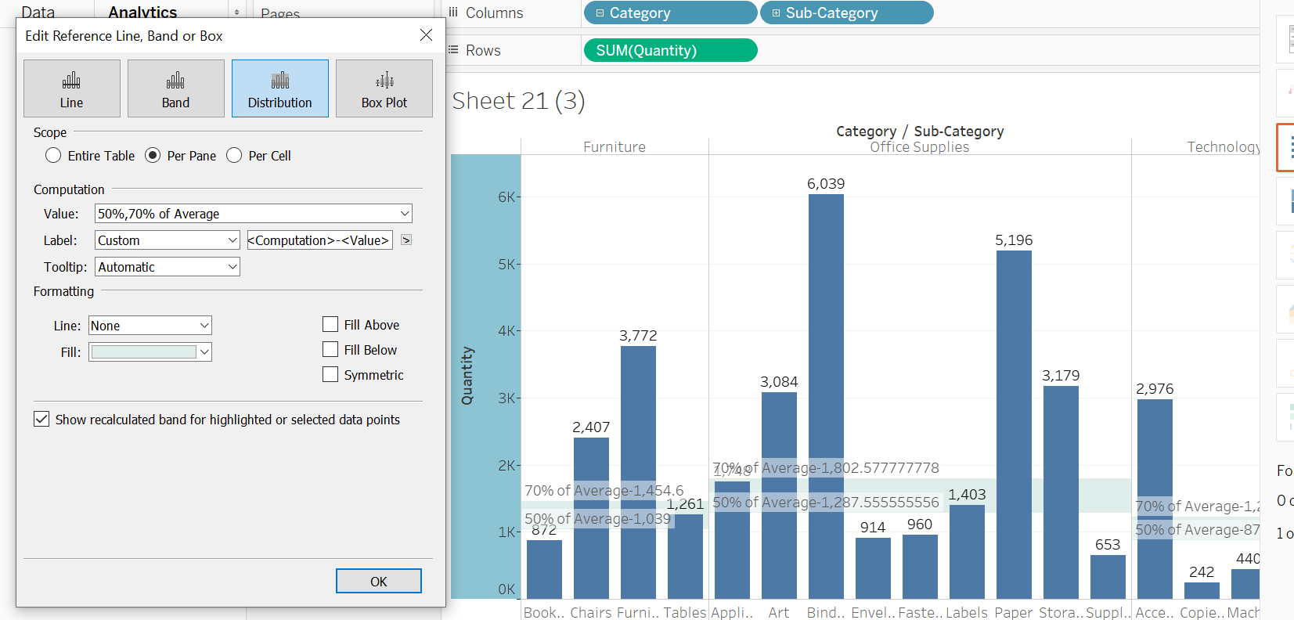
* Isme hum dekhte hai Average ka 50% and 70%.
* Click on this line for more options.
* 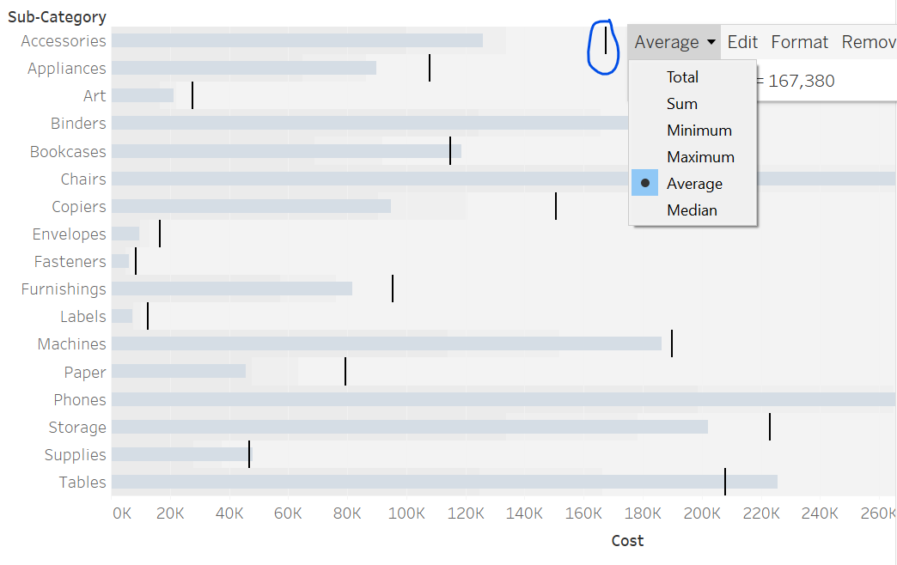
* 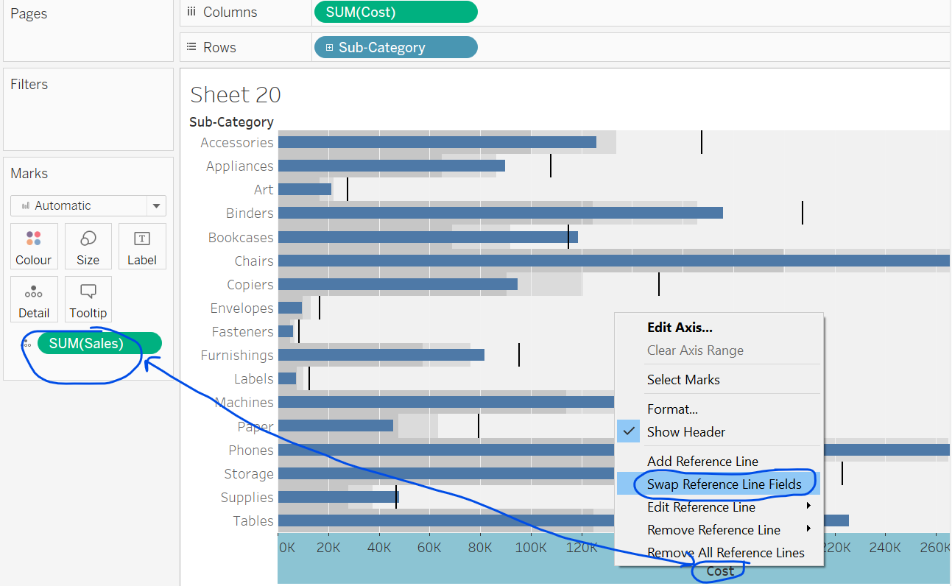
* 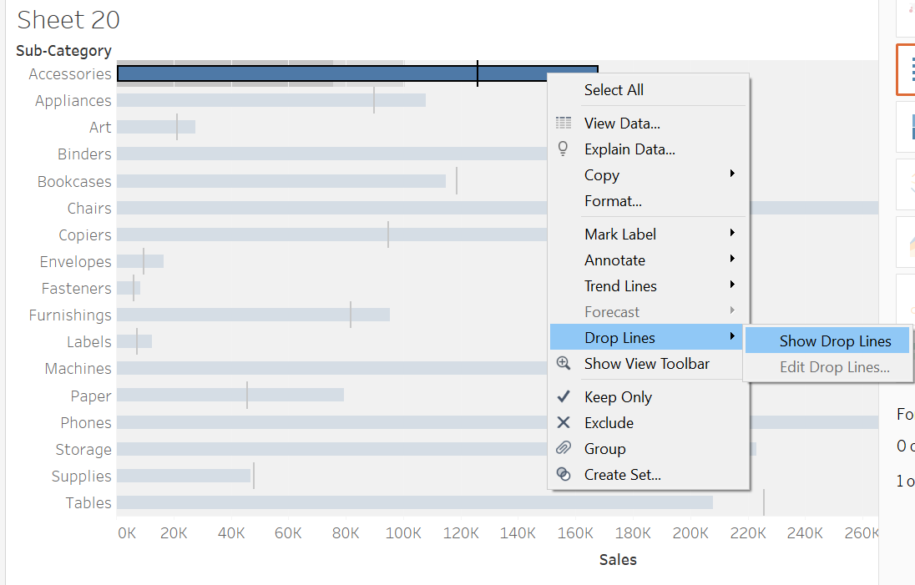
* We can fromat drop line like designing it more beautiful.
* Then edit drop lines.
* 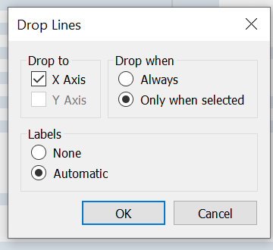
* 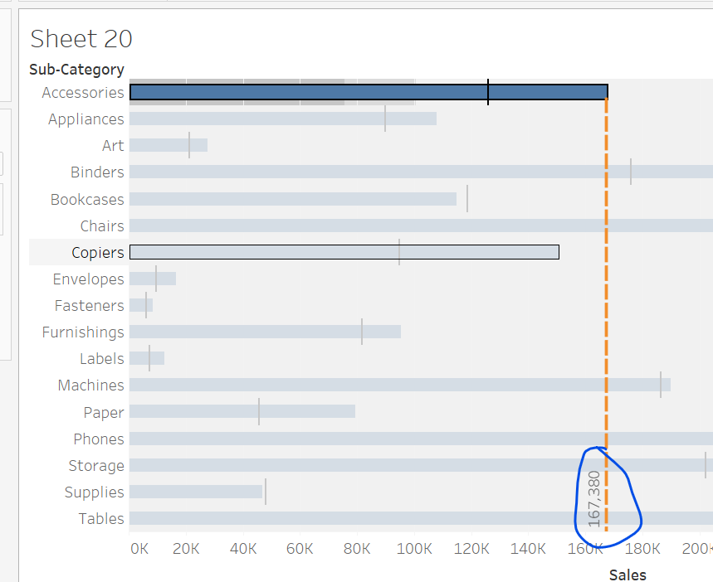
* Jha bhi bar black line ko cross kiya, wha SP>CP so profit hua. Else loss

Dual Axes Visuals- Part-1

* Do axis in x or y axis to represent two dimensions
* Take sales in rows and Sub-category in col
* Take cost to rows
* 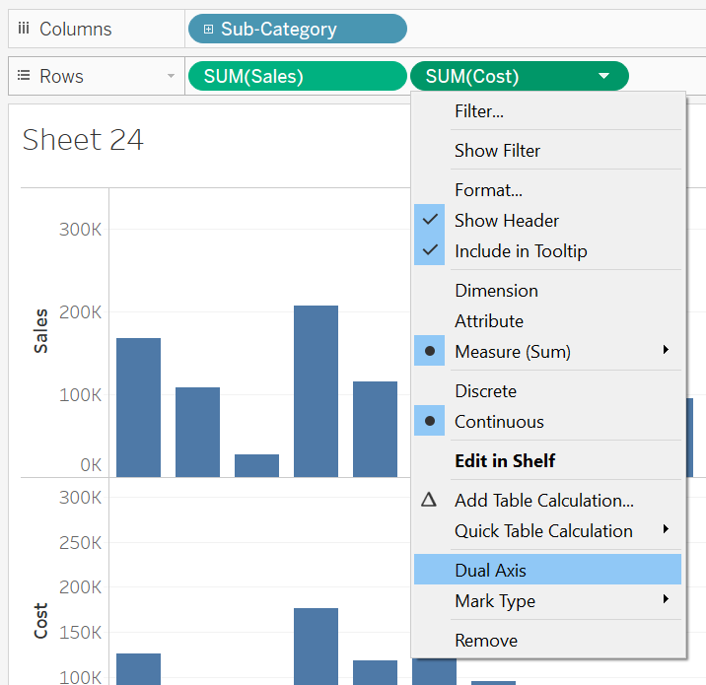
* Or
* Move cost to right corener then dashed lines will show then drop there cost columns.
* 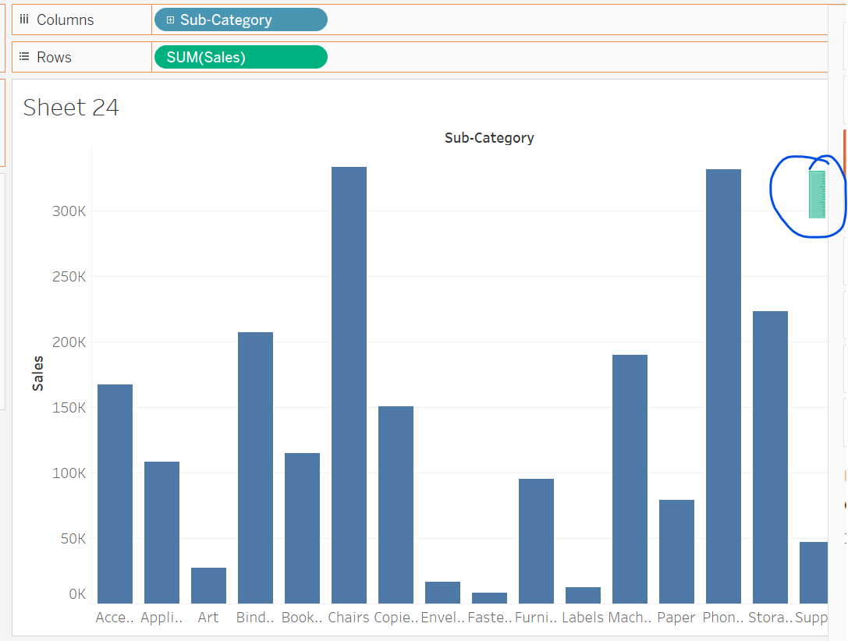
* O/P 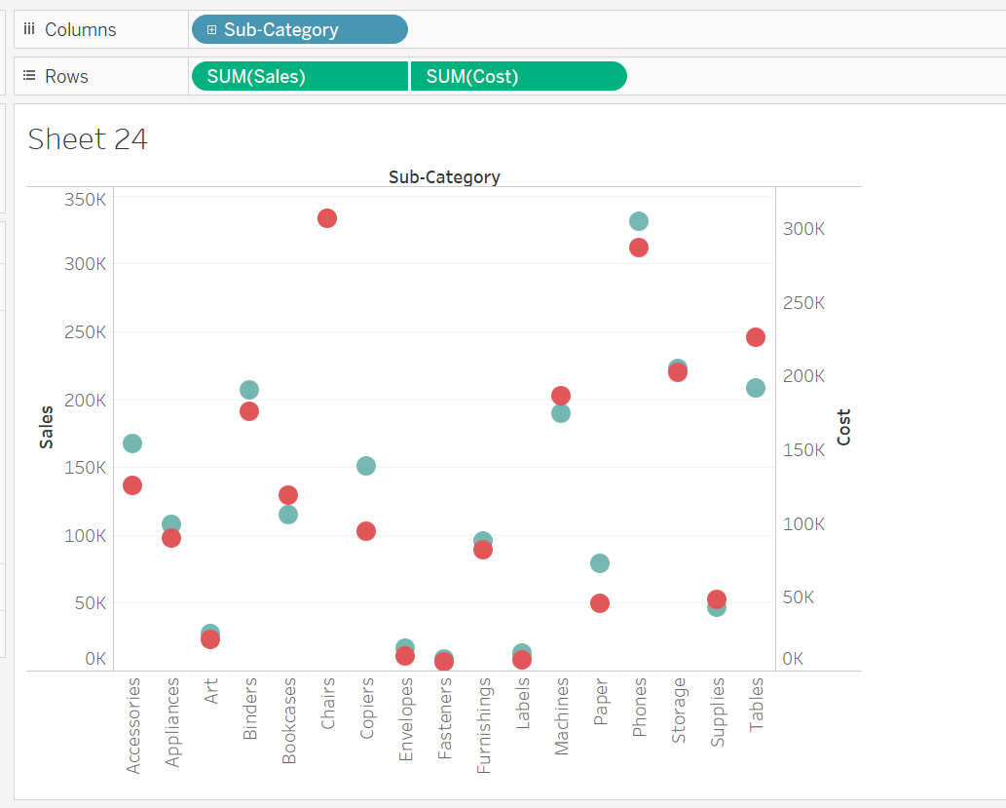
* Remove su-cat from col and add category
* Below saare options se hum kurafaati cheez kar sakte hai. Like designing of visual, ball etc..
* 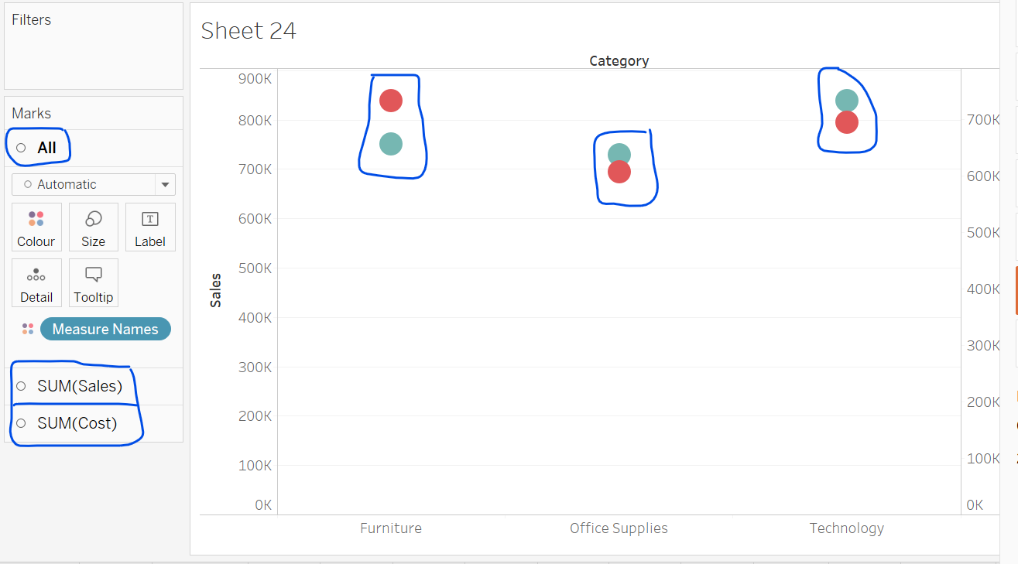
* Synchornize both axis so, that both y-axis should have same scale.
* 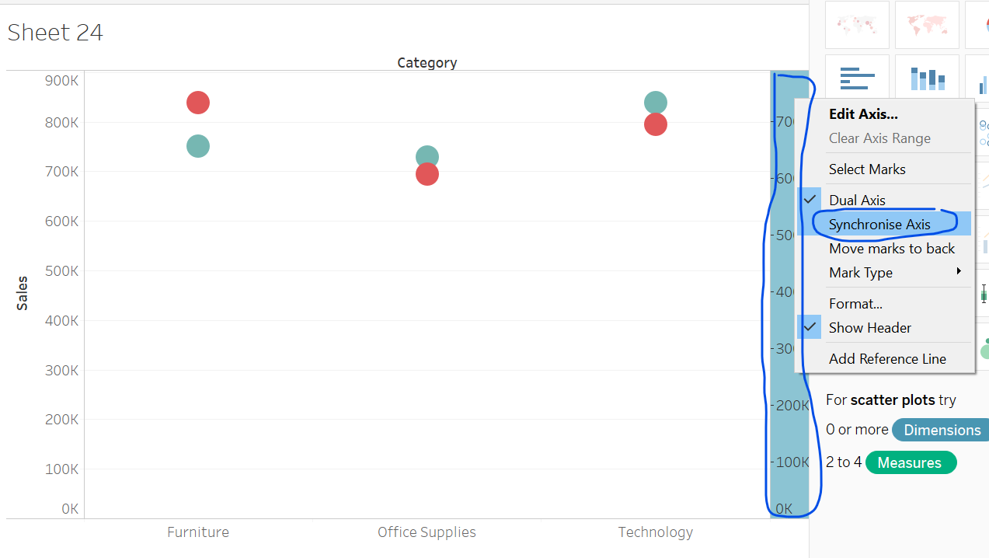
* 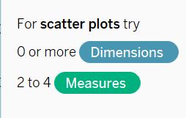
* Take sub-category to col and sales to rows in new sheet
* Add Cost as second y-axis.
* For line chart date fiels is mandatory.
* So take order date in col
* Visual is complex
* So, remove sub-category and add category in rows.
* 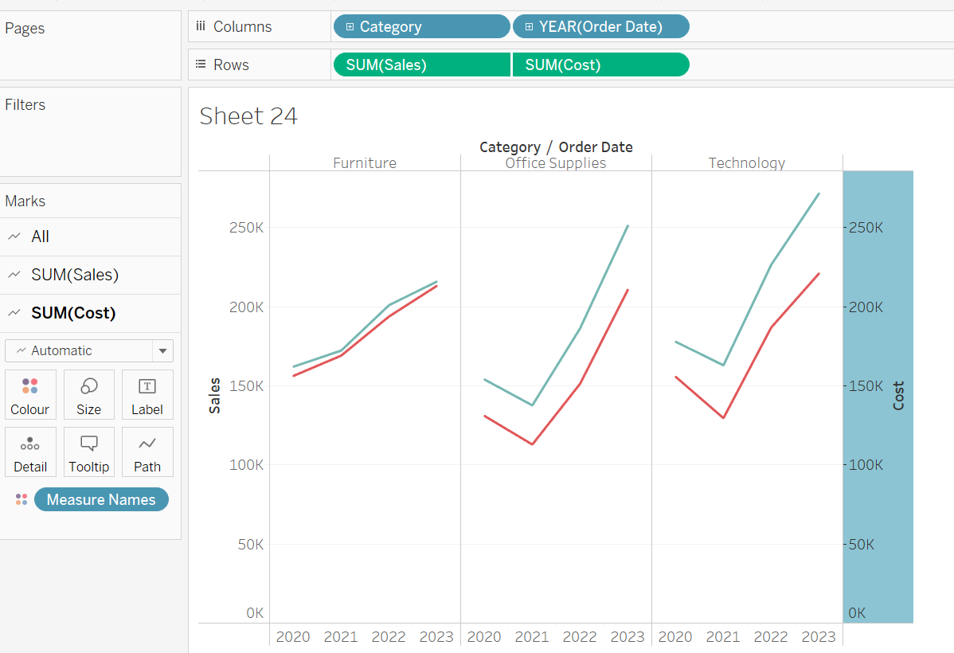
* Change cost to bar
* 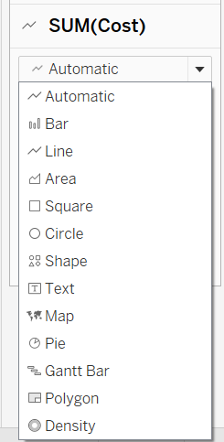

Dual Axex- Part -2

* Lollypop and Bar and Bar in Bar Chart
* Bar in Ba do axis honge dono bar me honge.
* Take category in col
* Sales in rows
* Cost as 2nd y-axis or drop cost to rows then from drop-down select dual axis.
* Change both shape to bar
* 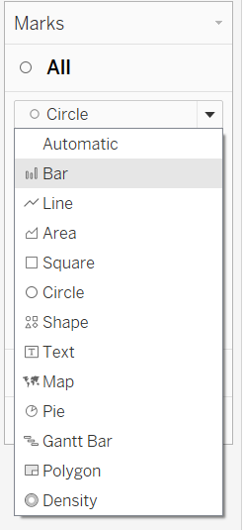
* Change colors of bar and y-axis for better visuals.
* Add sub-cateogy in col
* Now, clearly analyse kis products se acha profit hua aur kitna loss hua.
* 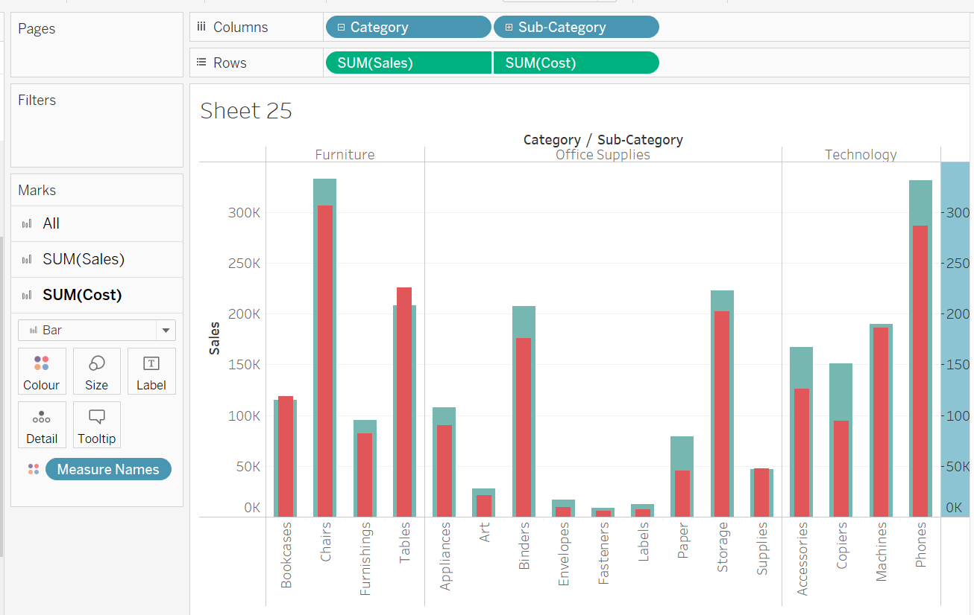
* Lollypop chart
* Take same measures two times and then make on bar other one circle shape.
* 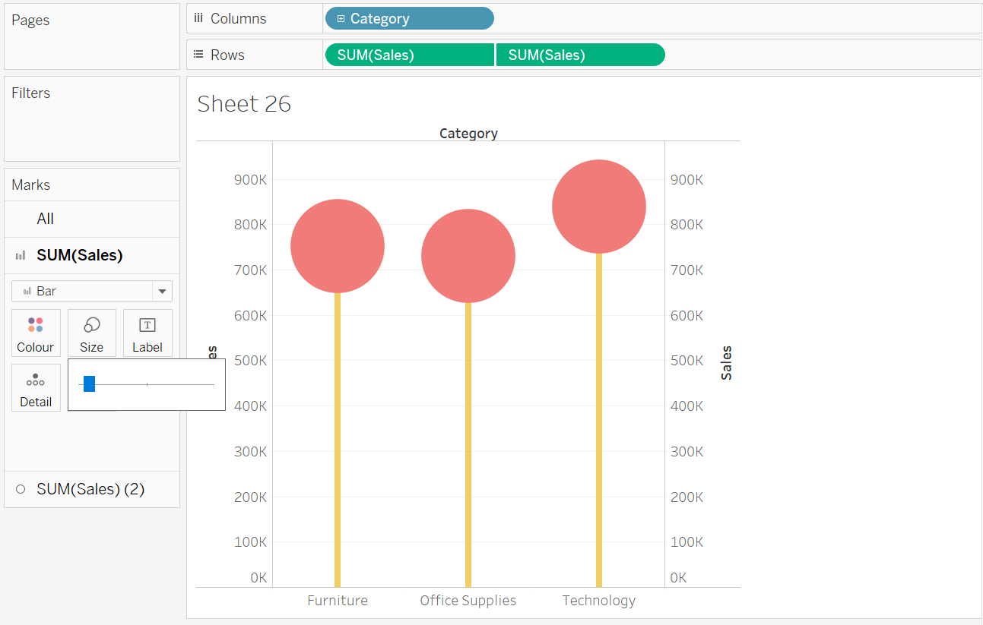
* We can use some chocolate,candies photo as a circle for better representation. Simply add those photo in shapes. And use chocolate photo as shapes.
* Lollypop chart is best for visualization over bar chart.

Animated Charts

* Something inc or dec over the time, uske animated form me visualize karna.
* Create simple bar or line chart first.
* Line chart ke date field mandatory hai and ek measure.
* So take order date in col and quantity in rows.
* Now use this for animation. 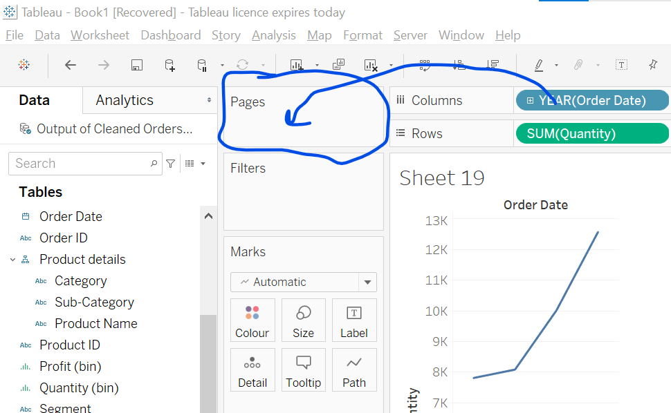
* Drag order date into pages area.
* Dono jagah same cheez select karni hai. Continuous or discrete but same honi chahiye.
* 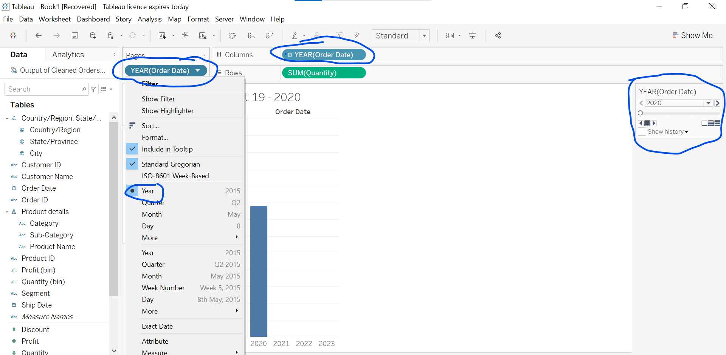
* Explore right hand side options.
* 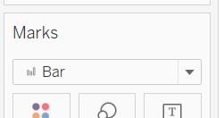
* Pages me blue color me hi order date dikhega.
* Change both order date to discrete (first year click)
* Add another Year in col and change it to quarter.
* Further expand quarter to month. Ctrl + click on quarter.
* Similar change pages order date to month
* 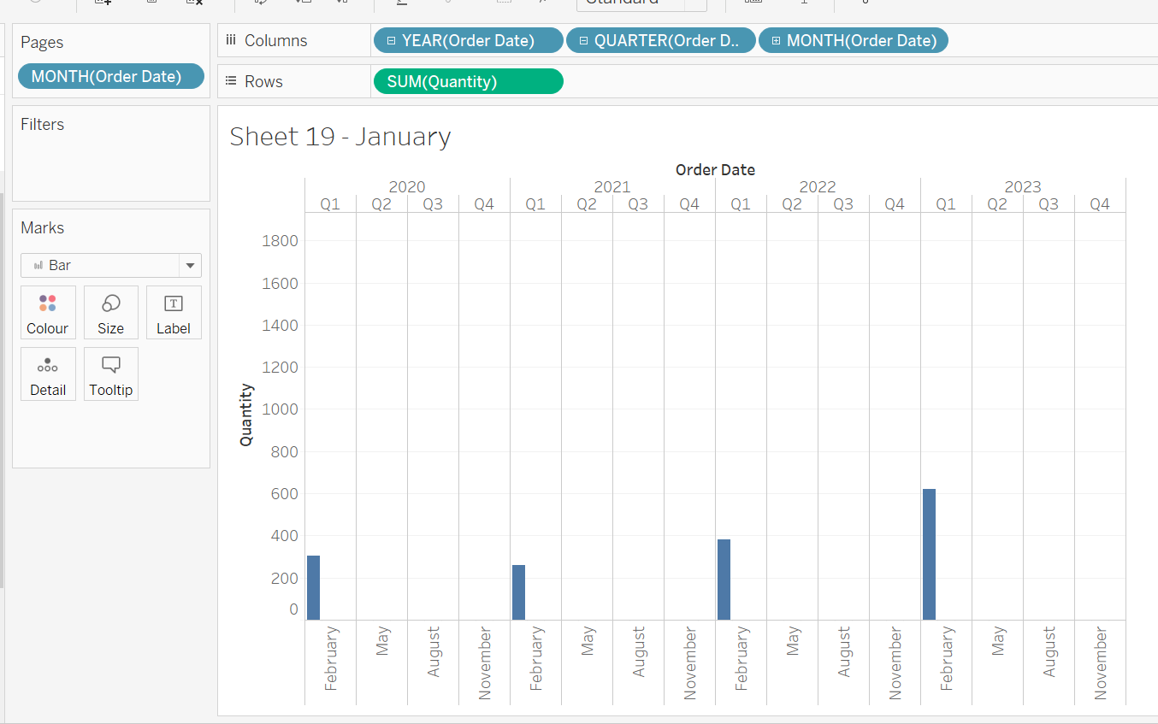
* Graph me kuch hi month likha hai space kam ki wajah se.
* For looping animation. 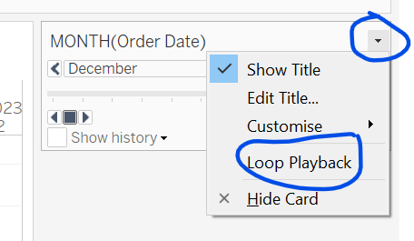
* We can loop, fade animation progress,.
* Just explore all options available.
* 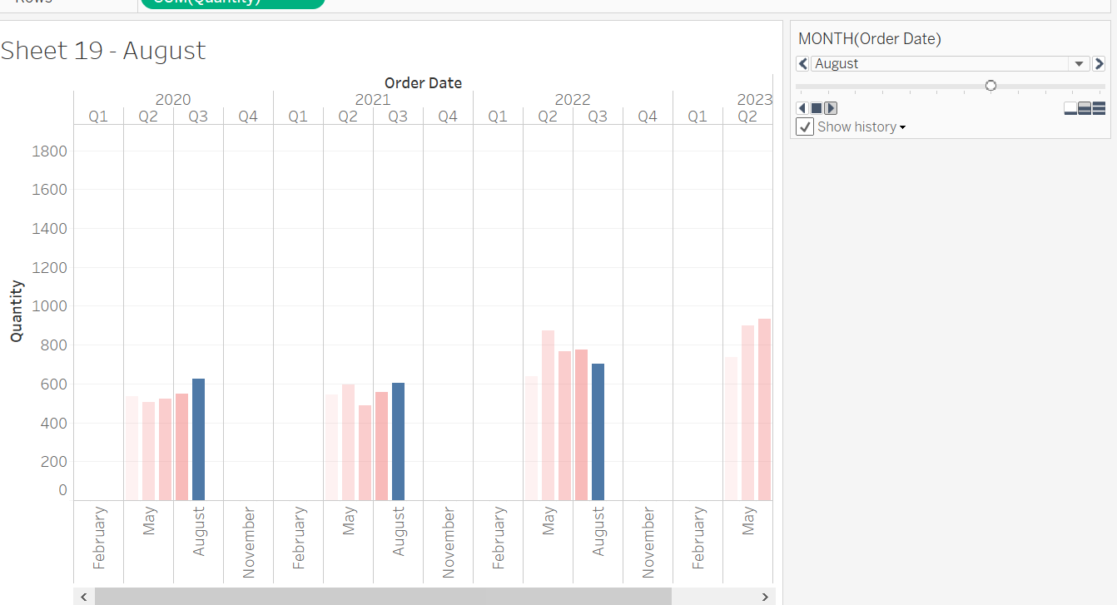
* We can see history of last bar like above.
* Go to format -> Animation and turn Workbook default off. Tub hum jo animation design karenge wo chalta dikhega nhi to Tableau ka setted animation dikhega.
* Add Category to colors.
* Set none fade color.
* 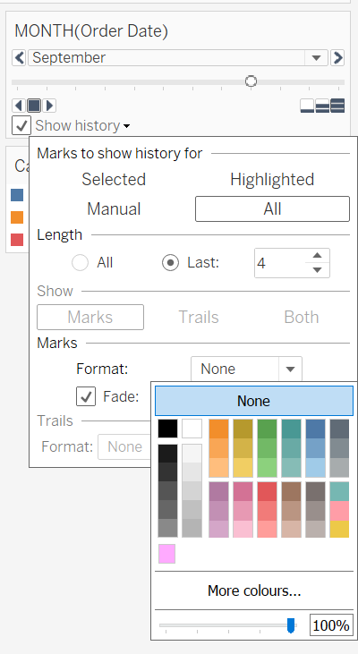
* Add category to label
* Jo major portion hai whi label me likha dikhta hai, so remove it from label.
* Instead add quantity in label.
* We can draw heartbeat like or trend show visuals.
* Duplicate this sheet.
* Change mark to circle and inc size of circle.
* remove quarter from columns.
* Start the animation.
* We don’t sort row or columns
* We can choose diamond or any other shapes in marks. 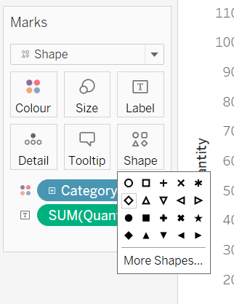
* BAR ke alawa agar koi dusra options lete hai to ye marks, trail and both activate ho jaata hai.
* 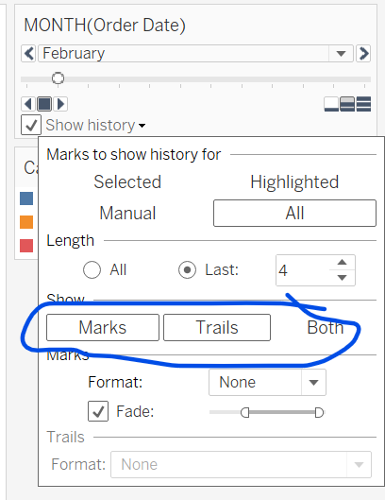
* Trail designing. 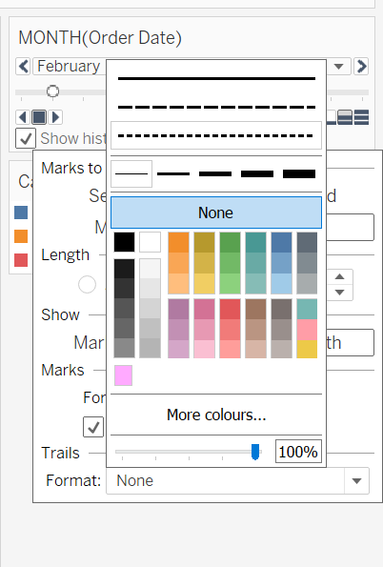
* 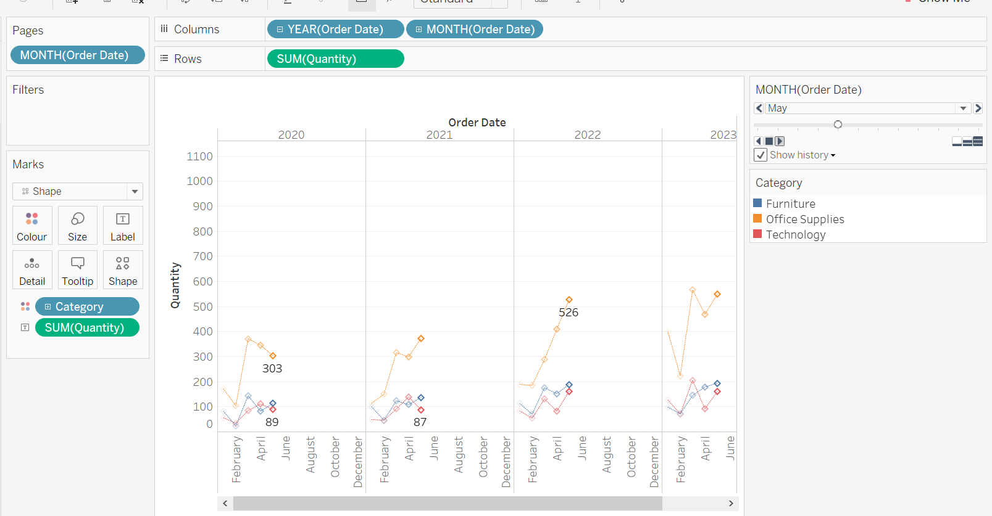
* Lets make visual more better.
* Remove month from col
* Change Order date to cont in col and pages both.
* Start animation.
* Change order date to quarter in both col and pages and start animation.
* Change order date to month in both col and pages and start animation.
* 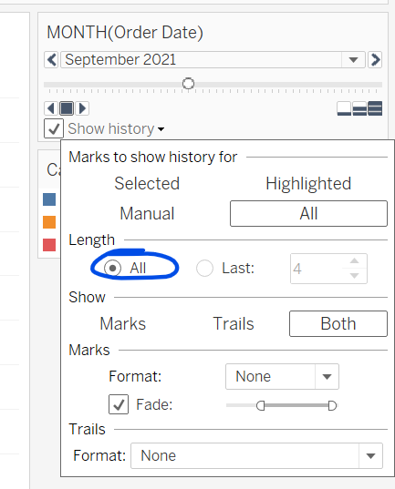
* Result:
* 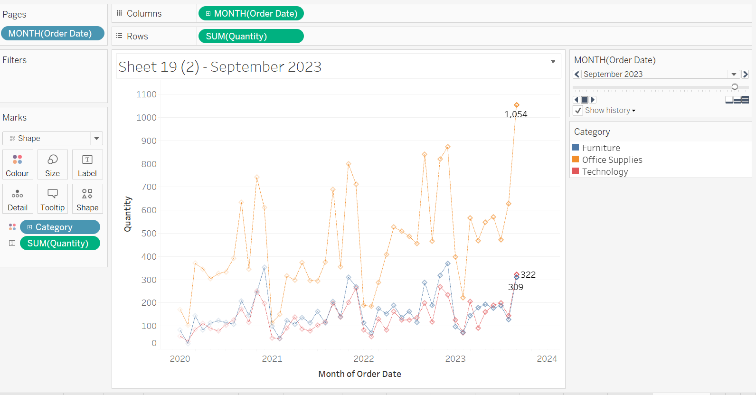

Funnel Charts And Its Types

* Funnel chart: Koi bade cheez se chhoti cheez me convert karna.
* Use: To see progress like sales funner, marketing progress, Lead generation step by step customer involvement like kitne log interest, register, payment, feedback etc.
* We need stacked bar chart or create a simple bar chart goto show me section and click on stacked bar chart.
* Take sales in rows and sub-category in columns.
* Click on show me -> stacked bar chart.
* We convert this stacked bar chart to funnel. 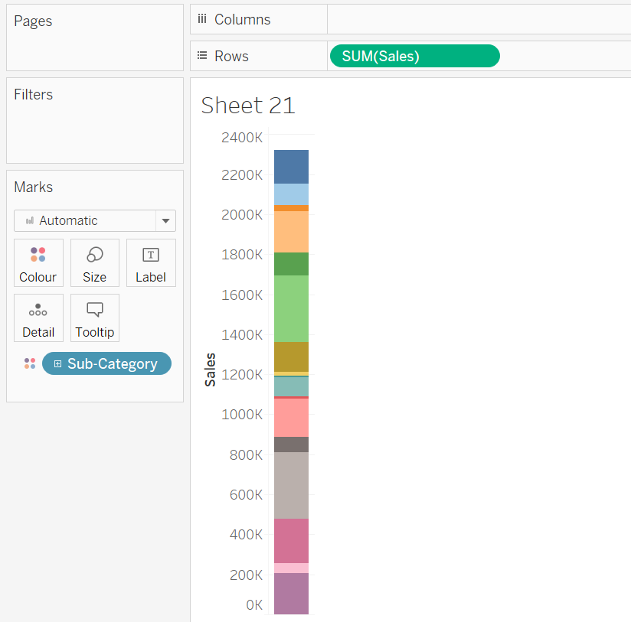
* Take sales in size section and Entire view.
* Funnel bde se Chhota hota hai to size arrange karna hoga.
* Click on sort.
* Sales and sub-category into labels.
* 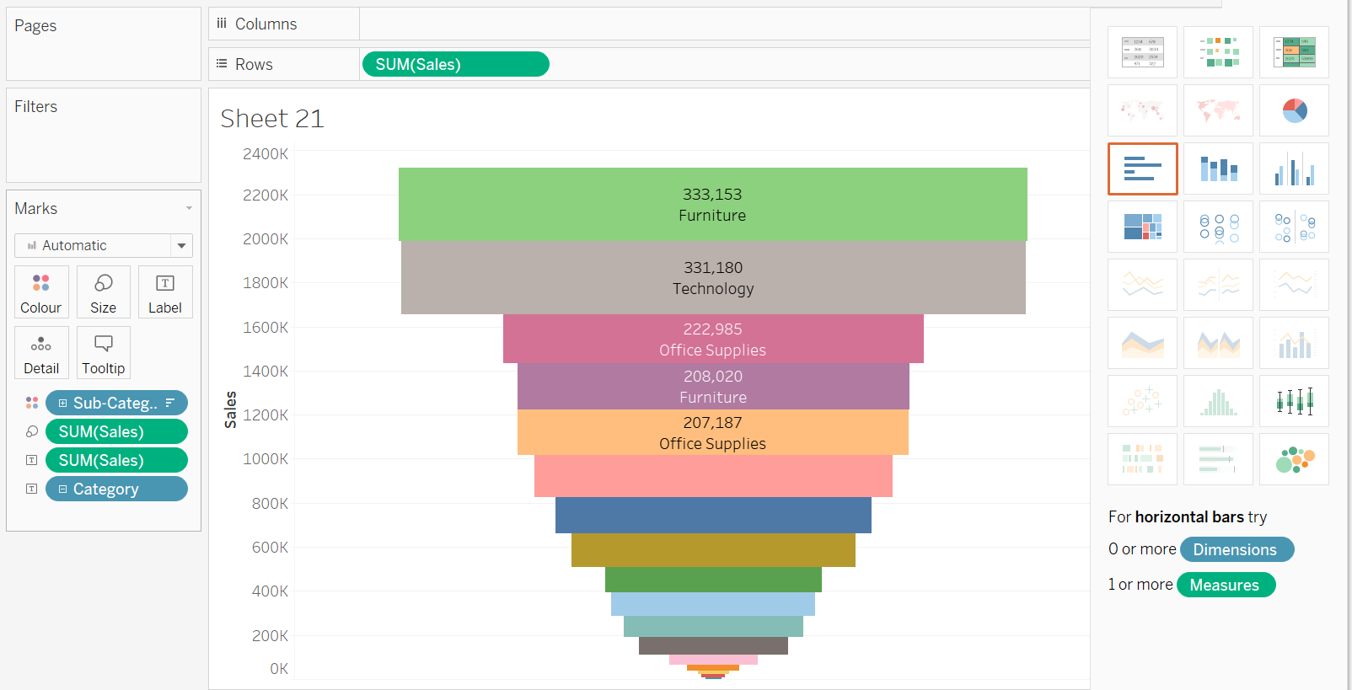
* Hum % me dekhna chhate hai kitne log ne interest dikhaya, kitne log ne course kharida fir kitna log ne complete kitya course.
* So goto analysis-> Percentage of tables select.
* Or from this way. 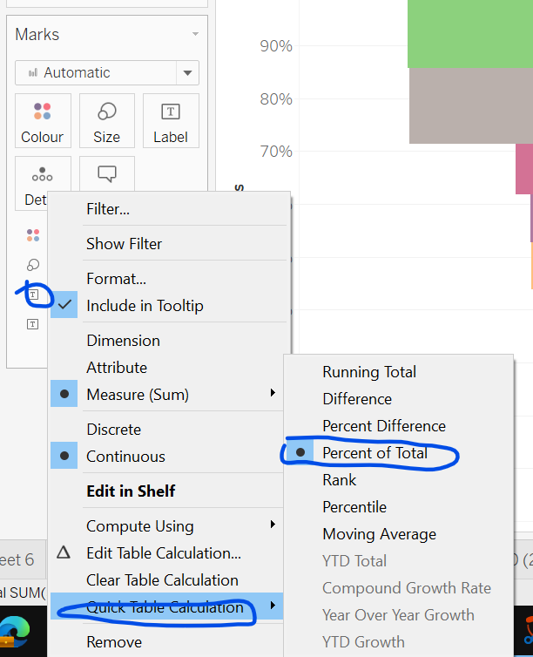
* This is funner chart we prepared. 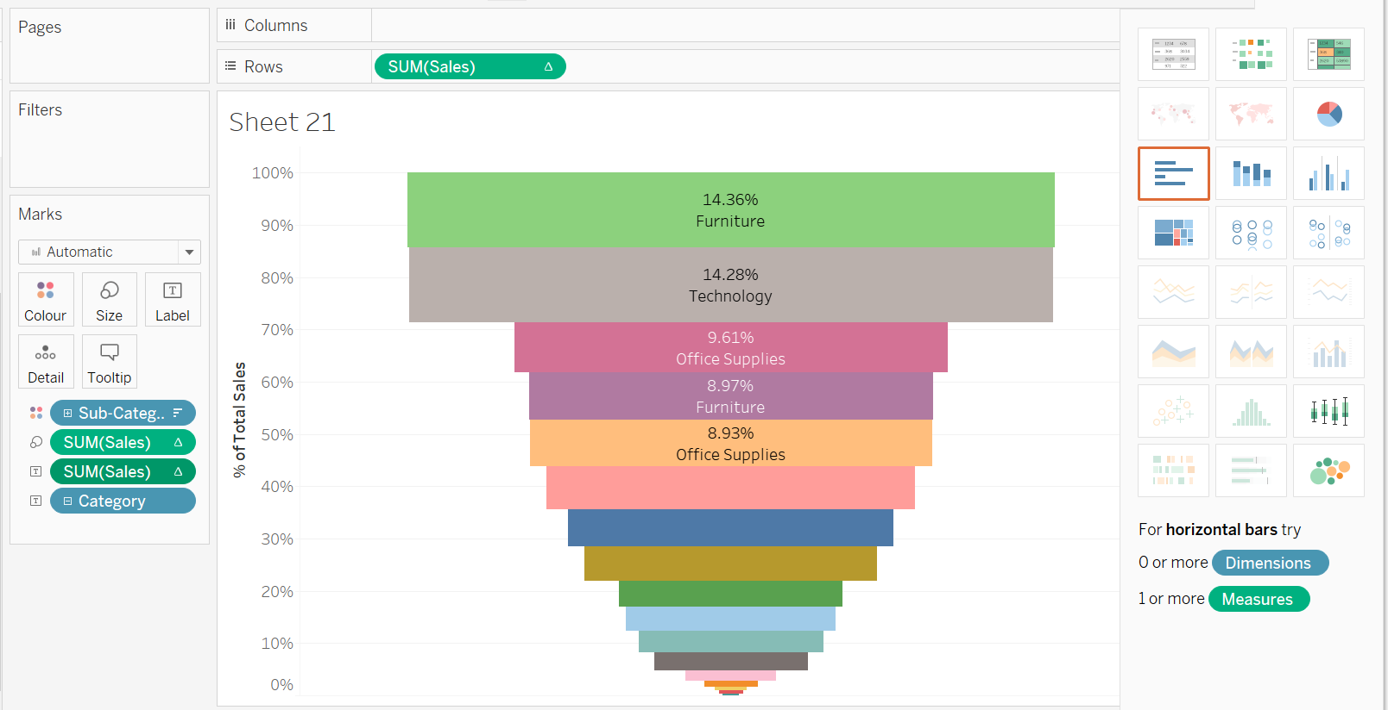
* Now, we will create advanced funnel chart.
* Takes sales in col and sub category in row and click on show me horizontal bar chart.
* Now, convert this bar chart into area chart.
* Goto Mark and select area type.
* Click on sort descending.
* Again take sales in col
* Negate first sum of sales and enter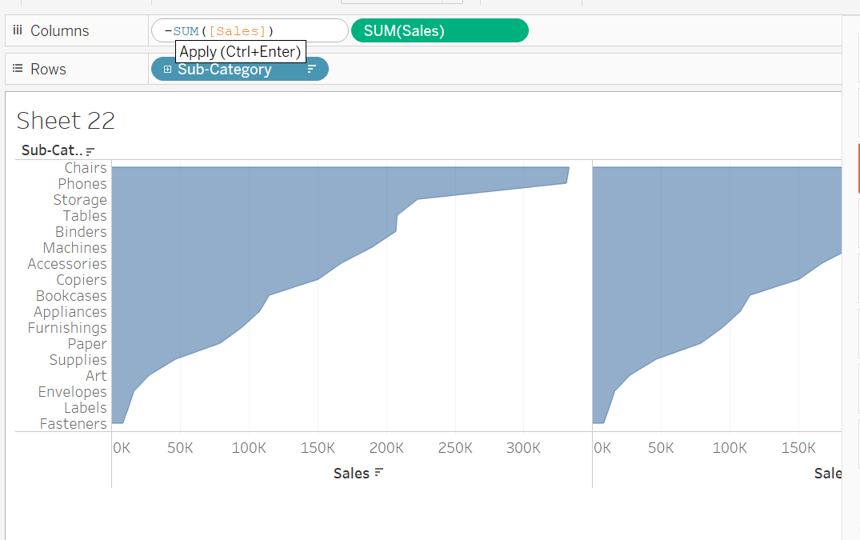
* 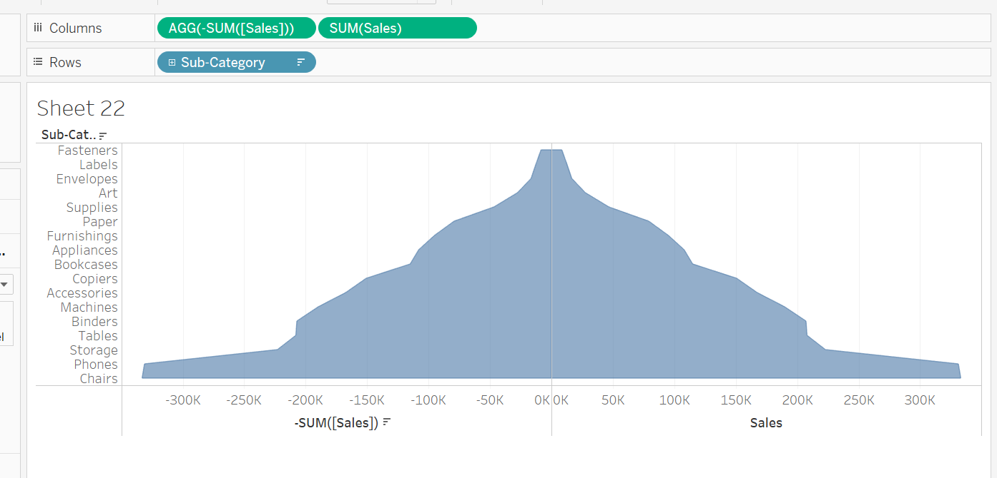
* Second method: Calculate negative field.
* Third method:
* Ctrl +z for undo
* Right click and edit axis and select reversed. 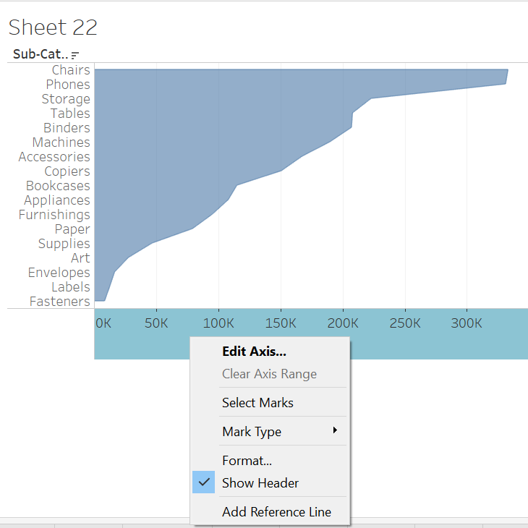
* 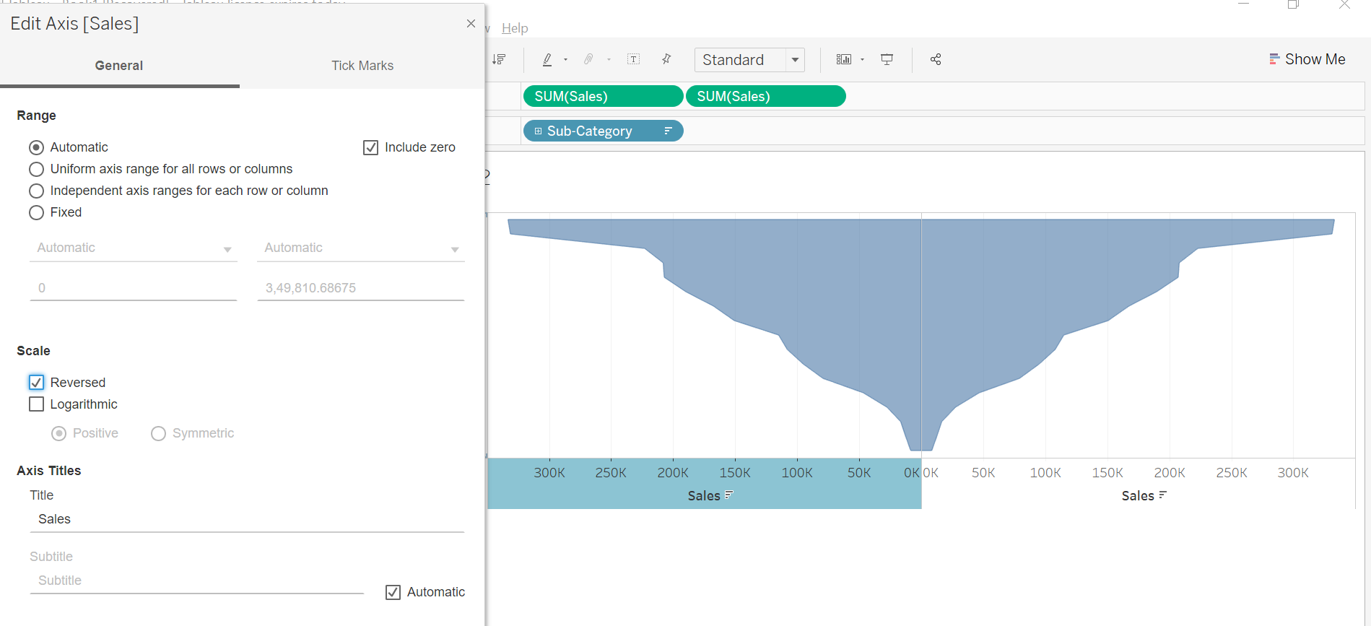
* We can inert it by sorting
* Add sales and sub-category in label of all.
* 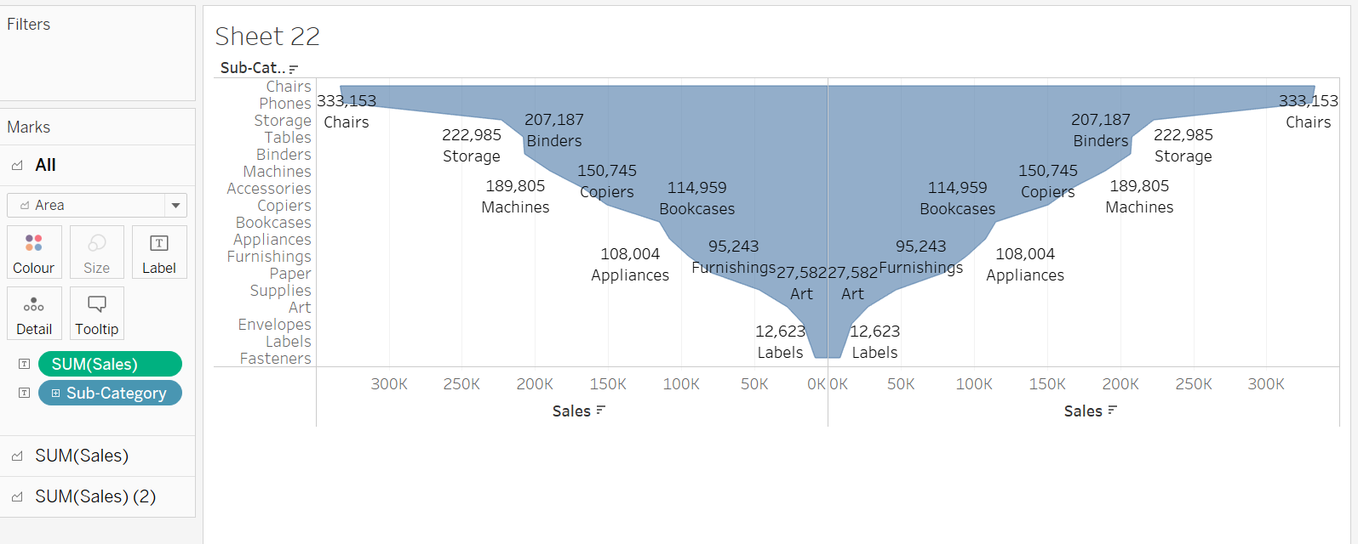
* This doesn’t look good bcz of repetition.
* So, undo both label
* Ek sales se sub-category label se remove kar do.
* Dusre sales se sales label remove kar do.
* Change both half color
* Finally, 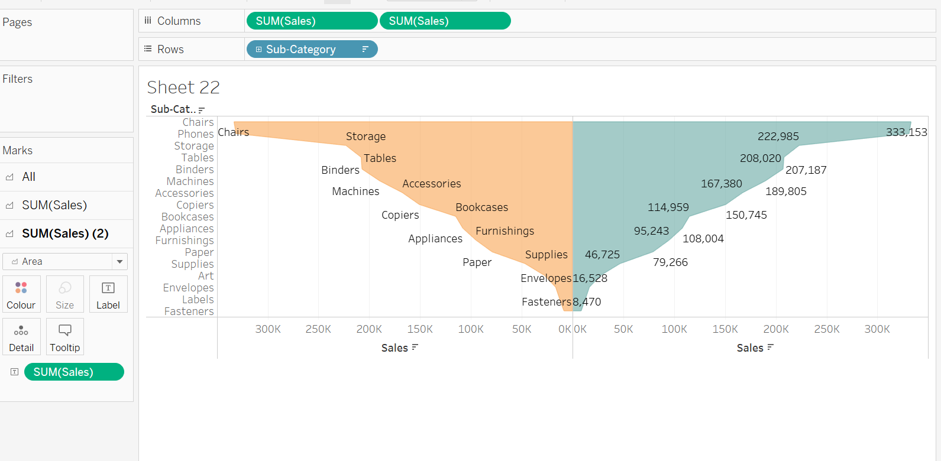

Donut Chart & Multiple Donut Chart

* We have to create a dummy axis.
* Double click in rows and type SUM(0) AND ENTER
* It is nothing just a pseudo axis.
* Or we can create it by calculated field. 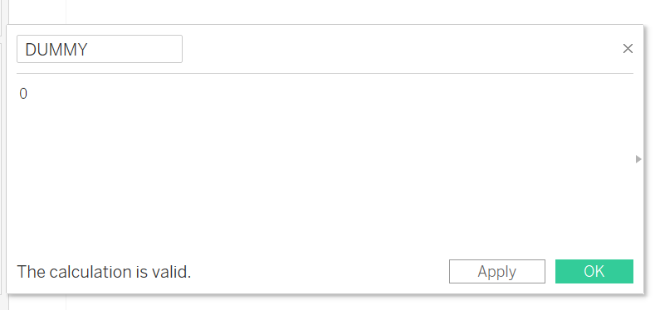
* So, again create a dummy axis and take it to rows.
* 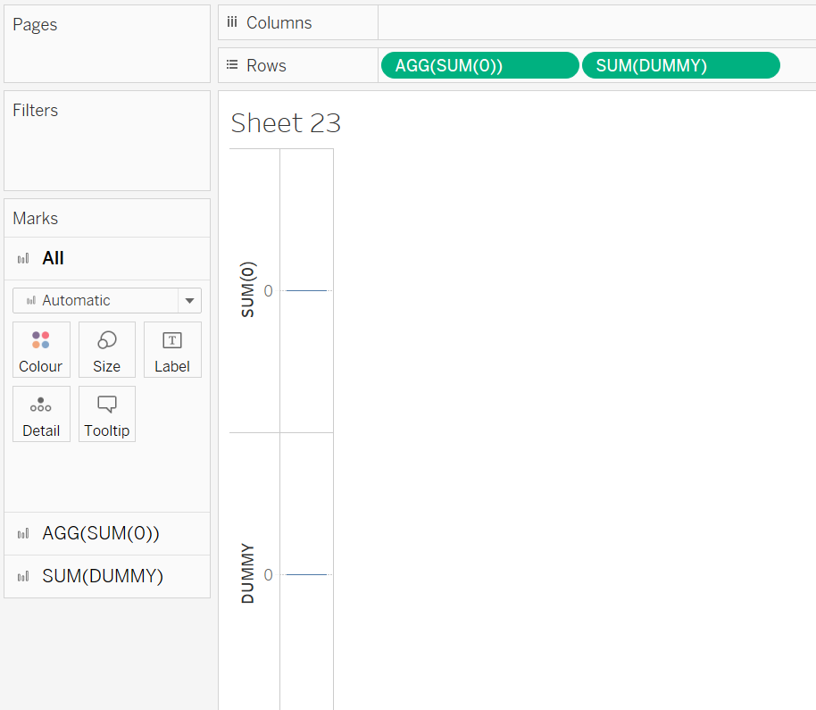
* Select AGG(sum(0)) shape as pie
* Select SUM(Dummy) shape as circle.
* Select Entire view
* Dono ka size increase karna hai to ALL ka size inc
* Take category in pie chart color.
* And Quantity in size of pie chart
* Add quantity and category to label of pie chart
* Now we have to merage both circle.
* 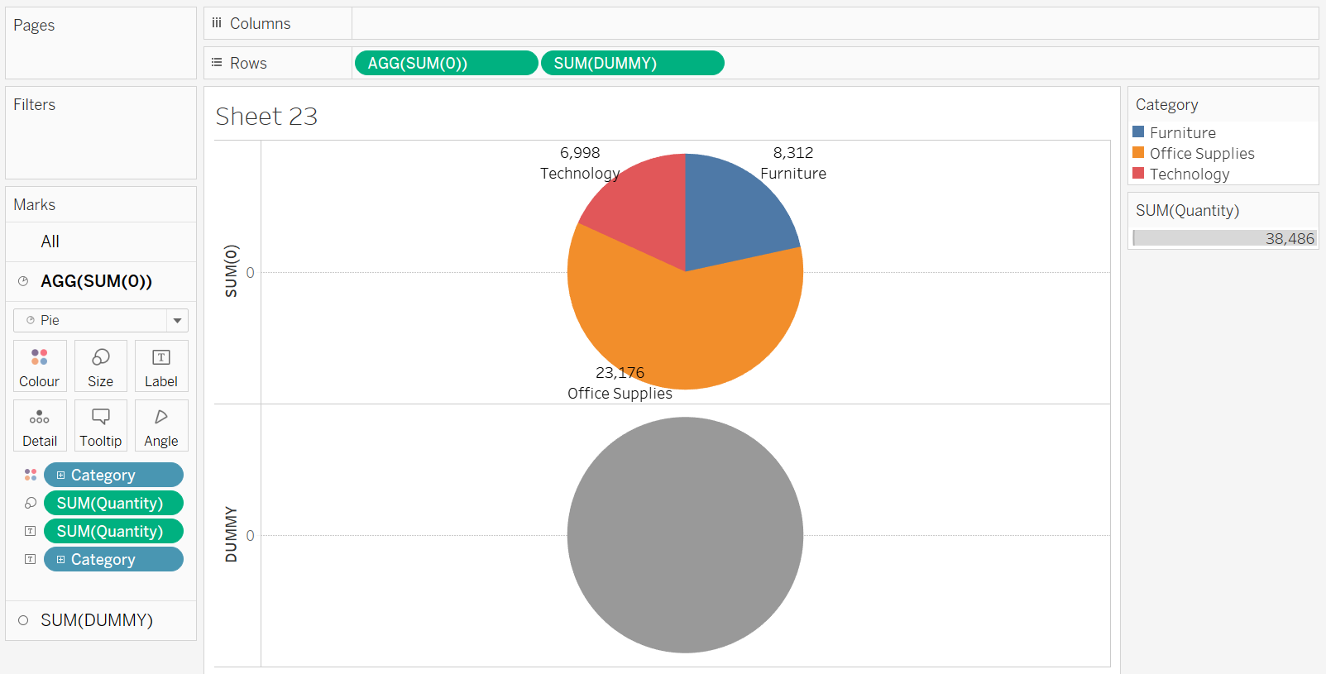
* 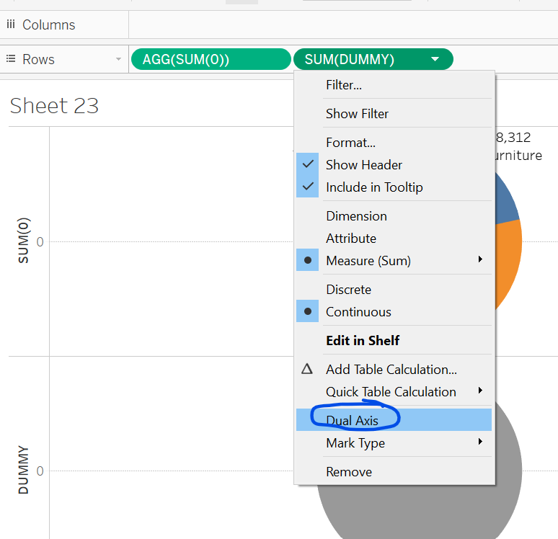
* Decrease size of dummy and change color to white.
* Take quantity in the label of Dummy
* Do this change 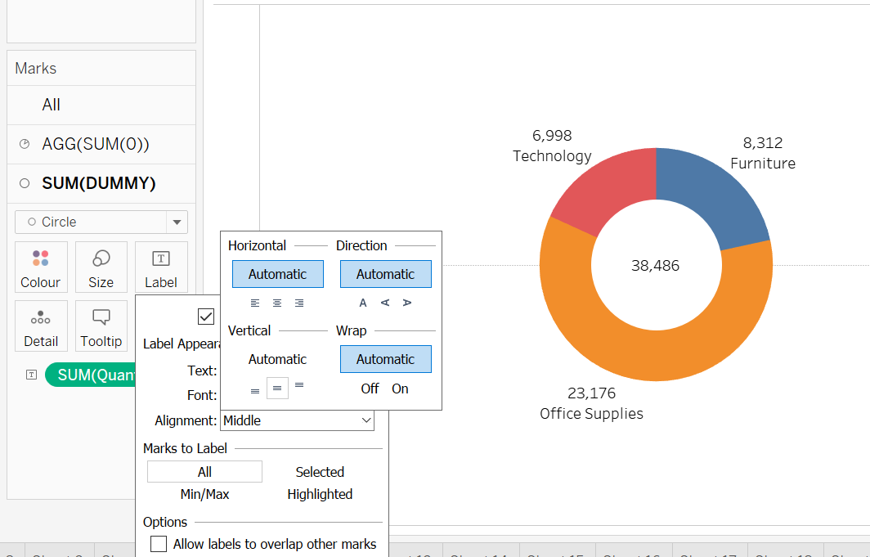
* Add labelling. 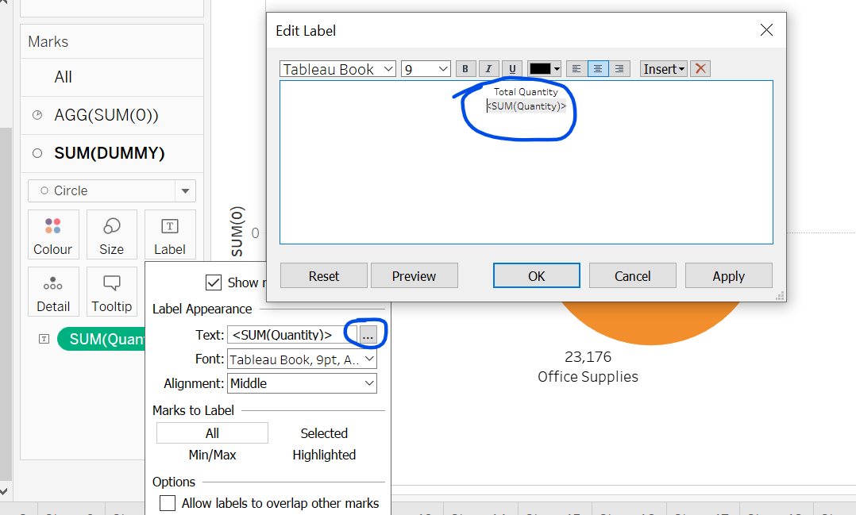
* Increase or decrease size of pie and circle accordingly.
* 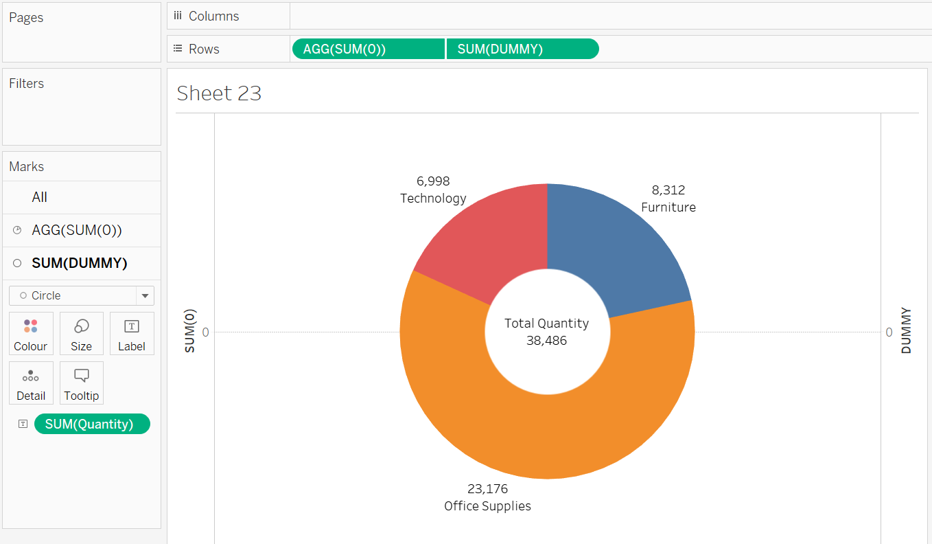
* Goto analysis tab select % of table
* 3 Null error will come select show data at default position for all null.
* 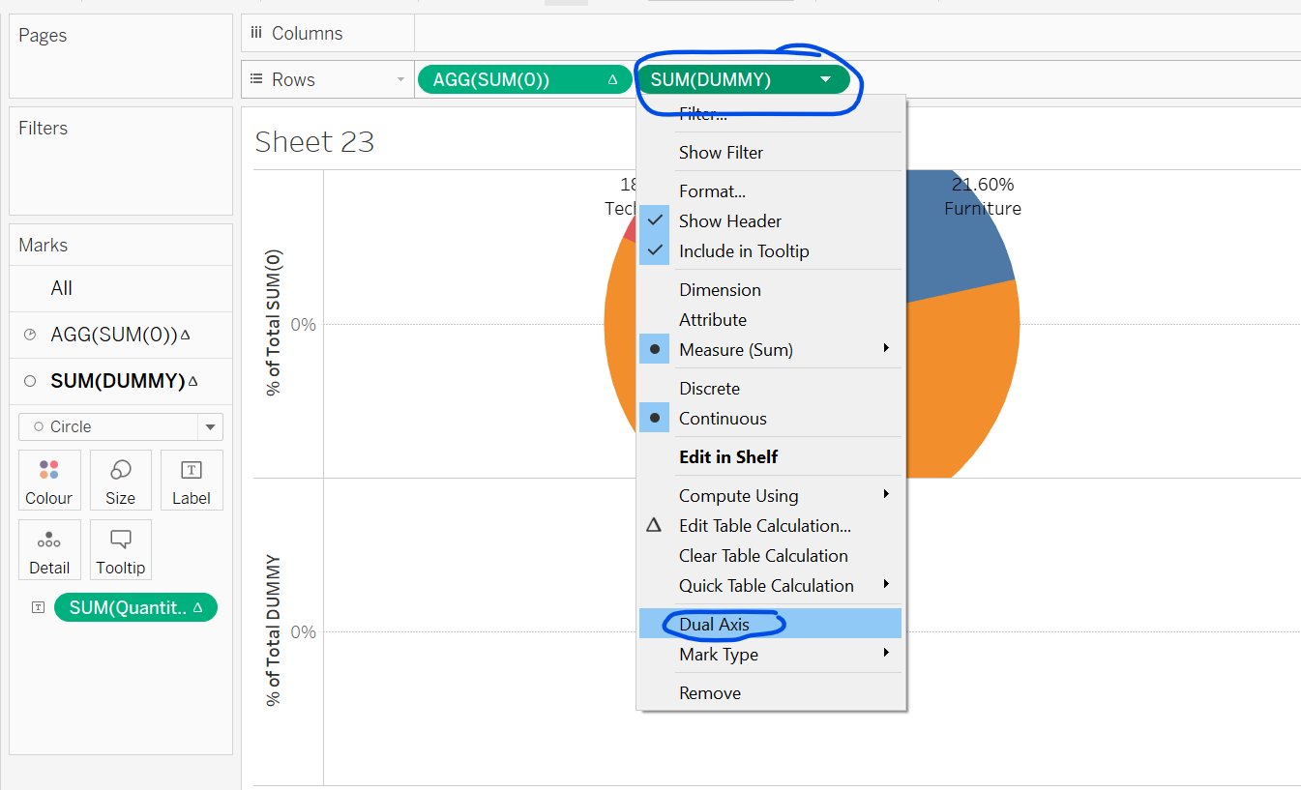
* Do for both axis to hide axis. 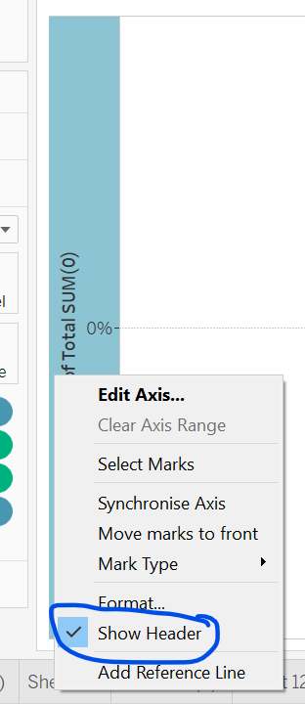
* Duplicate this sheet and make multiple donut chart.
* Remove category from label and colors of pie and add sub-category to labels and colors.
* Take category to columns.
* Analysis -% of none check
* Again make SUM(Dummy) axis as dual.
* 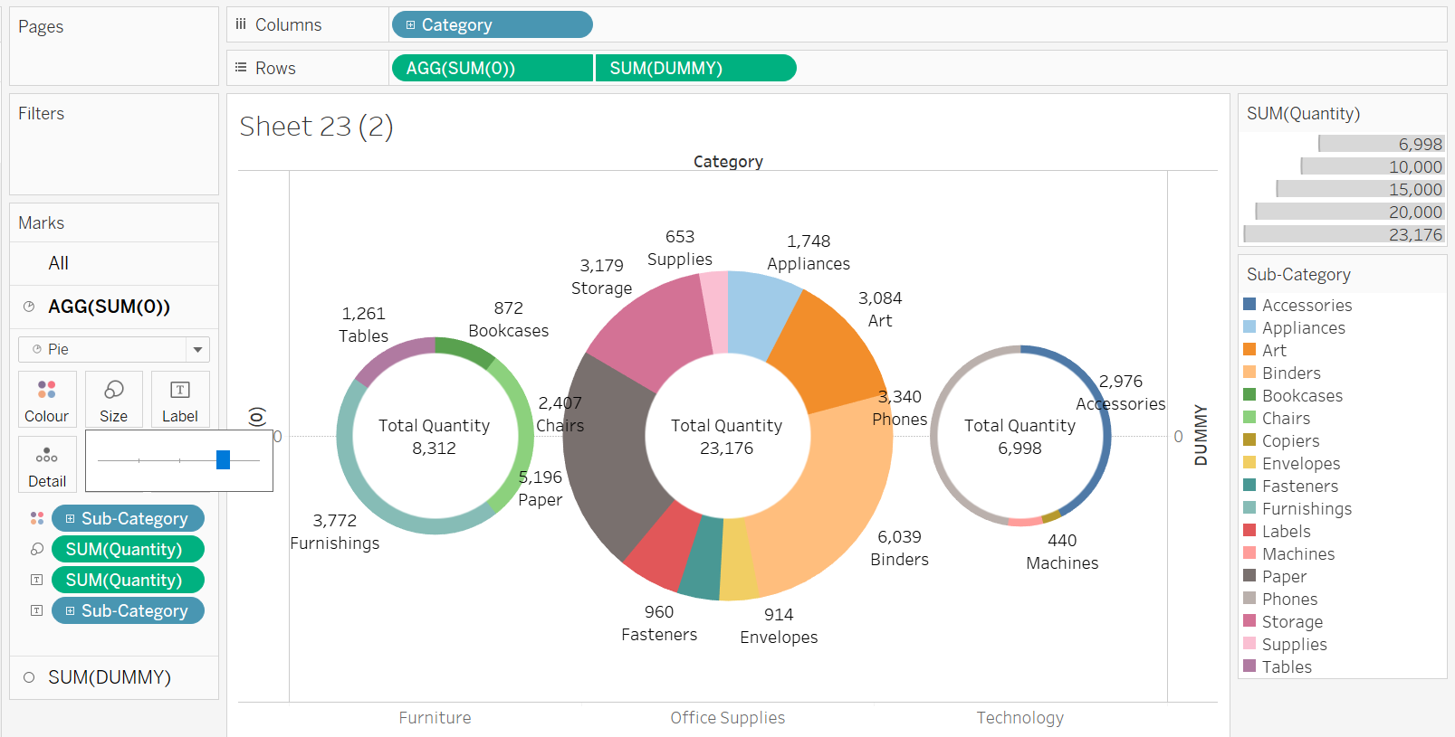
* We can change font, size, color, bold etc for better visuals.

Dumbbell, Barbell Or DNA Chart

* Dumbell chart is used to compare to datasets.
* Like Gantt Chart.
* Take Category to col and sales ot rows.
* Again sales to rows
* SUM(Sales) shape change to line and SUM(Sales)(2) shape change to circle.
* SUM(Sales) sir ek ko right click karke dual axis select and synchronize dual axis.
* Remove right side header of axis.
* Lets say we want to compare sales of 2020 vs 2021.
* Order date to colors of all
* Take order date to path of SUM(Sales)
* Click on swap option. 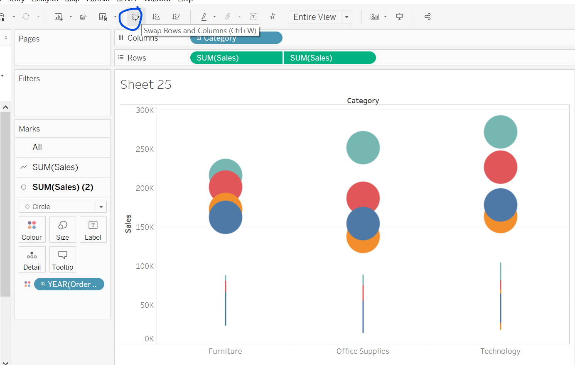
* Éxpand or click on + icon in rows in Category
* Right click on order date in Tables section and click on show filter or we can drop order date in Filters section.
* 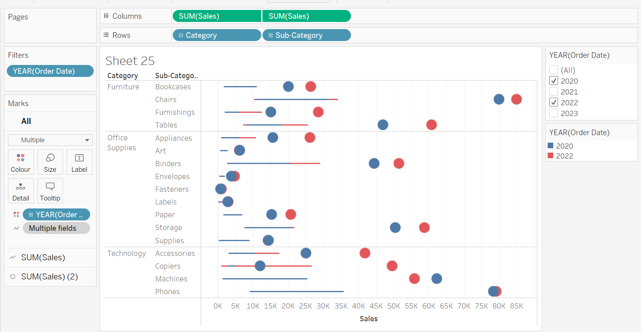
* Clik on SUM(Sales) Path QUARTER(Order Date) and select year. 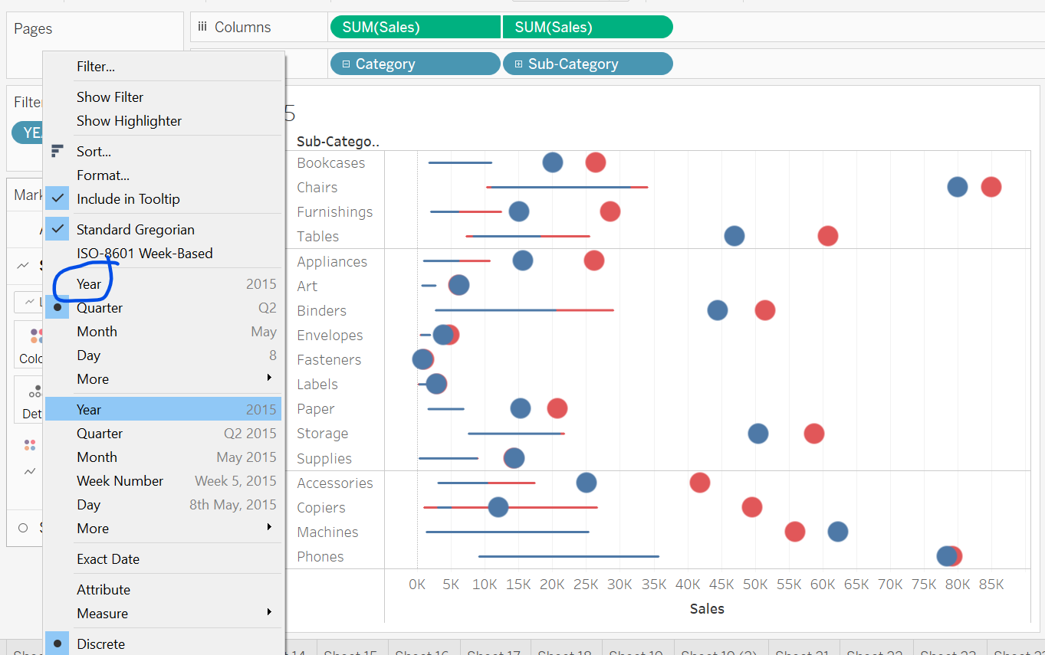
* Finally. 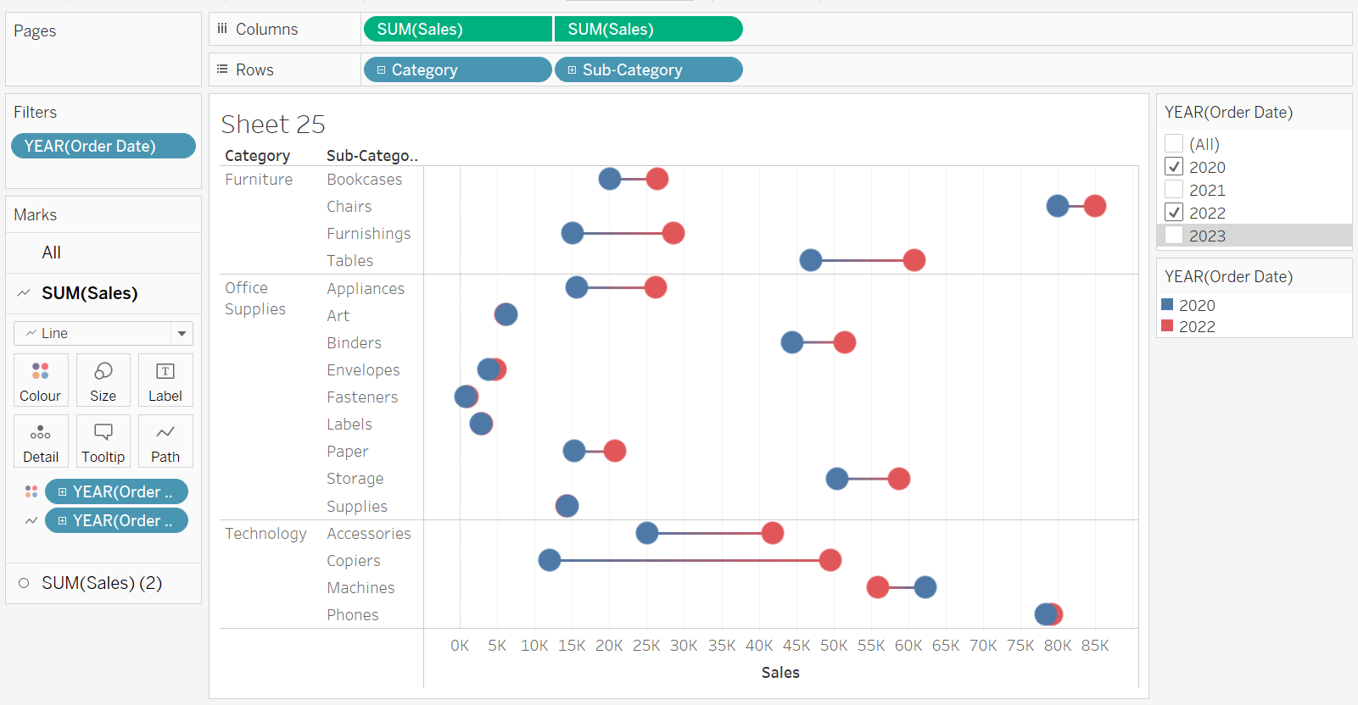
* We can change yearly wise color of circle in ALL
* 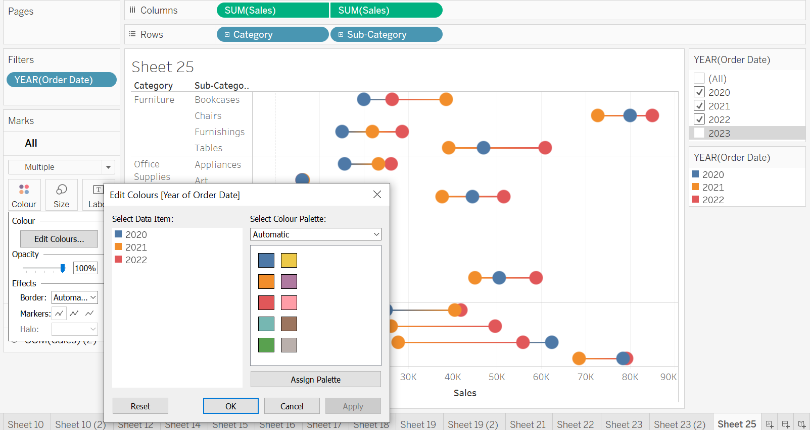

Butterfly Chart

* Let say we have to compare b/w SP vs CP
* 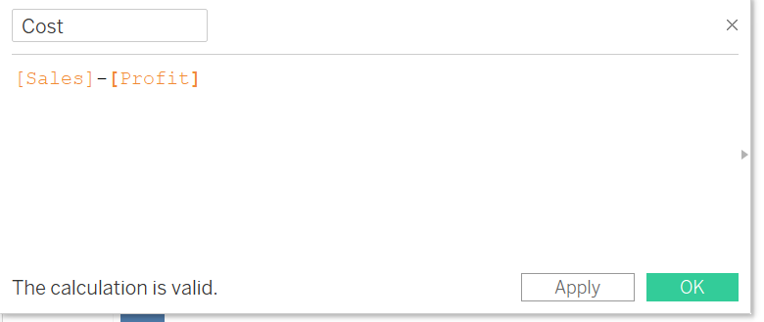
* Take Sales and cost in cols
* Sub-category in rows.
* 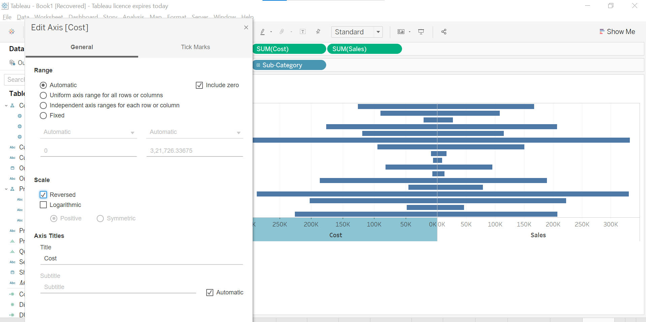
* Sort descending
* Take DUMMY axis in col and place b/w Sale and Cost.
* Take sub-category in label of SUM(DUMMY) and change it shape to text.
* Right click in DUMMY area and click on format.
* 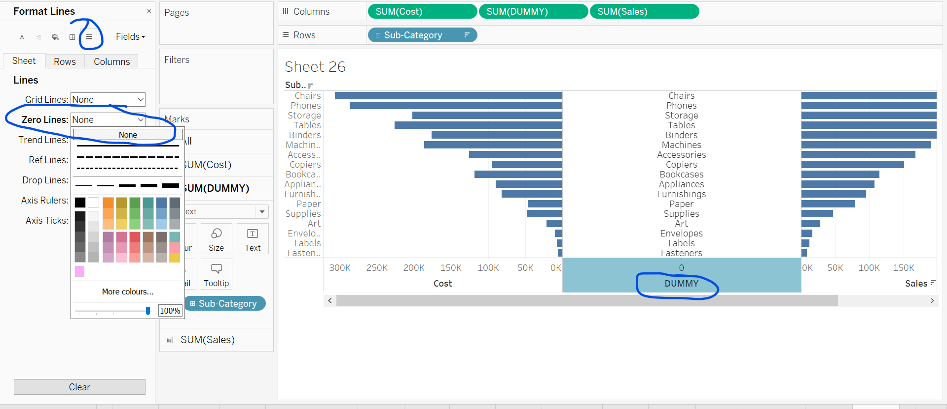
* Now, we can work on coloring and labelling.
* Take Sales in color. Apply shades of color
* Same do for cost.
* Work for alignment in both sales and cost
* Edit label of both like add sum of sales<sales>
* Remove header/axis left and right.
* 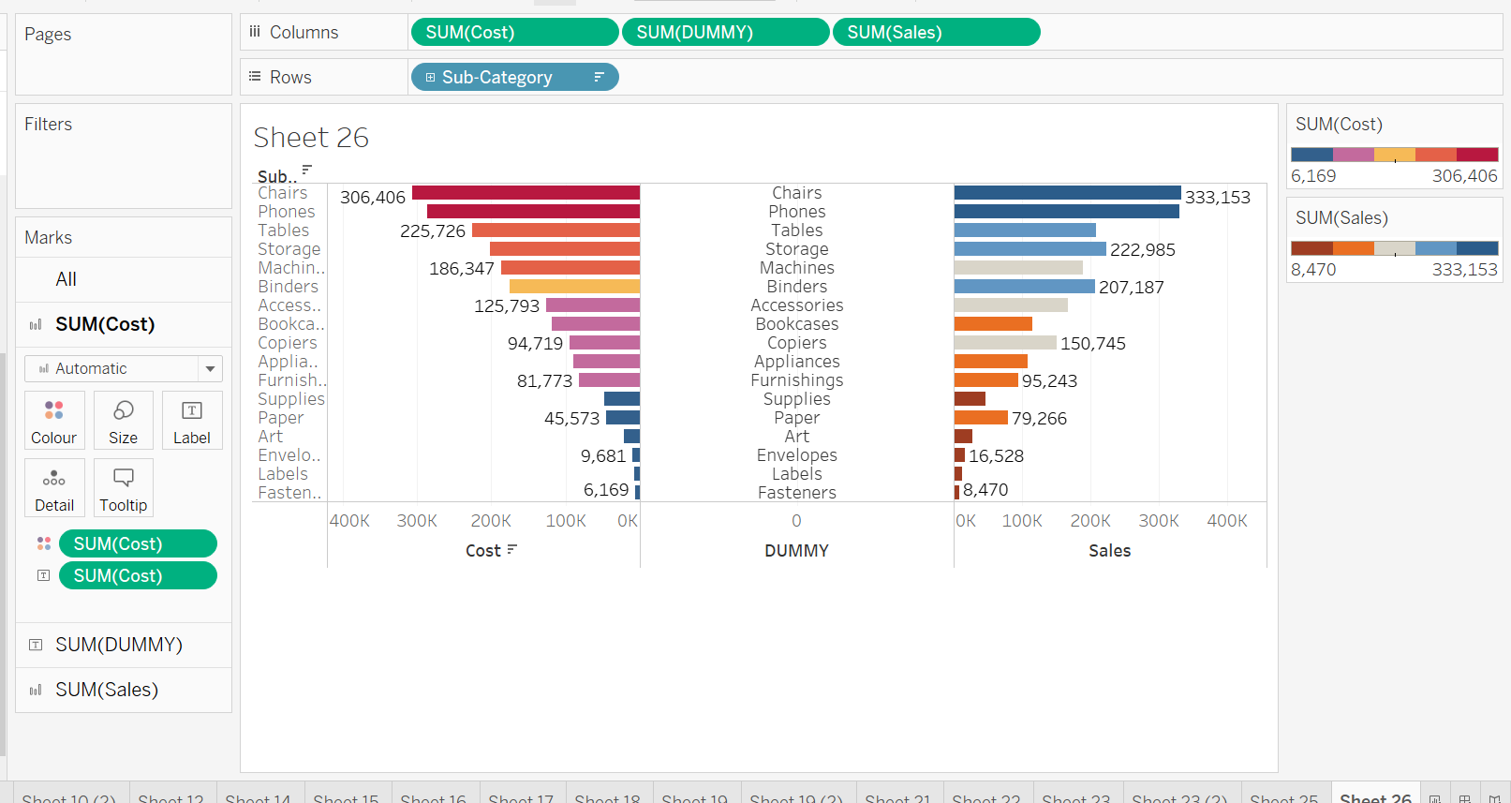
* 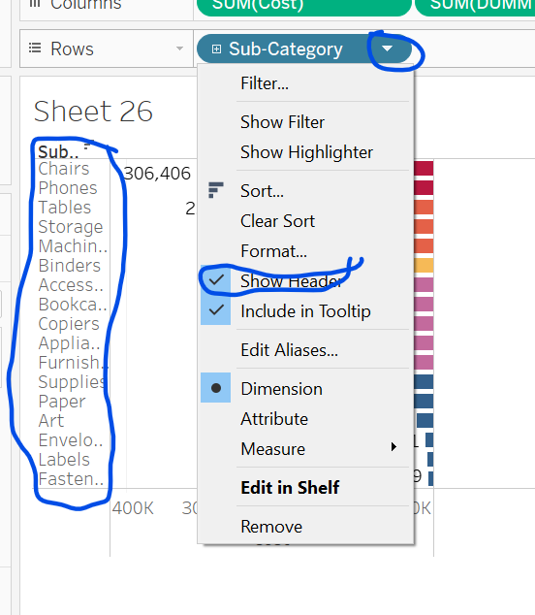
* Untick Remove header.
* Similarly remove Sales, Cost, Dummy axis label.
* To change sales labelling alignment. 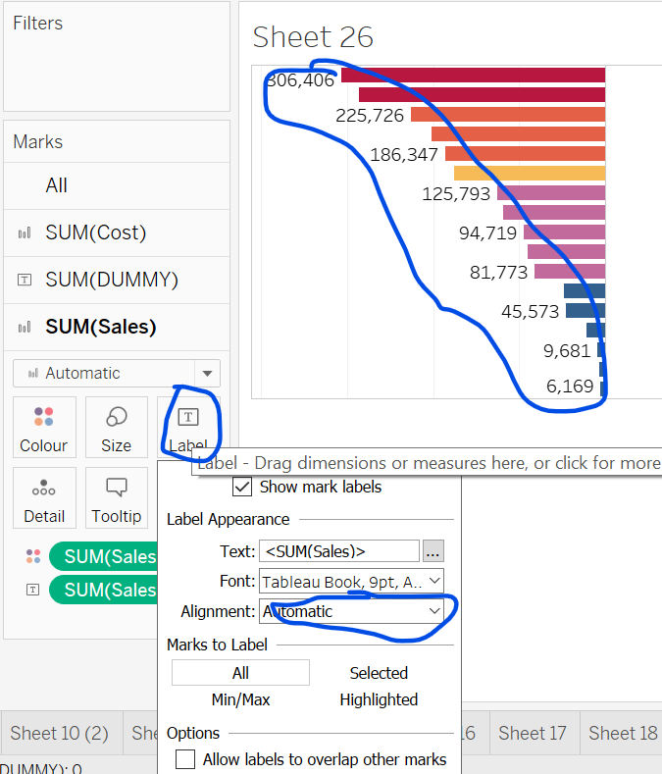

Box & Whisker Plot

* <https://help.tableau.com/current/pro/desktop/en-us/buildexamples_boxplot.htm>
* 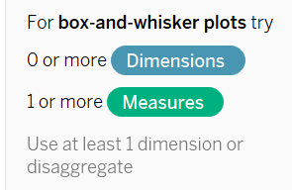
* Sub-category to columns and Quantity to rows
* Click on box and whisker plot
* Entire view
* Box and whisker plot ka use kisi dimensions ke baare me jaan ne ke liye karte hai jaise mean, median, upper, lower range etc.
* 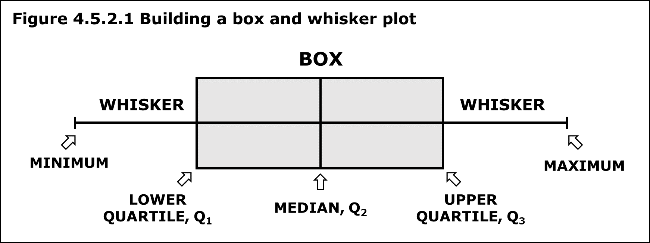
* 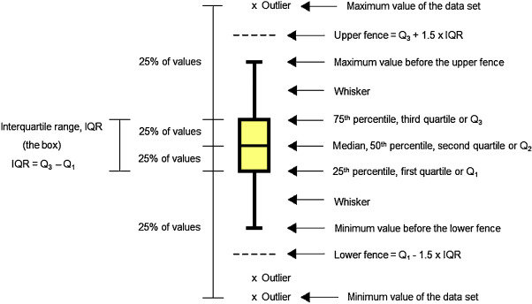
* Learn about quartile and inter-qauartile range calculation.
* Upper hinge= Largest but smaller than Q3
* Lower hinge=Smallest , greater than Q1
* Take sub-category to labels.
* Again take category to col for plotting multiple box-whisker plot.
* Formatting and editing by right clicking on plot.
* 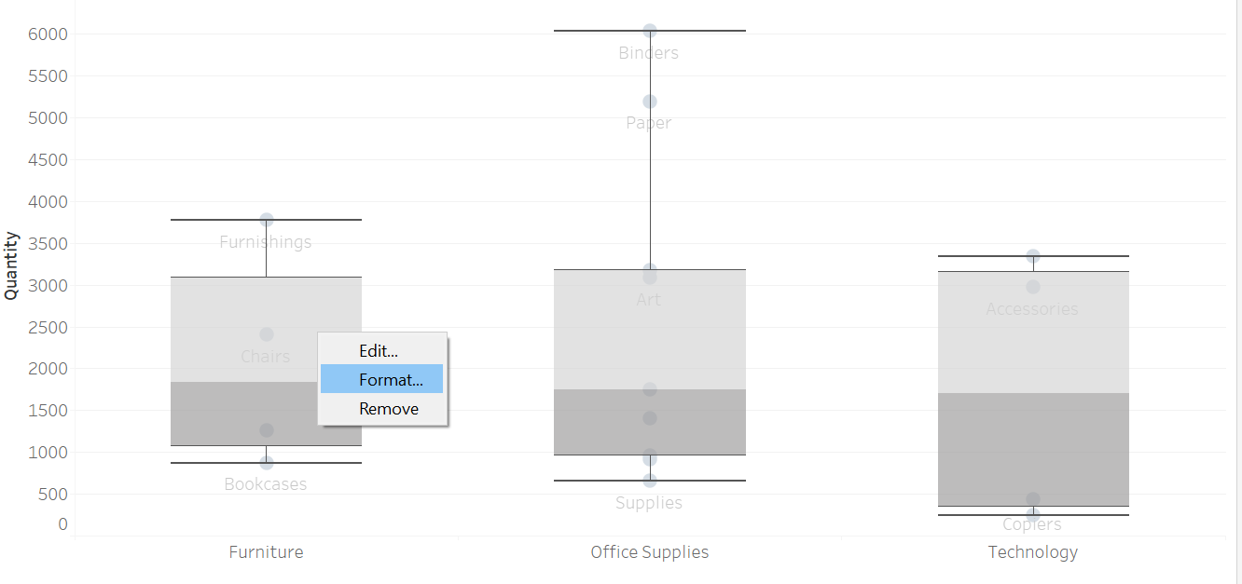
* Disaggregation: All value individual of a column.
* Take a new sheet and Add Category in to Rows and Quantity in label. Go to Analysis and uncheck Aggregate. All value will be displayed.

Filters In Tableau Part-1

* There are many different types of filtering in Tableau.
* Takes Sales in rows and Sub category in col
* Add sub-cat to color
* Drop sub-cat to filter area.
* 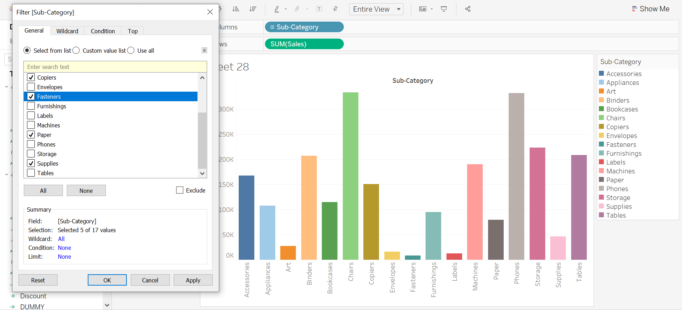
* Explore WildCard options, condition option,
* This is like slicer in excel.
* Explore all these options. 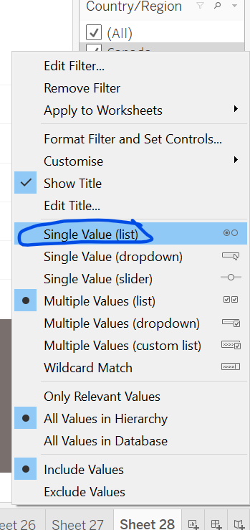

Filters in Tableau Part-2

* Aggregation level filter.
* Take Sub-cat in col and sales in rows.
* Sub-cat to color
* Sales to label
* Drop Sales to Filters pane
* 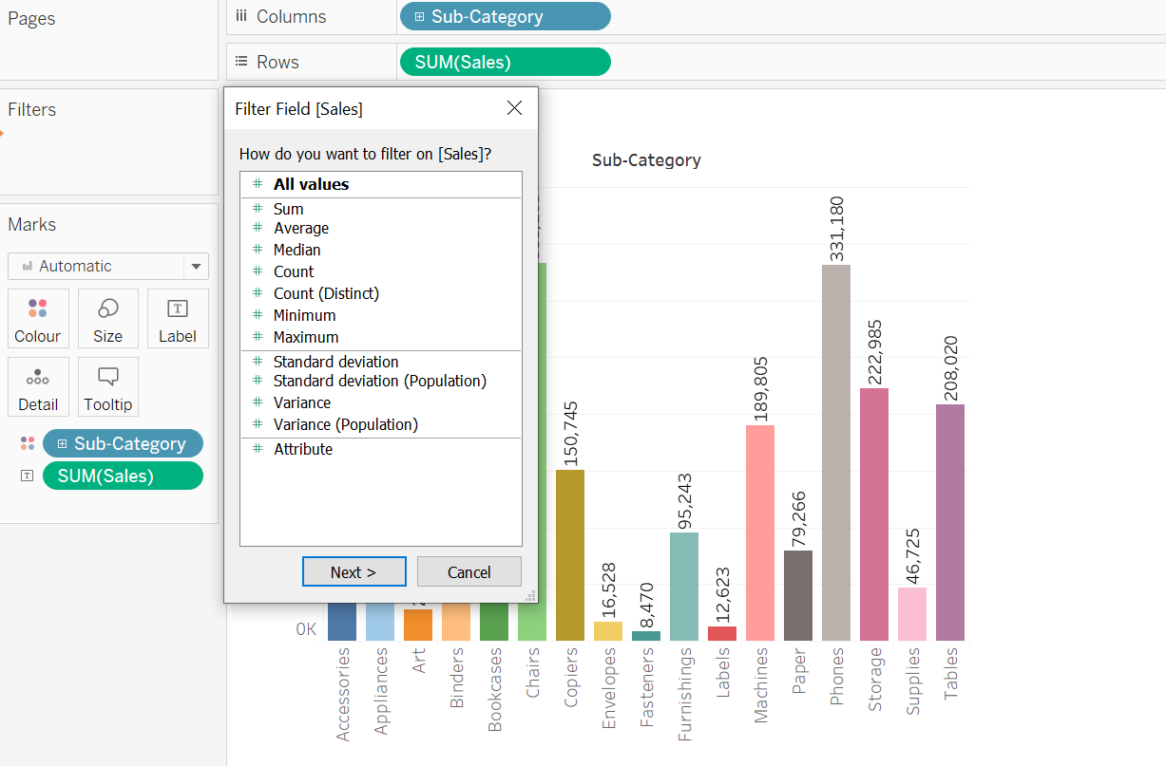
* We can drop multiple column in drop and show filter like slicer in excel.
* Like yar, month, Quarter ke liye alag alag filter.
* Quarter and Month slicer filter pe right click karke dependent select kar lenge.
* To 1st Q1 ko check karne pe sirf jan,feb,march hi month wale filter me dikhega.
* 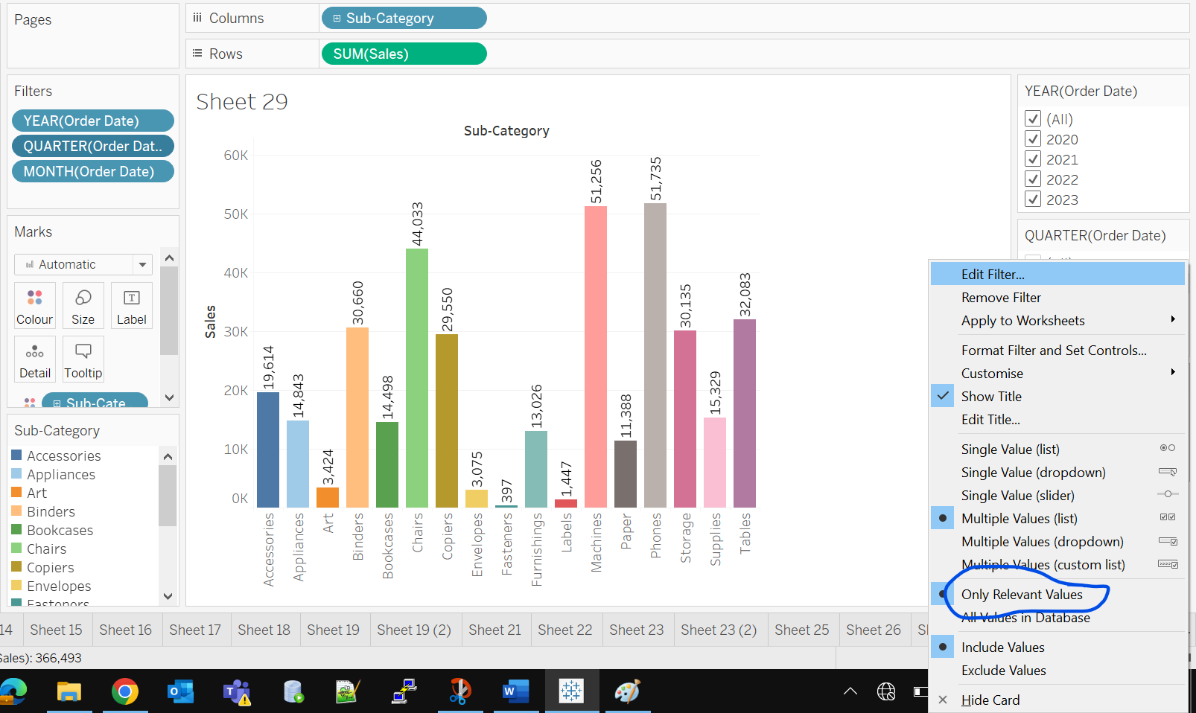
* 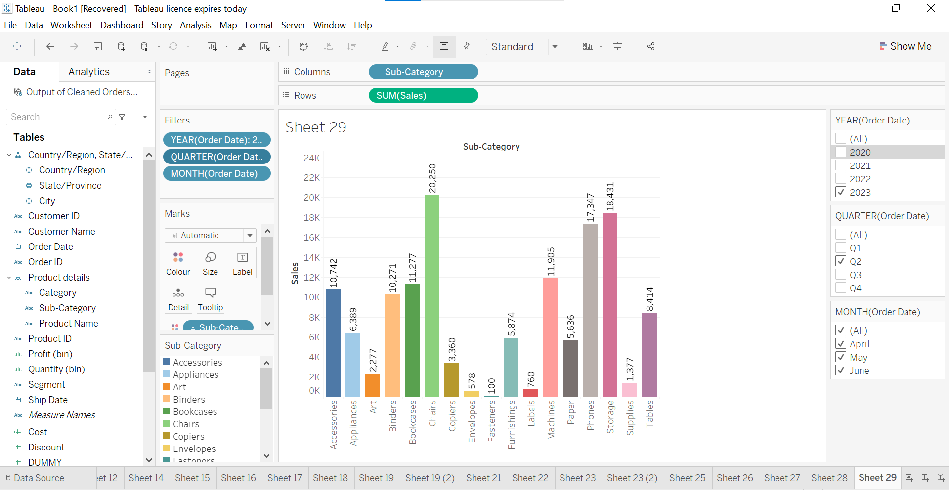
* DataSource Filter: In tableau prep there is add filters option.
* Isse data source pe pehle se hi fliter lag jaayega.
* Agar live connection hai to same filter ki huhi data tableau desktop me bhi dikhega.
* Or in tableau desktop right click on left top side Output of Cleaned and select Edit Data Source Filters. Same prep wala window open ho jaayea. Saare sheets me ye filter apply ho jaayega.
* 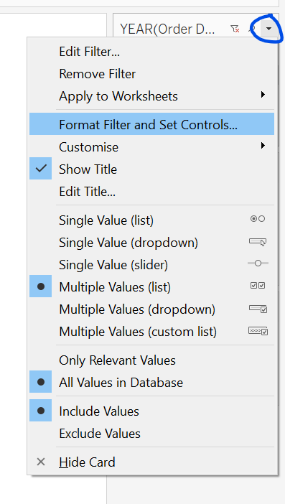 Custom design. Try these out for making better dashboard.
* We can simply double click on any to apply filter. 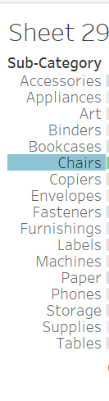
* Ctrl +click for multiselect and then choose keep only. Automaticaaly these filters will be added to Filters pane.
* 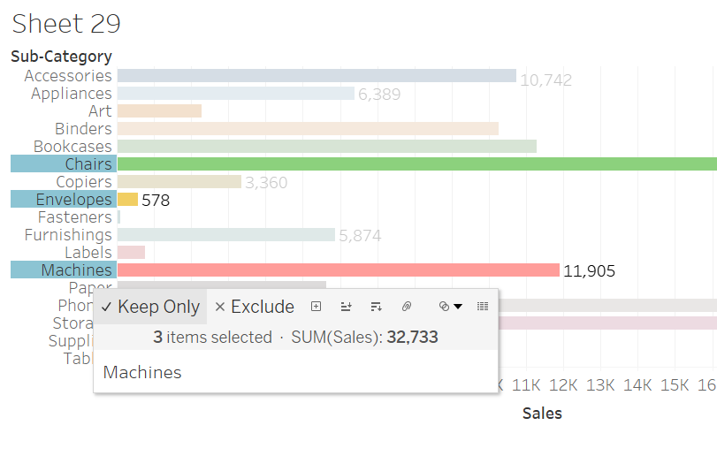
* We can now edit and apply more complex filter from filter pane.
* Try Exclude option as well.

Parameters In Tableau

* Dynamic value jisse hum visualization se interact karte hai.
* Like same filter hme multiple sheets pe apply karna hai, to parameters banake multiple sheet pe apply kar sakte hai.
* Parameter create method
  + Parameter alag se create karna.
  + Parameters with Filters
  + Parameter with sets
* Sale to rows and sub-cat to col
* Step:
* 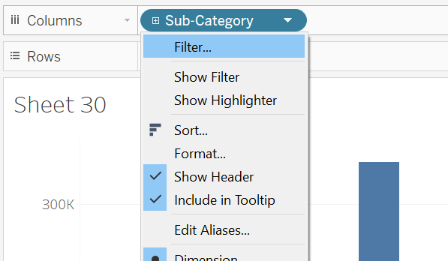
* Apply. 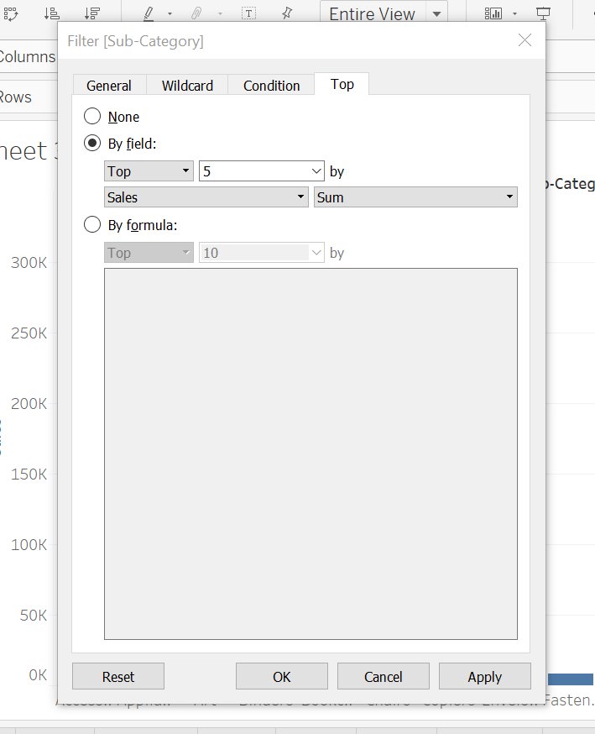
* Edit Filter 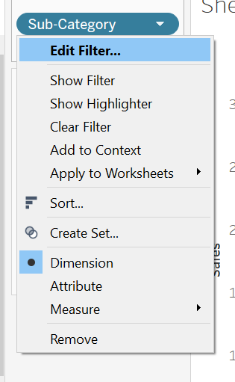
* 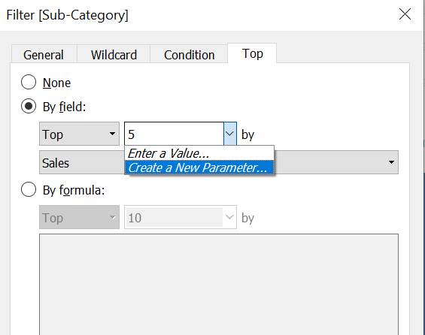
* 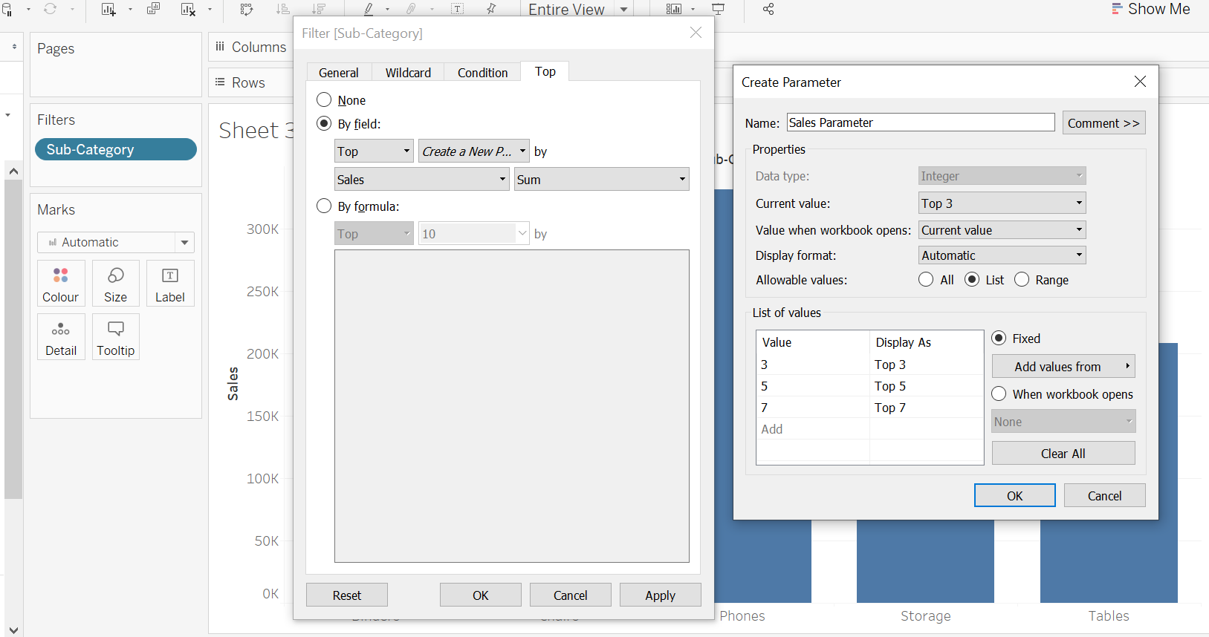
* 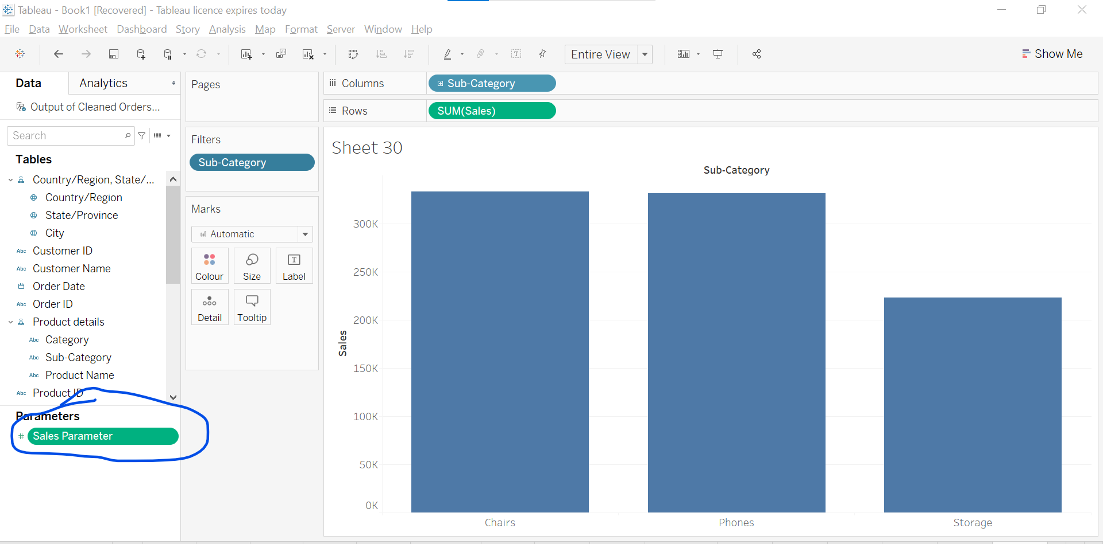
* 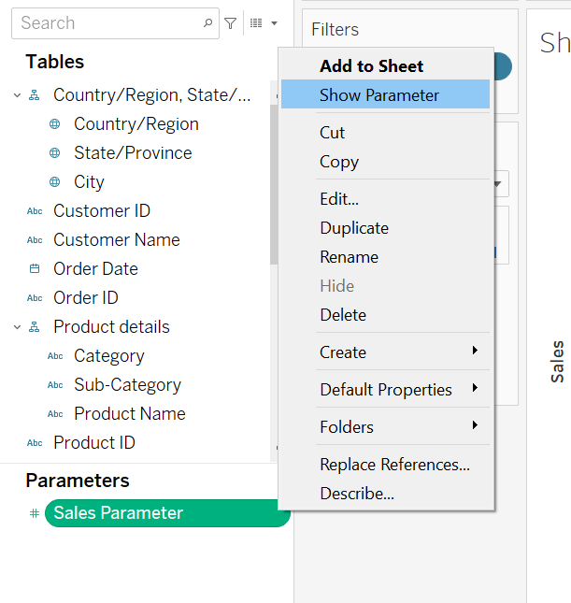
* 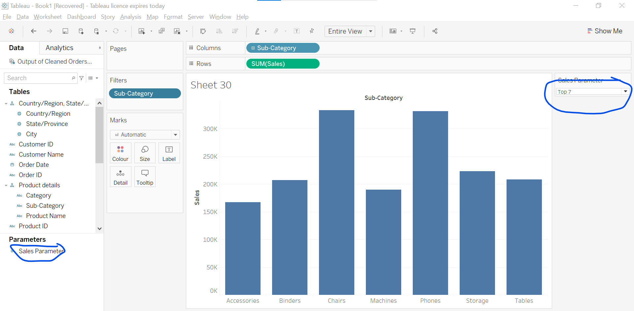
* Lets create another sheet and take sales in rows and Sub- cat in col
* Create parameter this way also.
* 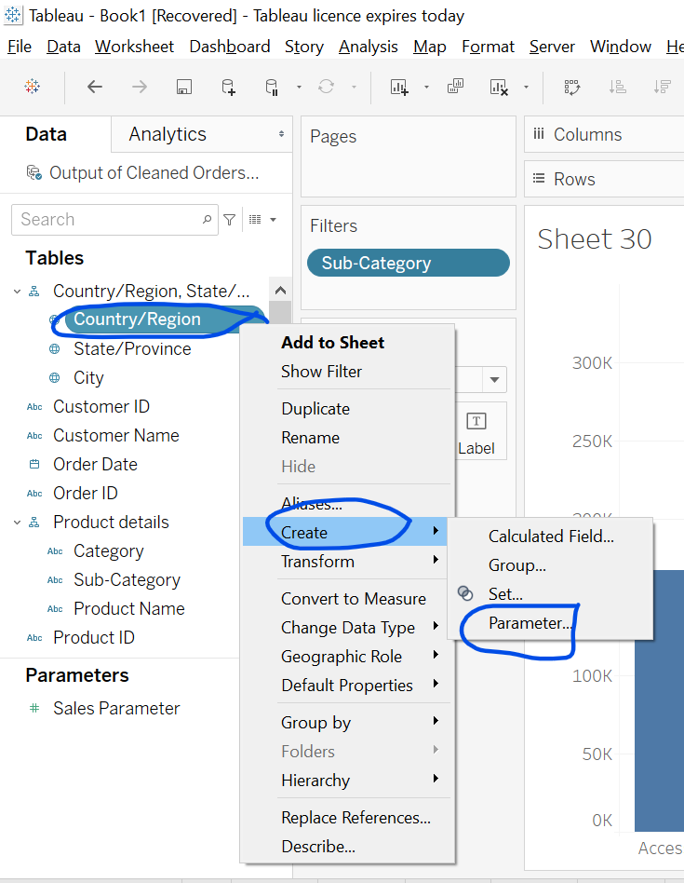
* 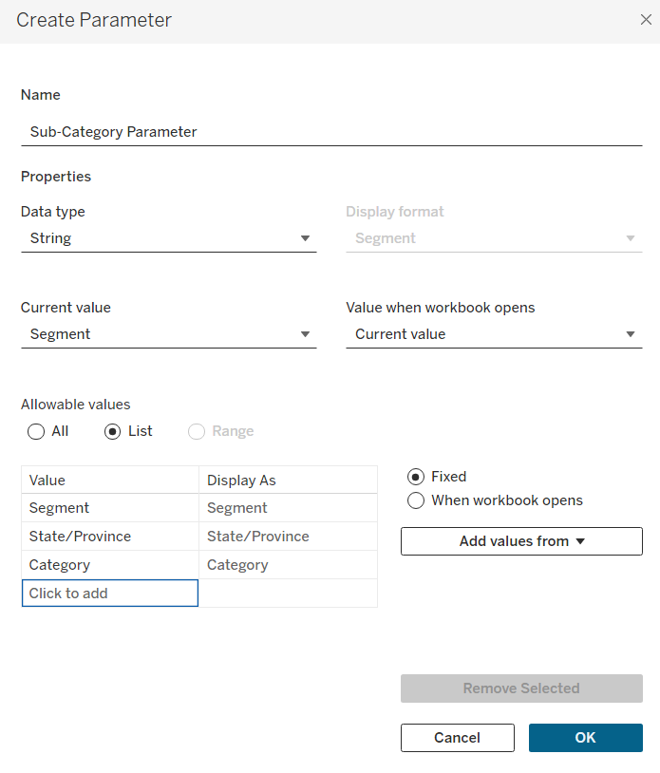
* Click ok
* 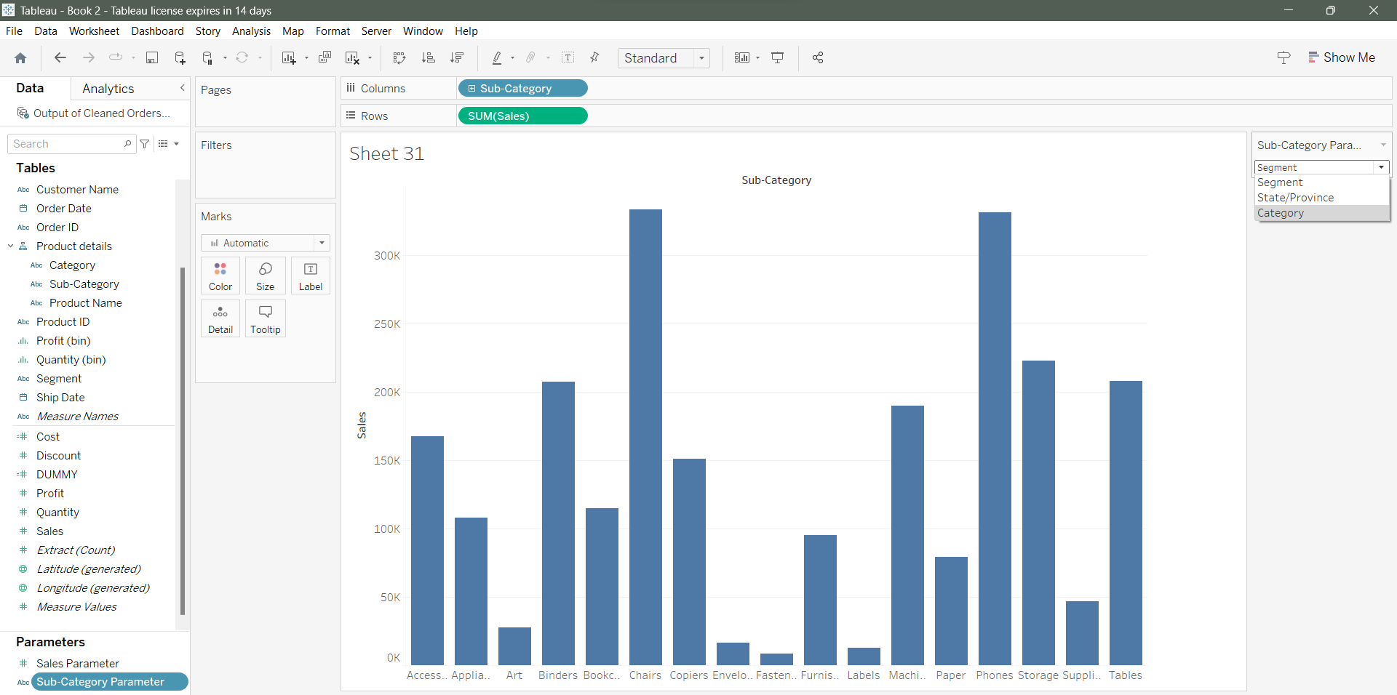
* Now, these filter is not working so, below changes.
* Right click on Sub-category parameter -> Edit -> 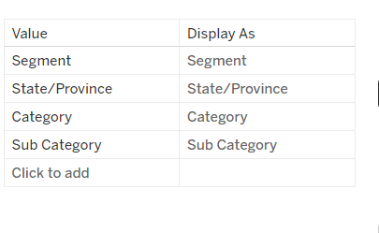 Add Sub-category -> Click ok
* Still filter is not working.
* So, we have to add calculated field.
* Go to Sub-category -> Click -> Create -> Create Calculated Field
* 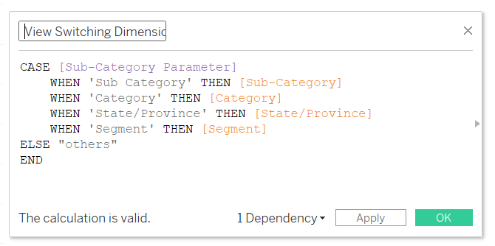 Apply -> Ok
* CASE [Sub-Category Parameter]
* WHEN 'Sub-Category' THEN [Sub-Category]
* WHEN 'Category' THEN [Category]
* WHEN 'State/Province' THEN [State/Province]
* WHEN 'Segment' THEN [Segment]
* ELSE "others"
* END
* Field should match with this. 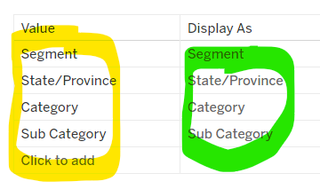
* Since, Filetr was not working so, we create it for switching when we want to apply filter.
* Remove Sub-cat from col and add View Switching Dimension in col
* Add sales as label and explore below options we created.
* 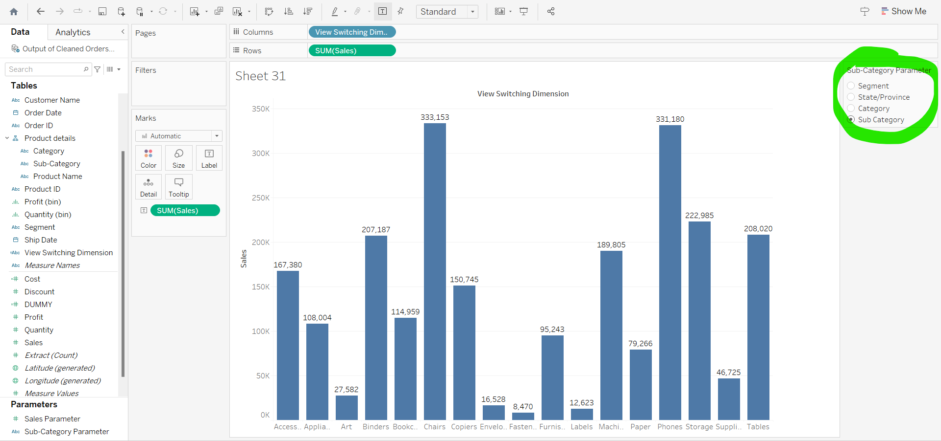
* Now, learn Parameter using sets.
* Create a new sheets.
* Sales to rows and sub-cat to col
* 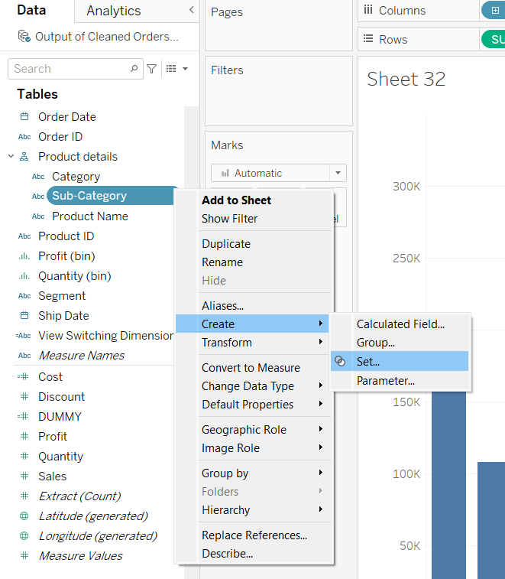
* 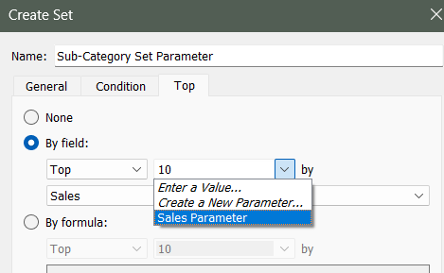
* 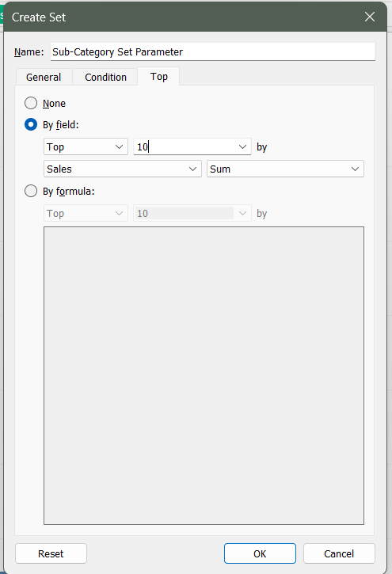
* Click ok
* 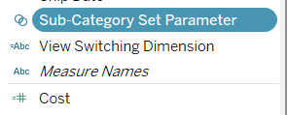 It will show
* Take these field in color.
* 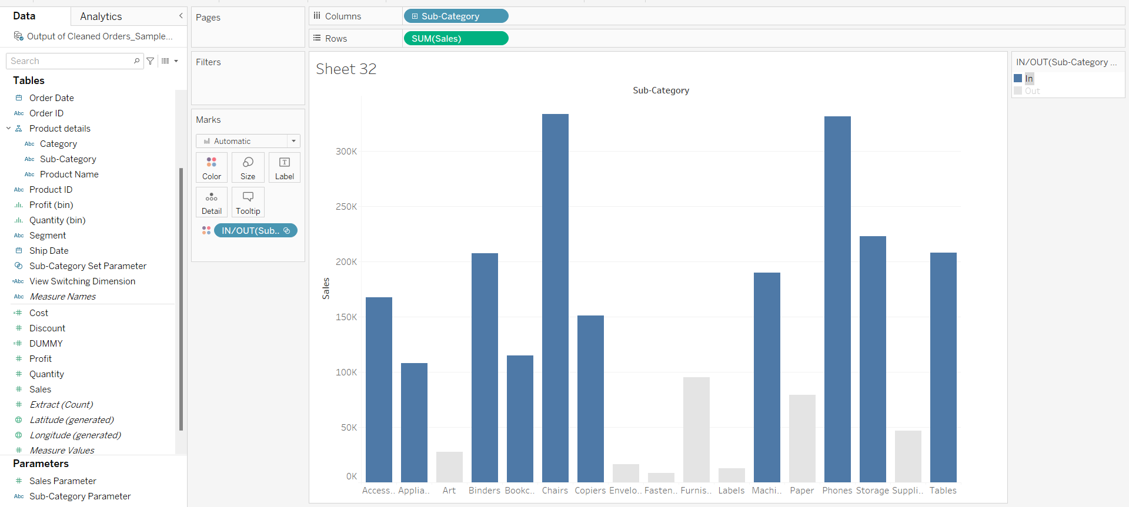
* Take sales to label
* In parameters -> Sales Parameter -> click -> show Parameter
* Top3 . Top 5, Top 7 should work, if not working fix it.
* Again we can format parameter as wish we want for better visuals.

Sets In Tableau

* We can not create sets from measures.
* Subcategory -> click -> Create -> Set
* Click ok 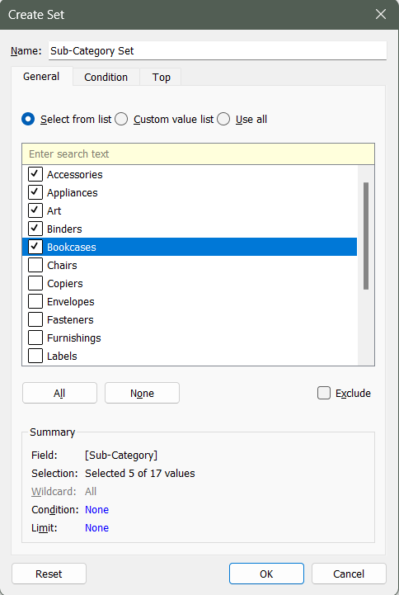
* Rename this set to Set 1 of Subcategory
* Take Sale in rows and sub-cat in col
* Take Set 1 of Subcategory to colors.
* Basically it will show data basis on in and out
* New Sheet -> Sale in rows and Sub-cat in col
* Sort in inc -> Sales in label
* 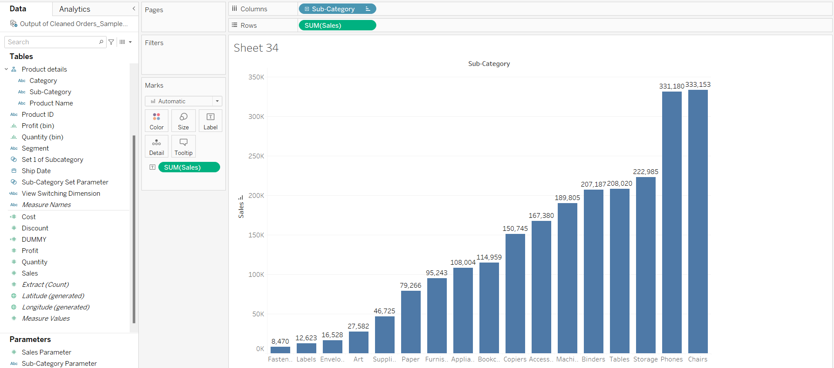
* Now, we want <1 lac ki sales ka set banana hai.
* Select all these 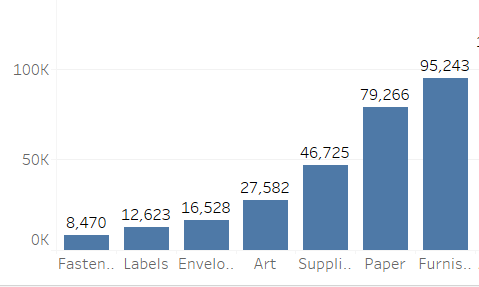
* 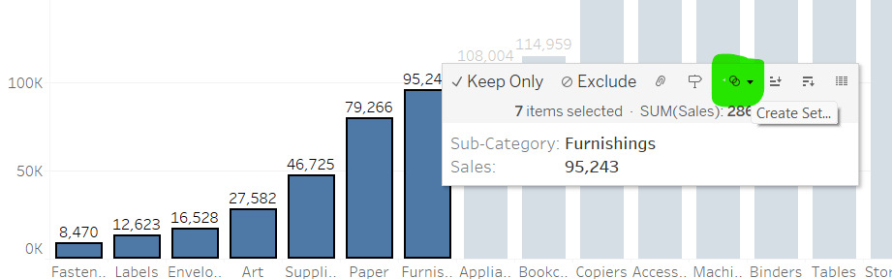’
* Create Set -> 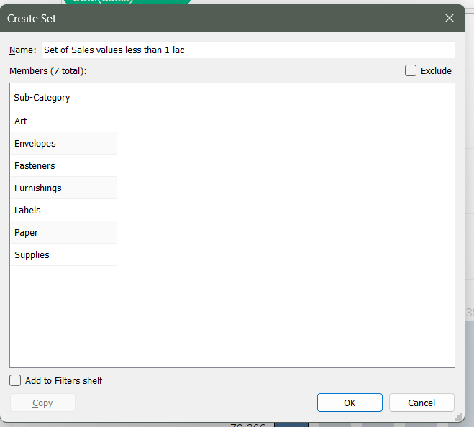 -> click ok
* Create a new sheet -> Sales in rows and Set of Sales value less than 1 lac to column
* Take sub-cat to color and label both
* 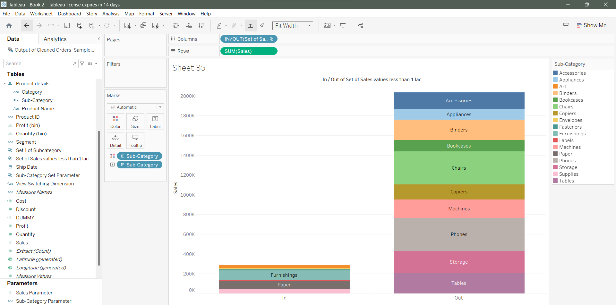
* Create a new sheet -> Sales in rows and profit in col
* Sub-cat to colors and label
* Remove sub-cat from color and label
* Set of Sales less than 1 lac to color move
* We can edit color of circle and format it for better visuals.
* 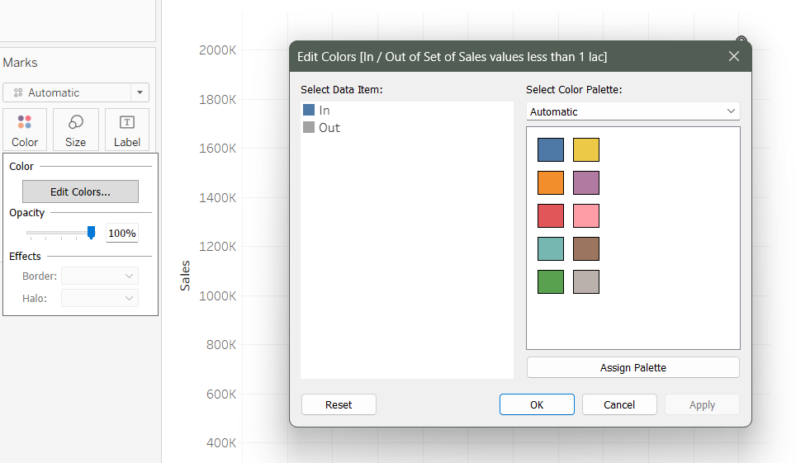
* Take Set 1 of Subcategory to colors
* This was all about static set.
* Now Create Dynamic set. Jo bhi changes hamare dataset me honge wo hamare set me bhi apply ho jaayega.
* Create new sheet
* Sub-cat -> click -> create -> create set-> 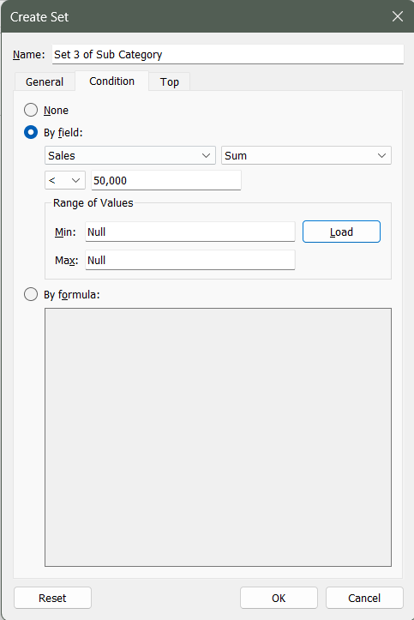
* Take sales in rows and sub-cat in col
* Take Set 3 of Sub Category in colors
* Sales in label
* Sort in inc or dec
* 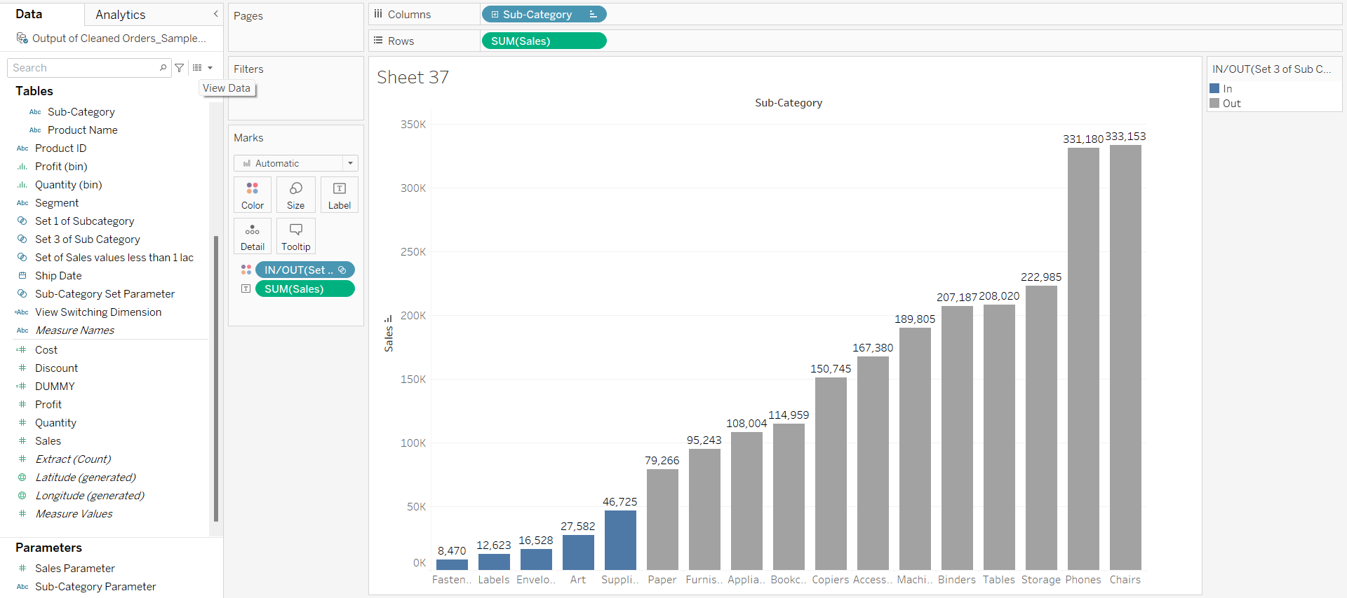
* Now we will see combine set.
* Combine set ya to sirf static set se jor ke banate hai ya sirf dynamic set se.
* Aisa set jisme hum multiple dimension liye hai, uska use hum combine set me nhi kar sakte hai.
* We will use these set for creating combine set.
* 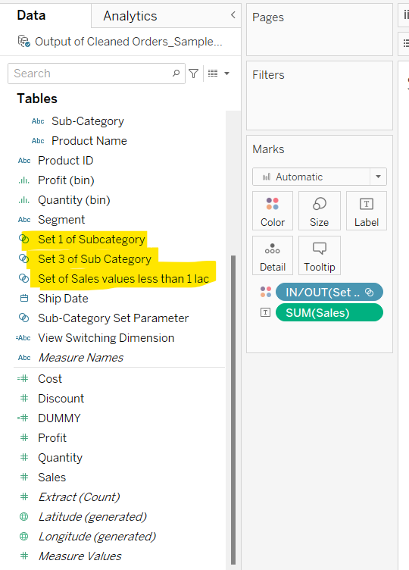
* Select these two set and create combined set. 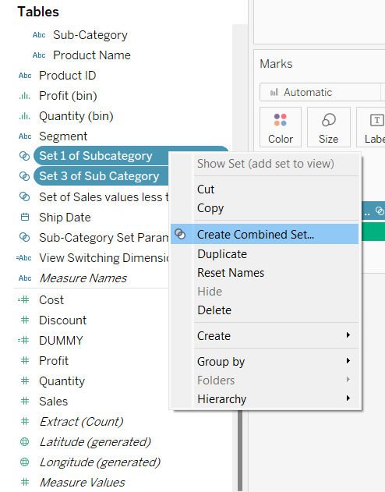’
* 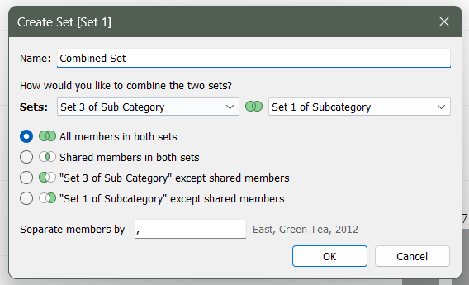
* Create a new sheet
* Take sales in col and sub-cat in rows.
* Sort inc or dec
* Sales to label
* Combined set to color
* Final
* 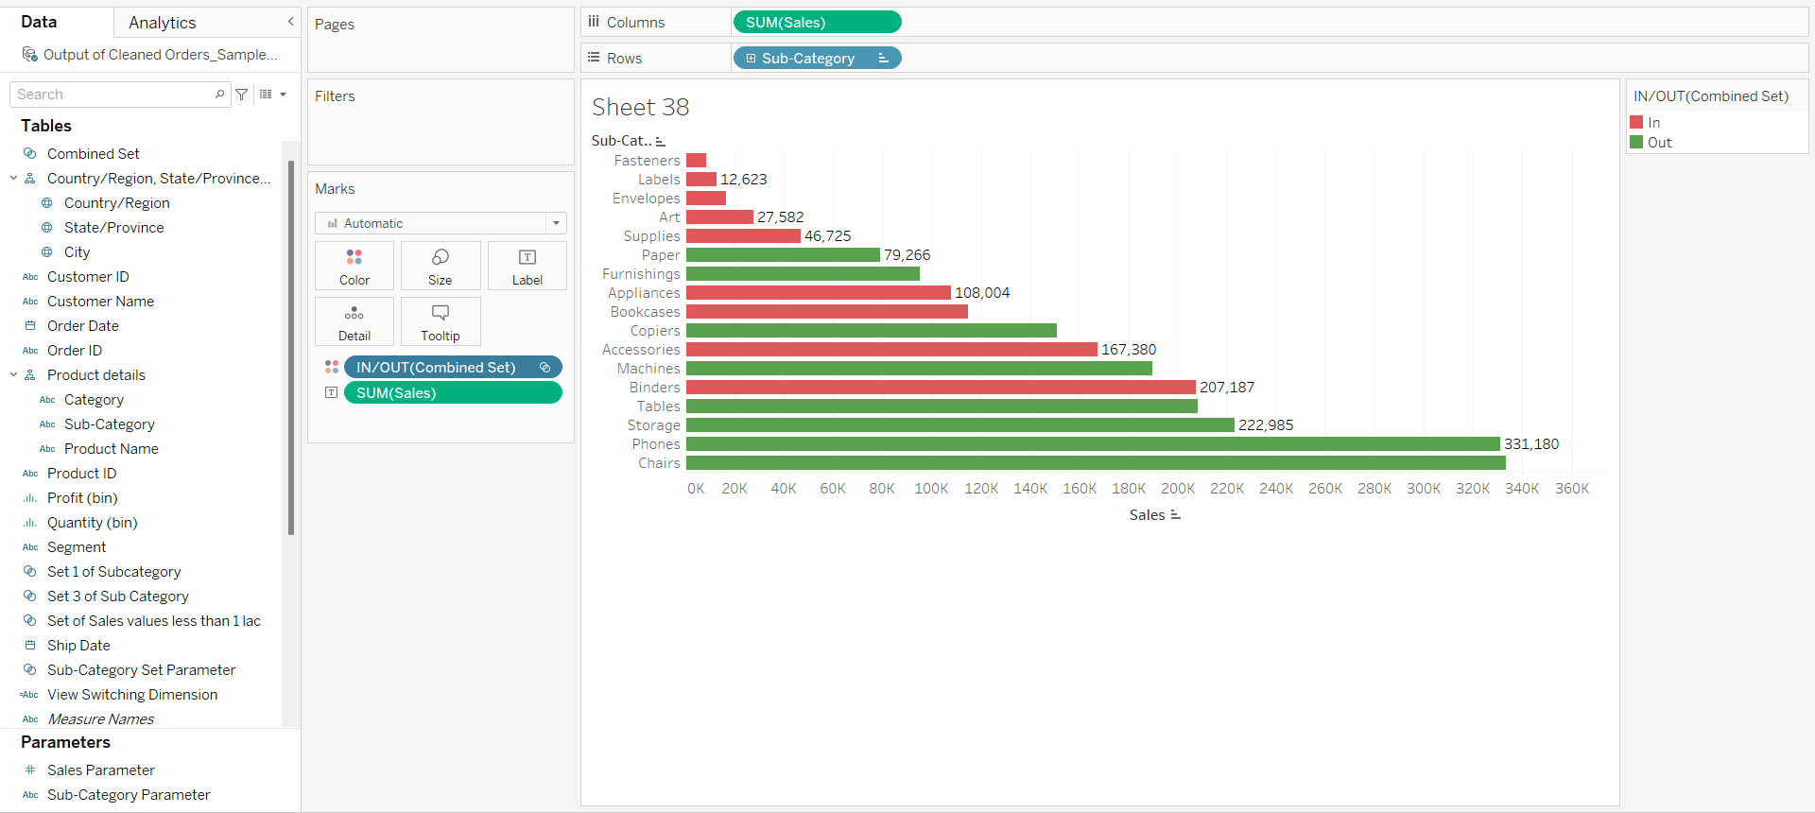

**Table Calculation**

* For Numeric Data Function are Aggregate Function like SUM,MIN,MAX,AVG,MEDIAN etc.
* We can calculate this by create calculated field options.
* Or simply right click field and in Measure options all functions are available.
* Take Sub-cat to Rows and Sales to label
* Right click on sales in label and inside measure all aggregate options are available. Lets click Maximum.
* Or we can create calculated field by right clicking on field.
* 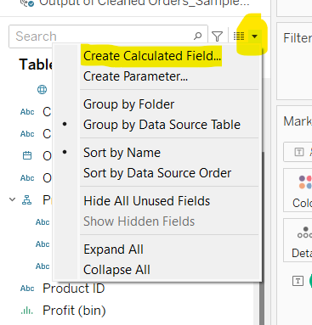
* 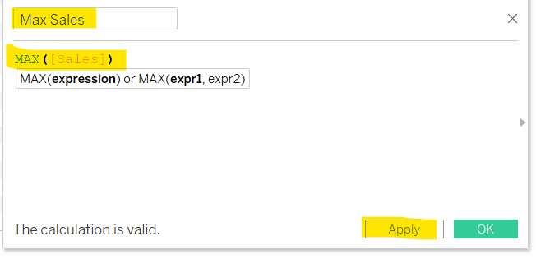
* 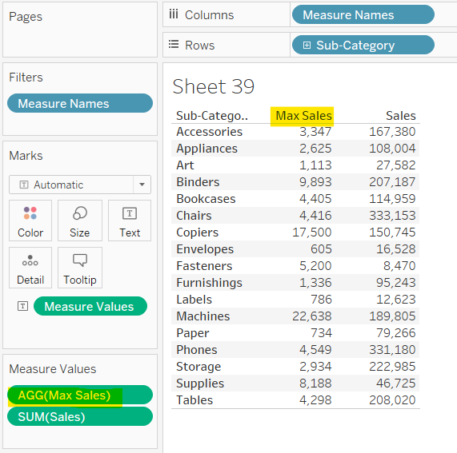
* Now, explore string function like UPPERCASE, LOWERCASE, REVERSE etc.
* We have to create a calculated field.
* 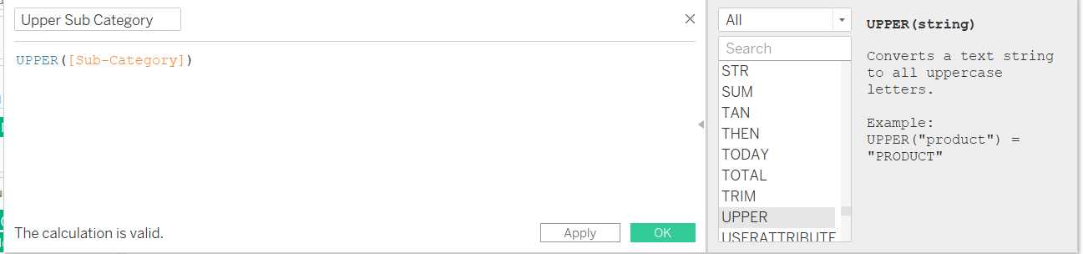
* Apply and OK.
* Drop this field to visuals area.
* Remove Sub-cat from rows.
* 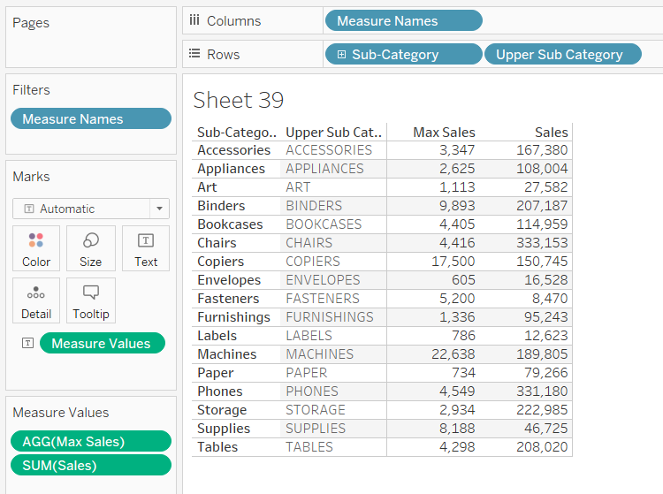 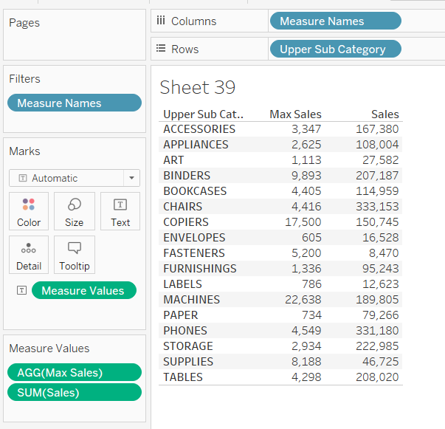
* Table Calculation: Ek calculaton create karenge jo ki visuals jo hme dikh rhi hai uspe kaam karegi.
* Create a new sheet.
* Sub-cat to rows and Profit to col
* Explore all these options and their meaning and usage.
* 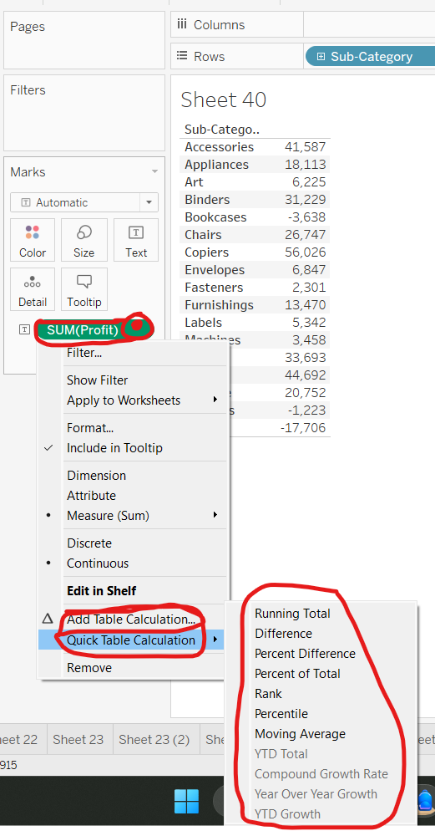
* Select running total.
* Again take profit to visuals area.
* 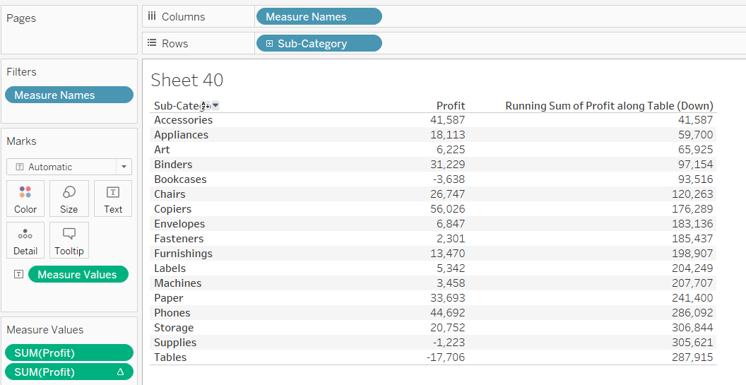
* 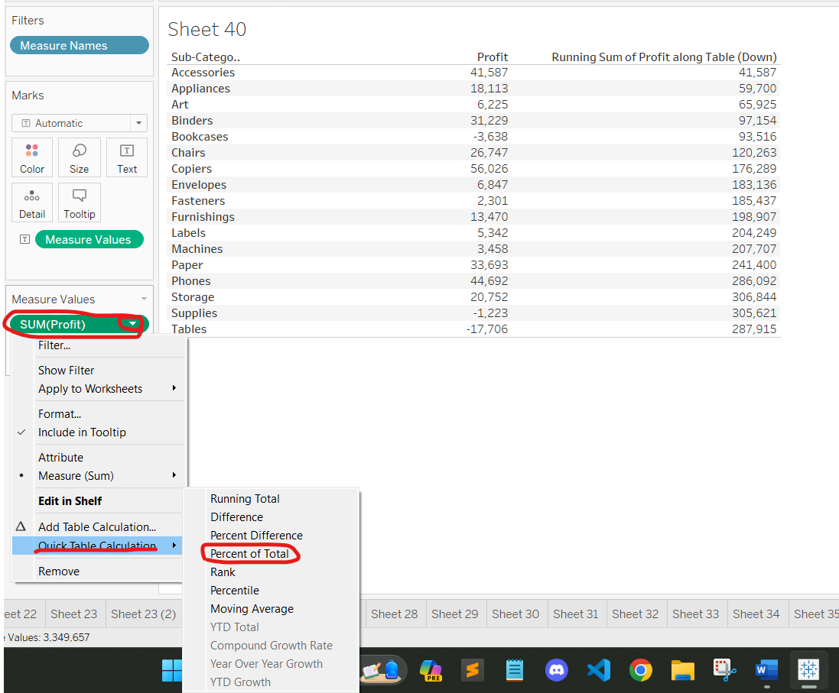
* Again take Profit to visuals area.
* Analyse this visuals.
* 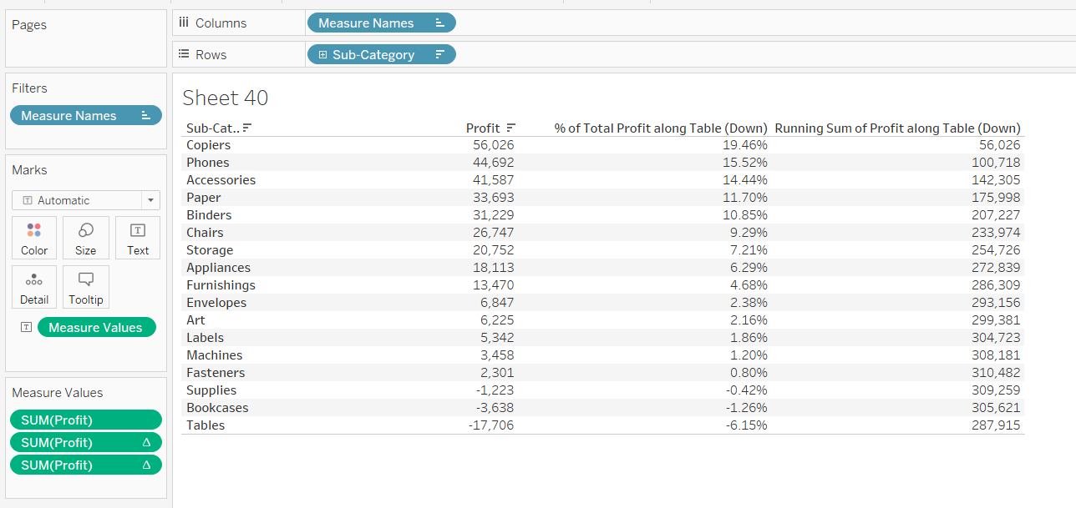
* 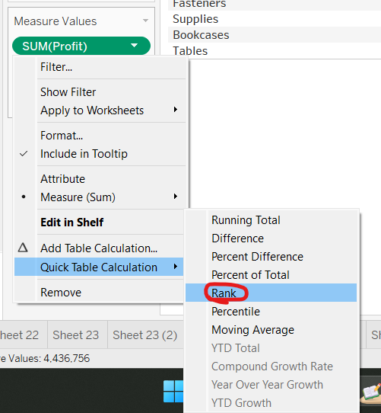
* 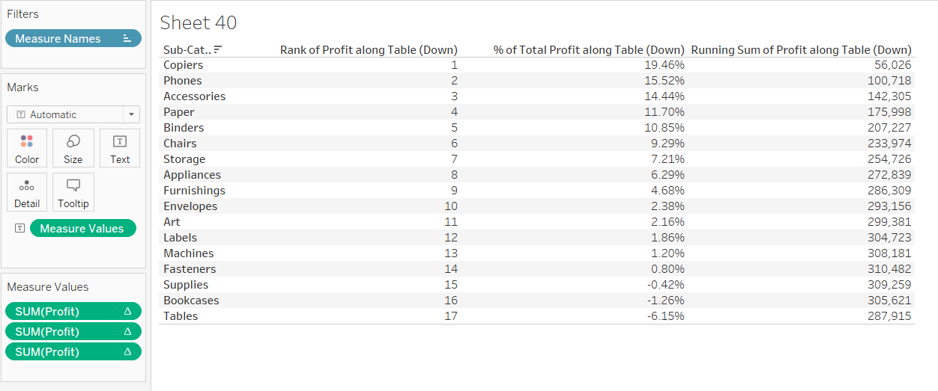
* Similarly explore all other options.
* 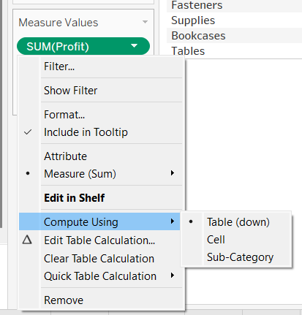
* Agar Category ke under sub-category bhi hai visual me to pane pe bhi option aayega Compute using karne hai.
* Explore these options as well 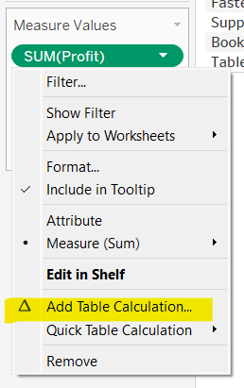
* 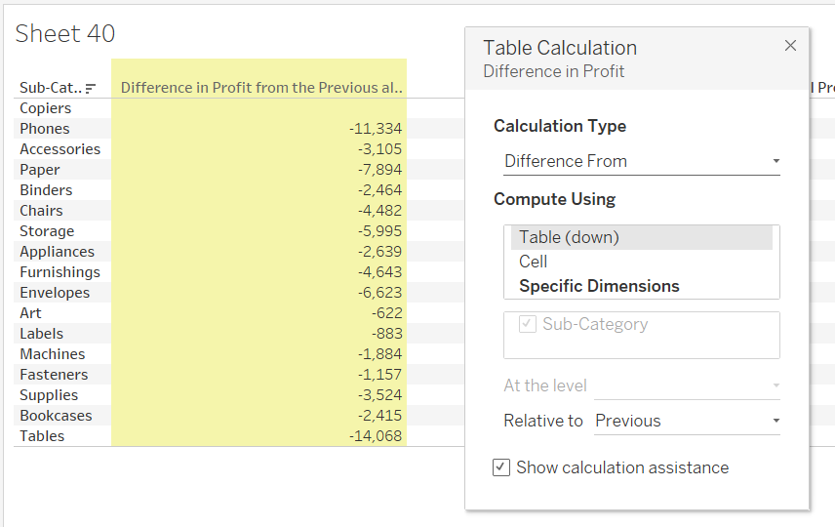

Joins And Unions

* Already taught in previous lecture.
* Go at once through lecture and practice it.

Data Blending

* Blend= Mixing things
* Alag- Alag Data Sources se data ko mix karte hai. Like two workbooks or excel file we are mixing data.
* Use ZoomAI_Department1 and ZoomAI_Department2 excel file

|  |  |  |
| --- | --- | --- |
| Period | Capitals | Revenue |
| Y2020 | Abidjan | $1,00,00,000 |
| Y2020 | Dakar | $2,00,00,000 |
| Y2020 | Bamako | $7,00,00,000 |
| Y2020 | Nairobi | $12,00,00,000 |
| Y2020 | Alger | $15,00,00,000 |
| Y2020 | Abuja | $6,00,00,000 |
| Y2021 | Abidjan | $80,00,000 |
| Y2021 | Dakar | $1,60,00,000 |
| Y2021 | Bamako | $5,60,00,000 |
| Y2021 | Nairobi | $9,60,00,000 |
| Y2021 | Alger | $12,00,00,000 |
| Y2021 | Abuja | $4,80,00,000 |

* ZoomAI_Department1

|  |  |  |
| --- | --- | --- |
| Year | Cities | Revenue |
| Y2020 | Abidjan | $1,50,00,000 |
| Y2020 | Dakar | $10,00,00,000 |
| Y2020 | Bamako | $5,00,00,000 |
| Y2020 | Nairobi | $4,00,00,000 |
| Y2021 | Abidjan | $1,05,00,000 |
| Y2021 | Dakar | $7,00,00,000 |
| Y2021 | Bamako | $3,50,00,000 |
| Y2021 | Nairobi | $2,80,00,000 |

* ZoomAI_Department2
* In joins hum same excel workbooks ke alag alag sheet ko join karte hai.
* Year and Period as a common field use kar sakte hai.
* Primary Data Source ZoomAI_Department1 bcx it has more data. But we can take ZoomAI_Department2 also as primary data source.
* Secondary Data Source ZoomAI_Department2
* Blending coomon dimension ke basis pe hoti hai. Jisko linking field kehte hai.
* 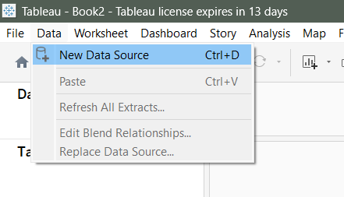 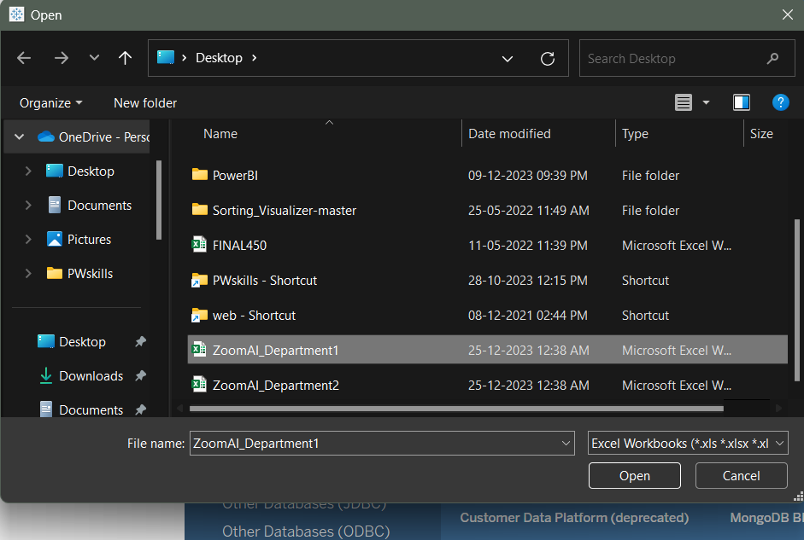
* 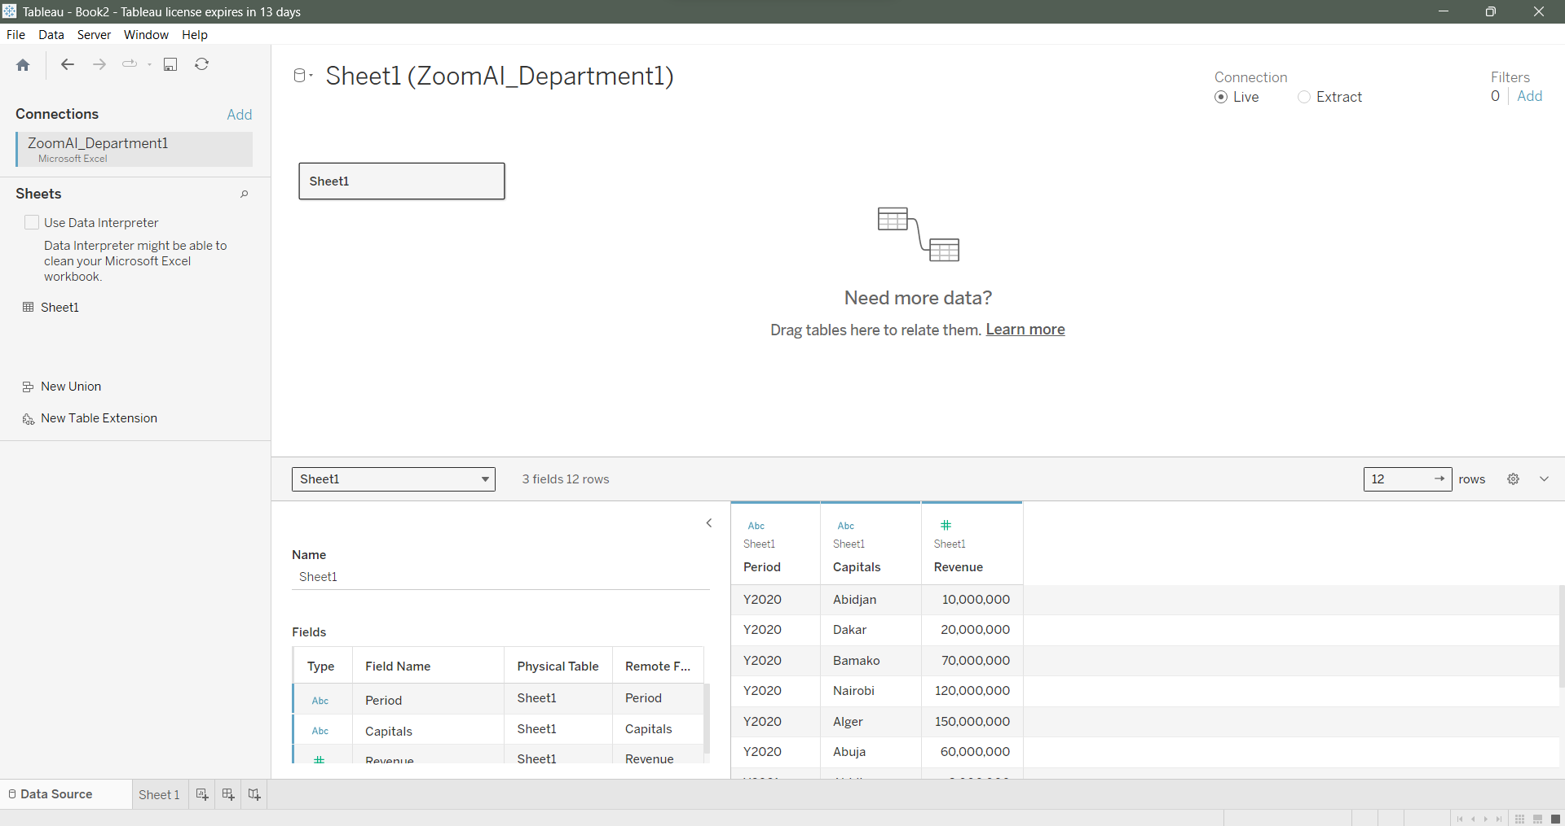
* 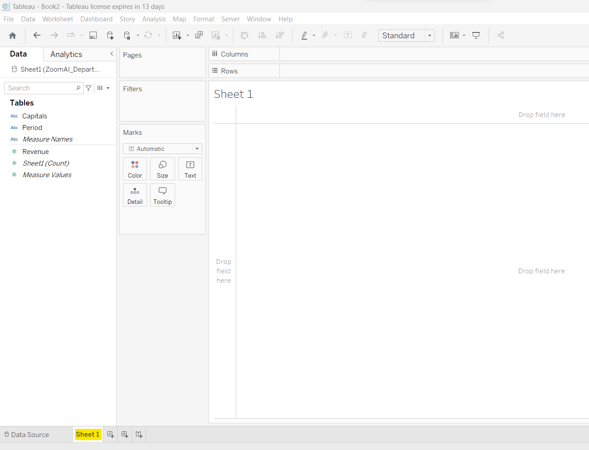
* 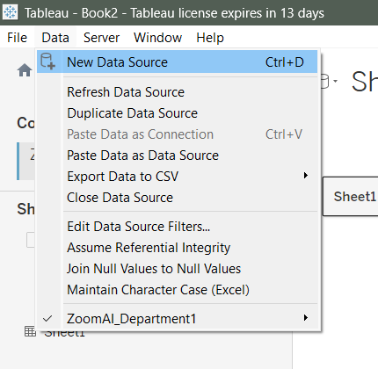
* Add connections nhi karna hai, nhi to wo same data source ka ho jaayega.
* 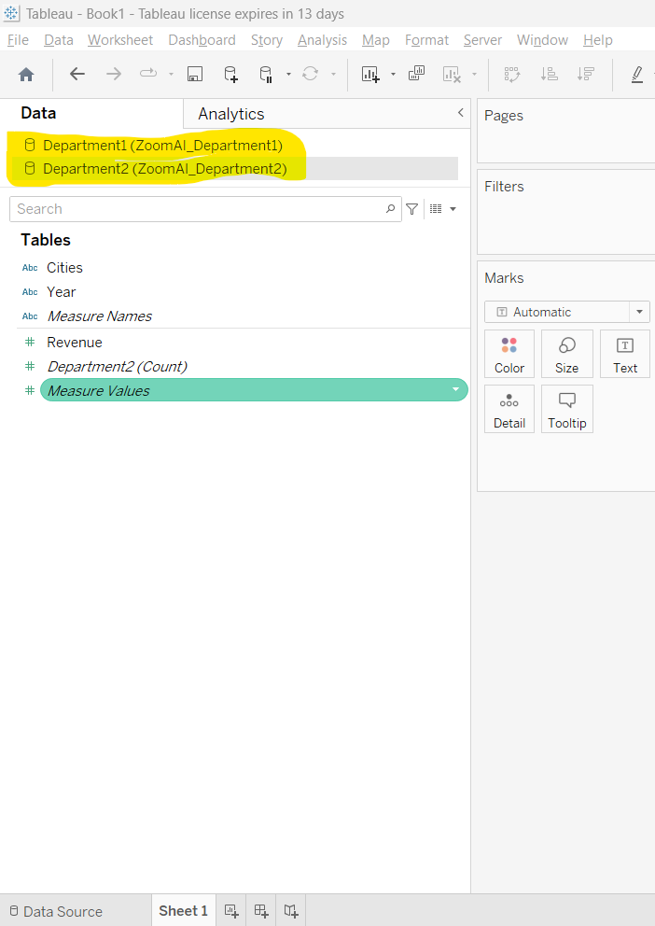
* Jha jyada data source hai usko primary Data Source manenge.
* Select Zoom DeptAI Dept 1 workbook -> Revenue in row and Capitals in col.
* 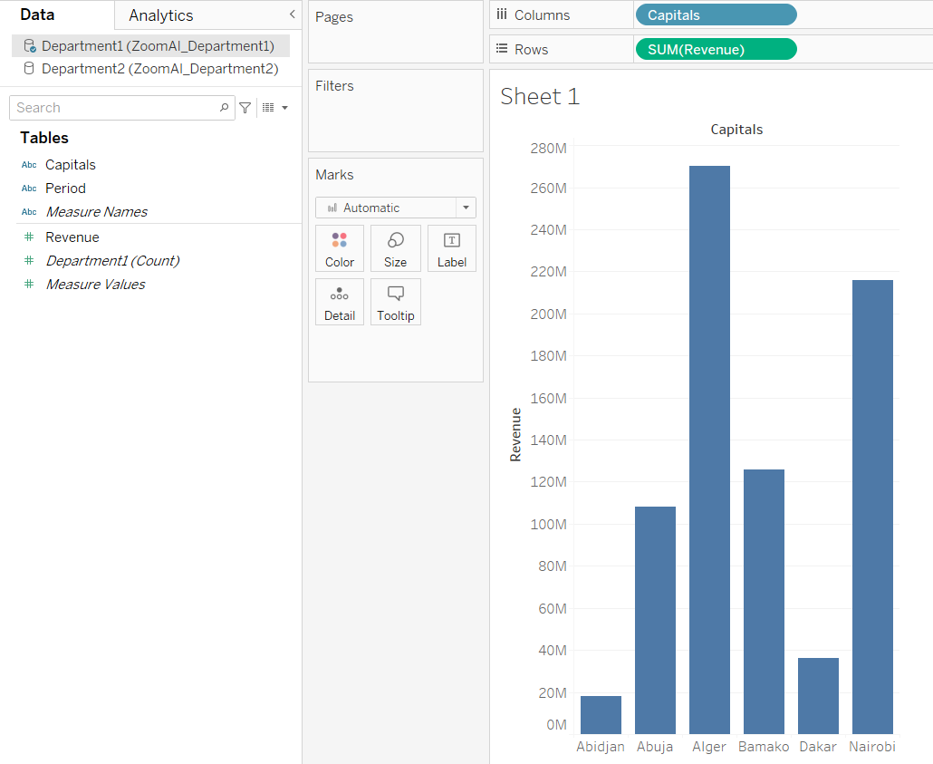
* Now, Zoom DeptAI Dept 1 will be treated as Primary Data Source.
* 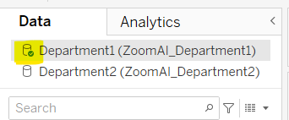
* Select Zoom DeptAI Dept 2 and take Revenue to rows.
* 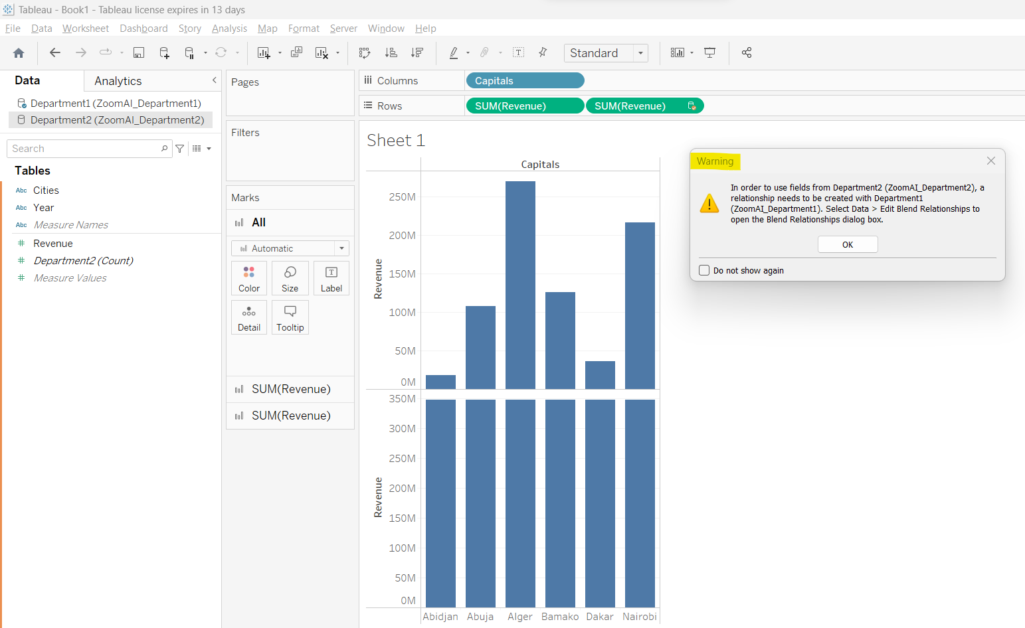
* This warn us to create blending relationship.
* Remove Revenue from rows.
* 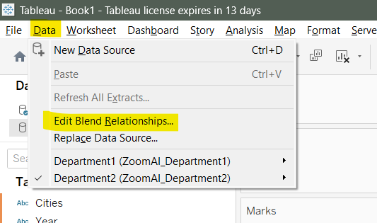
* Tableau can’t determine common col so, we have to choose custom.
* 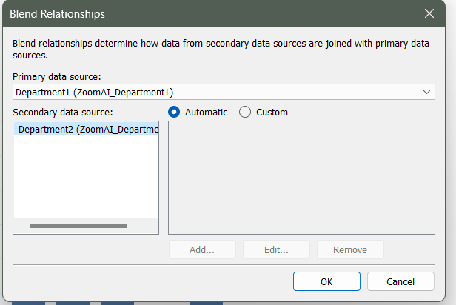
* 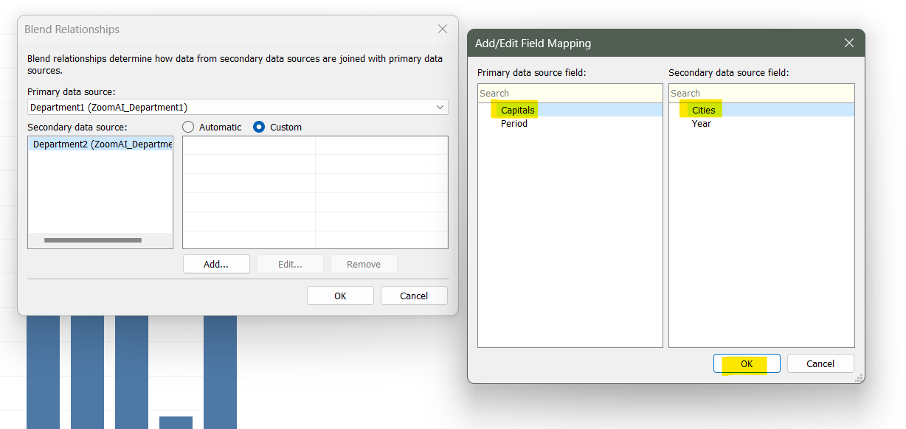
* This icon tell us that it is connecting field.
* 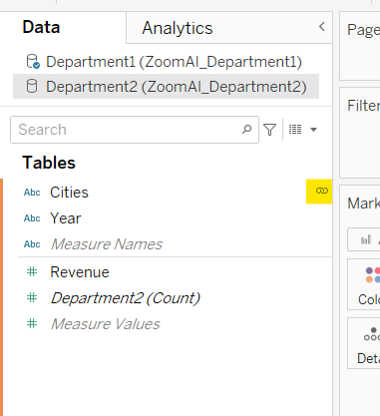
* Now, take Dept2 file revenue to rows
* Click on swap.
* 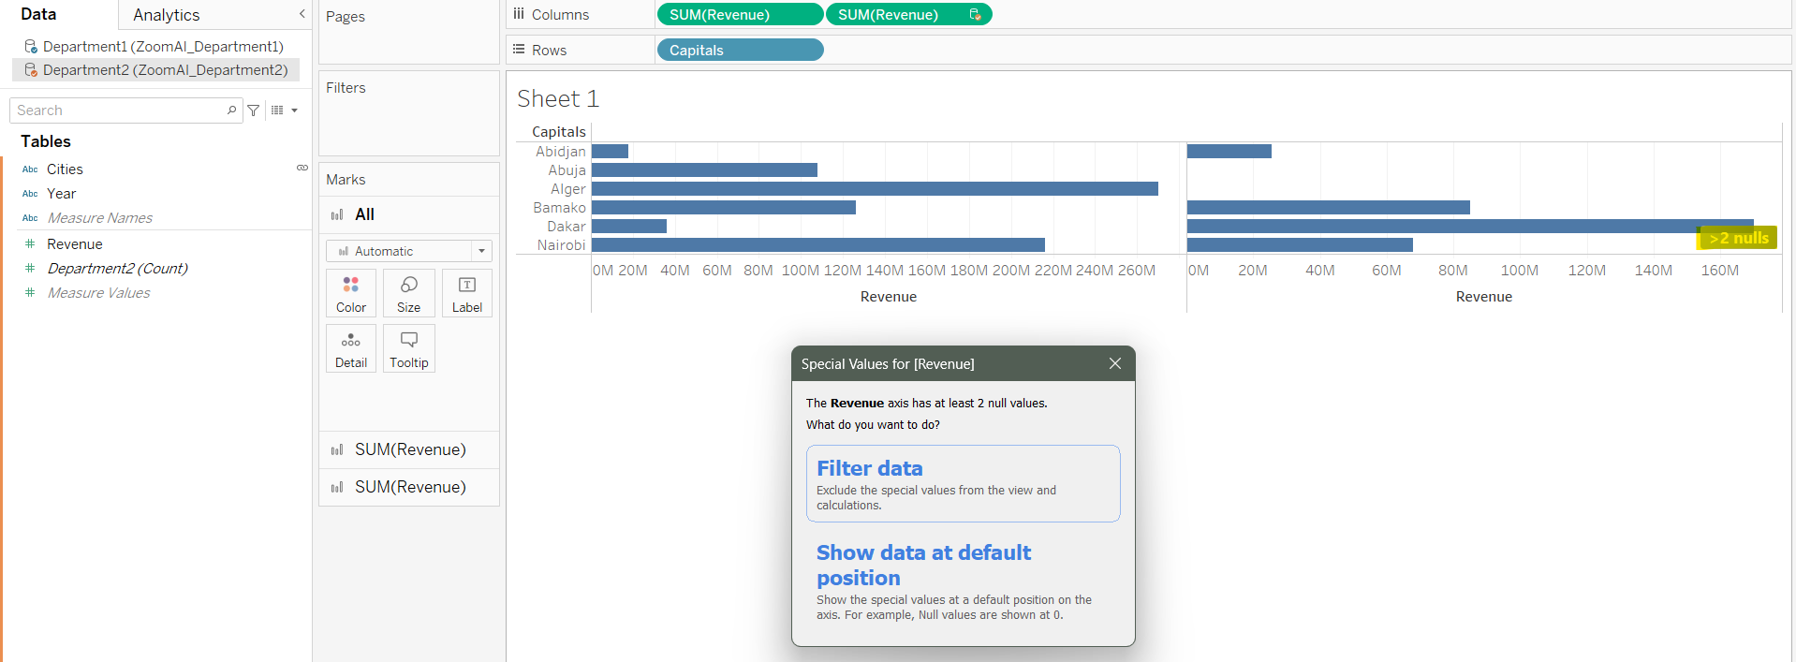
* Jo cheez ek me hai dusre me nhi hai wo null dikhayega.
* 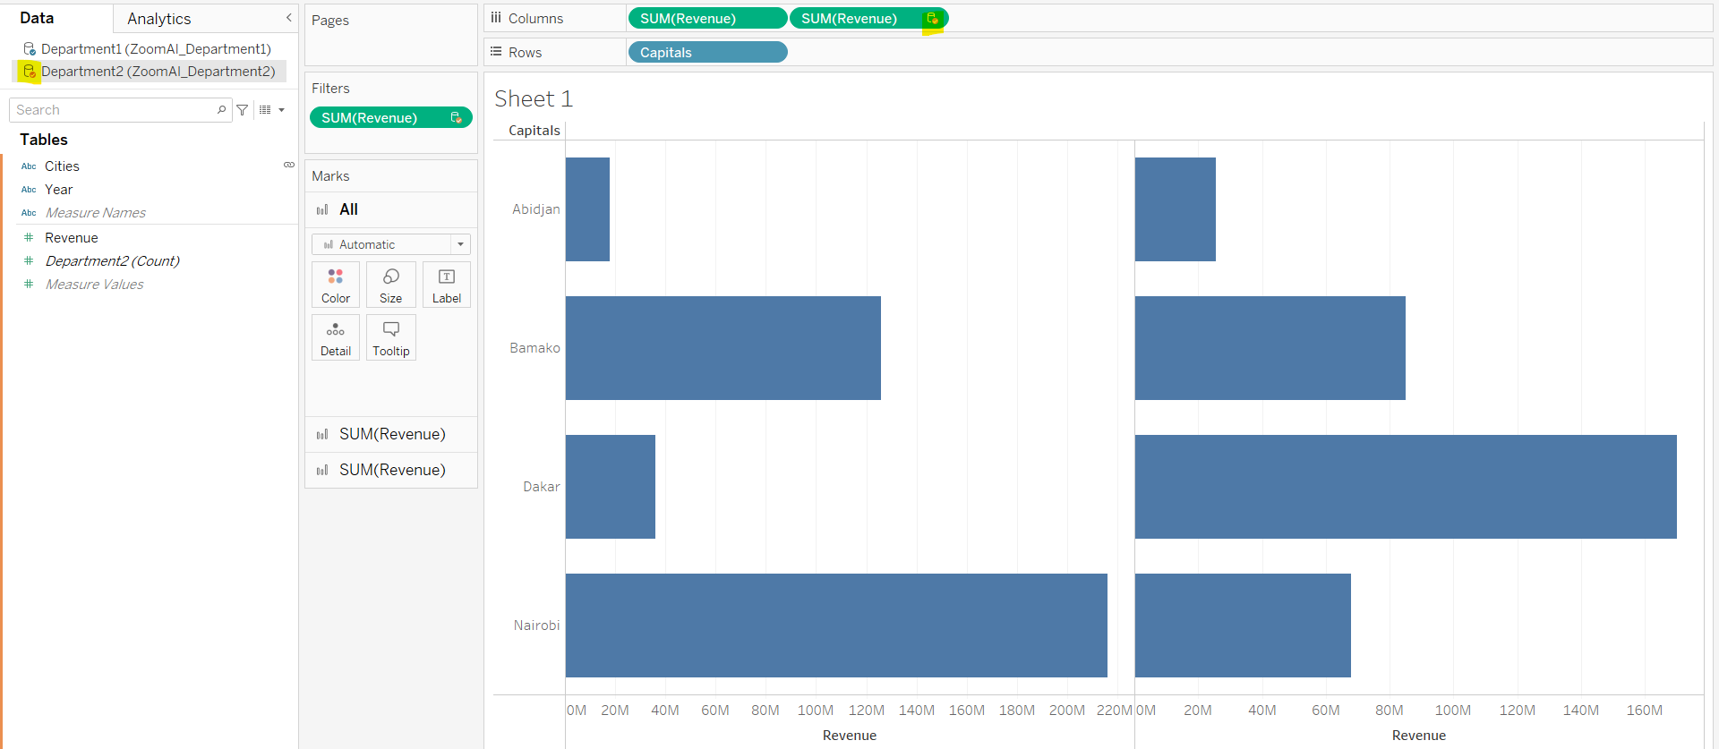
* This icon tells us that it belongs to secondary data sources.
* We change color of bar as well.
* Create new sheet.
* Then we have to make again Primary and Secondary DS. We have choose again and again in every new sheets.
* New sheet me jis workbook ko pehle use karenge visualization me wo Primary DS ho jaayega, dusra wala automatic Secondary DS hoga.
* Wo blend relationship automatic establish ho jaayega q ki pehle humne kiya tha ek baar so, tableau usi ko refer kar lega.
* Blending me humse left join hota hai. To is baar null error nhi aayega, whi plotting graph.
* Linking icon column ke side me hamesa secondary DS ke data me aata hai.
* We can edit Primary, Secondary DS from blend relationship otpions.
* Data blending me duplicates data nhi aata hai, so depending on data we can choose belnding or union or join
* Joining ke case me hme primary, secondary DS select nhi karna padta hai but blending me karna padta hai.
* Data join overall kaam karta hai.
* Blending ke case pehle data ko affregate karta hai fir combine karta hai, but data joins me pehle combine karta hai fir aggregate karta hai.
* Us wajah se joins thoda slow ho jaata hai.
* Data joins me level of detailing data ka subka same hona chaiye but not in blending.

Tableau Dashboard

* It is important to watch if we want to create dashboard and story.
* Useful information and techniques taught.

Tableau Server

User Security